Lab 4 Istio

1. Download Istio
Download Istio and set it up.
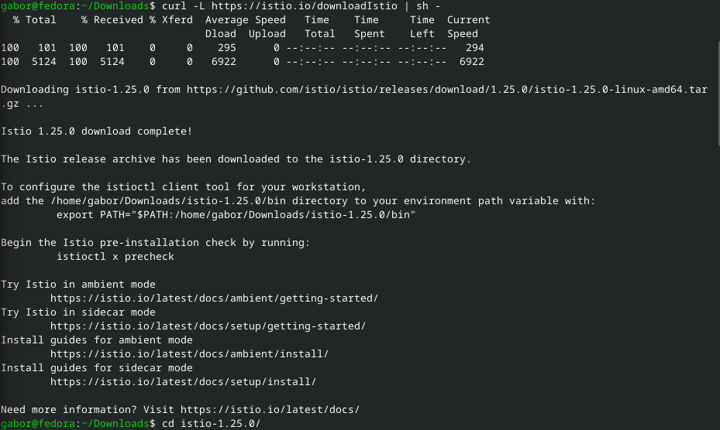

2. Install Istio & Kubernetes Gateway
Install demo profile.
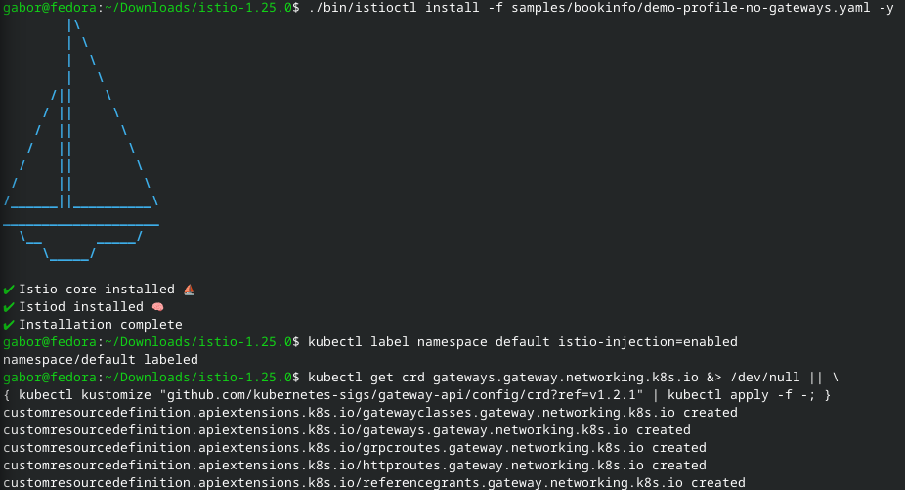

3. Deploy Sample Application
Deploy the Bookinfo sample application.
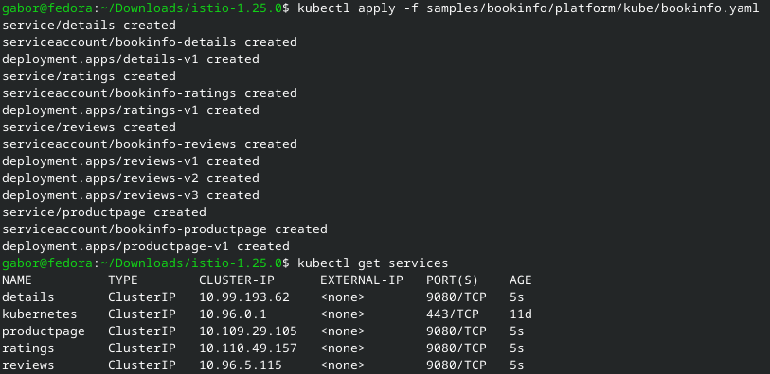
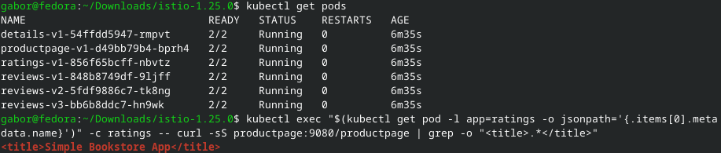

4. Open the Application to Outside Traffic
Make the application available to outside machines.
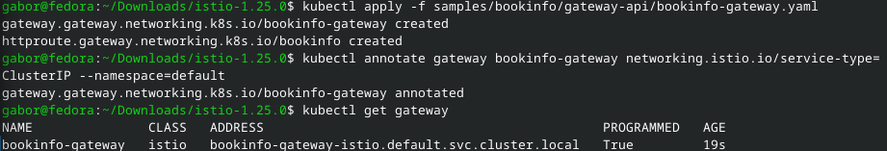

5. Access Application
Port-forward the application and access it.


6. Access the Dashboard
Deploy the telemetry and look at dashboard.
