Lab 2 Containers

Publishing and exposing ports
Running Nginx on port 8080.
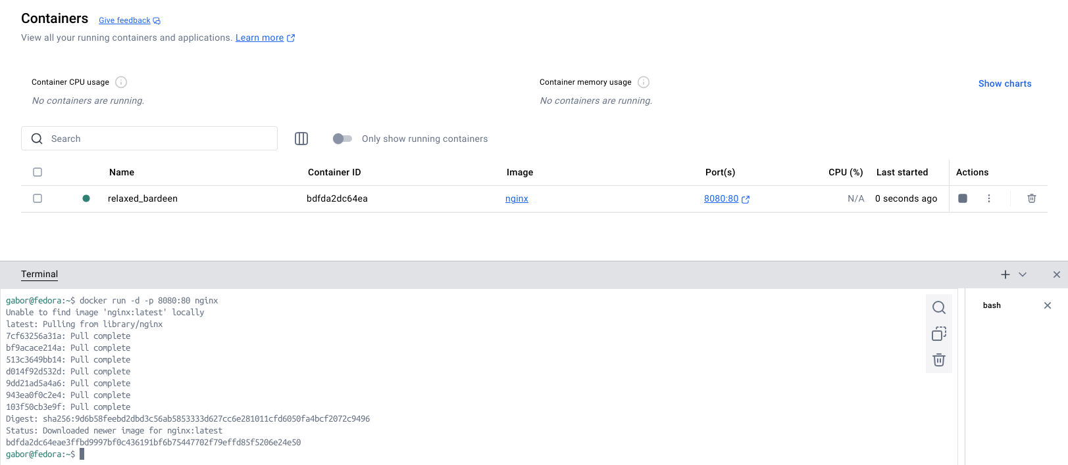
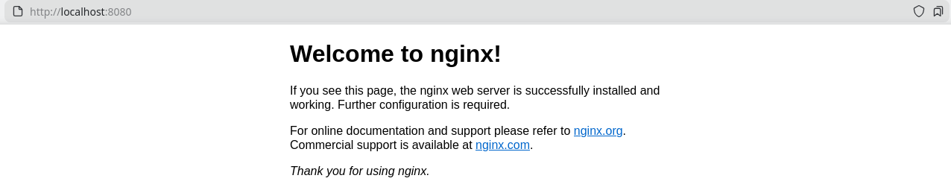
Running Nginx on automatic port.
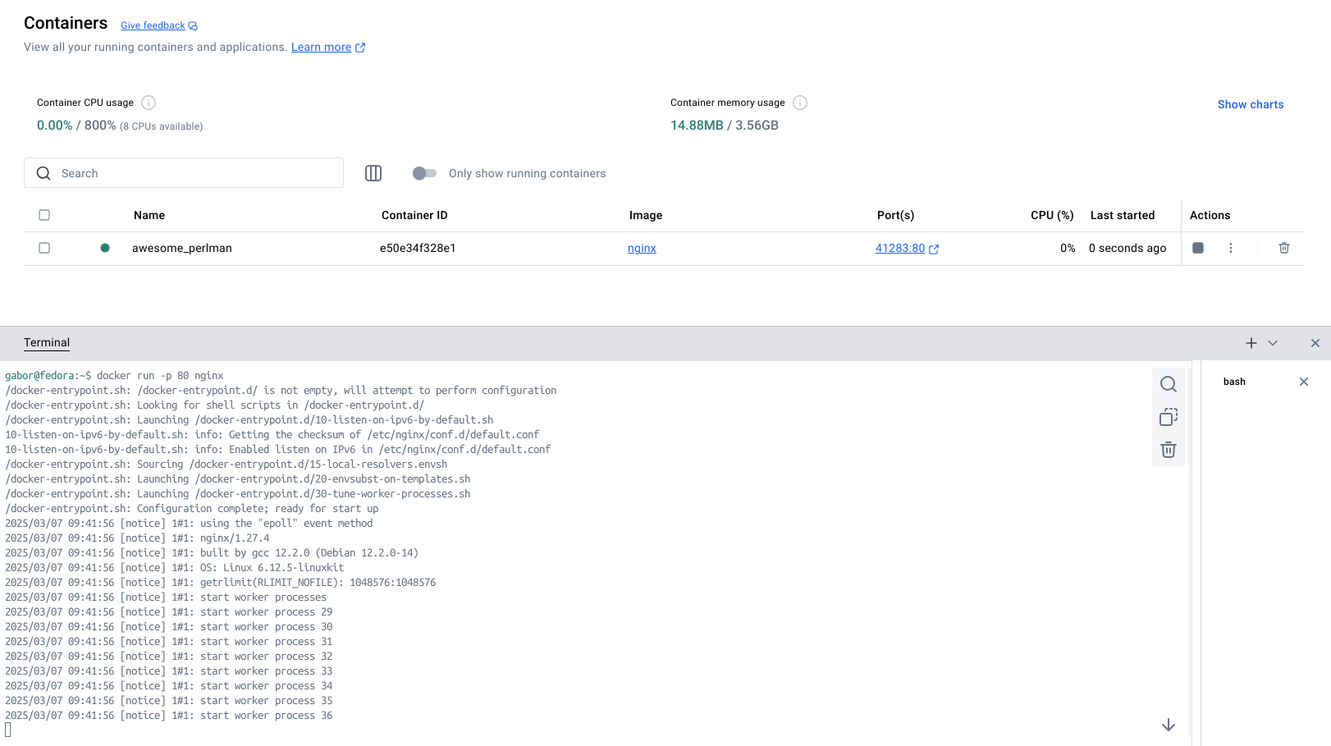
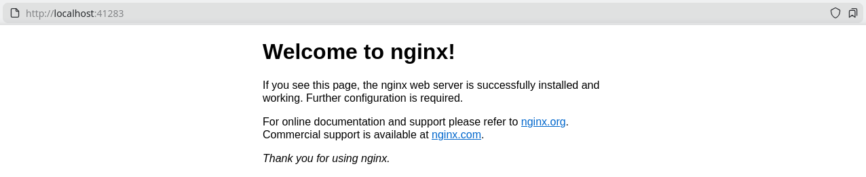
Running Nginx on all ports.
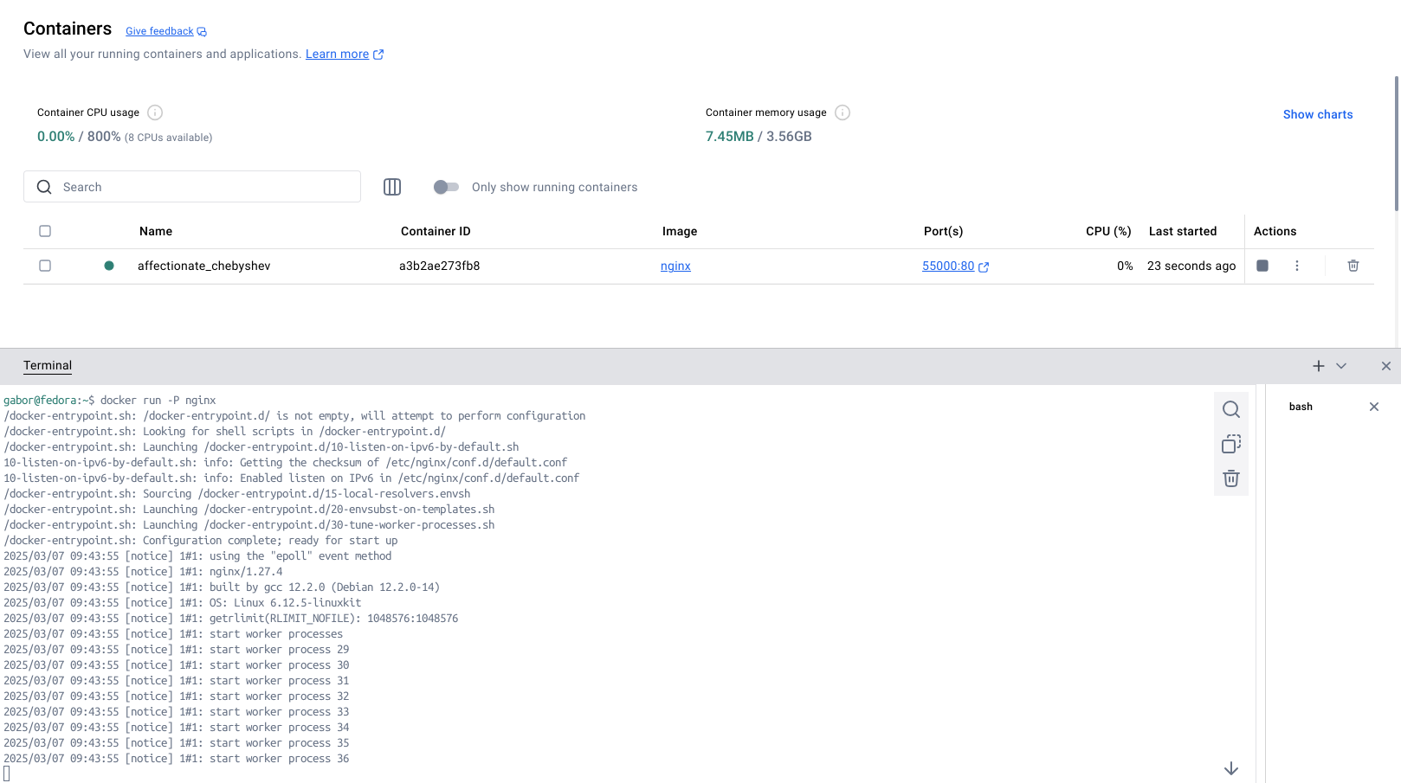
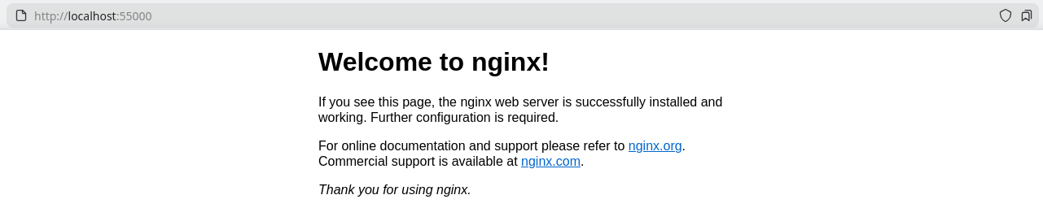
Run “Welcome to Docker” container.
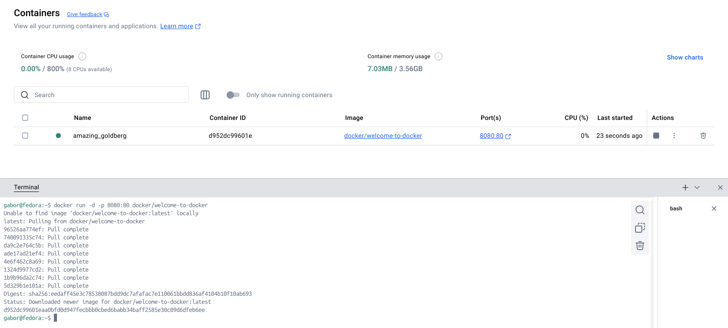
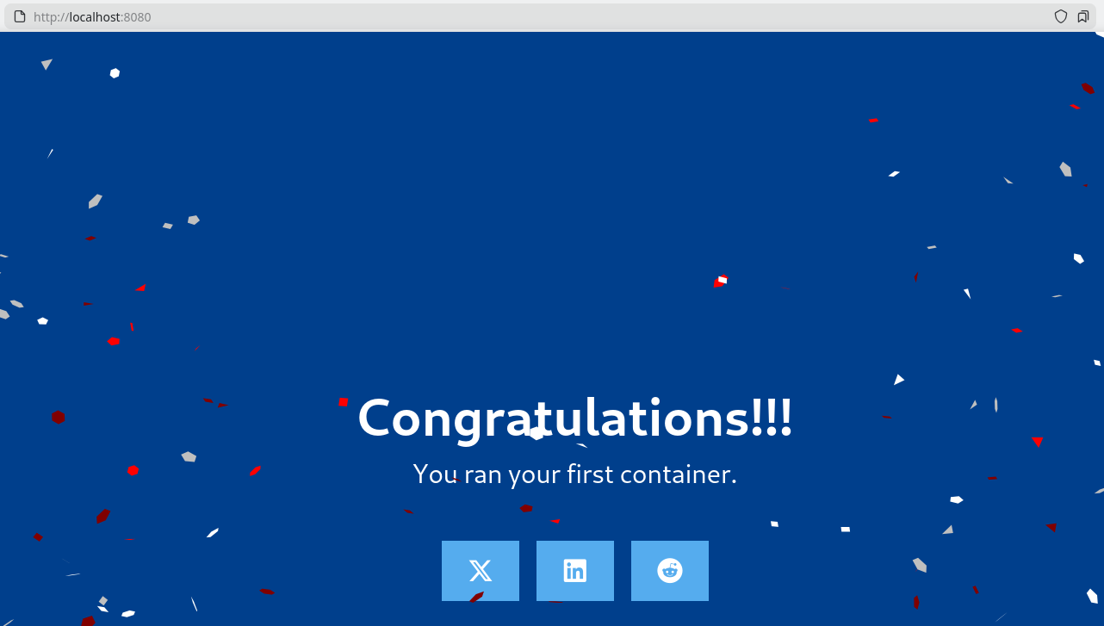
Use Docker Compose to run “Welcome to Docker”.
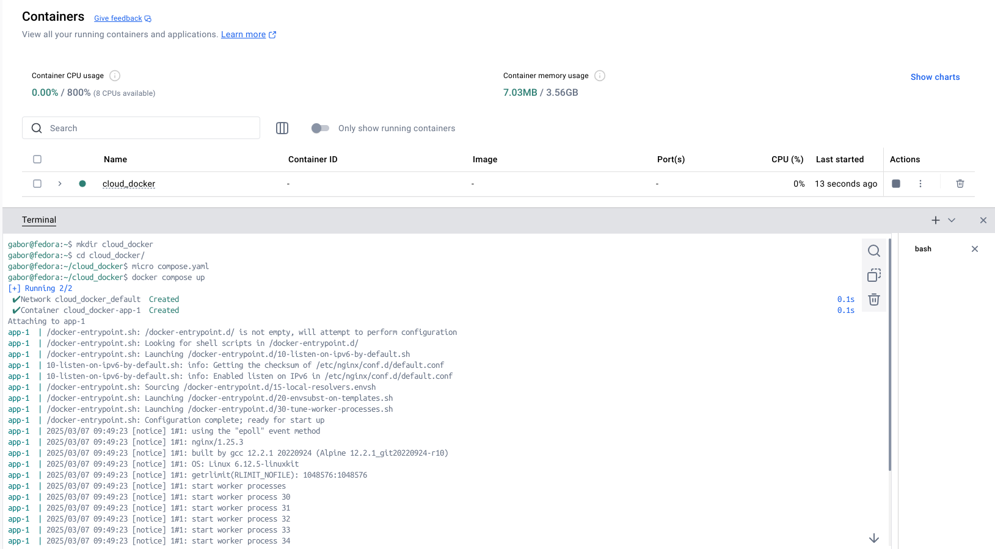
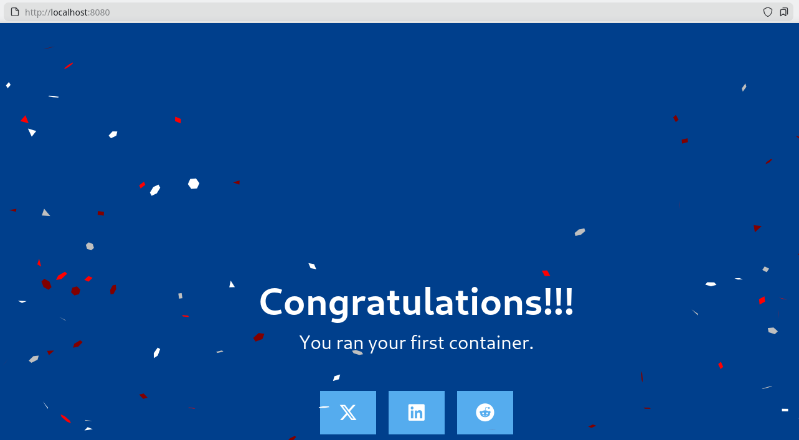

Overriding container defaults
Setting environment variables. Foo has been set as bar.
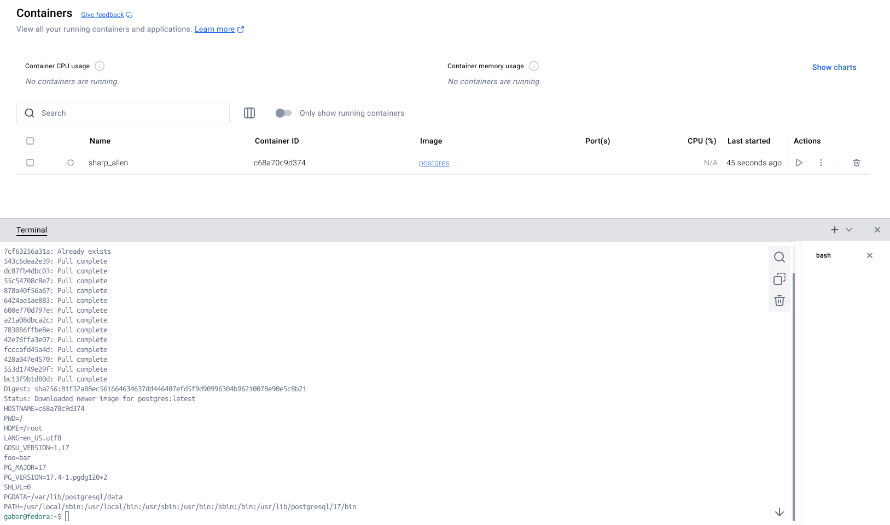
Restricting the container’s amount of resources. Only 0.5 CPU cores, and 512MiB of memory.
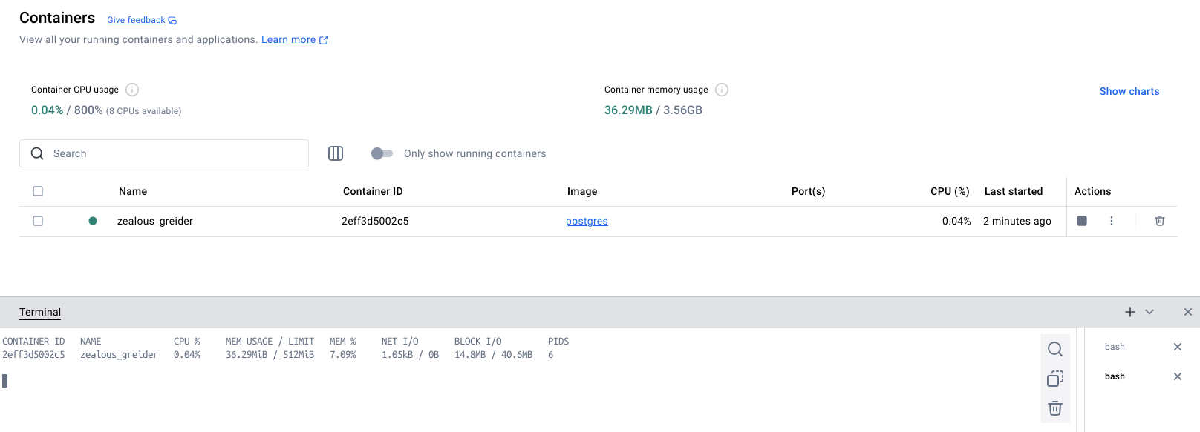
Run multiple instances of the Postgres database.
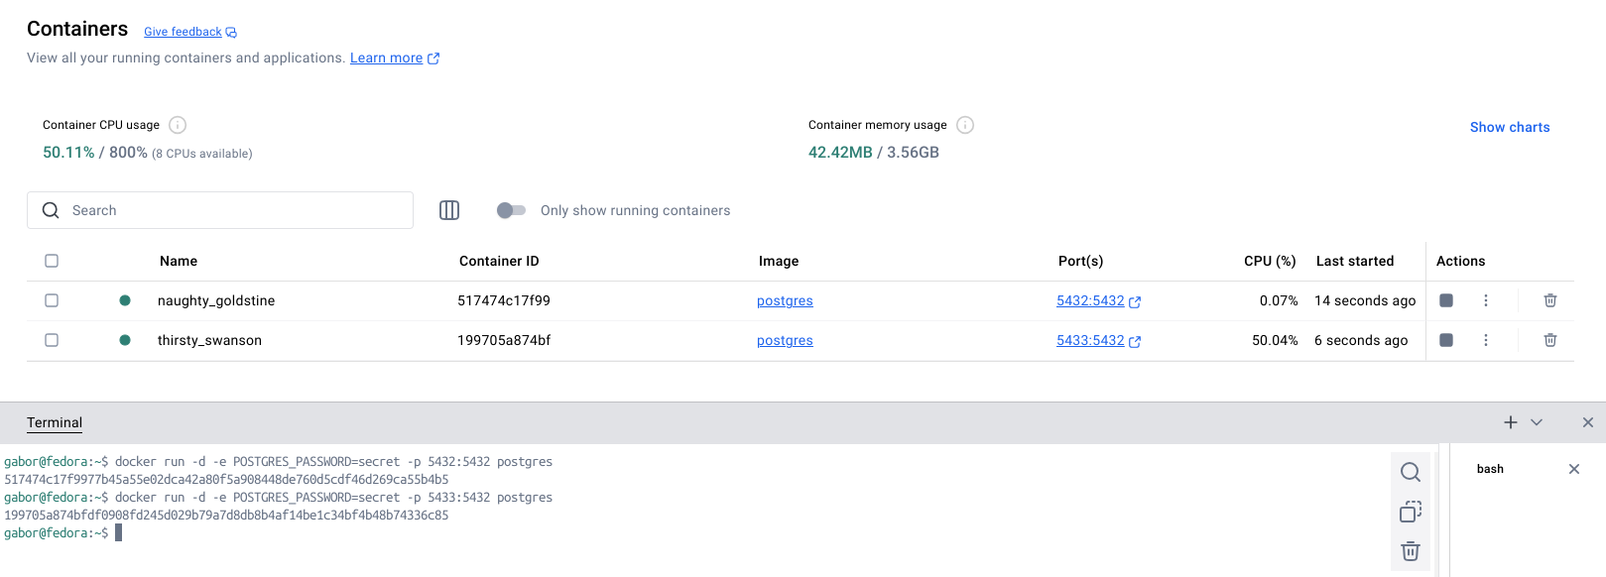
Run Postgres container in a controlled network.
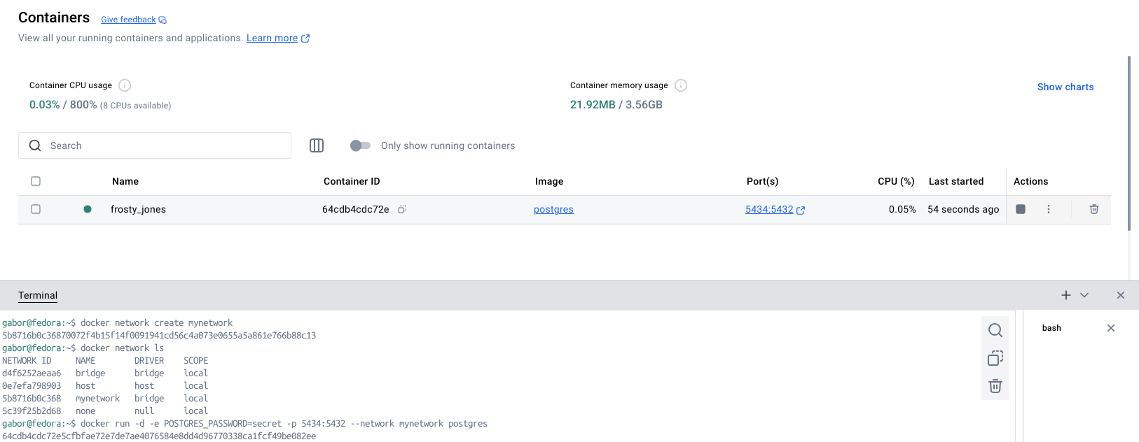
Override the default CMD and ENTRYPOINT in Docker Compose.
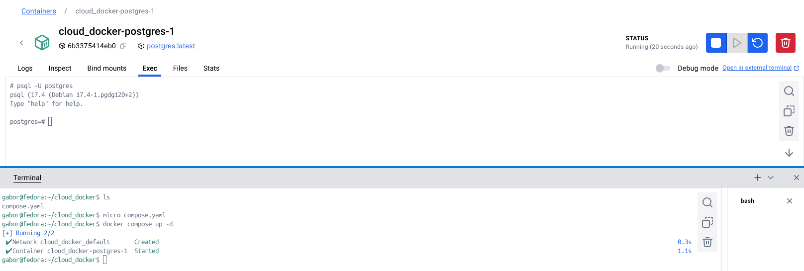

Persisting container data
Creating a container volume for logs.
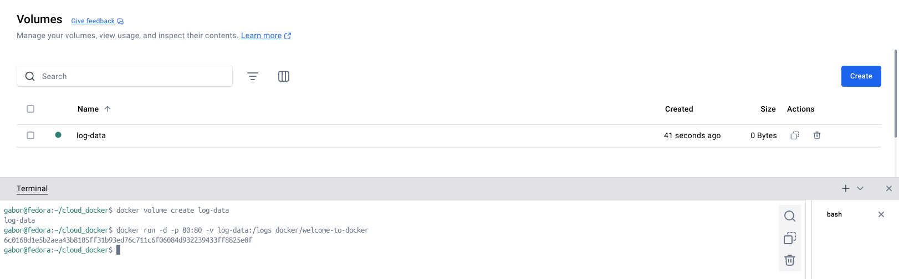
Using volumes.
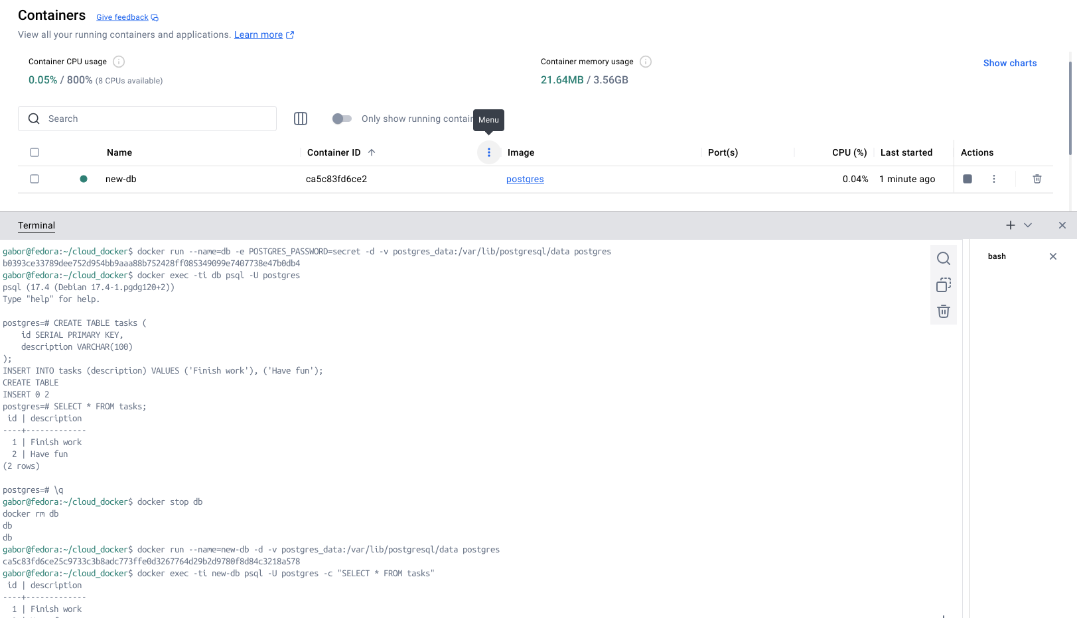
View volume contents.
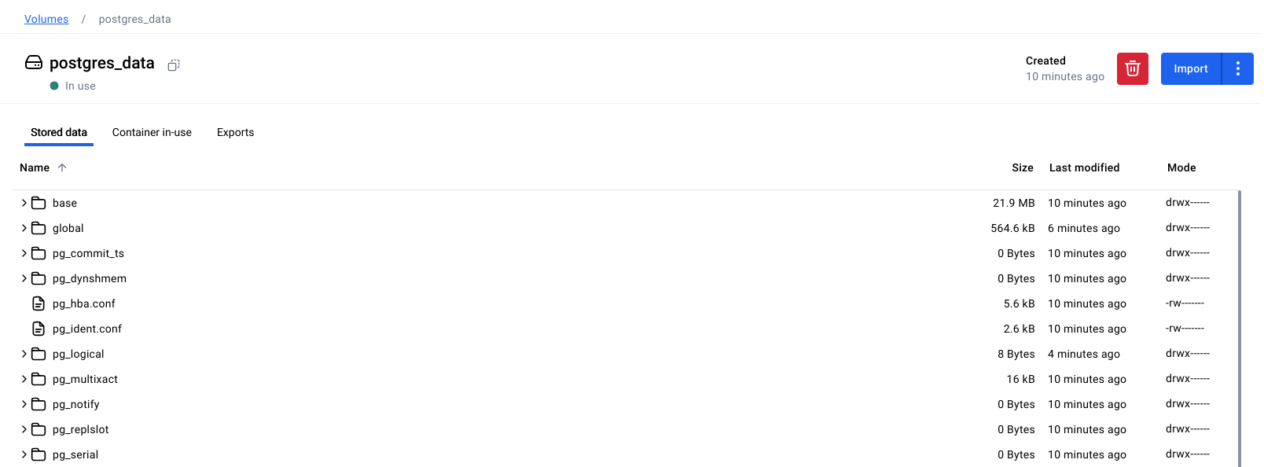

Sharing local files with containers
Using a bind mount.
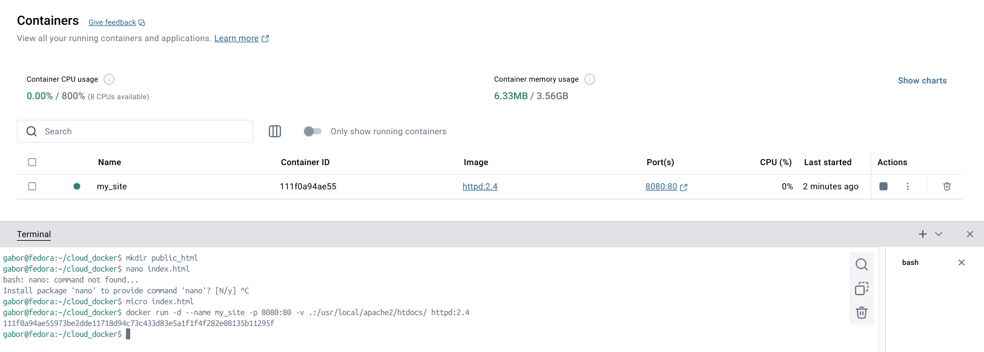
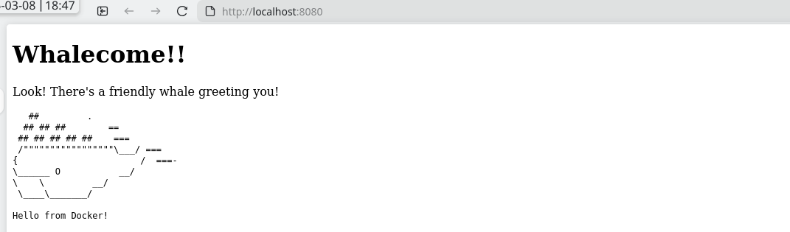

Multi-container applications
Deployment manually.
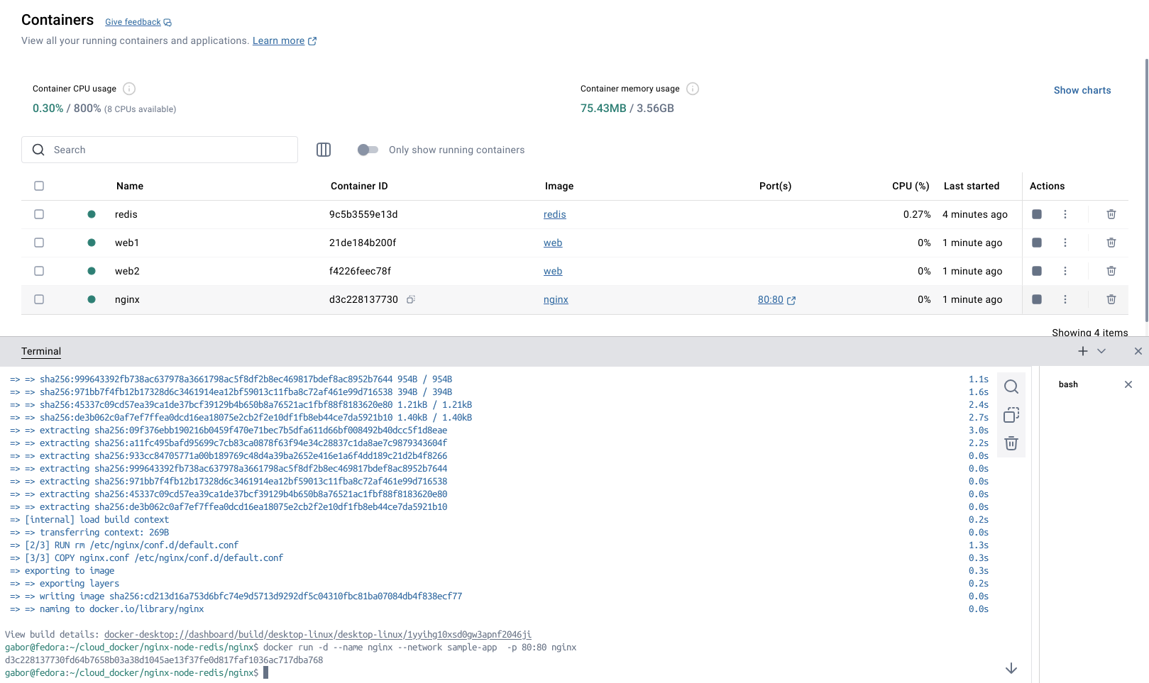
Deployment using Docker Compose.
