Lab 6 Knative

1. Setup
Start kn quickstart using minikube.
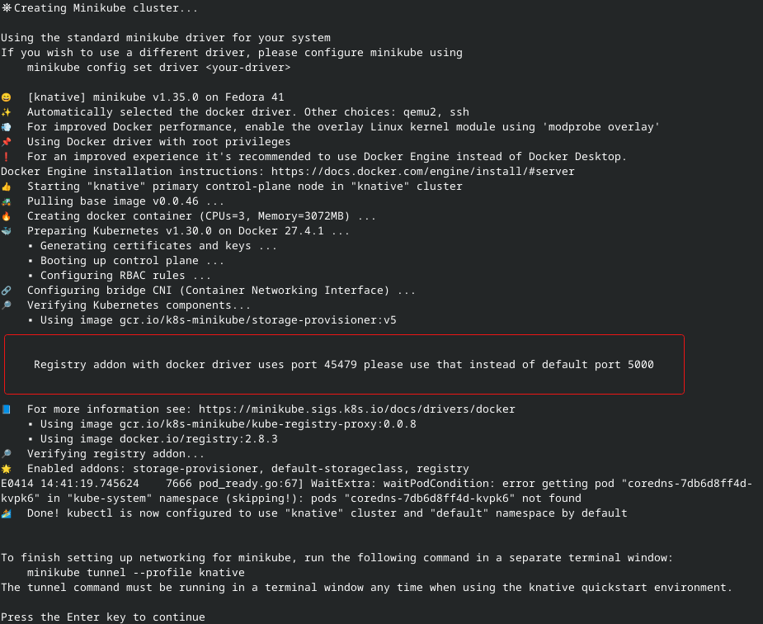
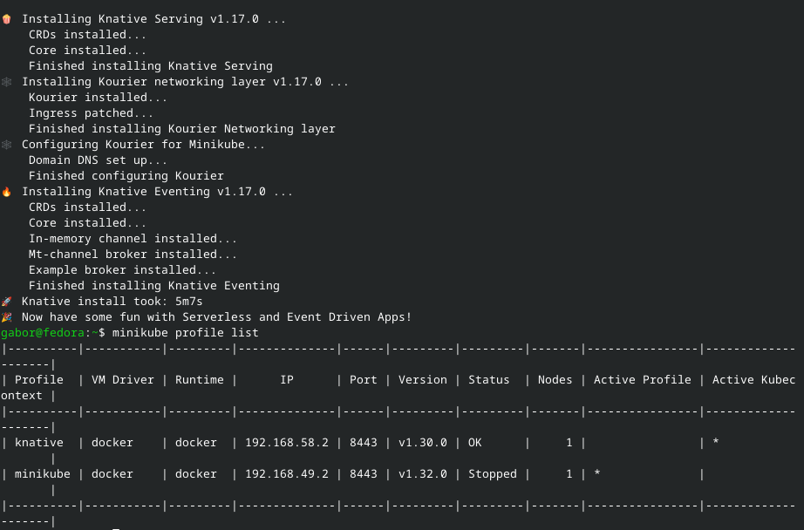

2. Knative Function
Create a knative function.
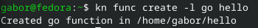

Run the function.
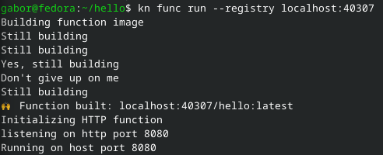

3. Deploying Knative Service
Create the service and deploy it.
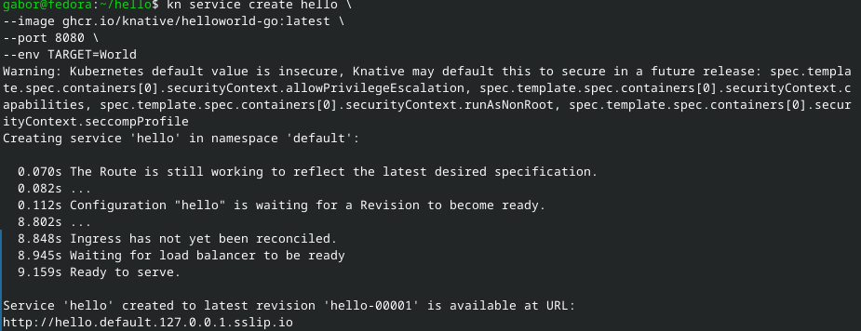
Test out autoscaling by waiting and then retesting the page.
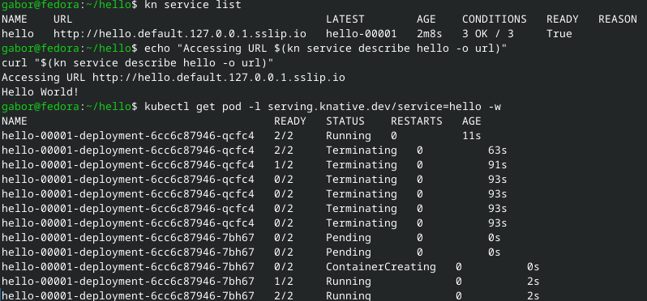
Test out traffic splitting by creating a new service and chranging the traffic flow amount.
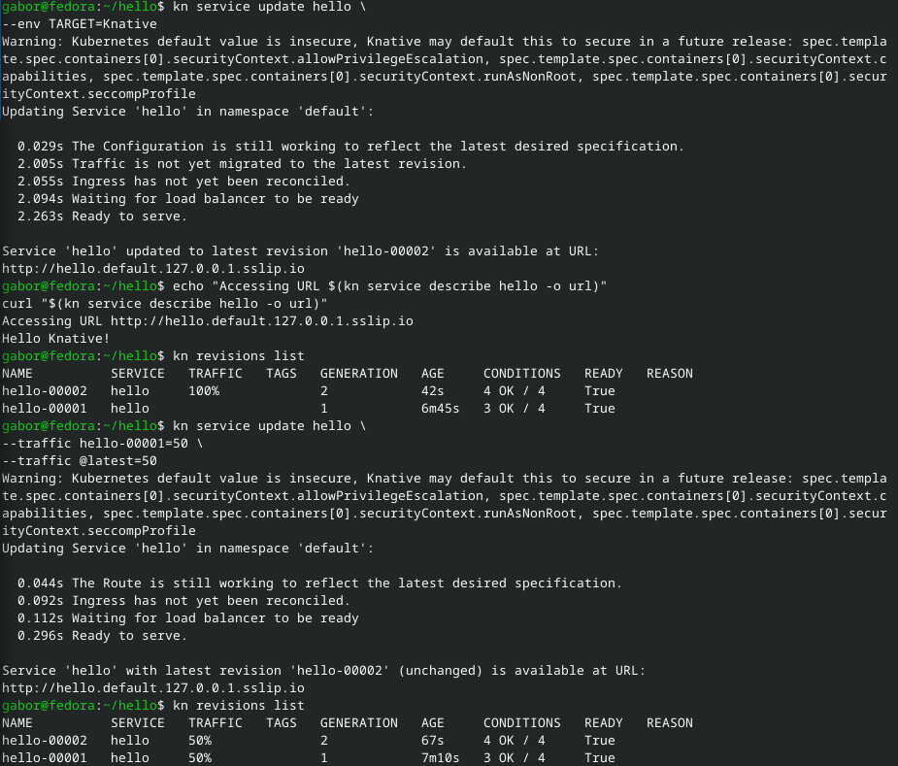
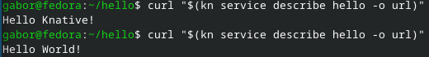

4. Knative Eventing
First create a Broker and UI.
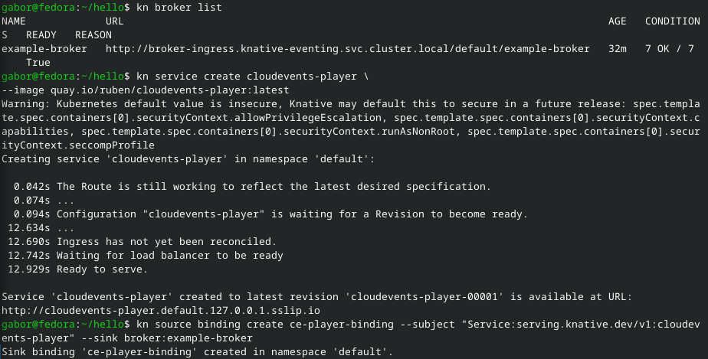
Next create a Trigger for the CloudEvents Player, and test it out by sending another event and receiving it.
