Lab 5 Istio

1. Traffic Shifting
Route all traffic to version 1 of the application.
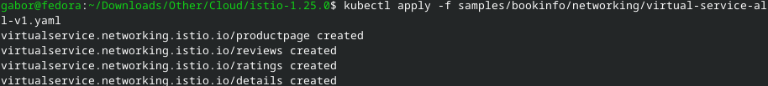
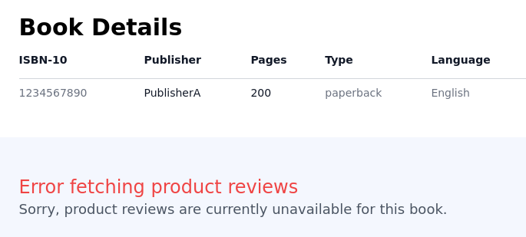
Change to 50% traffic to version 3.
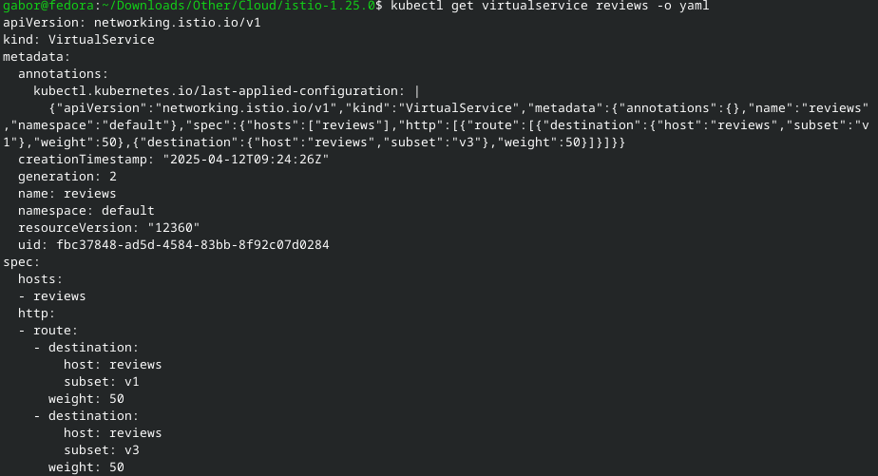
Apply 100% traffic to version 3.

2. Request Routing
Create route rules.
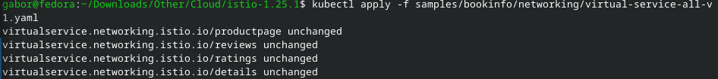
Change to version 2 for jason user.
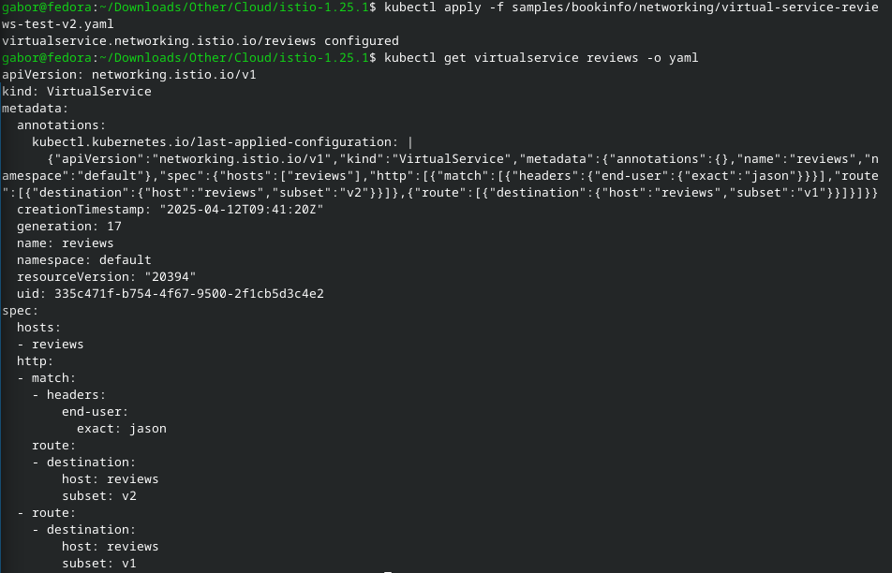

3. Fault Injection
Create a fault injection.
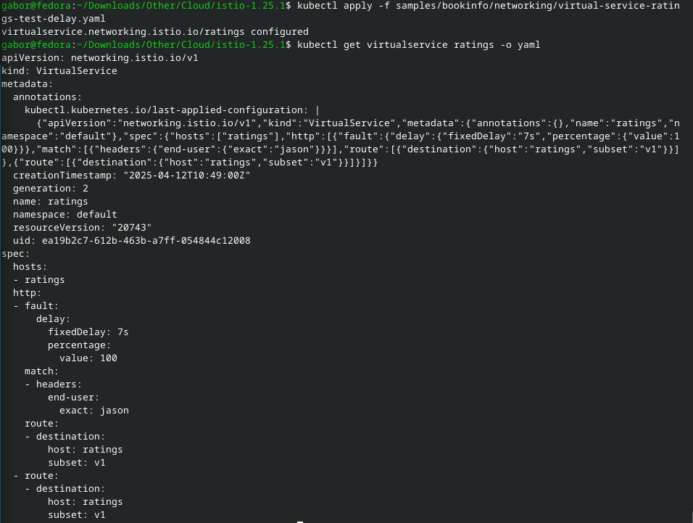
Inject a HTTP abort fault.
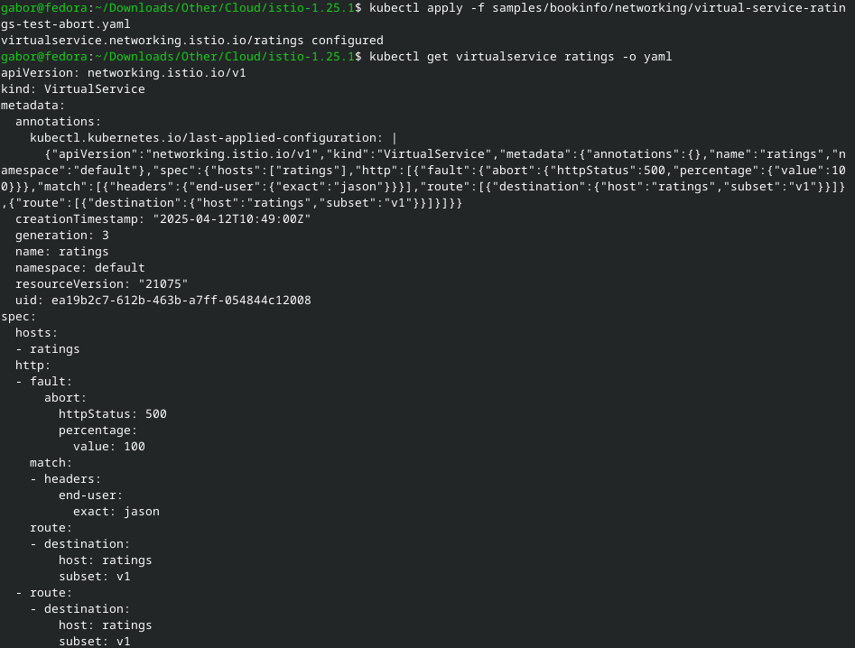

4. Circuit Breaking
Configure circuit breaker.
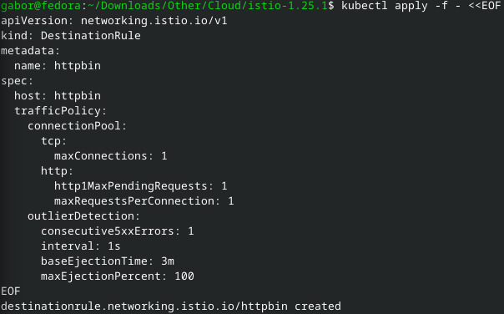
Create Fortio.
Log in to client pod.
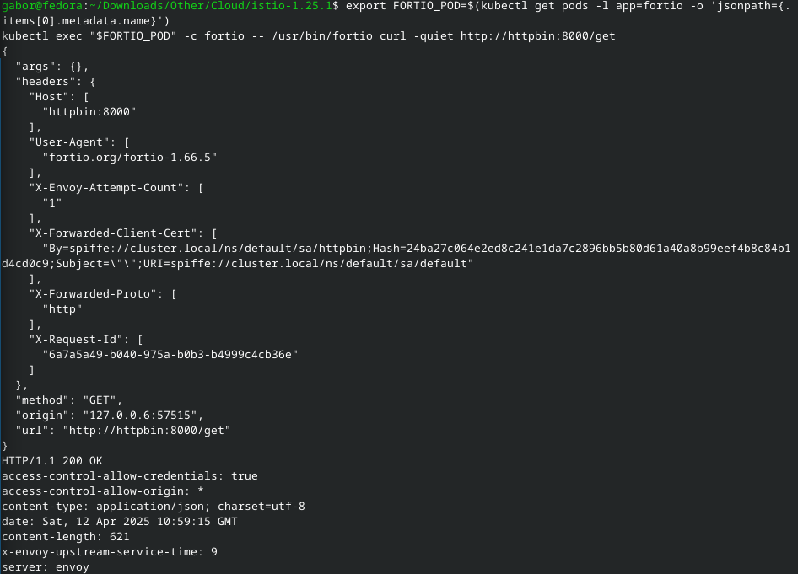
Call with more connections to break circuit.
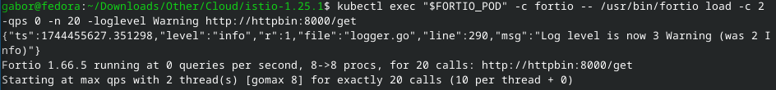
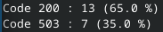

Go again with more connections.
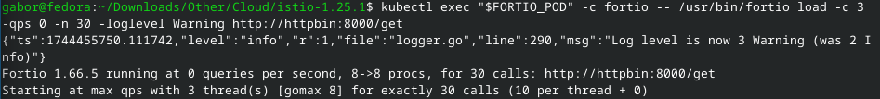
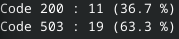

Look at the istio-proxy stats.
