QUESTION1

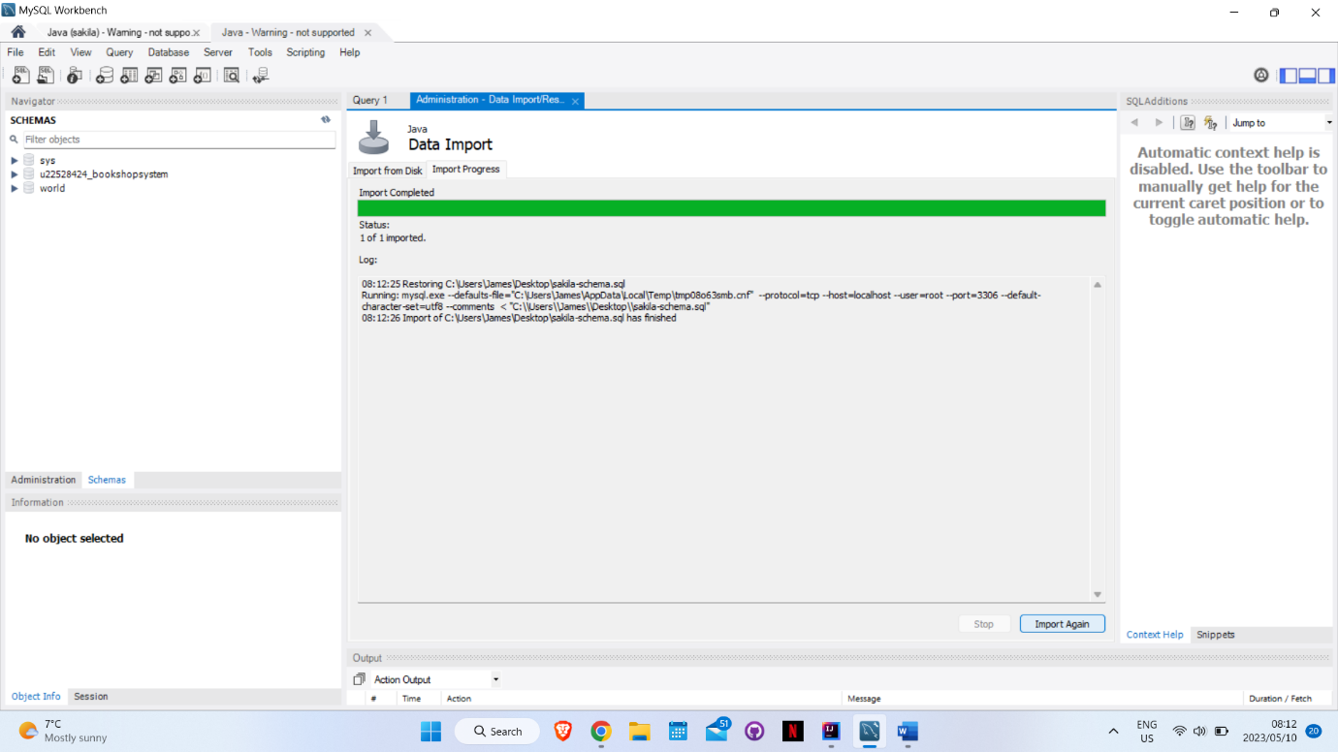

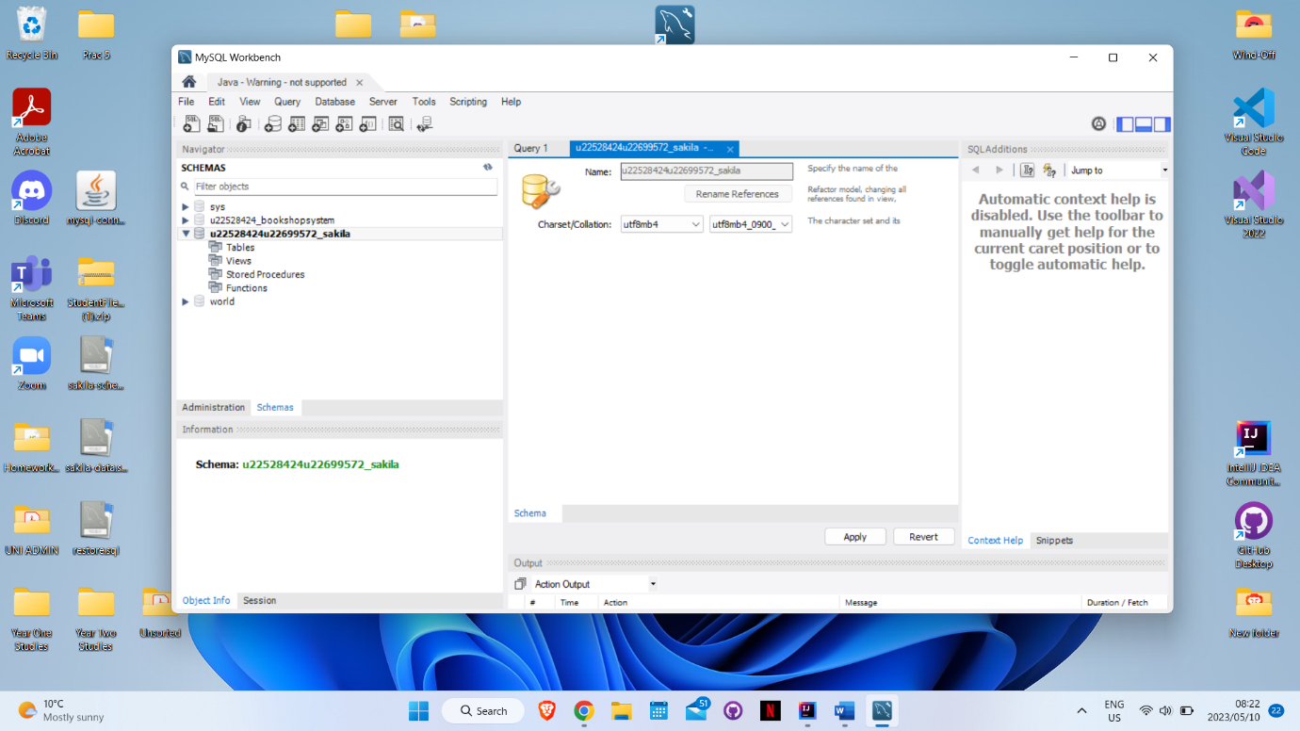

QUESTION 2

We chose MYSQL workbench as our Canned Application

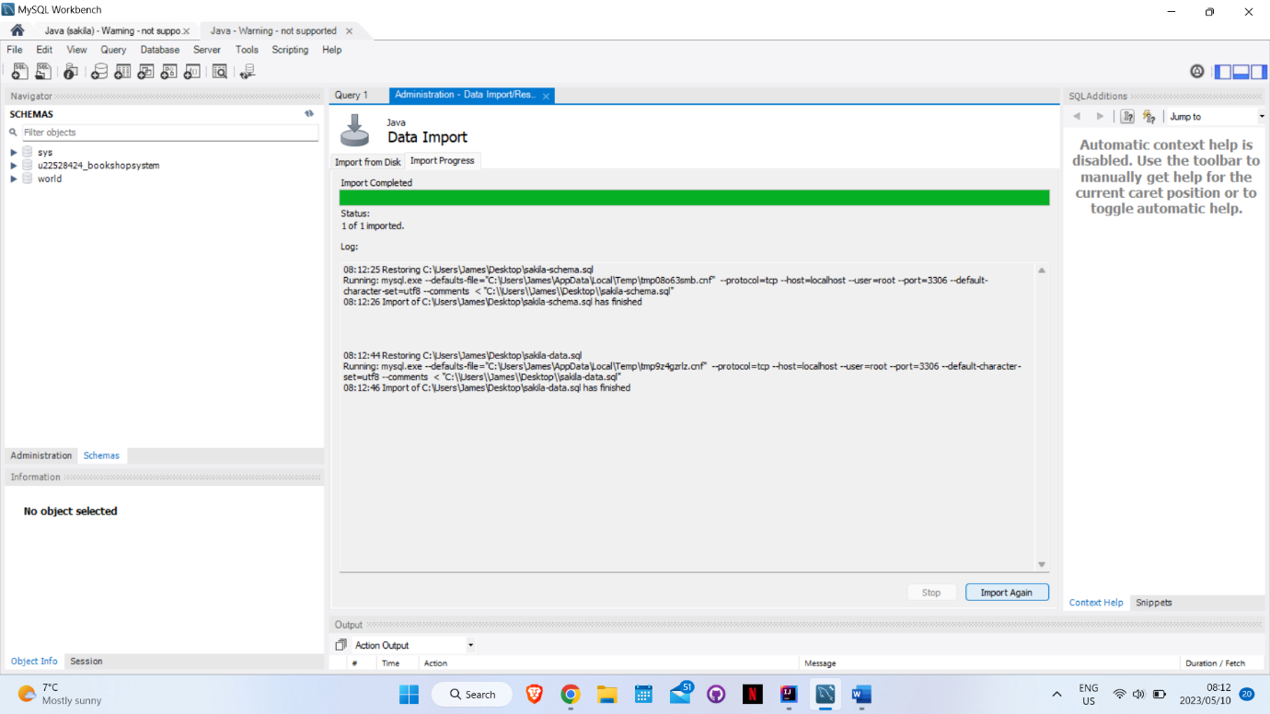

QUESTION 3

STORE TABLE

PK store_id TINYINT(3) Auto Increment

FK Manager_staff_id TINYINT(3) On Update CASCADE On Delete RESTRICT

FK address_id SMALLINT(5) On Update CASCADE On Delete RESTRICT

last_update TIMESTAMP

QUESTION4

QUESTION5