U22699572

u22528424

QUESTION1

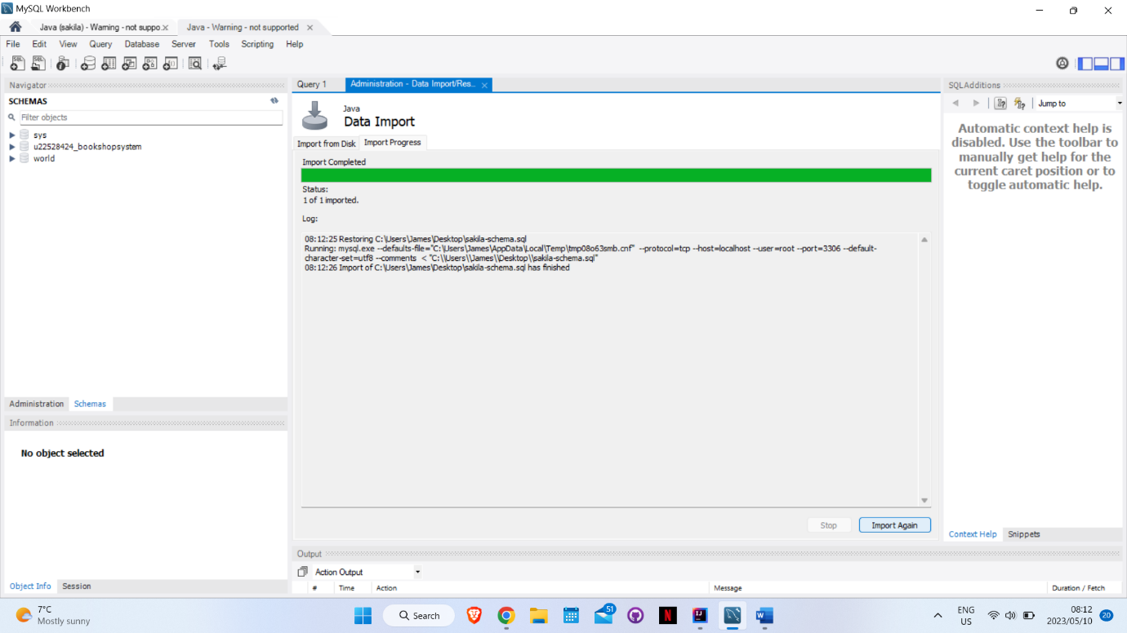

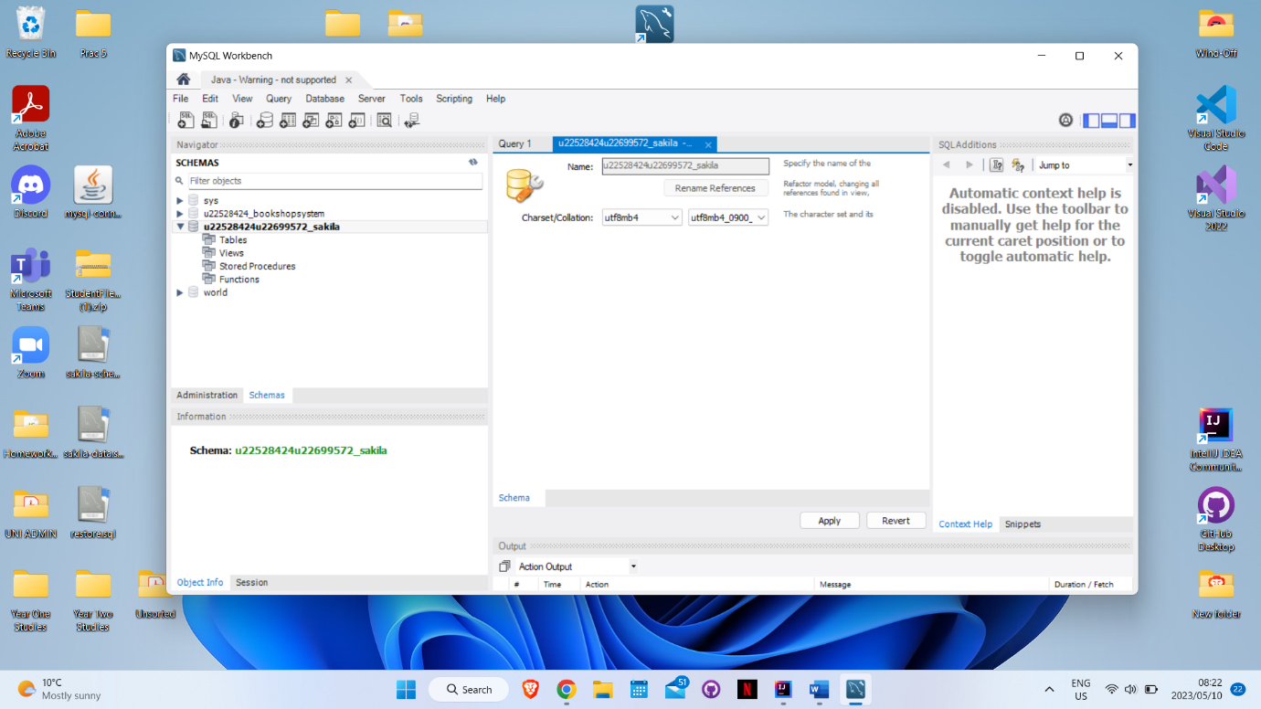

QUESTION 2

We chose MYSQL workbench as our Canned Application

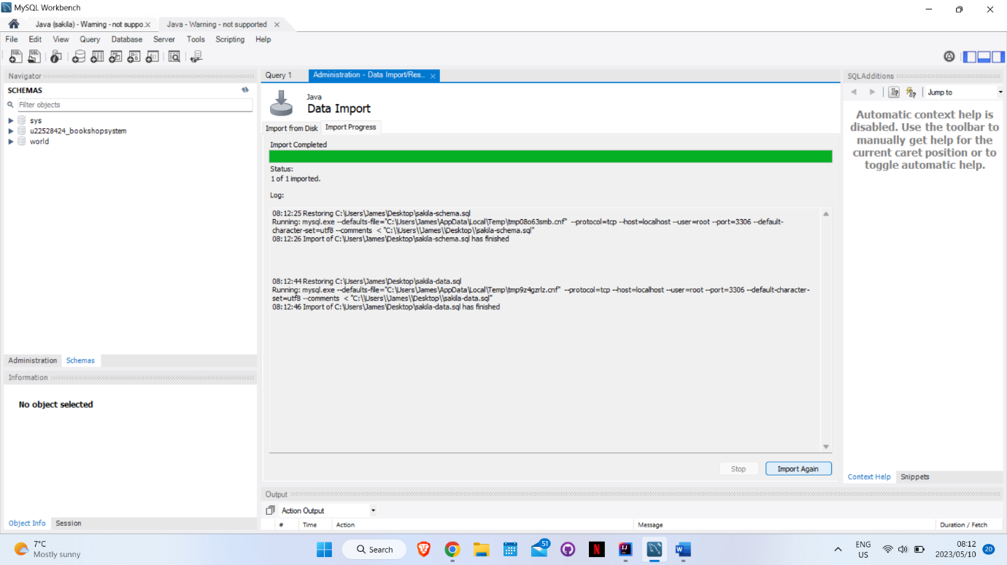

QUESTION 3

STORE TABLE

PK store_id TINYINT(3) Auto Increment

FK Manager_staff_id TINYINT(3) On Update CASCADE On Delete RESTRICT

FK address_id SMALLINT(5) On Update CASCADE On Delete RESTRICT

last_update TIMESTAMP

LINKS:

**Inventory**

The store table is linked to the inventory table. This is to show in what stores the inventory is stored at. 1:N

**Staff**

Store table uses the Staff table to get the store managers staff id 1:N

Staff table uses the store table to indicate at what stores employees work at 1:N

**address**

The store table is linked to the address table to indicate where stores are located

1:1 every store has one address

**Customer**

One store has many customers 1:N

The store table is linked to the customer table to indicate where customers have shopped.

QUESTION4

QUESTION5