Front End Assignment 3 Report
Team DMT | Group SE-2509
Yernur Kanapiyauly — Home and About us; Damir Argumbayev — Menu and Contact.
Published assignment site: https://notab123.github.io/coffee-shop/assignment-3/

Objective
Keep the existing Coffee Shop design and add responsive behaviour with CSS media queries and Bootstrap 5.3. The original website remains available at the main URL; this assignment uses a separate copy.

Result
The four existing pages now include a Bootstrap navbar, responsive grid and cards, buttons, a nine image carousel, and a responsive form. The Home card group uses CSS media queries without Bootstrap grid classes.
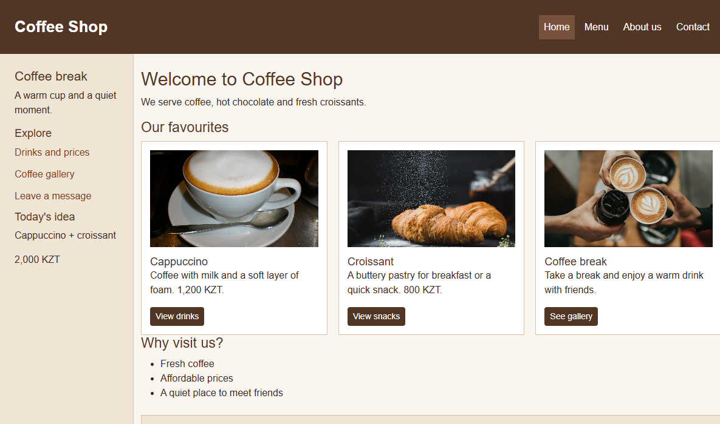
Figure 1 Home page on desktop

Part 1 Media Queries

Task 1 Responsive typography
We kept the existing headings and paragraphs. In css/style.css, the base sizes are for phones; media queries at 576 px and 992 px increase the font sizes for tablet and desktop.

Task 2 Three card layout
We changed the Home card row to CSS grid. A phone shows one card per row, a tablet shows two, and a desktop shows three. This particular layout does not use Bootstrap grid classes.
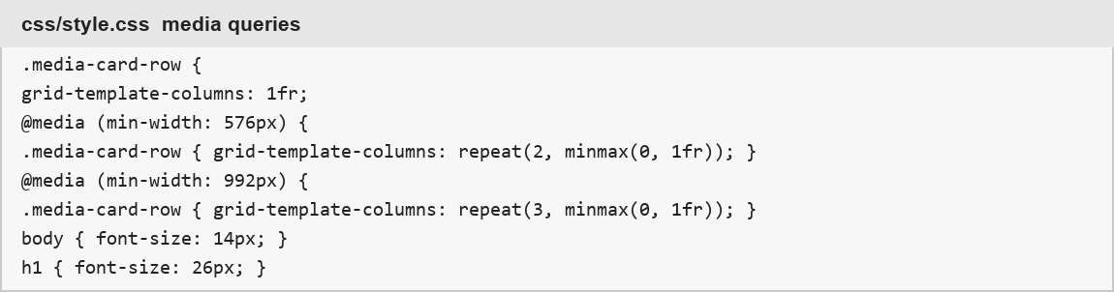
Figure 2 Media query code
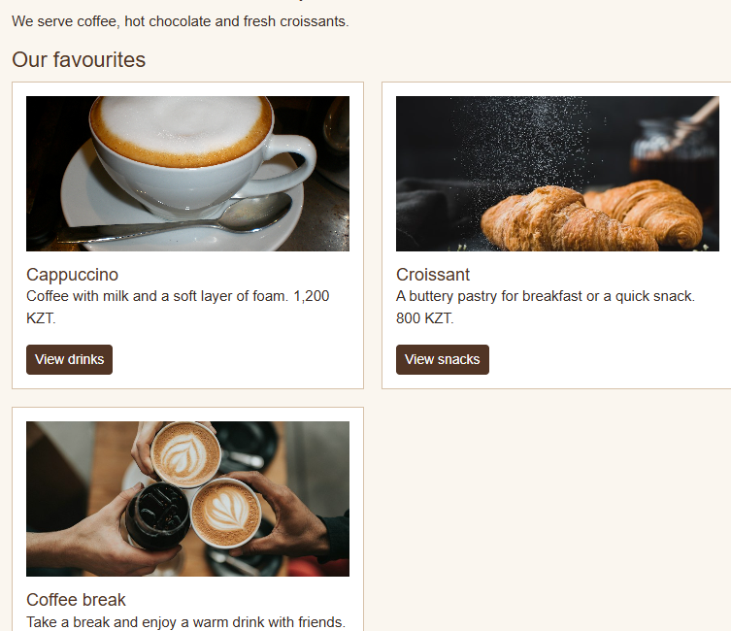 | 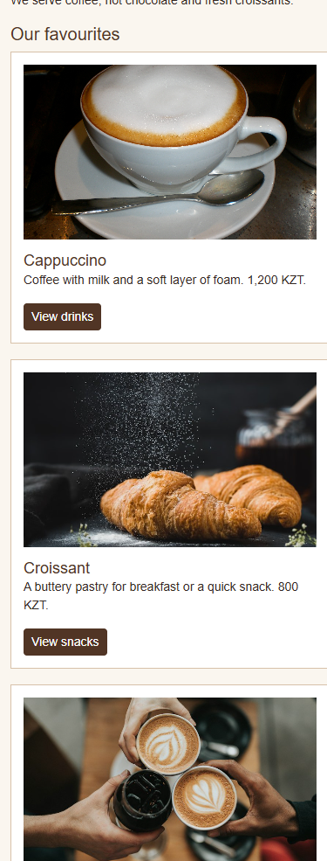
Figure 3 Two columns on tablet and one column on mobile

Part 2 Bootstrap Layout

Task 3 Grid
We used Bootstrap containers and rows. Menu cards use col-sm-6 col-lg-4 for three columns on desktop; the Contact section uses col-lg-6 for two columns.

Task 4 Spacing
New sections use Bootstrap spacing classes including g-3, g-4, p-3, mt-4, and mt-lg-4. The original outer page spacing stays close to Assignment 2.

Task 5 Navigation bar
The four page links now use a Bootstrap navbar. The navbar-toggler opens the links on narrower screens.

Task 6 Buttons
Cards and the form use Bootstrap btn classes. The Home page uses a btn-group with primary and outline buttons; small buttons are used on cards.

Task 8 Cards
The Menu page has three Bootstrap cards with an image, title, description, and button.
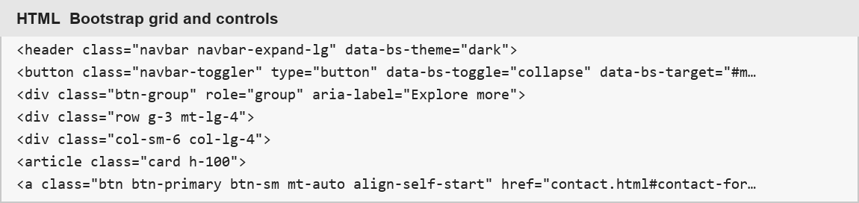
Figure 4 Navbar, grid, card, and button source
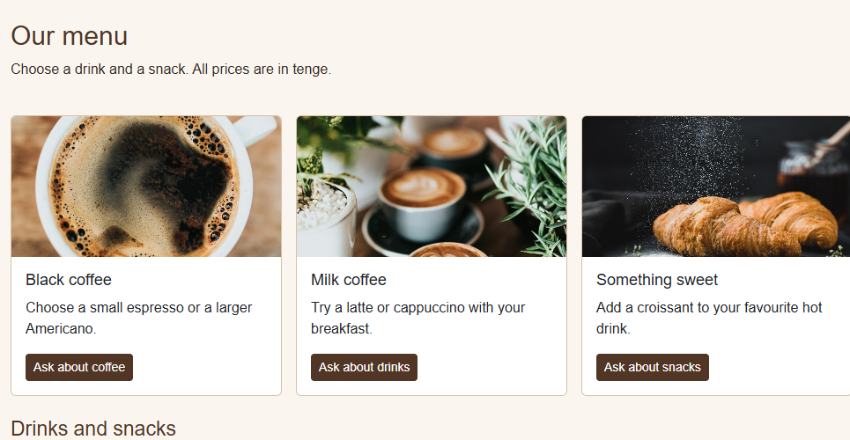
Figure 5 Three Bootstrap cards on the Menu page

Part 2 Components and Accessibility

Task 7 Carousel
The About page displays nine local photographs in a Bootstrap carousel. It has nine indicators plus previous and next buttons. We tested the next button in the browser.

Task 9 Form
The Contact page uses form-control, form-select, form-check, and a responsive two column layout. It includes labeled text fields, a dropdown, two radio choices, and a checkbox.

Task 10 Accessibility
The pages keep semantic headings, image alternative text, form labels, a labeled navigation region, an active link indicator, and visible focus styling.
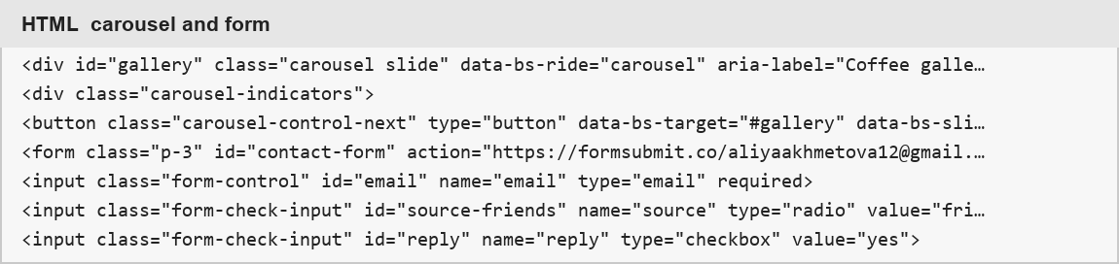
Figure 6 Carousel and form source
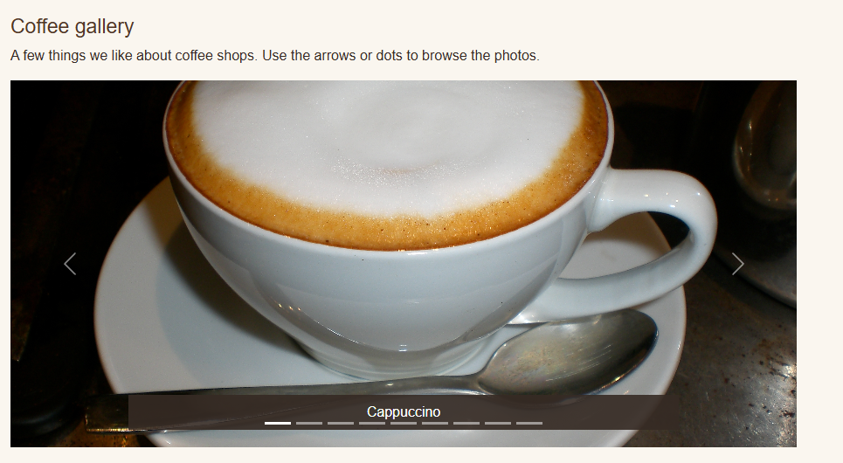
Figure 7 About page carousel with controls and indicators

Verification and Reflection
Browser checks: the CSS card group rendered 1, 2, and 3 columns at 390, 768, and 1200 px; no horizontal overflow appeared. The mobile menu opened, and the carousel contained nine slides and nine indicators. All four pages loaded with their local images and Bootstrap files.
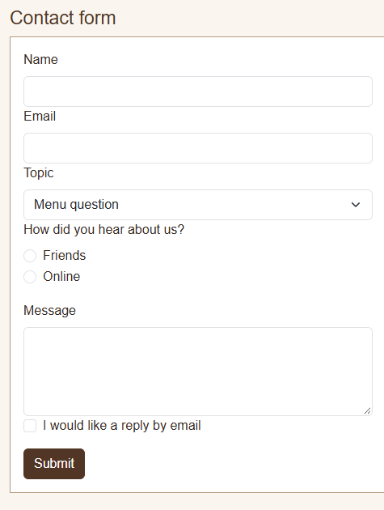
Figure 8 Contact form with Bootstrap fields

Reflection
Media queries are useful for a specific custom layout, while Bootstrap supplies ready-made grid and controls. Using a separate assignment folder preserved the original Coffee Shop site.

