Front End Assignment 3 Report
Media Queries and Bootstrap Grid
Team and group | DMT · SE-2509
Members | Yernur Kanapiyauly · Damir Argumbayev
Website | https://notab123.github.io/coffee-shop/

Objective
We updated the existing four page Coffee Shop website to adapt to mobile, tablet, and desktop screens. The site combines a CSS media query demonstration with Bootstrap 5.3 layout and components. This report records the implementation, source examples, and page results.

Result overview
The site now has a collapsible navigation bar, responsive typography, a CSS only three card group, Bootstrap grid sections and cards, a nine image carousel, a responsive contact form, and accessible controls. The Bootstrap CSS and JavaScript bundle are stored inside the project so the ZIP runs locally.
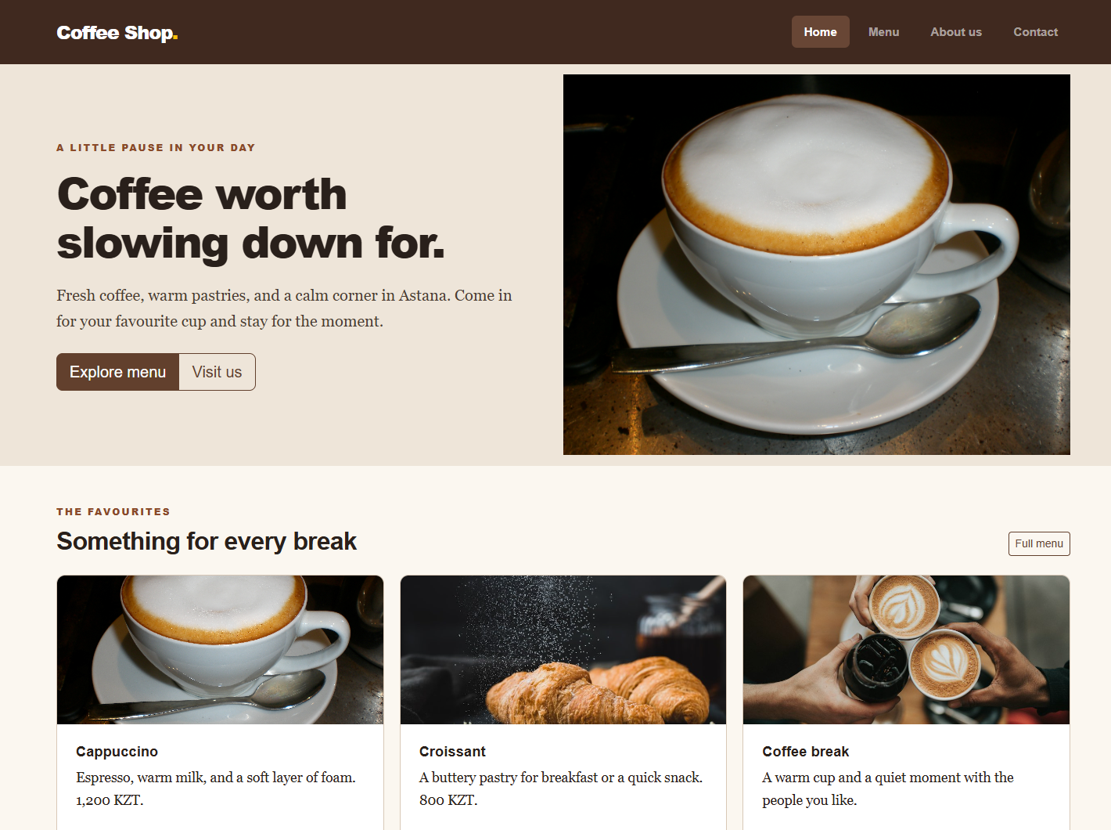
Figure 1 Home page at desktop width

Part 1 Media Queries

Task 1 Responsive typography
1. We defined mobile font sizes for headings and body text in css/style.css. 2. At 576 px the typography grows for tablets. 3. At 992 px headings and paragraphs grow again for desktop. We checked all three widths in the browser.

Task 2 Card group
1. The Home page contains three cards inside media-card-grid. 2. CSS grid starts with one column for phones, switches to two columns at 576 px, and switches to three columns at 992 px. 3. This group does not use the Bootstrap grid, as required for the media query task.
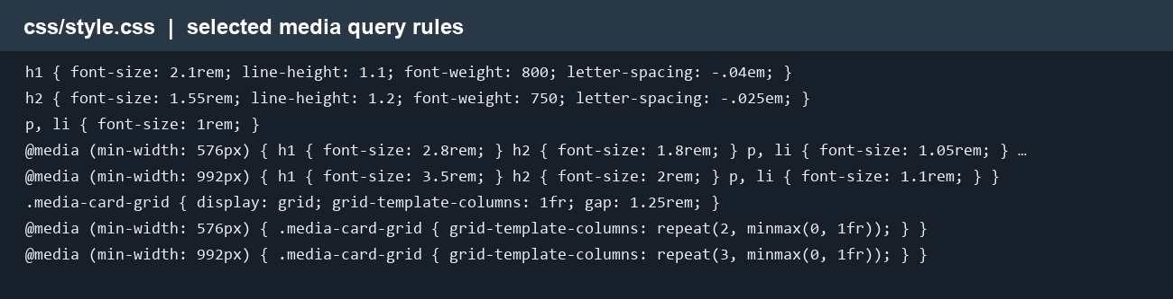
Figure 2 CSS source showing responsive typography and the card breakpoints
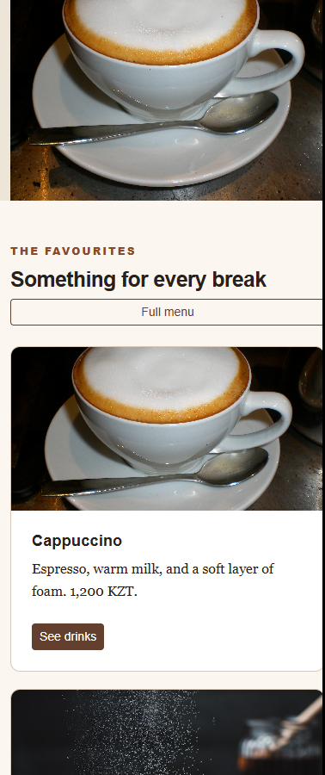
Figure 3 Home page at mobile width with stacked cards

Part 2 Bootstrap layout and controls

Tasks 3 and 4 Grid and spacing
1. We wrapped page sections in Bootstrap containers. 2. The Home hero and other two section layouts use col-lg-6. 3. The Menu cards use col-sm-6 col-lg-4, so they reflow from one to two to three columns. 4. Spacing uses utility classes such as py-5, p-sm-4, mt-lg-4, and px-3.

Tasks 5 and 6 Navigation and buttons
1. Each page uses a four link navbar. The navbar-toggler expands the menu below the lg breakpoint. 2. Buttons use btn-primary and btn-outline-primary, with btn-lg and btn-sm sizes. Related actions use btn-group. The active navigation link has aria-current="page".

Task 8 Bootstrap cards
The Menu page includes three Bootstrap cards with photos, headings, descriptions, and buttons in a responsive grid.
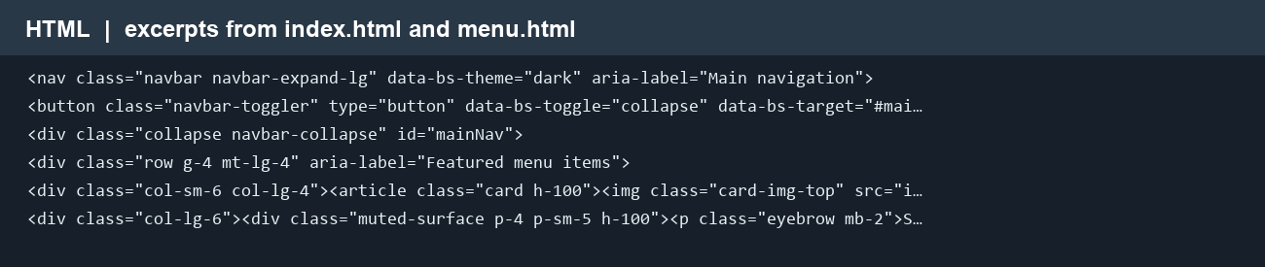
Figure 4 Selected HTML lines for the navbar, grid, cards, and buttons
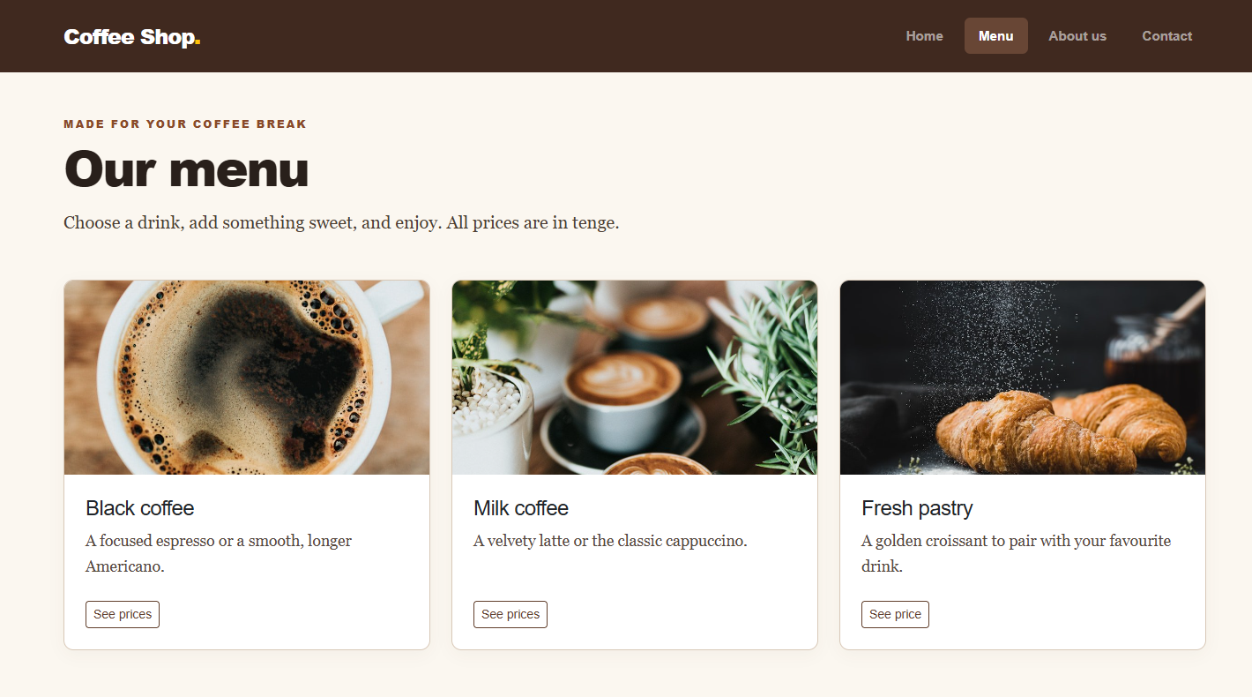
Figure 5 Menu page showing three cards in the Bootstrap grid

Part 2 Interactive components and accessibility

Task 7 Carousel
The About page carousel displays nine local images. It includes nine labeled indicators, previous and next controls, and descriptive alternative text. We clicked the next control and confirmed the active slide changed.

Task 9 Responsive form
The Contact page uses form-control, form-select, form-check, and Bootstrap grid classes. Name, email, and message are required; the browser validates the email field. The existing external form submission endpoint was retained.

Task 10 Accessibility
Semantic landmarks, headings, table headers, form labels, alternative image text, aria labels, visible focus states, and readable color contrast support keyboard and assistive technology use.
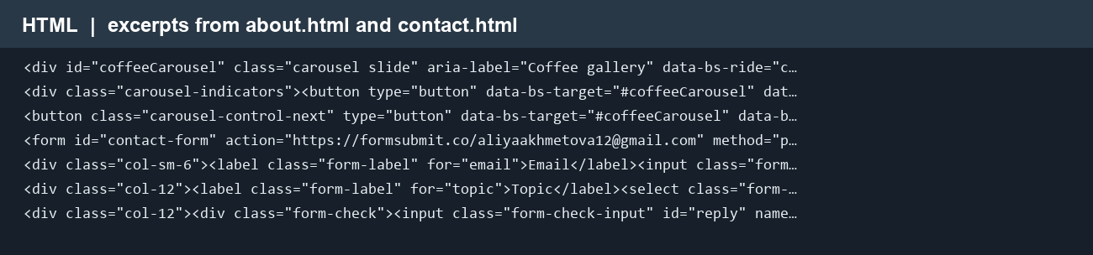
Figure 6 Selected HTML lines for carousel and form components
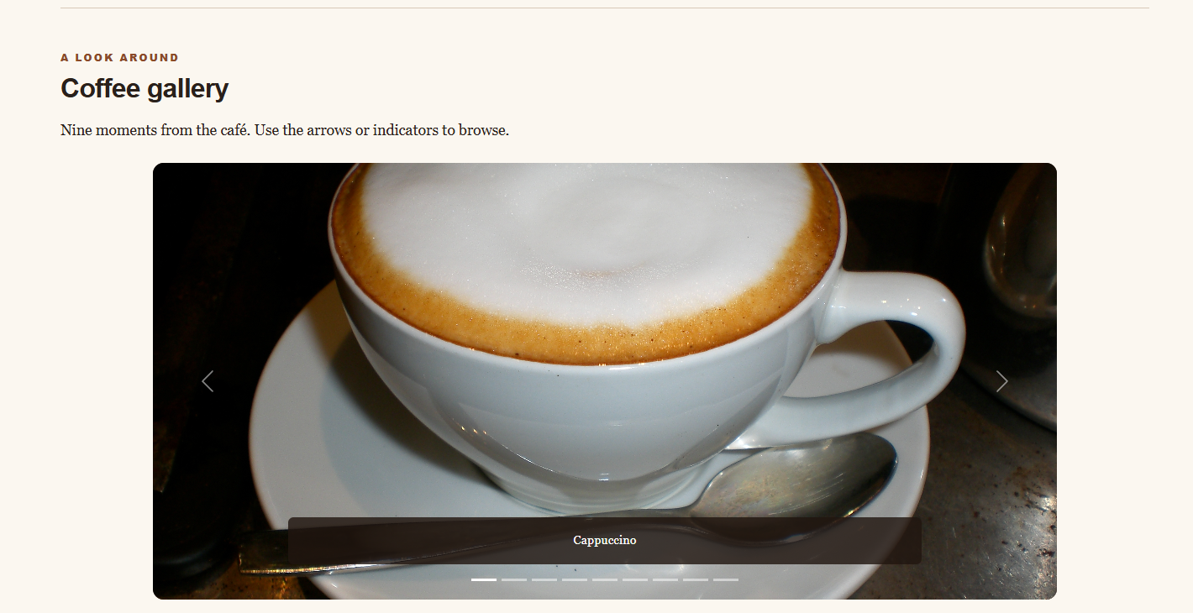
Figure 7 Carousel with indicators and controls

Verification and reflection

Browser checks
At 390 px the CSS card grid rendered one column with no horizontal overflow. At 768 px it rendered two columns. At 1440 px it rendered three columns. The mobile navigation opened, and the carousel contained nine items and indicators. We visually reviewed the Home, Menu, About, and Contact pages.
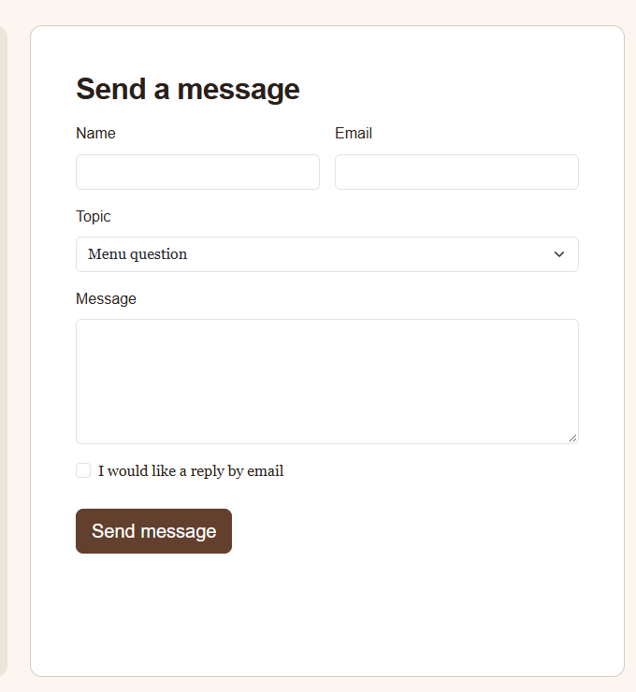
Figure 8 Responsive Contact form

Reflection
Media queries provide precise control over a specific component, while Bootstrap speeds up repeated page layout and component styling. Combining both approaches kept the card exercise explicit and made the rest of the website consistent. The live URL was checked after GitHub Pages completed deployment.

