To interface a table with the UI in model-view-controller format, you will need to make the table into a PHP class, like Make in the diagram below. The generate functions contain a print statement that prints html code containing a form. This will allow you to pass in input to queries through the use of form statements. The form statements invoke a helper PHP file that receives the Posted information from the form and invokes the RfidController to run the specific function with the variable(s) passed being used as criteria in the SQL queries embedded in the function. 

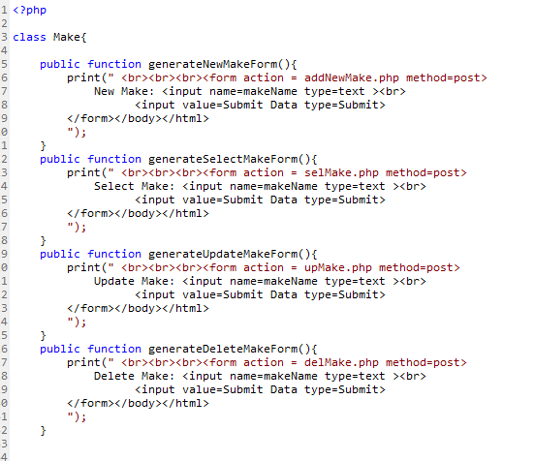

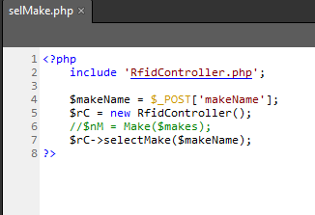

The Make Class and selMake PHP files.

The RfidController Class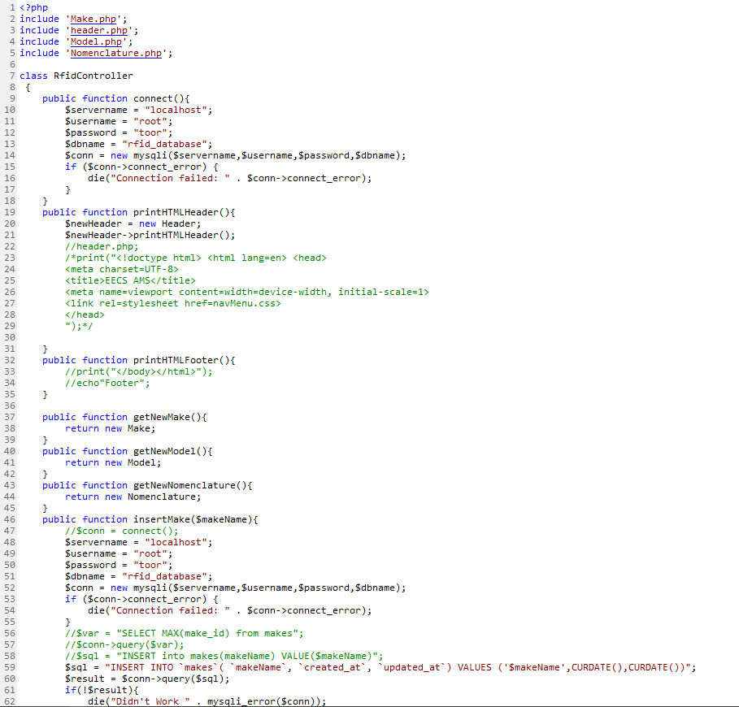

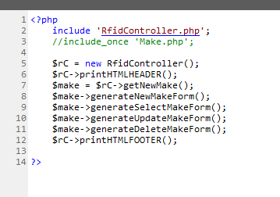

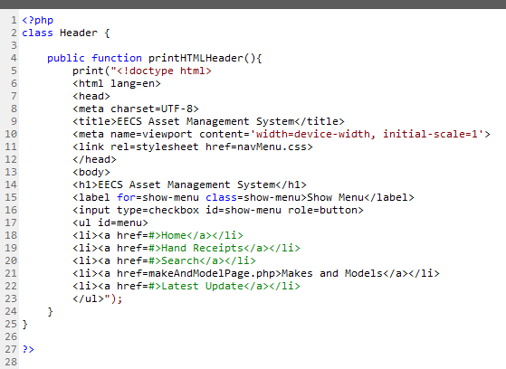

The MakePage file that generates the html interface and the Header class which creates our template.