Site Design

Design Approach
Site design is one of the fundamental parts of the system, acting as a link between the system function and the users. In order to meet the modern digital standards, the design focuses on the balance between the visual appeal and functional usage. The primary focus is to ensure that all users, from student uploading their articles to marketing coordinator managing the process for their faculty, can navigate the system comfortably. The web design is developed to meet a high professional standard, using the modern HTML5 and CSS3 specification. The layout utilizes modern design tools to maintain information organized. The system provides a logical flow through the effective management of space and clear borders. This simply directs the users through their tasks, ensuring an entire process of operating the system smooth and well-integrated.

Implementation Tools
The practical execution of the design uses a standard web stack. This choice of tools guarantees that the system stays light, responsive and operates effectively across all modern web browsers.
HTML5
The foundation structure of the system is made using HTML5. Its sematic elements offer a logical document structure that keeps the magazine’s content is sorted in a clear order. This is important for making the website accessible not only for the users but also for assistive tools and search engines. The organized nature of HTML5 make it possible to create the responsive design ensuring the system can be run on various devices.
CSS3
CSS3 offers the ability to mange the entire visual identity through the use of CSS variables. CSS grid and flexbox feature provides the creation of complex, multi-column for dashboard layout that standard HTML cannot handle. These features allow for precise control over spacing, alignment and card-based style utilized in forms and management panels. The flexibility of these tools offers the simple and adjustable layout for the web design.

JavaScript
JavaScript is the fundamental for creating interactive design. It allows the design to overcome the limitation of the static HTML and CSS by providing behaviour like clickable buttons and real-time form validation. JavaScript in this design transforms the simple frontend layout into dynamic space full of interactive elements. It offers a level of responsiveness, keeping user engaged, allowing for smooth updates like refreshing the notification or submitting articles without interrupting the user experience with a complete page reload.

Interface Design Principles
To make sure the system is accessible for every participant, the design follows four essential principles to ensure the efficiency and improve the user confidence in every digital interaction.
Consistency
The styling is applied globally throughout the interface. Elements that perform alike share a similar visual; for example, all primary action button use the same size, font, and rounded corners (8px) to ensure that the users understand what to do when they encounter similar buttons or feature.
Visibility
The layout is designed to provide a clear, overall look of the system. Elements are positioned logically and spaced strategically. This ensures that crucial status changes and navigation links are always visible, without having to look through external stuffs for the users.
Learnability
The system is intended to be self-explanatory. The design becomes simple when the interface is kept basic as possible and only shows the tools that are essential to the current task. Therefore, users can easily understand the information order knowing what to do with the system without requiring additional training.
Predictability
Every interactive element has its own purpose. Labels, icons and buttons for CRUD functions are placed in a standard place. This makes sure that the user is aware of the exact result of an action before they click.

Accessibility
Making sure that the side is usable for all university members was a key factor in the design. This was accomplished by carefully choosing the colors and fonts that prioritize readability and clarity.
Color Factors
The color scheme combination of Primary Navy (#003366) and Accent Gold (#FFCC00) were selected to provide a sharp academic visual. This combination also ensures the text and navigation elements are stood out clearly against the background. The utilization of these specific colors meets the accessibility standard for users with sight difficulties or color-related sensitivities, ensuring high readability across various screen sizes.
Typography
The inter typeface family was selected as the primary font for the entire system. It is a flexible font made especially for computer screens, providing x-tall height which makes it easier to read at tiny sizes. This is very crucial when the users frequently have to process of large amounts of text in data table or article previews, ensuring the interface looks appropriate without tiring the eyes when used for a long period of time.
Visual Feedbacks
All interactive components have been designed to provide a clear behavioural signal to improve usability. Buttons appears to be glow or color switch when hovered over, and input fields highlight when active, providing clear visual hint of the user’s current action and informing that the system is responding to their input.

Layout and Navigation
App Shell structured is utilized to separate the global navigation from the specific page content. Fixed global header is applied at the very top the screen with the display of last login timestamp. The navigation sidebar is located on the left side of the page, offering quick access to the main function of the system. It is a role-based design adapting to display only the links that are permitted to the individual user. Main content area occupies approximately 95% of the page below the header and to the right of the side bar, providing a space for forms and data tables.
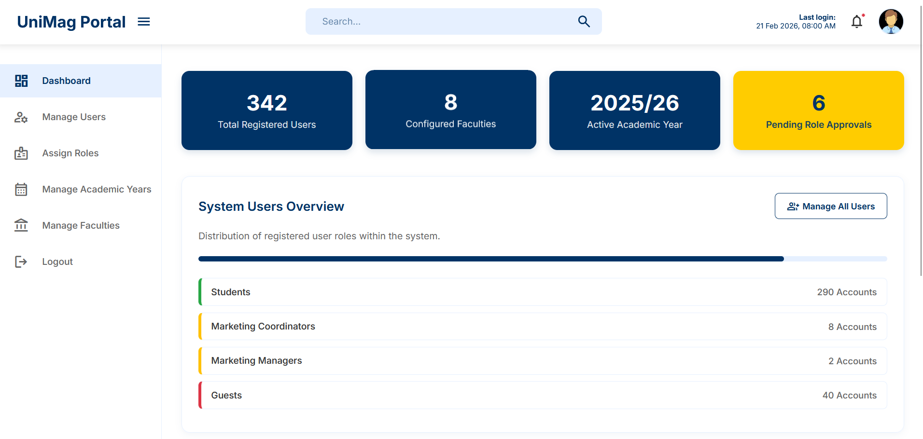
Figure: The primary layout structure featuring the fixed header and the persistent navigation sidebar.

Responsive Design
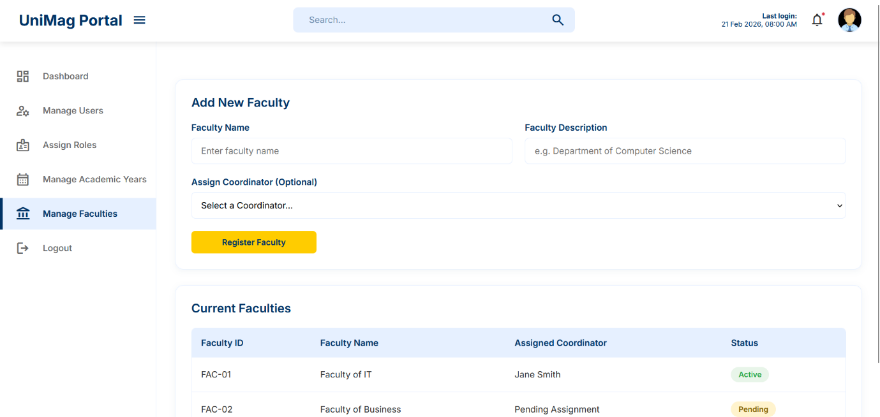
Due to the users accesses from the various devices, the design has to be fully responsive to ensure the screen size is never the problem for usability. On large computer monitors, the CSS Grid offers the extended view of metrics and tables by organizing data into multiple side-by-side columns. The layout automatically changed on the lower screen size. The navigation sidebar collapse to maintain screen space and the buttons are large enough to be easily tapped on the touchscreen. The use of inter font is beneficial here since it maintains the clarity even on smaller mobile displays.
Figure: The primary system layout on a desktop display

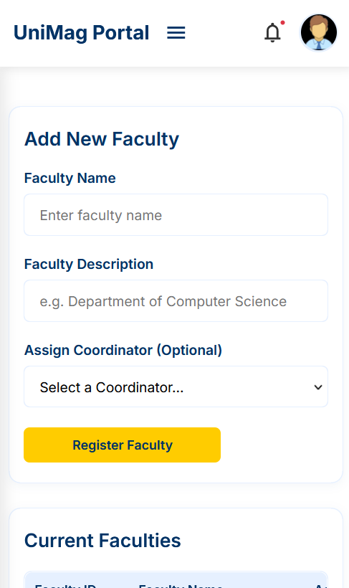
Figure: The responsive layout stack on a mobile device

