User Manager Documentation

INDEX
- Description
- Classes and Architecture
- Rest calls
- Rules for requests
- Configuration files
- Hard Mapping Router
- Throughput
- Deploying
- Database ERD

  - Description

The User Manager is built by using domains, to which users are assigned to. In these domains, users are assigned to zero, one or more different groups, according to their type. They become registered as members of a group. After a user is created in a domain, the front end can use this user to log in, from its ID and a password. The user information includes its attributes, to which group and domain it belongs to and the login information (password and a generated ticket that validates its access). Only after successfully logging in is the ticket generated and returned. The ticket is composed of the user's IP address, his or her user ID, the current time in milliseconds and a generated random value. This value is returned and can later be used to confirm or deny if the user has access to certain services. Tickets also have an expiration time, once a ticket reaches its expiration time the user will have to reconnect in able to validate his or her ticket.
All this is stored in a database or fetched from the user’s existing LDAP account. All operations regarding these elements (create, update, delete, assign to, return, …) are present in the application.
The User Manager also offers statistics capabilities, as it has methods which implement searches in the database, enabling the possibility to retrieve different user data and use it for statistic purposes.
All information presented and returned from the application is displayed in XML document format.

  - Classes and Architecture
This is a diagram view of the User Manager architecture. You can see which classes use which other through the arrows. However, Domain, User, Group and Ticket are packages containing several classes in each of them.
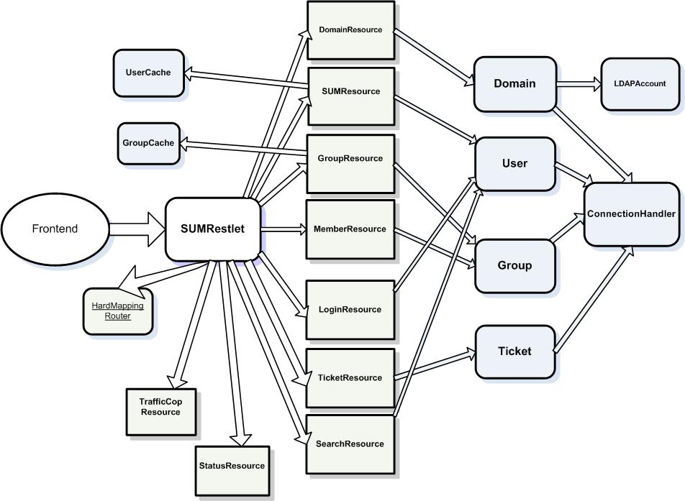
  - Rest Calls

URI | Methods and Functionalities | Parameters
/domain/ | GET – shows the list of domains | -
/domain/{domain} | GET – shows the {domain} data  PUT – creates a new {domain} | PUT - Name, throughput, host
/domain/{domain}/group/ | GET – shows all the groups in a {domain} | -
/domain/{domain}/group/{group}/ | GET – shows the {group} data  PUT – creates a new {group}  DELETE – deletes a {group}  POST – creates a new member on the {group} | PUT – group name  POST – userID
/domain/{domain}/group/{group}/member/ | GET – shows all members of the {group} | -
/domain/{domain}/group/{group}/member/{member} | DELETE – deletes the member | -
/domain/{domain}/user/ | GET – shows all users in {domain}
/domain/{domain}/user/{user}/ | GET – shows the {user} data  PUT – updates the {user}  POST – creates a new {user}  DELETE – deletes the {user} | PUT & POST-  frstName,lastName,password,email,birthdate,phone
/domain/{domain}/user/{user}/login | POST – logs the {user} into the {domain} | Password
/domain/{domain}/user/{user}/validate | POST – validates the {user}’s ticket | Value of the ticket
/domain/{domain}/user/{user}/policy | POST – checks {user}’s permissions | Xml
/domain/{domain}/user/statistics?{params} | GET – shows search results for the given {params} | DB fields and values, dates, limits

Possible URI’s for /domain/{domain}/user/{user}/statistics?
- Search the DB for a column with a given value: URI/statistics?column={column}&value={value}
- Search the DB for users between a beginDate and endDate: URI/statistics?from={value}&to={value}
The date format is STRICTLY “yyyy-mm-dd”. You can add “hh(h):mm(m):ss(s)”.
- Only give back the results between start and limit: URI/statistics?{params}start={value}&limit={value}
  - Rules for requests

- All identifiers must be Strings.
- All rest calls must be preceded by “/restlet/” in order to make jsp pages available outside of the resources.
- Parameters must always be sent in the body of the request (please not that identifiers in the url are not parameters).
- Every error that occurs in a resource returns “<error>[message]</error>”, except for formatting errors.

  - Configuration Files

Configuration files are stored in the simple-um/src/com/conf. Here is an example of an LDAP using domain:

<?xml version="1.0" encoding="UTF-8" standalone="no"?>
<!DOCTYPE properties SYSTEM "http://java.sun.com/dtd/properties.dtd">
<properties>
<comment>Config for domain: noterik</comment>
<entry key="Ldap DefaultDomainController">com</entry>
<entry key="throughput">Ldap</entry>
<entry key="Ldap DomainController">dc</entry>
<entry key="name">noterik</entry>
<entry key="Ldap Organisation">ou</entry>
<entry key="host">ldap://zhaan.noterik.nl:389</entry>
<entry key="domainID">noterik</entry>
<entry key="Ldap DefaultGroup">People</entry>
</properties>

The first 4 lines do not require explanation and do not configure anything. The two most important entries are 'domainID' and 'throughput'. 'domainID' is used as the identifier. The other entries are used to configure the Ldap connection. For MySQL throughput a host is not needed and Ldap configurations are not necessary.

The configuration file being used right now is stored in /simple-um/WebContent/META-INF/. It has MySql throughput and the settings for the database being used now – the HouseMovie project Database.

In the future, if intended to make the User Manager more generic, the only thing that needs to change is the configuration file, to the appropriate database settings.

  - Hard Mapping Router

The Hard Mapping Router is a modified Restlet.org.router class which allows the application to only route requests that completely match the specified URI. There is no setting in the standard router class that allows this at the moment. The only thing you have to do to start using the Hard Mapping Router is importing the HardMappingRouter and have your router class extend HardMappingRouter instead of Router.

  - Throughput

Each domain in the user manager may be configured with different throughput for each domain. This allows each domain to use different, possibly pre-existent, user storage. When you want to store tickets while frontend authentications uses a-select / entree the throughput should be set to MySQL because the tickets are still stored in the User Manager’s own database.

  - Deploying

Deploying the user-manager onto a server should be simple; all that is needed is to change the setting localhost to false and to create the database.

  - Database ERD

The create statement for this database can be found in the project in the CVS in the sql folder.
The following diagram describes the database relationships for the user-manager:
