**Experiment 7**

**Database Techniques: Basic SQL Queries**

**Content:**

Databases and SQL (Structured Query Language) are fundamental components of modern data management systems. Here's some information about them:

1. **Databases**:
   * A database is an organized collection of structured information or data, typically stored electronically in a computer system.
   * Databases are designed to efficiently store, retrieve, and manage data.
   * They provide mechanisms for defining, manipulating, and querying data.
   * Databases can range from simple single-user systems to complex, distributed systems that serve millions of users simultaneously.
   * Examples of popular databases include MySQL, PostgreSQL, SQLite, Oracle, Microsoft SQL Server, and MongoDB.
2. **SQL (Structured Query Language)**:
   * SQL is a domain-specific language used in programming and designed for managing data held in a relational database management system (RDBMS) or for stream processing in a relational data stream management system (RDSMS).
   * It is widely used for managing and manipulating data in relational databases.
   * SQL provides various commands for performing tasks such as querying data, updating data, creating and modifying database schemas, and managing permissions.
   * SQL is standardized by the American National Standards Institute (ANSI) and the International Organization for Standardization (ISO).
   * Common SQL commands include SELECT, INSERT, UPDATE, DELETE, CREATE, ALTER, and DROP.
3. **Key Concepts**:
   * **Tables**: In a relational database, data is organized into tables, which consist of rows and columns.
   * **Primary Key**: A primary key is a unique identifier for each record in a table.
   * **Foreign Key**: A foreign key is a column or combination of columns in one table that refers to the primary key in another table, establishing a relationship between the two tables.
   * **Indexes**: Indexes are data structures that improve the speed of data retrieval operations on a database table.
   * **Transactions**: A transaction is a unit of work performed within a database management system against a database.
   * **Normalization**: Normalization is the process of organizing the columns and tables of a relational database to minimize redundancy and dependency.
4. **Use Cases**:
   * SQL is used for a wide range of applications including web development, mobile app development, business intelligence, data analysis, and more.
   * It is used to create, read, update, and delete data in databases.
   * SQL queries are essential for extracting meaningful insights from large datasets.
5. **Challenges and Trends**:
   * As data volumes grow, scalability and performance become critical concerns for databases.
   * The rise of NoSQL databases offers alternatives to traditional SQL databases, especially for applications with high scalability and flexibility requirements.
   * New trends such as distributed databases, graph databases, and in-memory databases are reshaping the landscape of data management.

**Task 1**: Create a Database Table containing persons information about the PersonID, firstname, lastname, salary, dateofjoining and department

CREATE TABLE MyTable1 (

PersonID int,

LastName varchar(255),

FirstName varchar(255),

Salary varchar(255),

DateofJoining varchar(255),

Department varchar(255)

);

INSERT INTO MyTable1

(PersonID, LastName, FirstName, Salary, DateofJoining, Department) VALUES

(001, 'Monika', 'Arora', 100000, '21-02-20 09.00.00', 'HR'),

(002, 'Niharika', 'Verma', 80000, '21-06-11 09.00.00', 'Admin'),

(003, 'Vishal', 'Singhal', 300000, '21-02-20 09.00.00', 'HR'),

(004, 'Amitabh', 'Singh', 500000, '21-02-20 09.00.00', 'Admin'),

(005, 'Vivek', 'Bhati', 500000, '21-06-11 09.00.00', 'Admin'),

(006, 'Vipul', 'Diwan', 200000, '21-06-11 09.00.00', 'Account'),

(007, 'Satish', 'Kumar', 75000, '21-01-20 09.00.00', 'Account'),

(008, 'Geetika', 'Chauhan', 90000, '21-04-11 09.00.00', 'Admin');

OUTPUT:

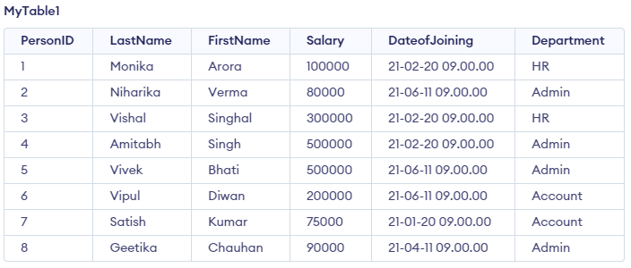

Create another table with the order details as:

CREATE TABLE MyTable2_items (

OrderID int,

item varchar(255),

amount varchar(255),

customerID varchar(255)

);

INSERT INTO MyTable2_items

(OrderID, item, amount, customerID)

VALUES

(19917, 'mouse', '500', '7'),

(19918, 'stationary', '700', '4'),

(32356, 'monitor', '4500', '9'),

(32546, 'staple', '70', '5'),

(76870, 'whiteboard', '7000', '2');

OUTPUT:

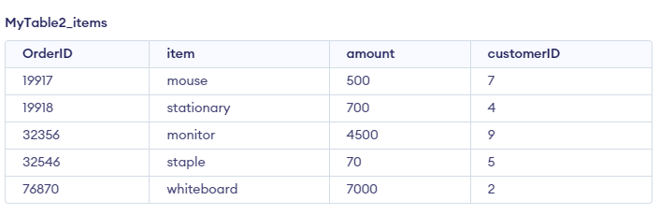

**Task 2**: EXECUTE –

Execute the following queries and generate the output

1. SELECT PersonID, LastName, Department FROM MyTable1;

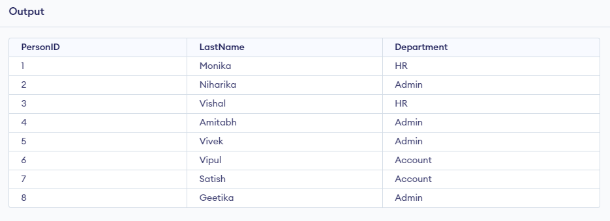

1. PersonID=3, LastName, Department FROM MyTable1;

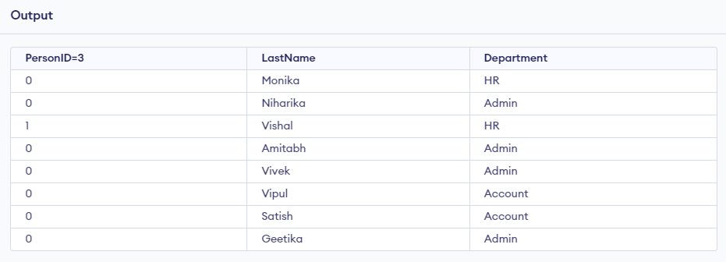

1. SELECT * FROM MyTable1;

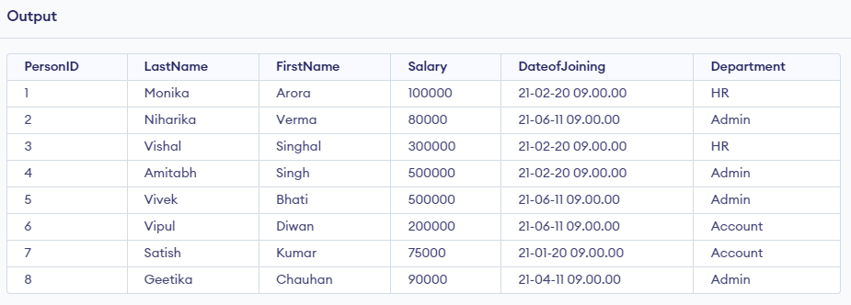

1. DROP TABLE MyTable2_items;

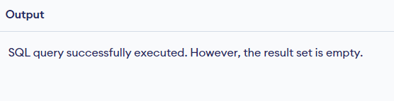

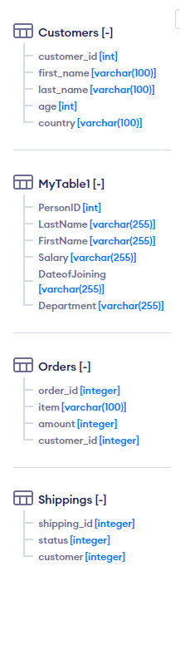

1. TRUNCATE TABLE MyTable1;

**Task3:**

1. Write an SQL query to generate data of all the customers having salary between 50,000 to 1,00,000



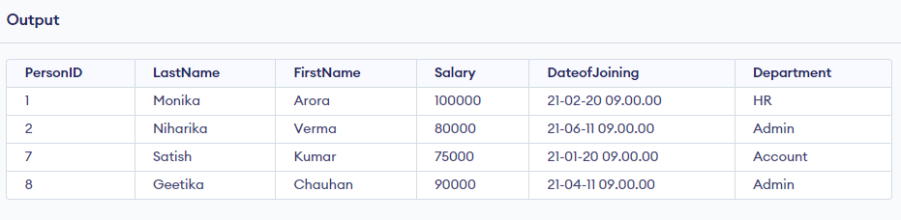

1. Write an SQL query to generate details of both the tables wherein customerID=PersonID



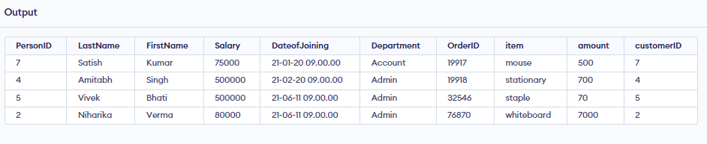

1. Write an SQL query to find the person with maximum salary in HR department



