Product And Category Application

FRUIT SA

**TECHSTACK**

*Web application Created using Visual Studio 2022, MSSQL.

*ASP.NET

*ENTITY Framework 6

*MVC - Model-View-Controller

*CSS with Bootstrap

**PURPOSE**

The Web-Application is created, to manage Products as well as the Category in which the Product belongs too, it is a Web-Application in which a new user needs to register, from there it allows a user to login and Manage Products.

**INSALLING AND CONFIGURING THE WEB_APPLICATION**

1. We use a Repository called GitHub.
2. Download/Clone the Repo to your PC

-You can copy and paste link

[NothaSibeko/Product-Category-App: C#, ASP.NET, Entity Framework, CSS, HTML, Bootstrap WebApp to manage Products (github.com)](https://github.com/NothaSibeko/Product-Category-App)

3. Unzip the file

4. Go to appsettings.json file, set up and configure you Database

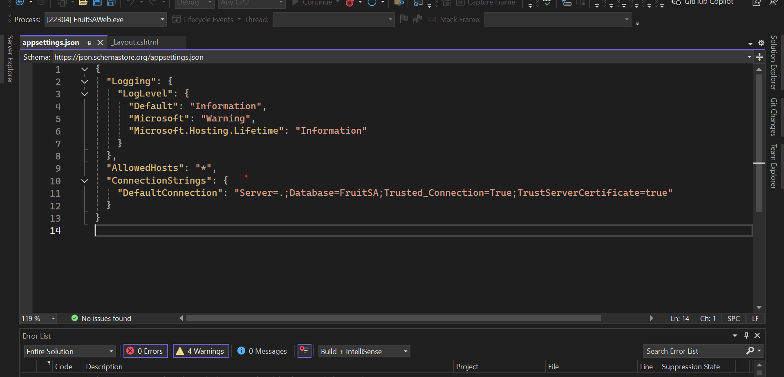

***** "AllowedHosts": "*",

"ConnectionStrings": {

"DefaultConnection": "Server=.;Database=FruitSA;Trusted_Connection=True;TrustServerCertificate=true"

}****

5. Add Migration - Tools - Nuget Package Manager - Package Manager Console(PMC) - Default Project should be FruitSA.DataAccess -

*Add-Migration MigrationName Migration name can be any name of your choice can be e.g. FirstMigration, SecondMigration etc.

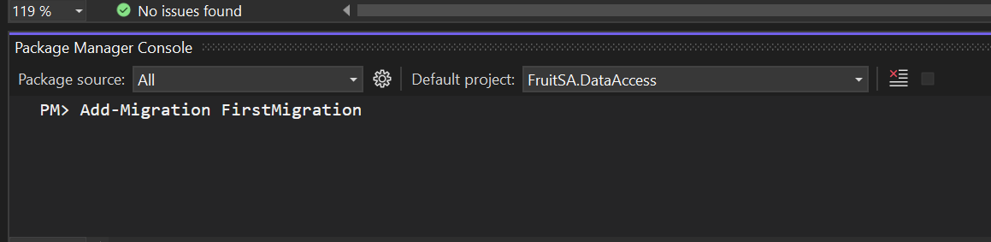

*Update-Database

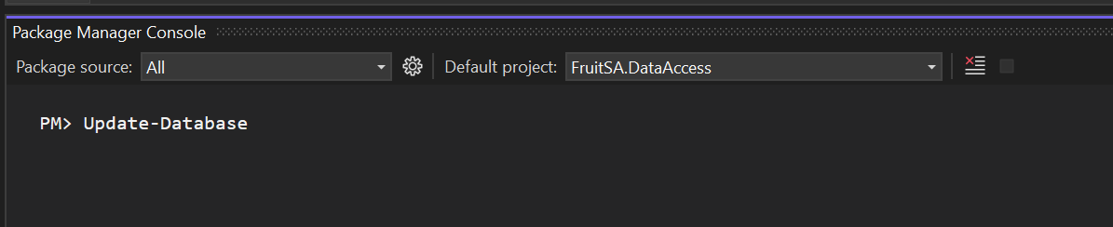

6. Build Application

7. Run Application

**WE NOW DONE WITH INSTALLING AND CONFIGURING THE WEB-APPLICATION!!!!!!!!**

**HOW TO USE WEB-APPLICATION**

1. Register NEW USER and I believe you will be able to play around the WEB-APPLICATION

IMPORTANT EXCEL FILE SHOULD HAVE BELOW COLUMNS IN THIS ORDER

*********ProductId, ProductCode, Name, Description, CategoryId, Price, ImageUrl, Username, CreatedDate, UpdatedAt_******

**HOW TO UPLOAD PRODUCTS USING EXCEL**

1. I attached a EXCEL DOCUMENT called Products, USE that one.

2. Content Managment - Product and upload the Excel file and Upload

3. Back to HOME PAGE, Products have been added

4. when download, AGAIN Content Managment, check downloadBUTTON

**HOW TO UPLOAD OWN PRODUCTS USING EXCEL**

1. First create Categories by navigating to Content Management - Category and click the Create New Category button

2. Then go to Content Management - Product and upload the Excel file