Methodology

AI vibrancy
AI Vibrancy measures the strength and maturity of each country’s AI ecosystem. The study uses the Stanford AI Index AI Vibrancy country scores stored in the project dataset. The main independent variable is the Total Score, renamed as AI Vibrancy Score in the correlation dataset.
Data file: data/AI vibrancy tool screen shot/ai_country_scores.csv.
Main variable: Total Score / AI Vibrancy Score.
Component dimensions retained for descriptive analysis include R&D, Responsible AI, Economy, Talent, Policy and Governance, Public Opinion, and Infrastructure.
Interpretation: higher values indicate a stronger and more developed national AI ecosystem.

Country | AI Vibrancy Score
United States | 77.85
China | 35.10
United Kingdom | 20.06
Japan | 17.70
France | 16.62
Canada | 15.46
Italy | 13.18
Germany | 12.35

Economic freedom
Economic freedom is measured with the Heritage Foundation Index of Economic Freedom. The analysis uses the latest available index year in the project panel, which is 2026 in the current dataset. The main economic freedom variable is the Overall Score.
- Data file: data/number/ief_g7_china_panel.csv.
- Main variable: Overall Score, renamed as IEF Overall Score.
- The latest year is selected programmatically from the panel rather than hard-coded.
- Interpretation: higher values indicate a more economically free policy environment according to the IEF methodology.
Country | Index Year | IEF Overall Score
Canada | 2026 | 75.6
United States | 2026 | 72.8
Germany | 2026 | 71.7
United Kingdom | 2026 | 70.4
Japan | 2026 | 70.3
France | 2026 | 64.6
Italy | 2026 | 63.3
China | 2026 | 48.3

Text analysis

Conceptual Framework
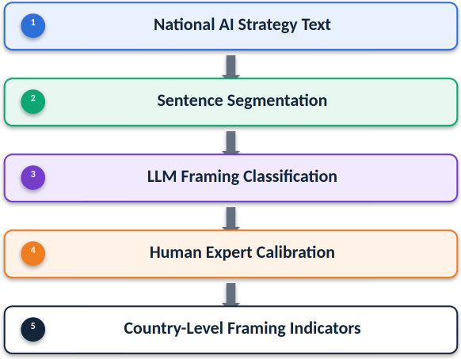
The conceptual framework treats AI regulatory discourse as a measurable policy signal. Sentences are assigned to one of five labels. The primary substantive contrast is between innovation-oriented and risk-oriented framing; mixed and neutral labels prevent the model from forcing ambiguous or descriptive sentences into substantive categories.

Label | Meaning
Innovation-oriented | Emphasizes innovation, investment, adoption, competitiveness, productivity, and flexible regulation
Risk-oriented | Emphasizes risk, safety, accountability, privacy, fairness, human rights, and regulatory obligations
Mixed | A single sentence contains both innovation and risk framing
Neutral | Descriptive, administrative, or procedural sentences

Data
- National AI strategy / AI policy documents
- G7 countries + China
- English texts are used directly; Chinese texts are translated using NLLB or have existing English corpora for analysis
- The unit of analysis is the sentence, not the paragraph or document

LLM Labeling Method
The sentence-labeling workflow uses DeepSeek through Ollama. The model classifies each sentence independently, which reduces cross-sentence leakage and makes each label auditable at the sentence level.
- Local model: deepseek-r1:14b.
- Deployment: local Ollama endpoint, improving reproducibility and data control.
- Independent classification: each sentence is labeled separately.
- Prompt design: the prompt includes the project codebook and human-annotated gold examples.
- Structured output: the model returns JSON with label, confidence score, and reason.
- Label tracking: both raw model labels and final corrected labels are retained.
Key advantages of the LLM labeling workflow:
- Local deployment supports reproducibility and avoids sending policy text to an external hosted API.
- Sentence-level granularity allows fine-grained measurement of regulatory framing.
- JSON formatting enables automated parsing and reduces manual post-processing.
- Confidence scores and reason fields make model decisions auditable.
- Retaining both raw and corrected labels allows the study to distinguish model behavior from human-calibrated final outputs.

Human Calibration
Human calibration is a central quality-control step. The workflow is designed to avoid blindly trusting LLM output. Human annotations are used both to guide the model through few-shot examples and to correct exact matched sentences in the final output.
- Sampling: 40 sentences were sampled for human annotation.
- Independent annotation: multiple human annotators labeled the sampled sentences independently using the framing codebook.
- Quality check: Annotator 1 showed lower annotation stability and was therefore not used for the final Daria + Stephen consensus calibration set.
- Gold set creation: Daria and Stephen reached agreement on 23 sentences. After excluding human-gold Unsure labels for the no-unsure calibration workflow, 16 substantive gold labels were used for prompt calibration, exact-match overrides, and model evaluation.
- Model evaluation: raw model accuracy against the substantive gold set was 75.00%; after exact human-gold correction, corrected accuracy was 100.00%. The current full run applied 4 human overrides.

Correction Logic
The final corrected label is generated using deterministic exact-match override logic:
corrected_label =
human_gold_label, if the sentence is present in the usable human gold set
model_label, otherwise
This correction logic means the model is trusted for the broader corpus only after it has been calibrated and benchmarked against human expert agreement. For sentences in the usable gold set, the human consensus label has priority over the model output.

4. Correlation study

The correlation study merges the corrected country-level framing summary with AI Vibrancy and IEF data. The analysis is exploratory because the merged country sample contains only eight observations. Therefore, the study emphasizes effect direction and correlation strength rather than treating p-values as confirmatory evidence.
- H1: Countries with higher AI Vibrancy scores are expected to show higher Innovation Share.
- H2: Countries with lower AI Vibrancy scores are expected to show higher Risk Share.
- H3: Countries with higher IEF Overall Scores are expected to show higher Innovation Share.
- H4: Countries with more risk-oriented discourse are expected to show lower IEF Overall Scores.
- Robustness measures include Mean Framing Score and Log Innovation-to-Risk Ratio.
- Models include Pearson and Spearman correlations, bivariate OLS regressions, a combined AI Vibrancy + IEF model for framing balance, and an exploratory mediation diagnostic.
Test | X | Y | Expected | N | Pearson r | Pearson p | Directional Support
H1: Vibrancy -> innovation framing | AI Vibrancy Score | Innovation Share | positive | 8 | -0.030 | 0.9429 | False
H2: Lower vibrancy -> risk framing | AI Vibrancy Score | Risk Share | negative | 8 | 0.407 | 0.3172 | False
H3: IEF -> innovation framing | IEF Overall Score | Innovation Share | positive | 8 | -0.689 | 0.0589 | False
H4: Risk framing -> lower IEF | Risk Share | IEF Overall Score | negative | 8 | 0.534 | 0.1728 | False
Ratio robustness: Vibrancy -> innovation/risk balance | AI Vibrancy Score | Log Innovation to Risk Ratio | positive | 8 | -0.264 | 0.5280 | False
Ratio robustness: IEF -> innovation/risk balance | IEF Overall Score | Log Innovation to Risk Ratio | positive | 8 | -0.478 | 0.2312 | False
Background association: Vibrancy and IEF | AI Vibrancy Score | IEF Overall Score | positive | 8 | -0.001 | 0.9973 | False

Limitations and Interpretation
- The correlation analysis is based on eight countries, so findings should be interpreted as exploratory patterns rather than causal estimates.
- Policy documents differ in length, scope, publication year, and institutional purpose; sentence shares and normalized ratios are used to reduce but not eliminate comparability issues.
- LLM labels are calibrated with human annotations, but the human gold set remains small. The current no-unsure substantive gold set contains 16 evaluation sentences.
- Translation and OCR quality may affect sentence segmentation and model labeling, especially for non-English source material.

Reproducibility Outputs
- Raw sentence labels: outputs/deepseek_ai_framing_sentence_labels_raw_daria_stephen_no_unsure_full.csv.
- Corrected sentence labels: outputs/deepseek_ai_framing_sentence_labels_corrected_daria_stephen_no_unsure_full.csv.
- Corrected country summary: outputs/deepseek_ai_framing_summary_corrected_daria_stephen_no_unsure_full.csv.
- Gold metrics: outputs/deepseek_ai_framing_gold_metrics_daria_stephen_no_unsure_full.csv.
- Correlation dataset: outputs/correlation_study_dataset_deepseek_corrected_daria_stephen_no_unsure_full.csv.
- Correlation results: outputs/correlation_study_correlations_deepseek_corrected_daria_stephen_no_unsure_full.csv.

