Results
AI Vibrancy, Economic Freedom, Framing, and Correlation Findings

1. Executive Summary of Findings
- The full G7 + China correlation sample does not support H1-H4: AI Vibrancy and Economic Freedom do not map cleanly onto innovation- or risk-oriented AI policy rhetoric.
- AI Vibrancy is highly uneven: the United States is a clear leader, followed by China, while other G7 countries form a tighter cluster.
- Economic Freedom separates China from the G7 more clearly than it separates G7 countries from each other.
- Most policy documents are more innovation-oriented than risk-oriented, but the United States and Canada are more balanced/risk-conscious than China, France, and the United Kingdom.
- Outlier sensitivity checks show that the United States and China are theoretically important cases: the United States is high-vibrancy but risk-conscious, while China is low-IEF but strongly innovation-oriented.

2. AI Vibrancy Results
The United States leads AI Vibrancy by a large margin, followed by China. This uneven distribution makes the United States a high-leverage case in AI Vibrancy correlation tests.
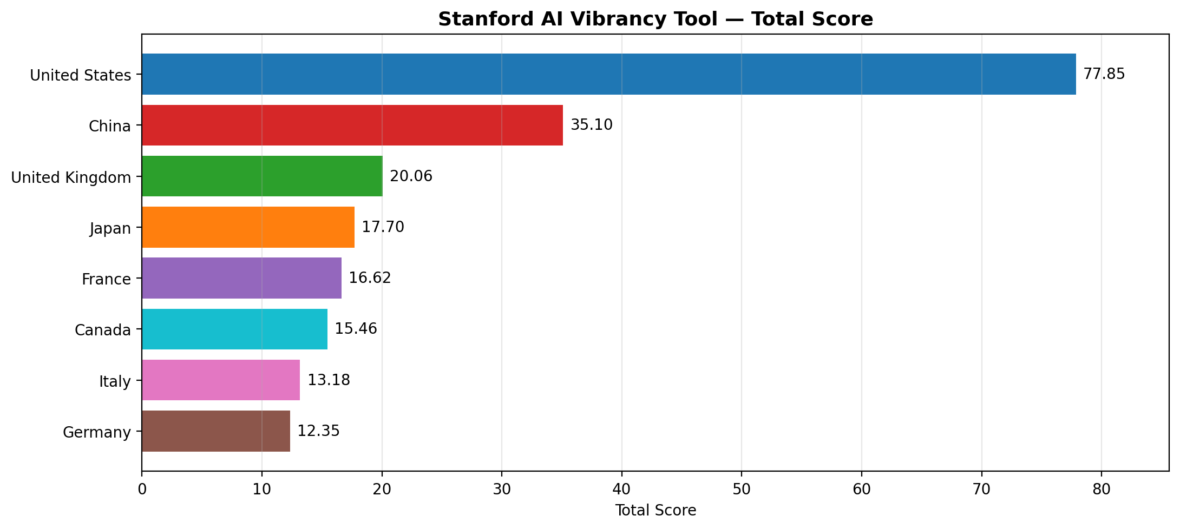
Figure 1. Stanford AI Vibrancy total score ranking.
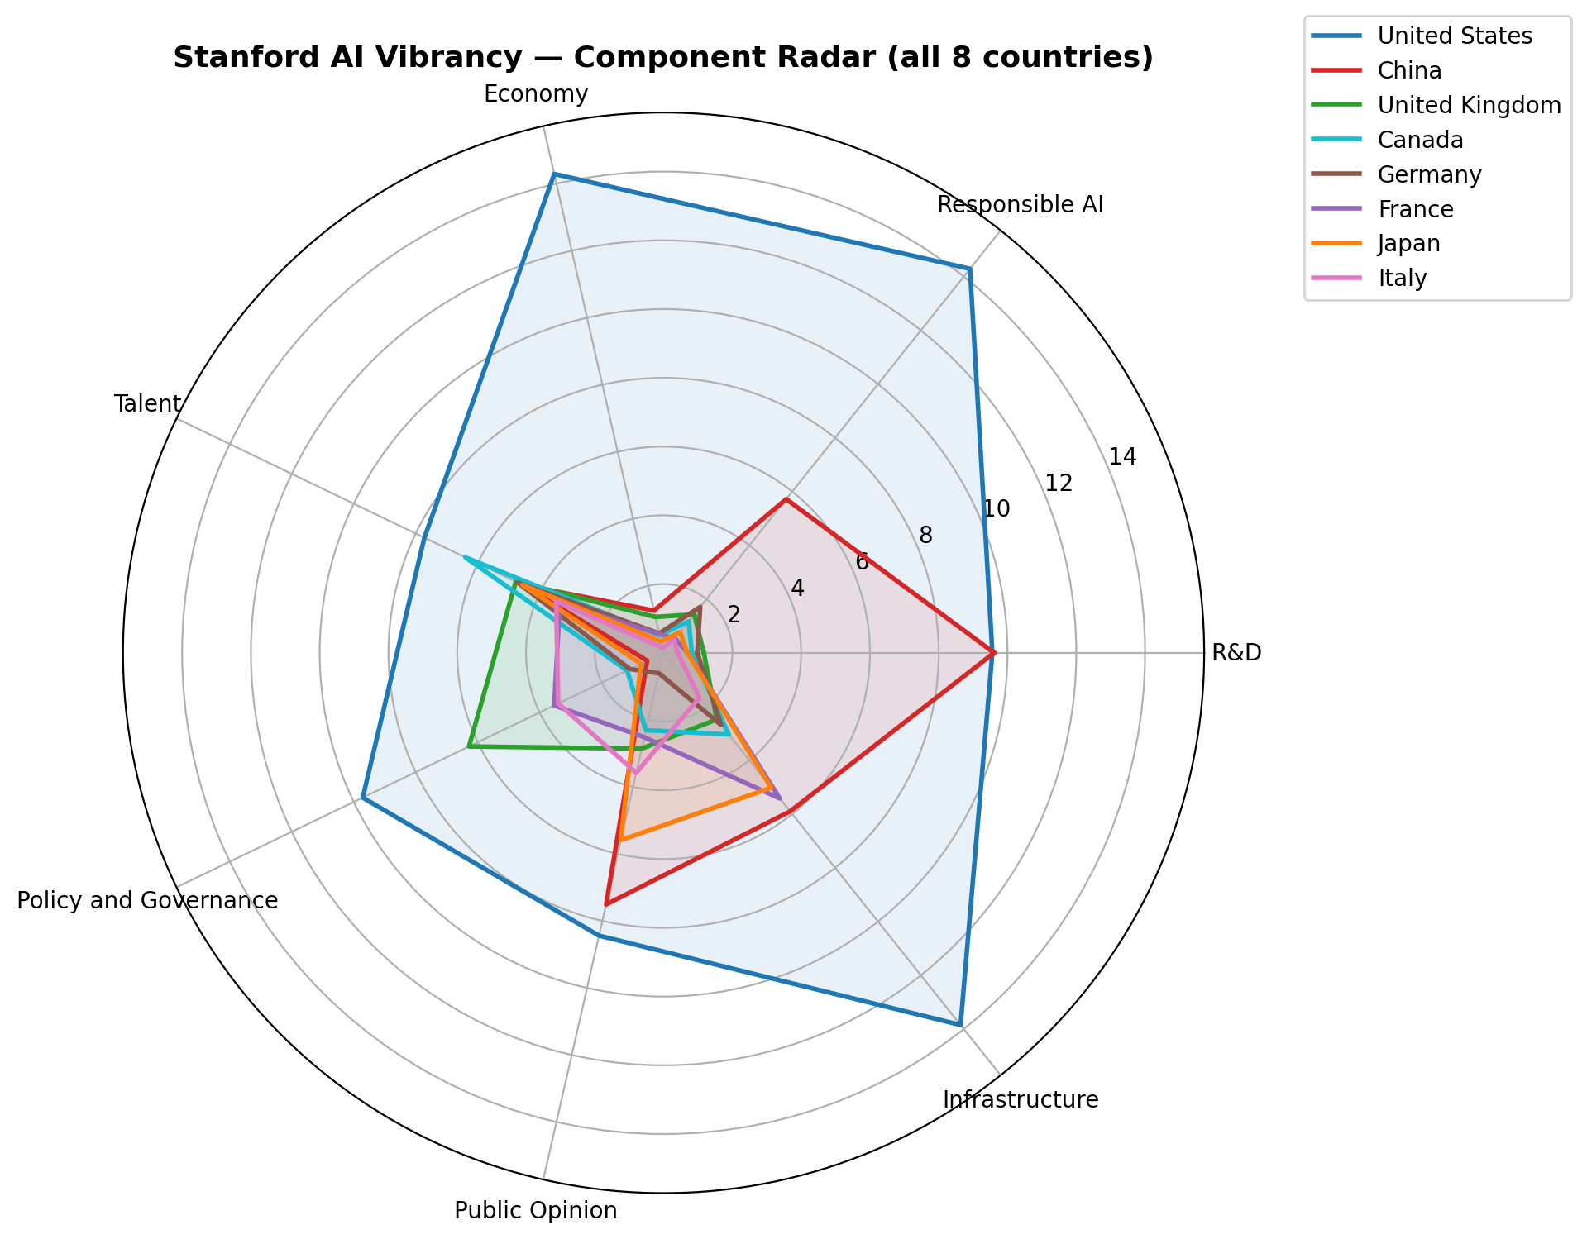
Figure 2. AI Vibrancy component radar.
Rank | Country | AI Vibrancy Score
1 | United States | 77.85
2 | China | 35.10
3 | United Kingdom | 20.06
4 | Japan | 17.70
5 | France | 16.62
6 | Canada | 15.46
7 | Italy | 13.18
8 | Germany | 12.35

3. Economic Freedom Results
Canada, the United States, Germany, the United Kingdom, and Japan score relatively high on the 2026 IEF Overall Score. China is substantially lower, making it a key contrast case for the economic freedom hypotheses.
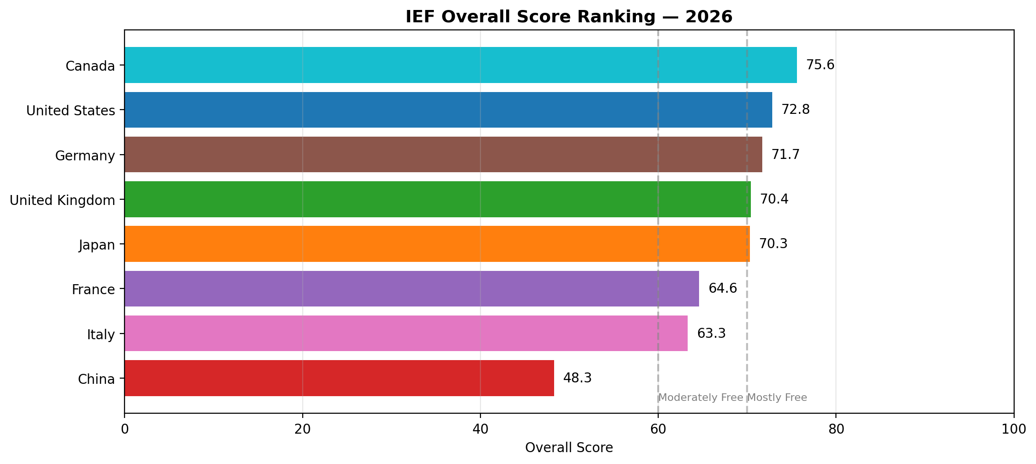
Figure 3. 2026 Index of Economic Freedom ranking.
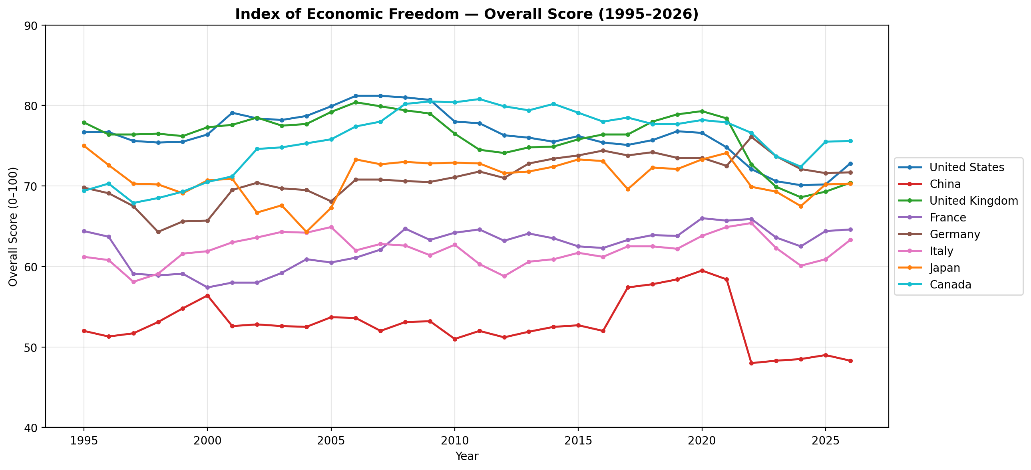
Figure 4. IEF Overall Score trajectories, 1995-2026.
Rank | Country | 2026 IEF Overall Score
1 | Canada | 75.6
2 | United States | 72.8
3 | Germany | 71.7
4 | United Kingdom | 70.4
5 | Japan | 70.3
6 | France | 64.6
7 | Italy | 63.3
8 | China | 48.3

4. Corrected Framing Results
The corrected DeepSeek run contains 3,730 sentences across nine countries/entities. China, France, and the United Kingdom show the strongest innovation-oriented framing. Canada and the United States have the lowest mean framing scores, indicating more balanced or risk-conscious rhetoric.
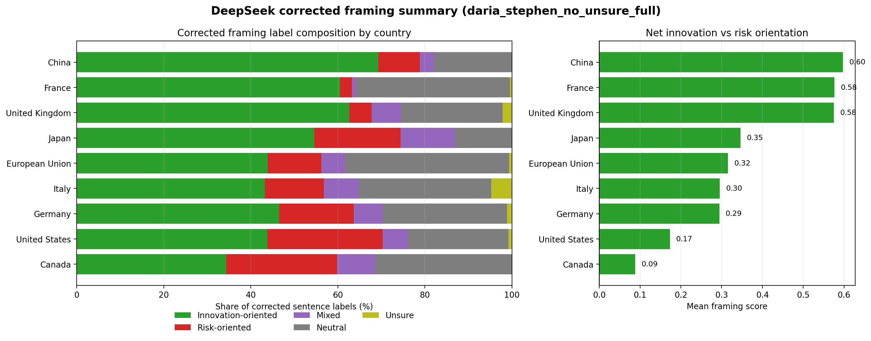
Figure 5. Corrected label composition and mean framing score.
Country/entity | Sentences | Innovation | Risk | Mean score | Innovation/Risk ratio
China | 241 | 167 | 23 | 0.598 | 7.128
France | 215 | 130 | 6 | 0.577 | 20.077
United Kingdom | 372 | 233 | 19 | 0.575 | 11.974
Japan | 176 | 96 | 35 | 0.347 | 2.718
European Union | 1137 | 499 | 140 | 0.316 | 3.555
Italy | 440 | 190 | 60 | 0.295 | 3.149
Germany | 462 | 215 | 79 | 0.294 | 2.711
United States | 381 | 167 | 101 | 0.173 | 1.650
Canada | 306 | 105 | 78 | 0.088 | 1.344

5. Full-Sample Correlation Results
The main H1-H4 tests use the full G7 + China sample. Results do not support the expected directions. Because N = 8, p-values should not be treated as confirmatory.
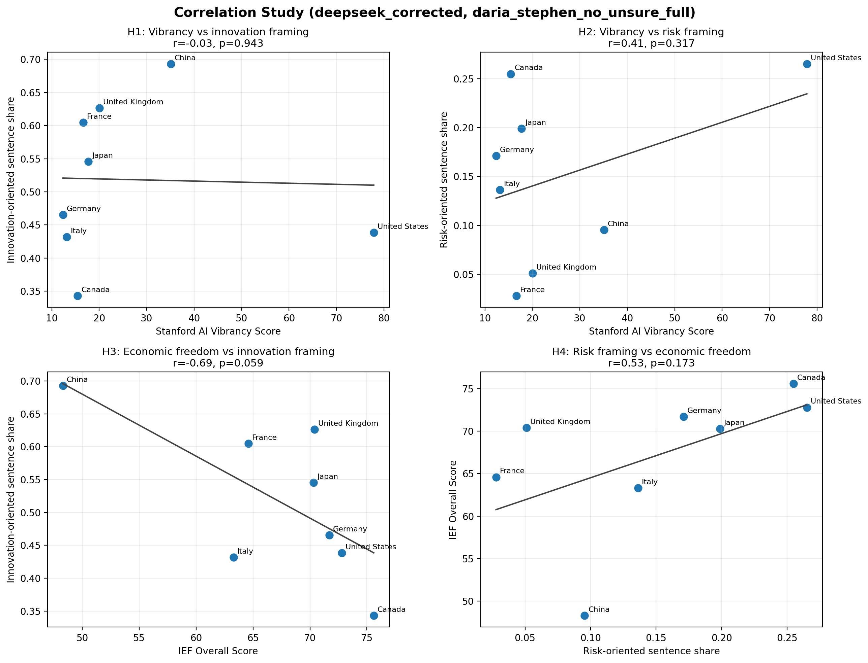
Figure 6. Full-sample H1-H4 correlation scatter plots.
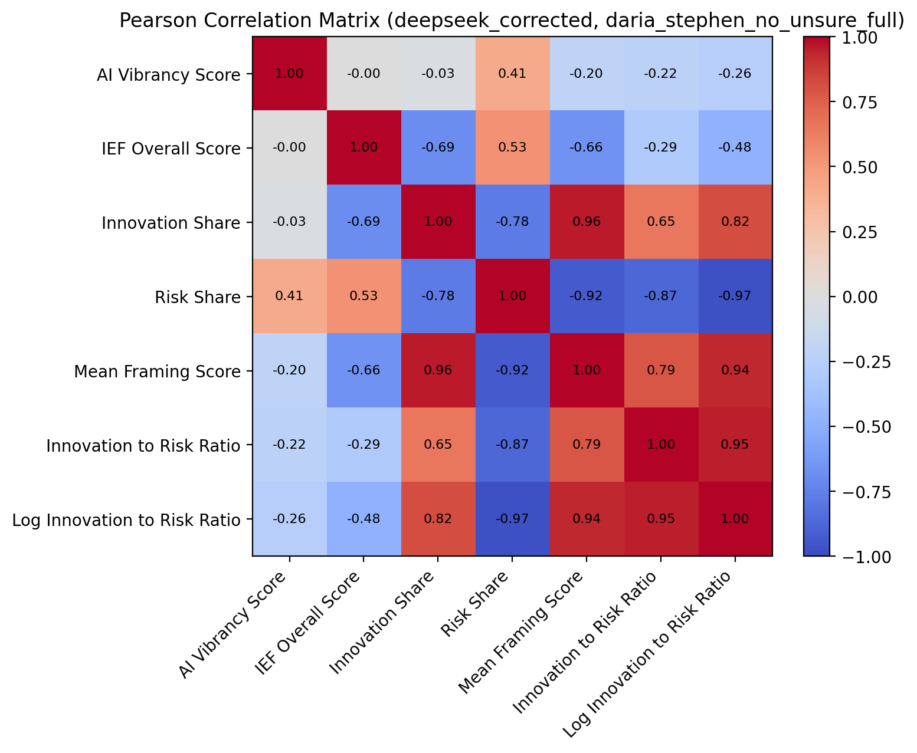
Figure 7. Pearson correlation matrix.
Hypothesis | X | Y | Pearson r | p | Support
H1: Vibrancy -> innovation framing | AI Vibrancy Score | Innovation Share | -0.030 | 0.9429 | No
H2: Lower vibrancy -> risk framing | AI Vibrancy Score | Risk Share | 0.407 | 0.3172 | No
H3: IEF -> innovation framing | IEF Overall Score | Innovation Share | -0.689 | 0.0589 | No
H4: Risk framing -> lower IEF | Risk Share | IEF Overall Score | 0.534 | 0.1728 | No

6. Outlier Sensitivity Results
Outlier sensitivity checks evaluate whether theoretically unusual cases drive the correlations. The United States is excluded for H1/H2; China is excluded for H3/H4.
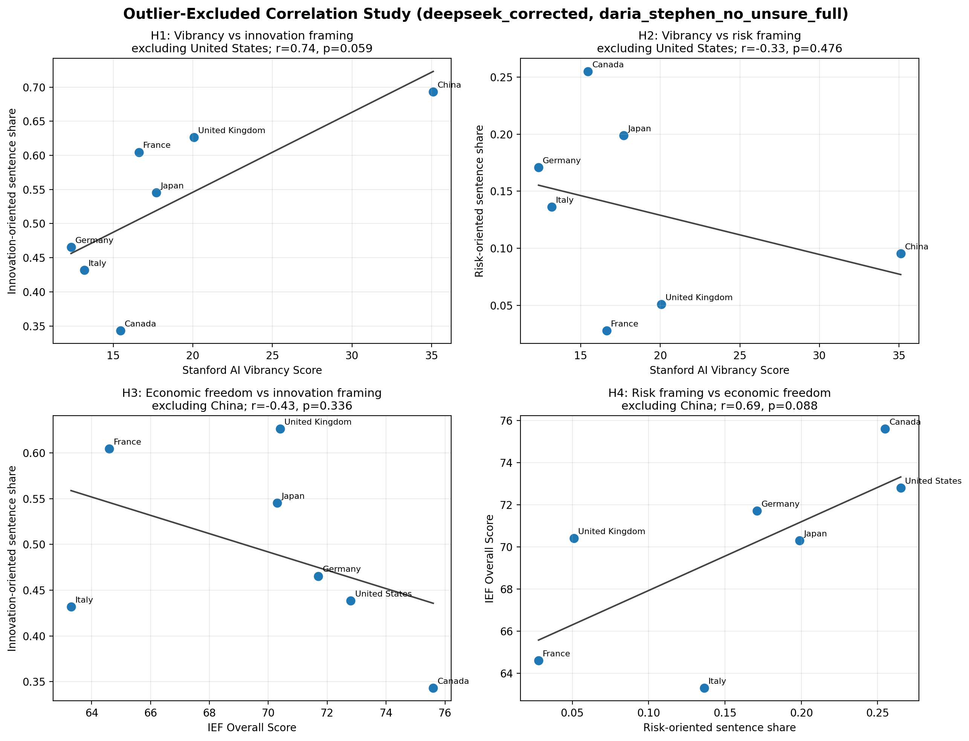
Figure 8. Outlier-excluded H1-H4 scatter plots.
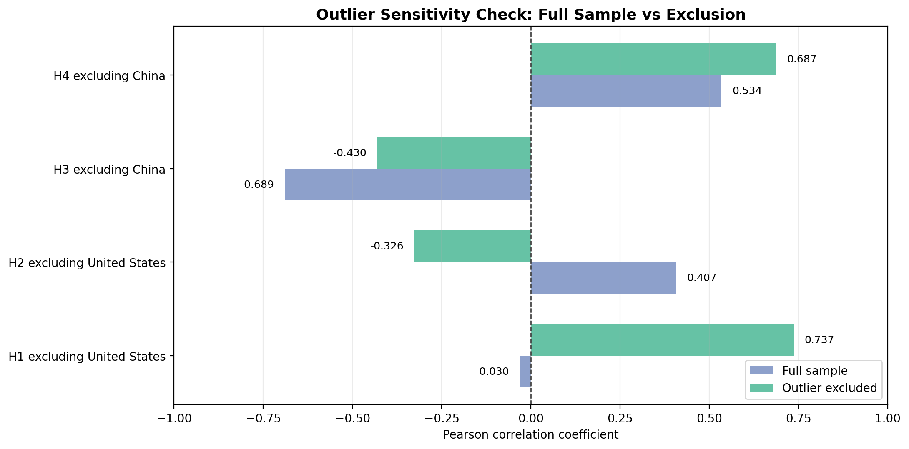
Figure 9. Full-sample versus outlier-excluded Pearson correlations.
Test | Excluded case | Full r | Sensitivity r | Interpretation
H1 | United States | -0.030 | 0.737 | H1 becomes strongly positive without the high-vibrancy, risk-conscious U.S. case.
H2 | United States | 0.407 | -0.326 | Direction flips to expected negative relationship, but remains weak.
H3 | China | -0.689 | -0.430 | Negative relationship weakens but still does not support H3.
H4 | China | 0.534 | 0.687 | Relationship remains opposite to H4 and becomes stronger.

7. Regression and Mediation Diagnostics
Regression models are descriptive diagnostics. The combined model predicting log innovation-to-risk ratio from AI Vibrancy and IEF has R2 = 0.298, but with only eight observations this should be interpreted cautiously.
Model | Term | Coefficient | p | R2
Combined: Log ratio ~ AI vibrancy + IEF | Intercept | 5.2952 | 0.1225 | 0.298
Combined: Log ratio ~ AI vibrancy + IEF | AI Vibrancy Score | -0.0115 | 0.5119 | 0.298
Combined: Log ratio ~ AI vibrancy + IEF | IEF Overall Score | -0.0532 | 0.2580 | 0.298

The mediation diagnostic estimates an indirect effect of 0.0545, with a bootstrap 95% CI from -1.1090 to 0.3073. This is retained as a mechanism check only, not as evidence of causal mediation.

8. Interpretation
The results suggest that AI policy rhetoric is not simply a reflection of AI ecosystem capacity or economic freedom. The United States and China complicate simple linear expectations: the United States combines high AI capacity with relatively risk-conscious discourse, while China combines low economic freedom with strongly innovation-oriented framing. This points toward a broader interpretation in which national AI rhetoric is shaped by strategic state priorities, governance traditions, geopolitical positioning, and document purpose.
The main policy takeaway is negative but informative: analysts should not infer AI regulatory orientation from macro-level AI capacity or economic openness alone. Direct text analysis remains necessary to understand the policy narrative each government is constructing.

