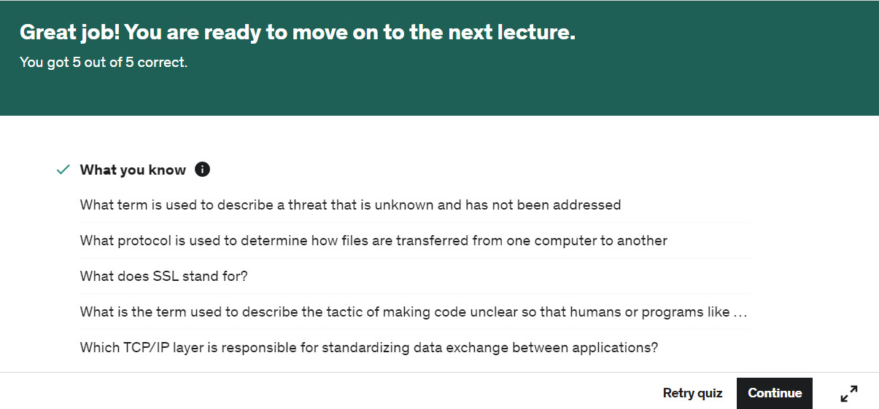

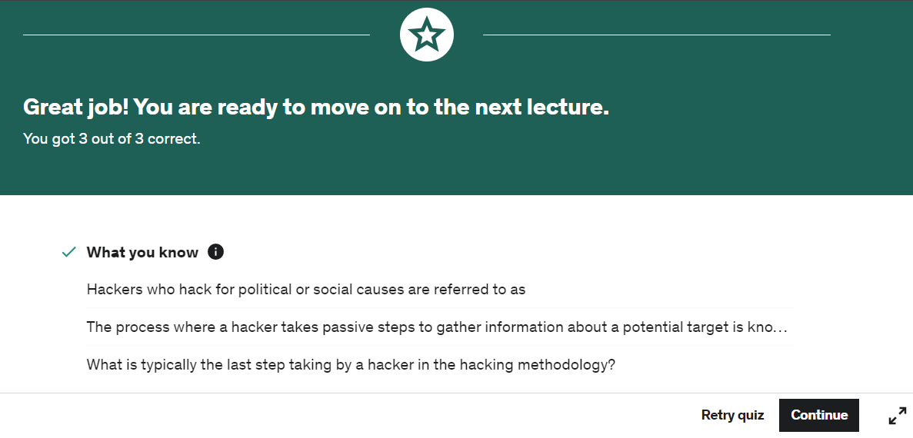

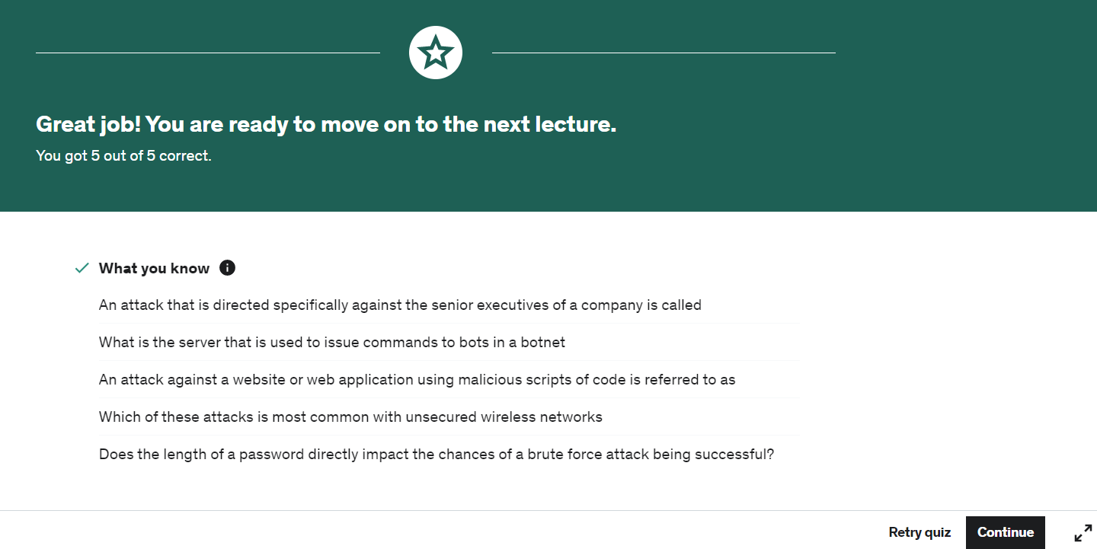

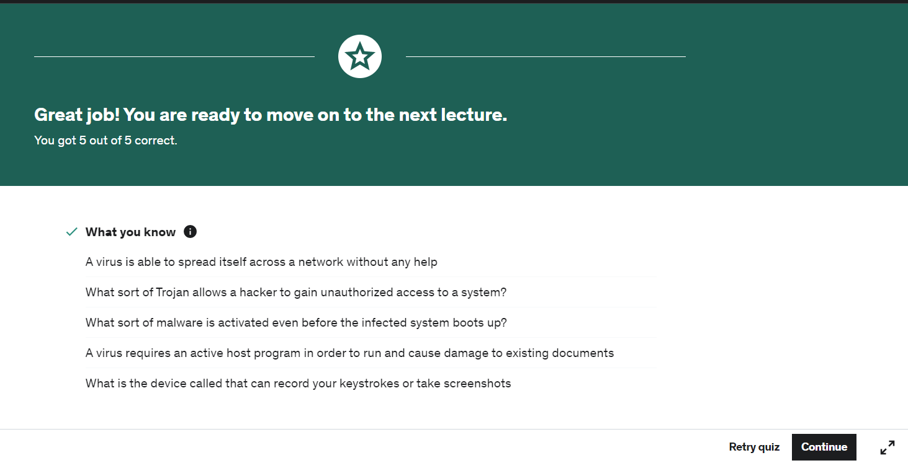

Day 3: In this module I learned about Antivirus, Firewalls, Encryption, Biometrics, Authentication Methods and much more

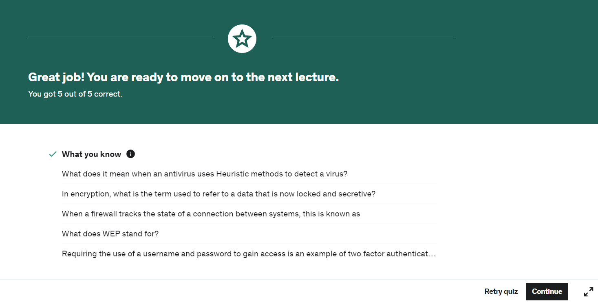

In this module I learned about Cyber Security at the workplace and its policies. I also learned about BYOD management.

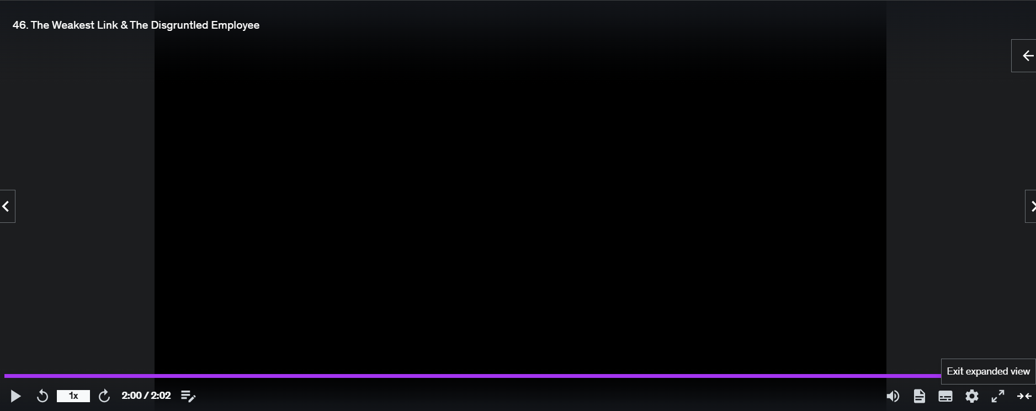

Day 4: Finally discussed other topics related to both information and cyber security such as the cyber warfare and cyber-attacks against companies.

