RENTAL CHAIN MANAGEMENT SYSTEM
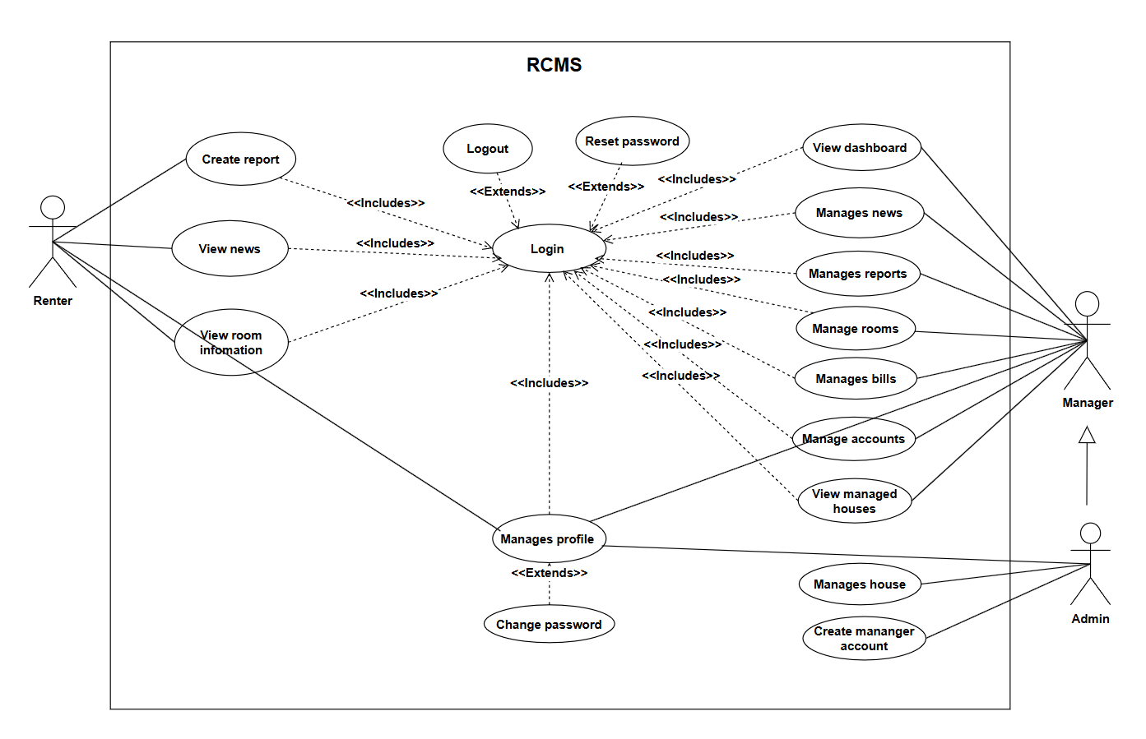
General use case diagram

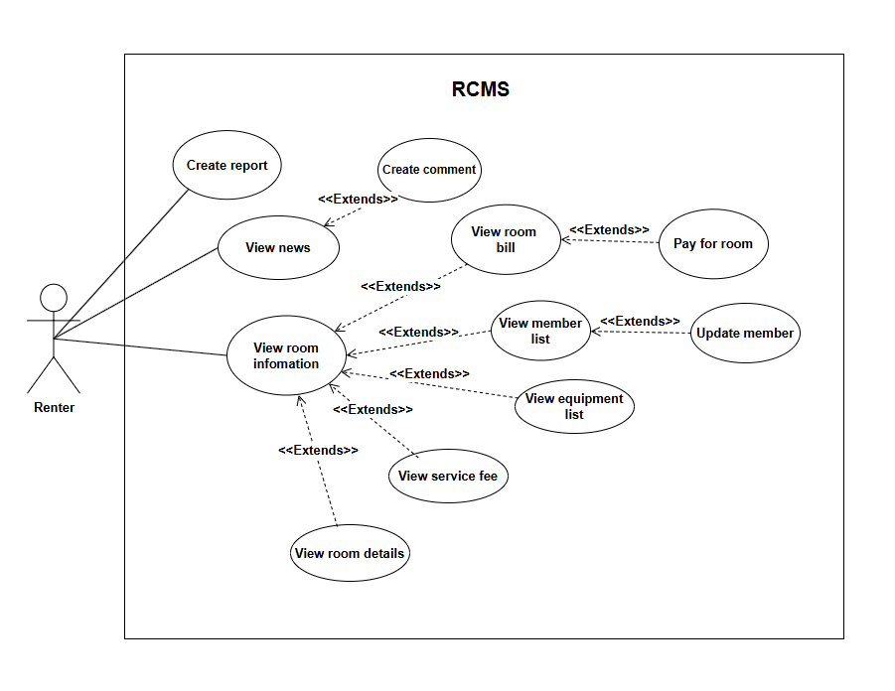
Detailed use case diagram for renter
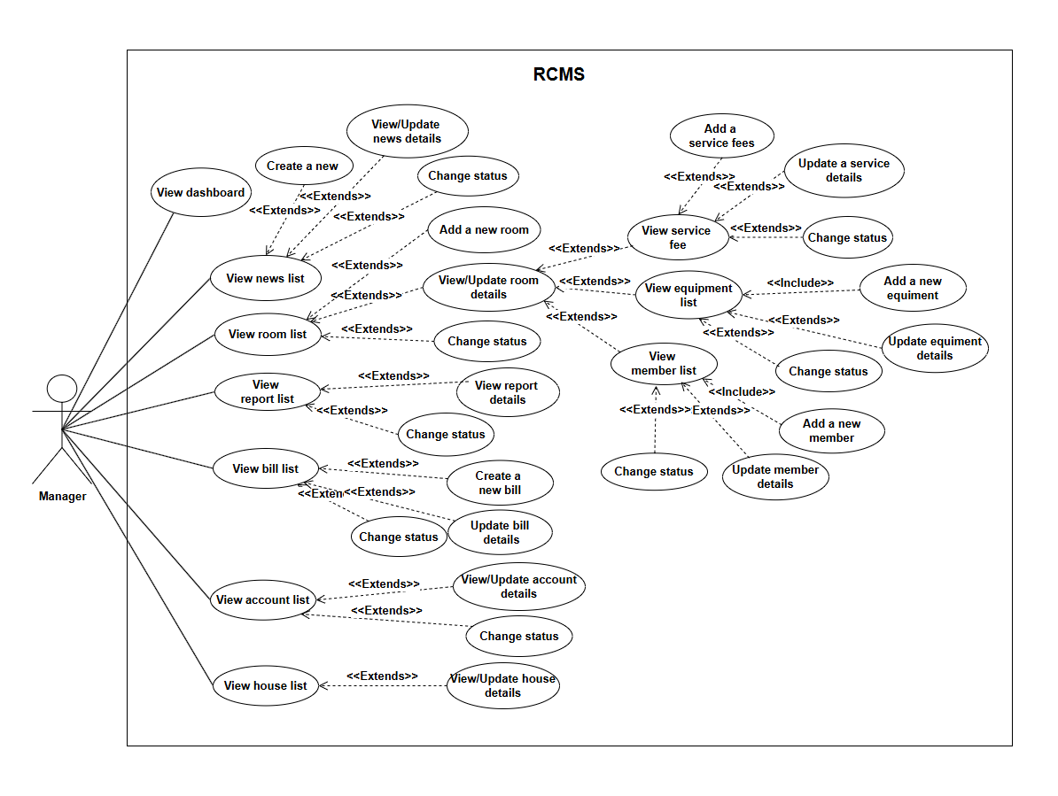
Detailed use case diagram for manager
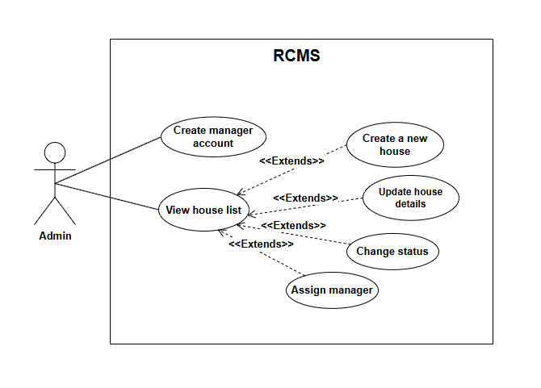

Detailed use case diagram for admin

