Cooperative Multi-UAVs system for Target Searching and Tracking

# Introduction

# Problem formulation

## The problem statement

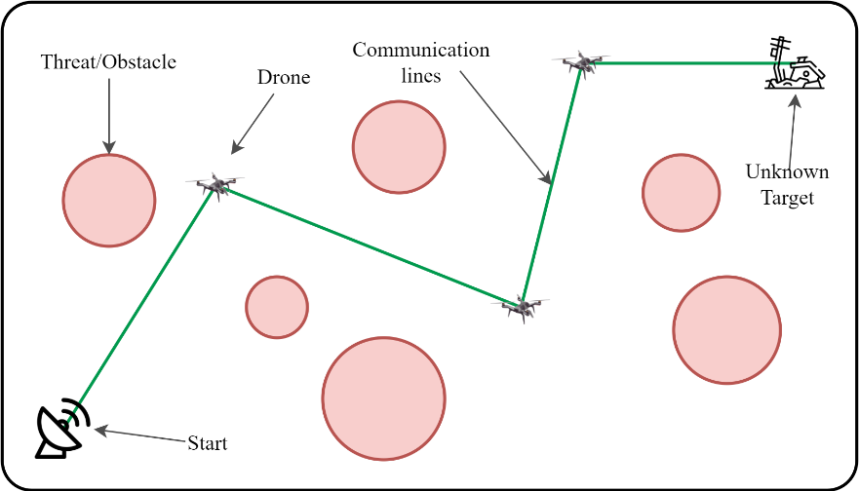

Figure . Illustrate the searching and tracking problem

## The UAVs representation

The model of a drone is shown in Fig.2. The drone is described by the virtual point with the position is $p=\left(x,y,z\right)$ and the heading angle $ψ$. The safe zone of the UAV is a circle with the radius is $r_{s}$. The communication zone and the observer zone of the UAV is the circle with the same radius $r_{c}$.

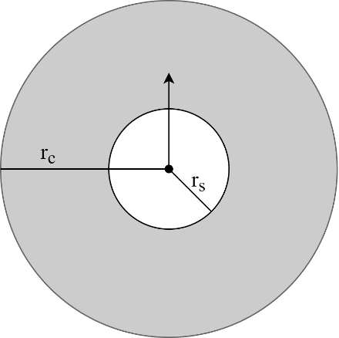

Figure . The drone representation

Assuming the drone moving in the space with $v=\left(v_{x},v_{y}, v_{z}\right)$, the sampling time is $T$. Thus, the position and heading of the UAV after each sampling time is updated as follow.

$$p\left(T+1\right)=p\left(T\right)+vT$$

$$ψ\left(T+1\right)=\tan^{-1}\left(\frac{v_{y}}{v_{x}}\right)$$

# SPSO-based Target Searching problem

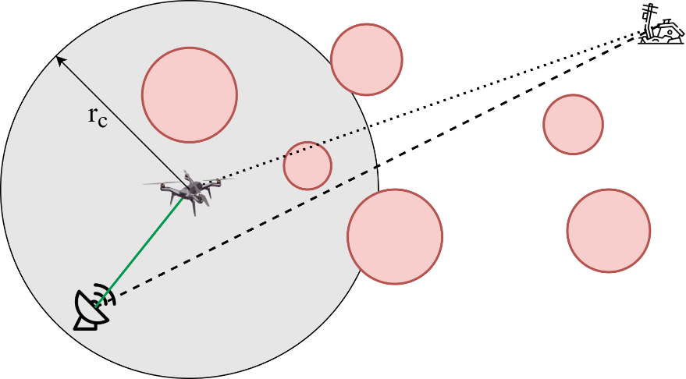

Figure . Search range of the UAV

Assume that the UAV can observe everything around and in range $r_{c}$, as shown in the Figure 3. To connect with another, each UAV must observe one UAV at least. There are some following optimal values and constraints.

## Cost functions

### The feasible route – line-of-sight route

The route of the UAV is the line-of-sight route to neighber UAV in the communication range. Therefore, the sponsored route needs to be no collision from any threats or obstacles.

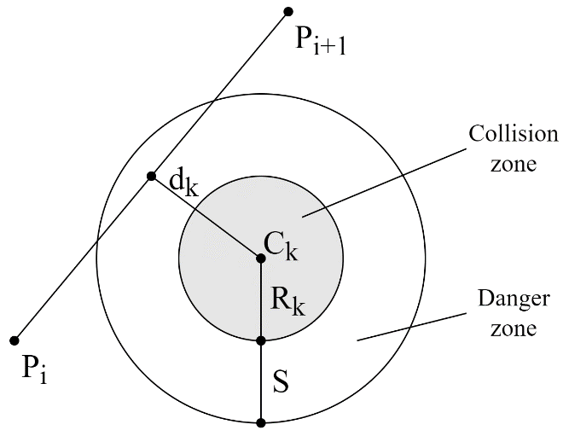

Figure . Determination of the threat cost

The quality of the communication signal cannot pass through the threats area/obstacles, and degrades as it gets closer to the threats. For a given route segment $\left\|\vec{P_{i}P_{i+1}}\right\|$, the associated threat cost is propotional to its distance, $d_{k}$, to $C_{k}$. By considering the danger distance, $S$, to the collision zone, the threat cost is computed across waypoints $P_{ij}$ for observable obstacle set $K$ as follows.

$$F_{1}=\sum_{i=1}^{n-1}{\sum_{k=1}^{K}{D_{k}\left(\vec{P_{i}P_{i+1}}\right)}}$$

$$D_{k}\left(\vec{P_{i}P_{i+1}}\right)=\left\{\begin{matrix}0 & d_{k}>S+R_{k} \\ S+R_{k}-d_{k} & R_{k}<d_{k}≤S+D_{k} \\ ∞ & d_{k}≤R_{k}\end{matrix}\right.$$

### Height cost

Let the minimum and maximum heights to be $h_{min}$ and $h_{max}$, respectively. The height cost corresponding to a waypoint $P_{i}$ is computed as.

$$F_{2}=\sum_{i=1}^{n}{H_{i}}$$

$$H_{i}=\left\{\begin{matrix}\left|h_{i}-\frac{h_{max}+h_{min}}{2}\right| & h_{min}≤h_{i}≤h_{max} \\ ∞ & otherwise\end{matrix}\right.$$

### Direction cost

Assume the ideal direction from the UAV to the target is known while the position of the target is unknown. Denote the angle from the UAV to the target is $α_{i}$. The direction from the UAV to the next UAV, $β_{i}$, need to close to the direction to the target, $α_{i}$. Thus, the cost function of the direction cost is proportional of the error angle and is defined as follow.

$$F_{3}=\left|β_{i}-α_{i}\right|$$

## Spherical vector-based particle swarm optimization (SPSO) for Searching

# Behavior-based Cooperative Multi-UAVs system for Target Tracking

The overall behavior conducted by an UAV is the combination of the several subbehaviors, i.e. moving to the goal, avoiding threats/obstacles, avoiding other drones. In pratical applications, each behavior of an UAV is represented by a vector that includes the magnitude and the direction. The weight of the vector can be change by adjusting the parameters. The behavior of an UAV is conducted by the detected information about the around environment. The overall behavior vector is the sum of all subbehavior vectors and decribed as follow.

$$v={\left[\begin{aligned}f_{m2g} \\ f_{ath} \\ f_{adr} \end{aligned}\right]}^{T}\left[\begin{aligned}v_{m2g} \\ v_{ath} \\ v_{adr}\end{aligned}\right]$$

where $v_{m2g}$, $v_{ath}$, $v_{adr}$ are the moving to goal, avoiding threats, avoiding drones, respectively; and $f_{m2g}$, $f_{ath}$, $f_{adr}$ are the controlling parameters of each behavior vectors, respectively.

## Behavior of moving to goal

The Fig.3 shows the behavior of moving to the goal. In the absence of obstacles in front of the drone, the drone will move to the target. In most occasions, the drone maintains the behavior of moving to the goal.

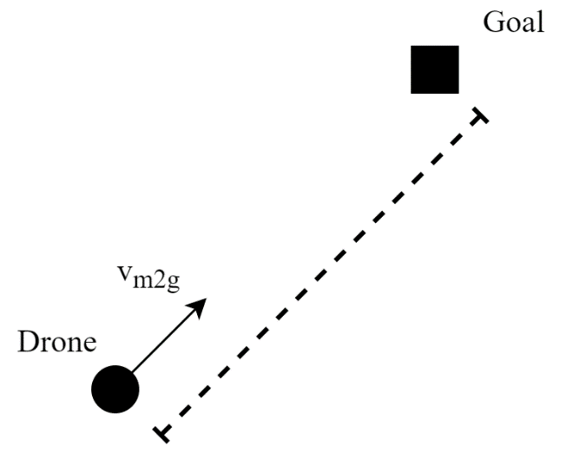

Figure . Moving to the goal

Assuming the current position of the drone is $\left(x,y,z\right)$ and the target position is $\left(x_{d},y_{d},z_{d}\right)$. The distance between drone and the target is given as follow.

$$d_{m2g}=\sqrt{{\left(x_{d}-x\right)}^{2}+{\left(y_{d}-y\right)}^{2}+{\left(z_{d}-z\right)}^{2}}$$

Thus, the behavior vector of moving to the goal is as follow.

$$v_{m2g}=\frac{1}{d_{m2g}}\left[\begin{aligned}x_{d}-x \\ y_{d}-y \\ z_{d}-z\end{aligned}\right]$$

The controlling parameter of this behavior is defined as.

$$f_{m2g}\left(d_{m2g}\right)=\left\{\begin{matrix}a_{m2g} & d_{m2g}≥b_{m2g} \\ a_{m2g}\frac{d_{m2g}}{b_{m2g}} & d_{m2g}<b_{m2g}\end{matrix}\right.$$

where $a_{m2g}$ and $b_{m2g}$ are the adjustable parameters.

## Behavior of avoiding Threats

When any threats is detected, the drone will perform the behavior of avoiding threats. To solve the deadlock cause by the moving backward, the direction of the movement is changed an angle of 90 degrees to the threats and the rotation direction is depended on the heading angle of the drone. The force of avoiding threats behavior will be enhanced when the robot is close to the threats. Fig.4 shows the behavior of the avoiding threats.

Assuming that the current position of the drone is $\left(x,y,z\right)$ and the current heading is $ψ$. The threats is considered as the cylinder with the position is $\left(x_{th},y_{th}\right)$ and the radius is $r_{th}$. Then the distance between the drone and the threat is given as

$$d_{ath}=\sqrt{{\left(x_{th}-x\right)}^{2}+{\left(y_{th}-y\right)}^{2}}-r_{th}-r_{s}$$

where $r_{s}$ is the safe radius of the drone.

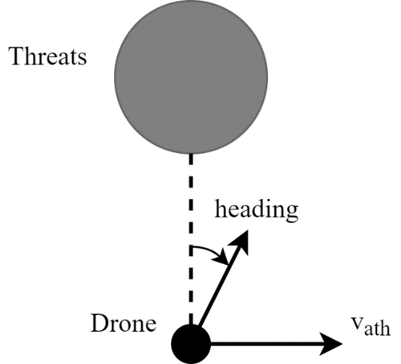

Figure . Avoiding the threats

Thus, the vector of avoiding threats is

$$v_{ath}=\frac{1}{d_{ath}}\left[\begin{aligned}x_{th}-x \\ y_{th}-y \\ 0\end{aligned}\right]$$

The rotation direction is defined as follow

$$ρ=-\operatorname{sign}\left(v_{xath}\sin{θ}-v_{yath}\cos{θ}\right)$$

where $v_{ath}={\left[v_{xath},v_{yath},0\right]}^{T}$ and

$$\operatorname{sign}\left(x\right)=\left\{\begin{matrix}1 & x>0 \\ -1 & x<0 \\ 0 & x=0\end{matrix}\right.$$

Therefore, the updated velocity avoiding threats is as follow

$$v_{ath}=v_{ath}\left[\begin{matrix}0 & -ρ & 0 \\ ρ & 0 & 0 \\ 0 & 0 & 1\end{matrix}\right]$$

The control parameter is set as

$$f_{ath}\left(d_{ath}\right)=\left\{\begin{matrix}0 & d_{ath}≥b_{ath} \\ a_{ath}\left(1-\frac{d_{ath}}{b_{ath}}\right) & d_{ath}<b_{ath}\end{matrix}\right.$$

where $a_{ath}$ and $b_{ath}$ are the adjustable parameters.

## Behavior of avoiding another drones

In order to prevent collision between drones, the behavior of avoiding drone will be performed when the drone is too close to another as shown in Fig.5. The movement direction of this behavior is opposite to the drone in front of it. The virtual force of the avoiding behavior will be enhanced when the drone moves close to another.

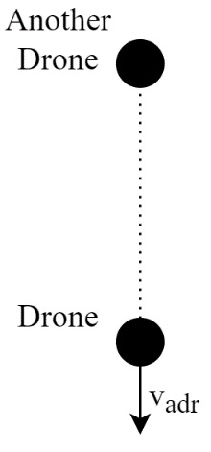

Figure . Avoiding another drone

Assuming that the current position of the drone is $\left(x,y,z\right)$ and another drone is $\left(x_{dr},y_{dr},z_{dr}\right)$. The distance between drone and another is given as follow.

$$d_{adr}=\sqrt{{\left(x_{dr}-x\right)}^{2}+{\left(y_{dr}-y\right)}^{2}+{\left(z_{dr}-z\right)}^{2}}$$

Thus, the behavior vector of avoiding drone is as follow.

$$v_{adr}=\frac{1}{d_{adr}}\left[\begin{aligned}x_{dr}-x \\ y_{dr}-y \\ z_{dr}-z\end{aligned}\right]$$

The controlling parameter of this behavior is defined as.

$$f_{adr}\left(d_{adr}\right)=\left\{\begin{matrix}0 & d_{adr}≥b_{adr} \\ a_{adr}\left(1-\frac{d_{adr}}{b_{adr}}\right) & d_{adr}<b_{adr}\end{matrix}\right.$$

where $a_{adr}$ and $b_{adr}$ are the adjustable parameters.

# Simulation and Discussion

# Conclusion