DGOP

System Design and Feature Structure

STATUS  Engineering Baseline |  | OWNER  DGOP Product & Engineering |  | LAST UPDATED  July 29, 2026

Authors | Codex, acting as senior software engineer documentation support
Reviewers | DGOP product, senior data governance, security, and engineering reviewers
Related docs | README.md; apps/api/prisma/schema.prisma; apps/web/src/app/app.routes.ts; apps/web/src/app/layout/navigation.ts; QA/ENTERPRISE_READINESS_0_43.md
Scope | Explains the DGOP monorepo structure, runtime architecture, feature engines, governance workflows, security model, and operational readiness gates.

1. Abstract
DGOP is an authenticated Data Governance Operations Platform that turns enterprise governance work into operational queues, governed records, workflow cases, evidence trails, and executive-readable dashboards. It is built as a local monorepo with an Angular web console, a NestJS API, Prisma-managed PostgreSQL persistence, and dedicated governance engines for ownership, workflow, data quality, security, compliance evidence, open data, FOI, privacy, data sharing, search, integrations, training, reporting, and release readiness.
The design prioritizes integrity and auditability. User actions enter through permission-aware Angular routes, pass through API authentication and authorization guards, run service-level validation and data-scope checks, then persist through transactional Prisma writes. Important actions can create workflow cases, audit events, search index changes, notifications, or evidence records before the UI refreshes the relevant work queue.

2. Goals and Non-Goals
Goals | Non-goals
Provide one operating console for governance, administration, access, workflow, quality, privacy, FOI, open data, and reporting work. | Replace every enterprise source system such as catalogs, DLP, PDP, LMS, risk tools, or the National Data Index.
Enforce enterprise integrity through JWT/CSRF protection, RBAC permissions, ABAC/data-scope checks, DTO validation, cross-field validation, and database constraints. | Treat demo seed data or local .env secrets as production data or production credentials.
Make complex governance actions understandable for nontechnical users through command-console pages, queues, detail panels, visual maps, bilingual copy, and light/dark support. | Create a public marketing site; DGOP is an authenticated operations workspace.
Keep governance evidence reconstructable through workflow cases, tasks, comments, attachments, audit logs, search events, notifications, and release QA gates. | Bypass approval rules, especially ownership accountability, workflow publication, security scope, or evidence readiness checks.

3. Background and Problem Statement
Enterprise data governance often fails when ownership, evidence, quality, privacy, access, and transparency work live in separate trackers. The result is unclear accountability, missing proof, late approvals, inconsistent role decisions, and dashboard views that do not show the operational reason behind a risk.
DGOP addresses that gap by making governance work executable. The platform links data assets to domains, subjects, classifications, systems, owners, workflow cases, NDI evidence, quality issues, security decisions, publication candidates, privacy records, sharing requests, and reports. Its boundary is the governance operations layer: it governs and integrates with specialist systems rather than trying to replace them.

4. Proposed Architecture
The repository is organized as a two-application monorepo. `apps/web` contains the Angular 22 frontend with standalone components, signals, route guards, shared UI tokens, i18n, and layout navigation. `apps/api` contains the NestJS 11 backend, REST controllers under `/api`, Prisma services, domain modules, global guards, business validation, audit writing, and built-UI serving. `apps/api/prisma` contains the schema, migrations, and seed process.
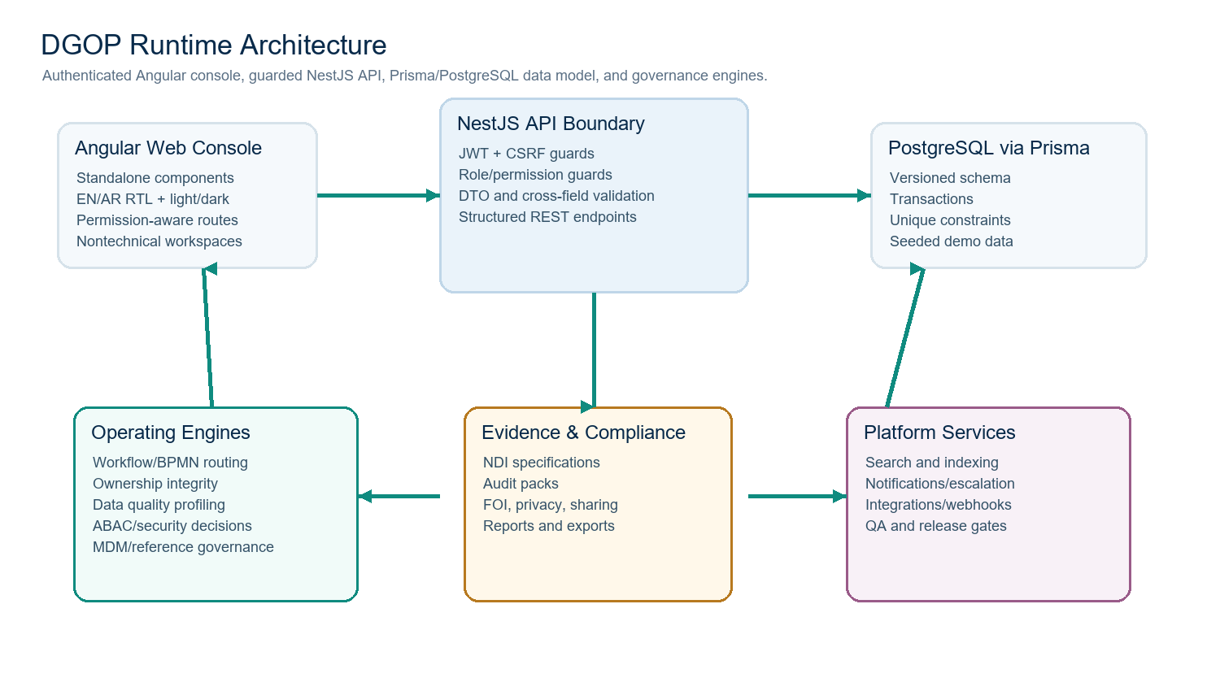
Figure 1. DGOP proposed runtime architecture.

Application layers
Layer | Responsibility | Implementation evidence | Primary failure behavior
Web console | Authenticated user experience, route protection, command-console pages, bilingual copy, theme state, visual maps, work queues, detail panels, modals, and expandable evidence panels. | Angular 22 app in apps/web; app.routes.ts; layout/navigation.ts; core i18n dictionary; page folders under governance/admin. | Route guards redirect unauthenticated users; permission guard blocks unauthorized pages; UI shows validation/error guidance instead of raw stack traces.
API boundary | Receives REST requests, authenticates sessions, validates payloads, enforces RBAC/permission/data-scope rules, and delegates to domain services. | NestJS AppModule with JwtAuthGuard, CsrfGuard, RolesGuard, PermissionsGuard; controllers under apps/api/src. | Fail closed for protected routes; validation returns user-facing errors; health endpoint remains separate.
Governance services | Own domain logic for workflow, ownership, data assets, quality, security, NDI, FOI, privacy, data sharing, open data, integrations, search, and reporting. | Domain service modules in apps/api/src and tests under apps/api/test. | Service methods reject out-of-scope or inconsistent writes and use transactions when multiple records must move together.
Persistence | Durable operational state, versioned models, constraints, migrations, seed data, audit records, search records, and event tables. | Prisma schema and migrations under apps/api/prisma. | Database constraints and transactions protect uniqueness, referential integrity, and replay safety.
Release and demo operations | Prepare demo secrets, generate Prisma client, seed data, run QA gates, build apps, serve production-style UI, and optionally publish through a temporary tunnel. | Root scripts: dev, build, start:demo, qa:release, publish:external. | Publishing aborts unless runtime safeguards and QA gates pass.

Feature and engine structure
Area | Main routes or endpoints | Feature responsibilities
Foundation | /dashboard, /about, /governance-map | Command center, product brief, governance map, shared visual language, shell search, language switching, theme switching, and navigation grouping.
Administration | /admin/* and master-data controllers | People, domains, data subjects, capabilities, org units, systems, classifications, role types, RACI templates, status values, integrations, trees, and reference setup.
Access management | /admin/users, /admin/roles, /admin/audit | Users, roles, permissions, role scopes, scope preview, access assignment, audit log, audit chain verification, and protected system role behavior.
Data assets and ownership | /assets, /governance/ownership, /governance/assignment-rules | Asset 360 registry, CSV import, relationships, ownership registry, assignment recommendations, primary-owner uniqueness, approval paths, conflicts, and exceptions.
Workflow engine | /governance/workflow and /api/workflow/* | Templates, BPMN designer, stage/transition validation, route preview, case/task runtime, decisions, comments, attachments, delegations, SLA templates, dashboard, graph, version diff, rollback, and migration preview.
NDI and evidence | /governance/ndi/* | NDI domains, specifications, evidence submission/review/revocation, readiness scoring, gap analysis, audit packs, export, and domain traceability.
Data quality | /governance/data-quality and /api/data-quality/* | Quality issue queue, profiling imports, CSV file profiling, rule lifecycle, scorecards, RCA records, SLA breaches, issue evidence, and workflow case creation.
Security governance | /governance/security and /api/security-governance/* | Role-data access maps, masking policies, access reviews, DLP incidents, classification requests, ABAC decision logs, decision simulation, and workflow backfill.
Transparency operations | /governance/open-data, /foi, /privacy, /data-sharing, /transparency | Open data candidate lifecycle, FOI request/review/disclosure/appeal, DPIA/DSR/breach/retention records, data sharing agreements, ODIAO cockpit, release readiness, and publication monitoring.
Platform services | /api/search, /api/integrations, /api/governance-operations | Permission-aware search, autocomplete, registry, saved searches, index changes, analytics, connectors, webhooks, reconciliation, notification templates, delivery plans, escalations, calendar templates, and production readiness signals.
Business and extended domains | /governance/business-value, /extended-domains | Business glossary, lineage, valuation, surveys, lifecycle decisions, BIAs, KPIs, MDM matching, golden records, reference data versions, metadata certifications, and architecture reviews.

5. Request Lifecycle
- A user opens the Angular console and authenticates through the login page. The shell then loads the signed-in profile, permissions, language, theme, and navigation model.
- Angular route guards check authentication and required permission keys before loading feature pages. Navigation only exposes pages the user can reasonably access.
- A page action calls an `/api` endpoint. The NestJS global guards authenticate the request, apply CSRF protection where relevant, check roles, and verify permission requirements.
- The domain service validates DTO shape, reference existence, cross-field rules, data-scope visibility, workflow prerequisites, and business constraints such as one approved accountable owner per target/responsibility.
- The service writes durable state through Prisma. Multi-record actions use transactions so workflow cases, tasks, evidence, audit events, status changes, and index events move together.
- The API returns normalized records or structured validation errors. The UI updates the queue/detail panel and presents nontechnical guidance when a governance rule blocks the action.
- Operational side effects, such as search indexing, notifications, workflow maintenance, audit verification, export, or external publishing, run through explicit endpoints and QA gates rather than hidden background assumptions.

6. API and Data Contracts

Primary data contracts
Contract | Type | Required | Description
AuthUser | JWT/session-derived identity | Yes | Carries user id, email, active roles, and permissions used by guards and service-level object checks.
Permission key | String code | Yes | Controls route and endpoint access, for example `workflow_tasks.view`, `roles.edit`, or `data_quality_issues.view`.
RoleDataScope / EffectiveScope | Prisma model and resolved service object | Yes for scoped users | Limits visible and writable assets, domains, org units, and classifications.
DataAsset | Prisma model | Yes for governed data | Core governed object linked to domain, organization, system, capability, classification, subjects, relationships, owners, quality, security, and evidence.
StewardshipAssignment | Prisma model | Yes for accountability | Connects a person and responsibility to an asset/domain/subject/capability with approval status, active flag, dates, and primary/proposed/backup semantics.
WorkflowTemplate/Stage/Transition | Prisma models plus BPMN XML | Yes for routed cases | Versioned route definition used by BPMN designer, validation, publishing, simulation, rollback, and active-case migration.
WorkflowCase/Task/Event | Prisma models | Yes for operations | Runtime case, task, decision, comment, attachment, SLA, and event data used to reconstruct governance execution.
Evidence and audit records | Prisma models and file metadata | Yes for compliance | Captures proof, review status, audit log entries, audit-chain verification, and export readiness.
SearchIndexRecord and SearchIndexChangeEvent | Prisma models | Optional but supported | Permission-aware search registry, index records, CDC-style change queue, saved search, and click analytics.
IntegrationEvent / ImportBatch | Prisma models | Optional by connector | External connector, webhook, import error, reconciliation, writeback, and catalog sync records.

Contract guarantees
- API routes stay stable around existing `/api` resources while services add stricter validation and scope checks behind the boundary.
- Business-critical writes use generated codes, UUIDs, transaction boundaries, audit events, and Prisma constraints so records can be reconstructed.
- Workflow templates retain version snapshots, model signatures, validation output, publish state, and migration previews before active cases are moved.
- Search, integration, notification, and audit side effects are represented as records or explicit endpoint actions so they are reviewable and replay-aware.
- The Prisma schema and migrations are the authoritative data contract for persistence; TypeScript DTOs are the request contract at the API boundary.

7. Consistency, Idempotency, and Replay
Scenario | Expected behavior | Reasoning
Duplicate ownership primary | The system rejects or safely demotes conflicting primary/accountable assignments depending on approved workflow semantics. | A migration-backed uniqueness model and service validation prevent multiple active approved accountable owners for the same target/responsibility.
Duplicate role-data access map | The API rejects duplicate active access mappings with the same role and scope key. | The scope key and unique constraints protect ABAC integrity and avoid ambiguous data access decisions.
Workflow route replay or rollback | A route can be saved, validated, published, diffed, rolled back, and migration-previewed before active cases are moved. | Version snapshots preserve the executable model used by cases and support reconstruction.
CSV import or profiling run | Bad files fail with structured validation; valid rows create database-backed profile/issue/rule records rather than sample-only UI state. | The data quality engine parses and writes records through scoped service logic.
External connector event retry | Events and batches retain status, errors, reconciliation, and retry endpoints. | Integration work is observable and can be retried without hiding failure state.
Search index refresh | Index changes can be queued, processed, refreshed, and linked to analytics events. | Index state is not treated as the only source of truth; source records remain authoritative.

8. Security and Privacy Considerations
- The API installs global guards in order: JWT authentication, CSRF protection, role checks, then permission checks.
- Role and data-scope services enforce object visibility and write permissions across assets, data quality, workflow, security governance, and search.
- Demo publication requires non-placeholder `JWT_SECRET`, seeded passwords, webhook token, production demo safeguards, and health detail redaction.
- Evidence storage is configurable through `EVIDENCE_STORAGE_DIR` and file size limits; production should replace local storage with secure object storage.
- Audit fail-closed behavior is configurable through `DGOP_AUDIT_FAIL_CLOSED`; sensitive values should stay out of committed files and logs.
- Privacy and security workspaces track DSR, DPIA, breach, retention, masking, classification, DLP, and access-review records instead of relying on informal notes.
- The current architecture supports enterprise controls but still requires production SSO, managed secrets, monitored hosting, backup/restore, and formal data-residency decisions before real regulated data.

9. Operational Readiness
Signal | SLO or alert | Owner | Launch gate
API health | GET `/api/health` reports service state; production-like demo mode redacts detailed metadata. | Platform engineering | Required
Build health | `npm run build` must build web and API without TypeScript or Angular failures. | Engineering | Required
Prisma health | `npm run db:generate`, `db:status`, and migrations must agree with the target database. | Backend engineering | Required
API quality | `npm --prefix apps/api run test` covers service behavior across auth, access, workflow, ownership, assets, NDI, DQ, security, integrations, FOI, privacy, sharing, reports, search, and dashboard. | Backend engineering | Required
Web quality | `npm run qa:web` and Angular build check routes, i18n, theme/RTL assumptions, and static UX hazards. | Frontend engineering | Required
UI smoke | `npm run qa:ui` logs in and opens key routes against a running app. | QA / release owner | Required for demo
Release gate | `npm run qa:release` combines QA, Prisma, dependency audit, whitespace checks, and build before external publish. | Release owner | Required
External publish | `npm run publish:external` exposes the local app only after release safeguards pass. | Demo owner | Recommended for temporary demos only

10. Alternatives Considered
Alternative | Why it was considered | Why it was not selected
Spreadsheet or document tracker | Fast to start and familiar to governance teams. | Cannot enforce object-level authorization, workflow decisions, audit chains, cross-field validation, or evidence reconstruction.
Separate tools for catalog, workflow, quality, privacy, and access | Each specialist tool may be stronger in its own vertical. | Leaves senior users with fragmented accountability and no single operational map of governance work.
Generic BPM-only workflow product | Could handle some routed approvals quickly. | Does not naturally understand data assets, ownership integrity, NDI evidence, quality issues, ABAC scope, privacy, FOI, and data sharing records.
Public landing-page first product | Could make DGOP easier to pitch externally. | The current priority is an authenticated operations platform for steward, admin, and executive work.
Search engine as the only query layer | OpenSearch or Elasticsearch can provide advanced indexing and ranking. | The database remains the source of truth; search is valuable as an index and discovery layer, not as governance authority.

11. Open Questions
- Which production hosting model will be approved: on-premises, private cloud, managed cloud, or hybrid?
- Which identity provider should become the system of record for authentication and role provisioning?
- Which external enterprise systems are first-class connector priorities: catalog, DQ, DLP, PDP, LMS, NDI, risk, ticketing, or data portal?
- Where should evidence files, workflow attachments, audit exports, and backups live for regulated production use?
- What observability platform will receive logs, metrics, traces, security events, and uptime alerts?
- Which workflow route families require formal UAT before the platform is exposed to real governance data?

12. Decision and Next Steps
The recommended decision is to treat DGOP as the enterprise governance operations layer: it should govern the work, preserve accountability, orchestrate evidence, and integrate with specialized systems rather than replace every system of record. The codebase already reflects that approach through dedicated backend modules, guarded API boundaries, Angular command-console workspaces, schema-backed engines, and QA/release scripts.
Milestone | Deliverable | Exit criteria
M1 | Architecture baseline and demo stabilization | Build passes, login works, core routes smoke-test, and this system-design document is accepted as the engineering baseline.
M2 | Workflow and validation UAT | Workflow designer/runtime, assignment integrity, DQ, security, FOI, privacy, sharing, and open-data scenarios pass role-specific tests.
M3 | Production hardening | SSO, managed secrets, object storage, backups, monitoring, audit retention, HTTPS hosting, and data residency decisions are implemented.
M4 | Enterprise connector rollout | Approved connectors run with reconciliation, retry, writeback logs, webhook tokens, and clear operational ownership.
M5 | Pilot governance rollout | One or two domains use DGOP for real steward work with severity thresholds, rollback plan, and executive review cadence.

Use footnotes for definitions, assumptions, or terms that need precision without interrupting the main narrative.

