Nama: Gandi Napoleon Putra
NIM: 2702236250

Soal
Case

Asphatl 9: ReJends
Asphatl 9: Rejends, an enthralling racing game, delivers an extraordinary racing experience with stunning graphics and exhilarating gameplay. Developed by Gamefolt and RJStudio, this game propels players into an adrenaline-fueled world with a collection of luxurious cars and spectacular racing tracks. Serving as a sequel to the renowned Asphatl series, Asphatl 9 takes arcade-style racing to the next level with innovative features such as Shockwave, Barrel Roll, and Nitro Pulse.
Utilizing cutting-edge graphic technology, players are invited to explore an open world of racing with a variety of dream cars from well-known manufacturers. Each race serves as a stage for epic action, where high speeds and acrobatic maneuvers are key to claiming victory. Furthermore, the online multiplayer mode allows players to compete globally, showcasing their skills and building an exciting racing community.
For information purposes, Gamefolt and RJstudio hires you as a front-end developer to create a website. First Asphatl 9: Rejends need to create a website prototype then a website that represents the game and company image. As the website is ready, Gamefolt hopes the community will grow bigger and any information can be shown easily. Below are the requirements you need to fulfill.

1. Gamefolt and RJstudio want you to design the website prototype of all five pages before making the HTML files. The website prototype will be created using Figma. Ensure the website prototype that you created is intentionally different from the website that you will make later, even if the themes are the same. Each page will contain header, navigation, content, and footer as its structure. Consider the color, layout, and consistency when designing the prototype.

2. Gamefolt and RJstudio want you to build the website attractive, appealing, fully functional, and make sure the website is responsive. The website should be accessible using a mobile phone in a perfect way. To achieve that, use 5 kinds of CSS property and JavaScript. Use meta viewport tag and media screen rule that will be applied if the screen is below 768px screen width.

3. The website consists of five main pages. They are Home Page, Gallery Page, News Page, Esport Event Page, and Subscribtion Page. Below are the requirements for each page:
· Home Page
This page shows the overview and common information of Asphatl 9: Rejens game. This information can be about the gameplay.
· Products Page
This page shows a gallery of cars available in the game. There are five classes of the car from S Class down to D Class. Show 4 cars for each class. Make sure to provide the car’s name, and the image. You can refer to the Asphatl 9 cars database for the information.
· News Page
This page shows a list of news published by Gamefolt and RJStudio about the Asphatl 9: Rejends game. Make sure to provide image, news title, published date, and read duration for each news.
· Esport Event Page
This page provides information about Asphatl 9: Rejends Esport Event held by Gamefolt and RJStudio. Shows esport trailer video in the first section, then information like number of events that have been held, number of participants, prizes pool, and total races. Also show some sponsors supporting the event.
· Subscription Page
This page provides a subscription form for those who want to be content creator and viewer. Registrant needs to submit some personal information, such as name, email, date of birth, gender, and agree to terms and conditions. You are asked to create five kinds of form components and five kinds of validation. For validation, you must create it using JavaScript and not use regular expression.

Guidelines:
a. Design your website by observing the principles of human and computer interaction. Set up your site as creative as possible but still strive for consistency.
b. The website prototype must be designed using Figma and make sure to create some features, such as color and text style, effect, component, variant or interactive component, and navigation.
c. Consider the color, font, size, and layout that you use to design the prototype and website.
d. Use only external CSS. Internal or inline CSS will not be marked.
e. Use CSS box positioning to design your web structure, do not use table for the layout.
f. Consider the language you use, including spelling and grammar, feel free to choose either Bahasa or English, but you cannot have both at the same time.
g. Make your website responsive so it can deliver in any size, particularly for desktops, tablets, and mobile devices.
h. Any kinds of framework are prohibited. Do the project with vanilla (original) HTML, CSS, and JavaScript.
i. Organize your files with subdirectories.
j. Include references (link from a website, book, etc) that you use in creating the website.

figma design:

https://www.figma.com/design/AaRE9FCkOfulackoKDtHnk/Untitled?node-id=0-1&t=YArAv75V9TxK9uEc-1

prototype:

https://www.figma.com/proto/AaRE9FCkOfulackoKDtHnk/Untitled?node-id=0-1&t=YArAv75V9TxK9uEc-1

Pada proyek Figma, saya memanfaatkan beberapa halaman dari template yang telah diunggah oleh pengguna lain. Saya melakukan modifikasi pada teks, gambar, dan warna, contohnya pada bagian berita dan esport.

Untuk bagian galeri, saya mengambil gambar langsung dari database game Asphalt 9. Namun, untuk komponen dan prototype, saya membuatnya sendiri tanpa menggunakan referensi.

Dalam pembuatan HTML, saya banyak merujuk pada referensi dari website yang telah dibuat oleh orang lain. Misalnya, untuk bagian esport, saya melihat langsung dari acara esport Asphalt 9 Porsche yang diadakan pada tahun 2023. Berikut adalah referensinya:
[Esport](https://en.idcgames.com/asphalt-9-legends/news/porsche-asphalt-series-2023-2023-04-18-11-00-6867).

untuk bagian homepage:
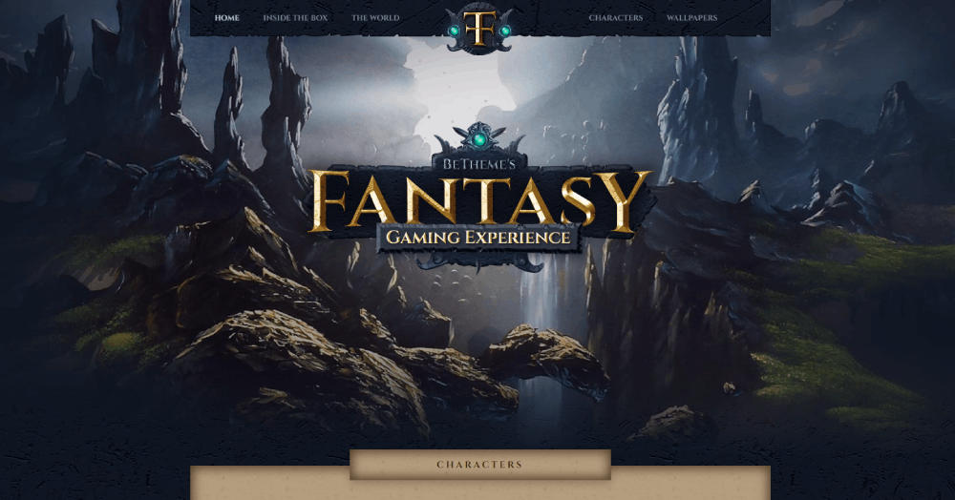

Untuk halaman galeri, saya mengalami kesulitan dalam desain sehingga saya menggunakan desain yang sederhana dengan mengikuti referensi dari desain di Figma.

Untuk halaman subscribe, saya menggunakan desain halaman login pada umumnya. Pada halaman ini, sebetulnya lebih seperti pop-up. Saat tombol di homepage ditekan, maka pop-up akan muncul di homepage. Namun, saat tombol di news atau esport ditekan, pengguna akan dibawa ke halaman subscribe. Saya tidak yakin apakah diperbolehkan hanya menggunakan pop-up karena dalam dokumentasi disebutkan harus ada 5 halaman.

Dalam desain Figma, saya lebih mendesain seperti game karena awalnya saya berpikir untuk membuat game. Namun, saya menyadari bahwa yang diminta adalah membuat website. Oleh karena itu, HTML lebih saya desain seperti website game.dibanding desain dalam figma

