

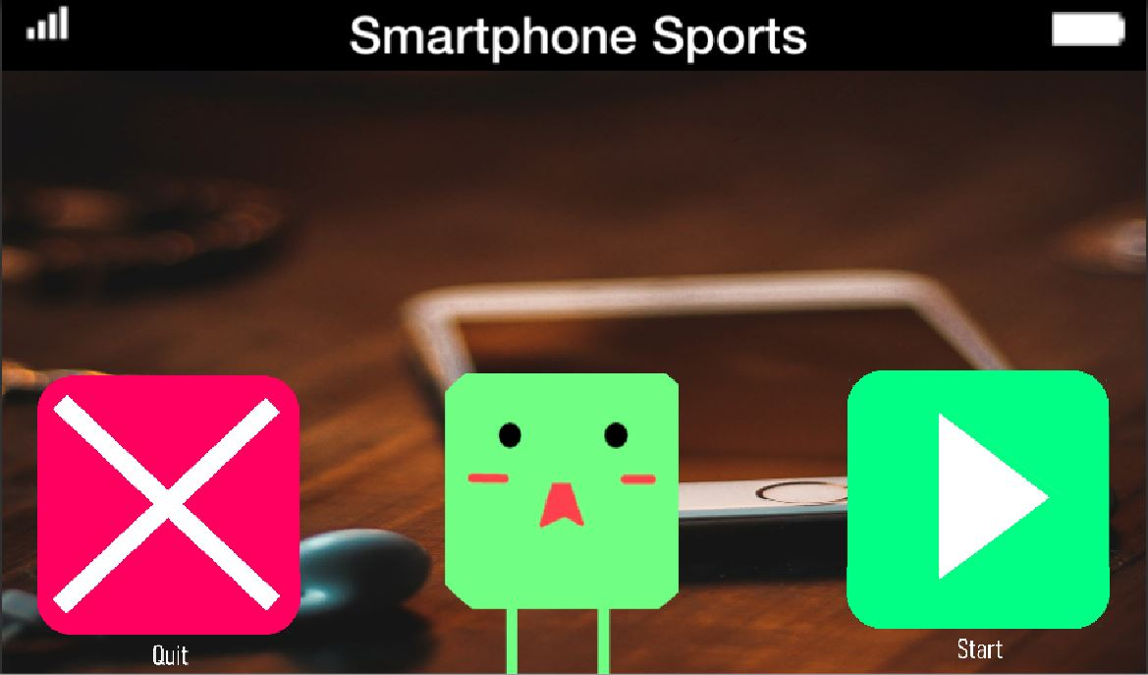

**SMARTPHONE SPORTS ALPHA REPORT**

**BUGS** (Prioritized **A** (game breaking) **B** (gameplay difficult) **C** (does not affect gameplay)):

B:

1. Movement does not stop immediately when initiating dialogue
2. Player must reenter collider when it becomes a warp gate

C:

1. Animation continues during dialogue
2. After Dialogue Display name doesn’t change back
3. Need to create softer screen transitions

GAMEPLAY ISSUES (Prioritized **A** (game breaking) **B** (gameplay difficult) **C** (does not affect gameplay)):

A:

1. Need to in cooperate remaining scenes or loop to beginning

B:

1. Need to balance car difficulty
2. Need to reposition trash (Add a reset button)

C:

1. Need to add sound effects for objects
   1. Cars
   2. Player Death
2. Make text UI more intuitive