

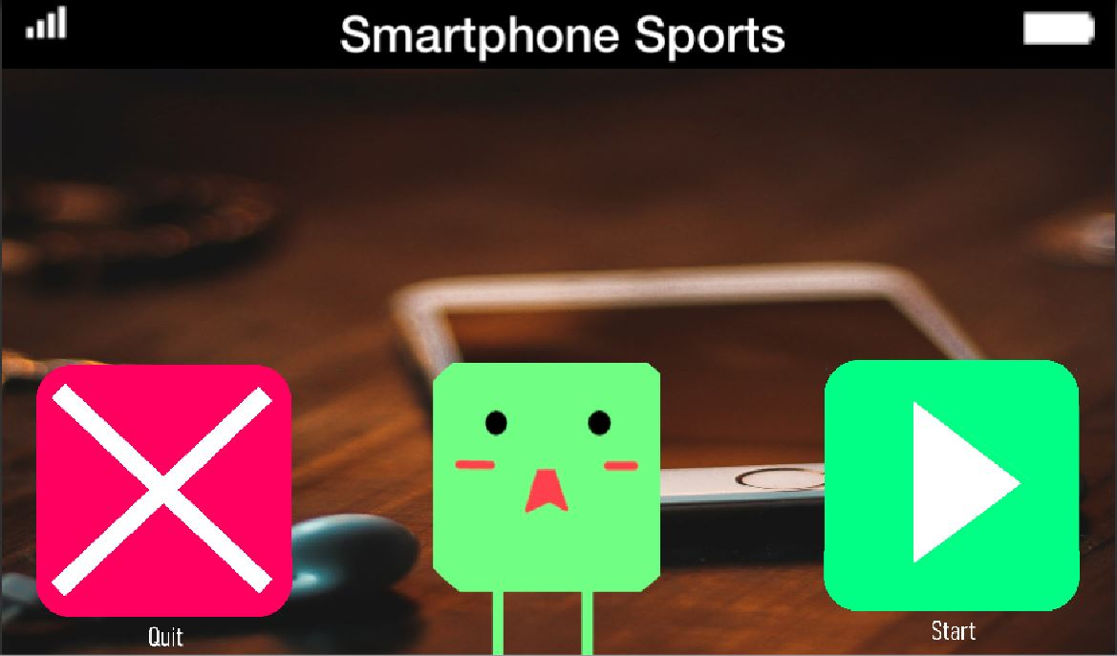

**SMARTPHONE SPORTS BETA REPORT**

**BUGS** (Prioritized **A** (game breaking) **B** (gameplay difficult) **C** (does not affect gameplay)):

B:

1. Create a change scene function after dialogues (fixes needing to enter colliders after they change to warp gates) (player will not have to wait in plane section anymore)

GAMEPLAY ISSUES (Prioritized **A** (game breaking) **B** (gameplay difficult) **C** (does not affect gameplay)):

B:

1. Need to adjust and teach gyro controls

C:

1. Need to add sound effects for objects
   1. Cars
   2. Player Death
2. Improve Messaging
   1. Make text UI more intuitive
   2. Teach user to tap on characters to talk to them
   3. Need to create softer screen transitions (Death screen or animation)