**Smartphone Sports**

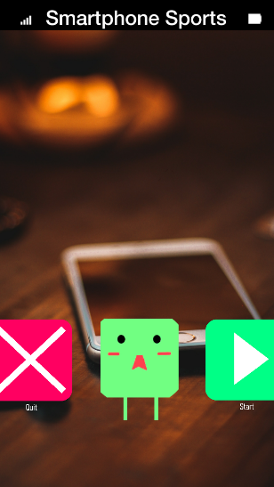

*Game Design Document (GDD)*

## Game Identity / Mantra:

A game made to celebrate the smartphone.

Play as Appy and discover your true potential and master the sacred art of Smartphone Sports.

Will never receive controller support or console release.

Play while you still have a smartphone.

## Design Pillars:

Action-Packed, Recurring Mechanics

## Genre/Story/Mechanics:

Start as a terrible athlete who will one day master the secret art of Smartphone Sports!

You may get to ***tap***, ***drag***, ***move***, ***shake,*** ***steer***, ***rotate***, or even ***shout!***

## Features:

**5 Game Acts (All share the same controls)**

**Act 1: Running out of Battery**

* 100m hurdles
* Learn how to move (tapping) and limitations (You can’t jump hurdles so you push them)

**Act 2: No Service**

* Meet a wise Smartphone sport master and do busy work
  + Pushing trash (learned from Act 1)
  + Introduces Dialogues for the game are handled via “notifications” from the top
  + Going to the grocery store (finessing movement *dodge cars)
    - Introduces gags, such as waiting for a download
  + Making a “Shake” (teaches player gyro)

**Act 3: Airplane Mode**

* Plane is crashing because you are playing on a phone (High Stakes “Climax”)
  + You are ridiculed for forgetting to turn off your phone
  + Free fall/ snowboarding (gyro learned from Act 2)

**Act 4: Enter Passcode**

* Heist mission
  + You have an ally who will help you get into the building
  + Slower paced, but also climactic
  + Incorporates electronic corruption and asks for a passcode

**Act 5: Skip Ad**

* Starts by running for your life at the end of Heist Mission
  + Ends with the same 100 m hurdles track from the beginning
  + You start slowing down, you are told above that it is pointless to run
  + You find yourself at the beginning of the game

## Interface:

Uses features of a smartphone: Focusing on touch and gyro input

## Art Style:

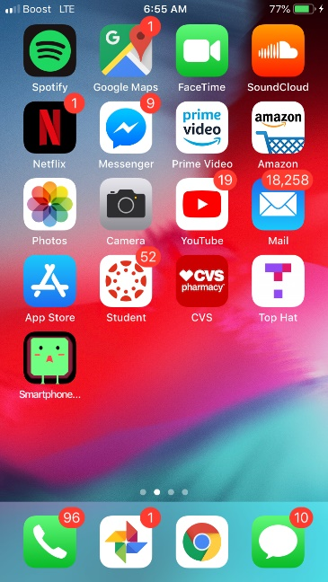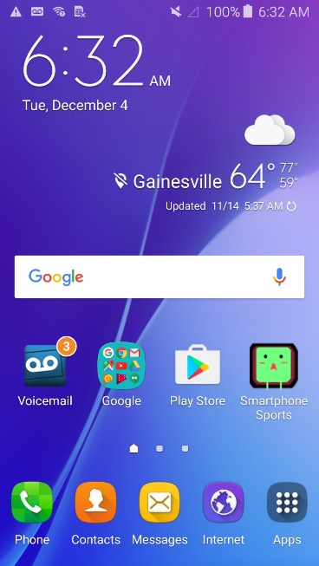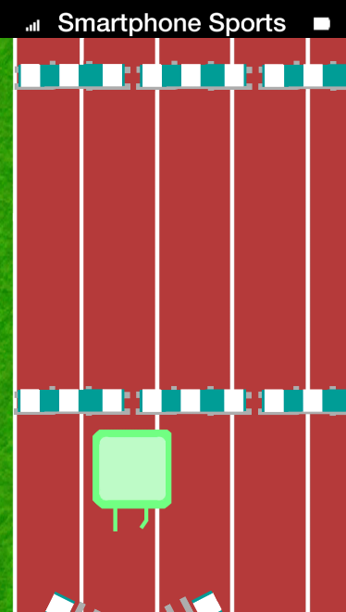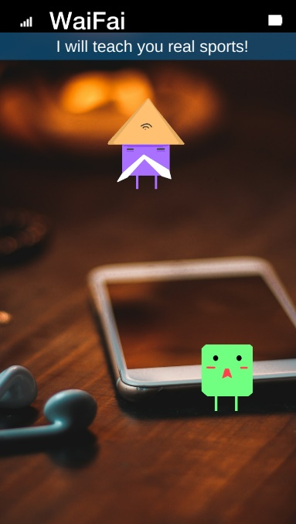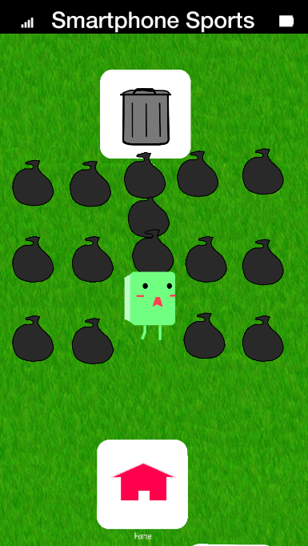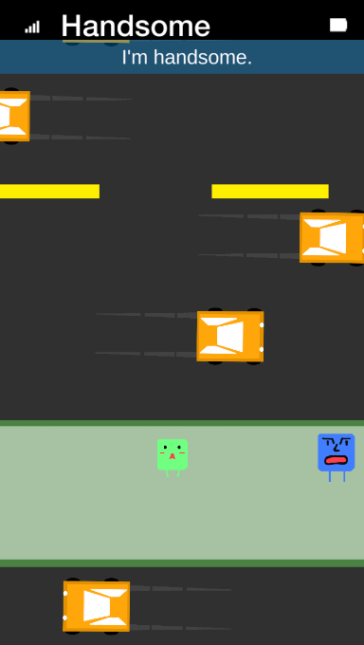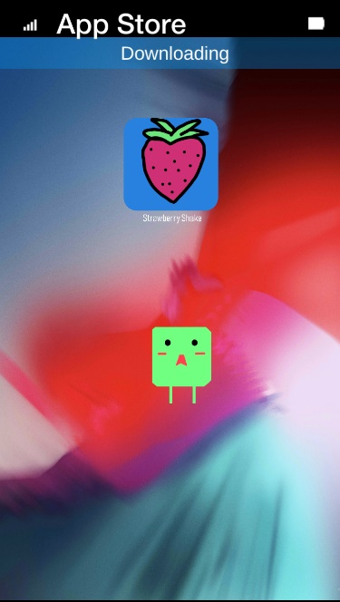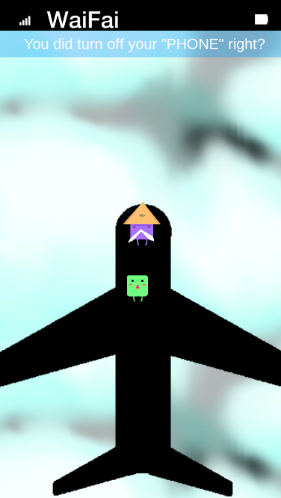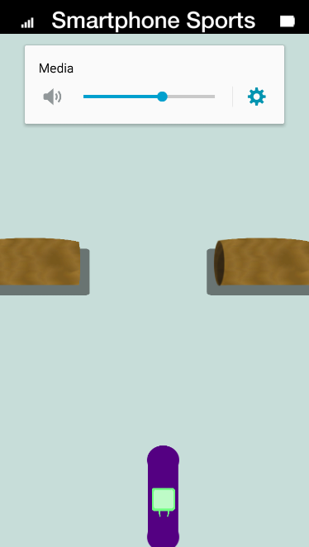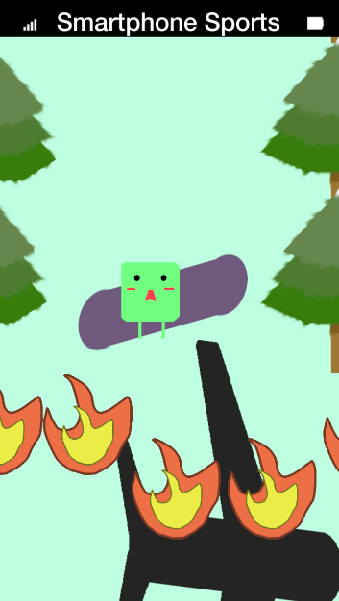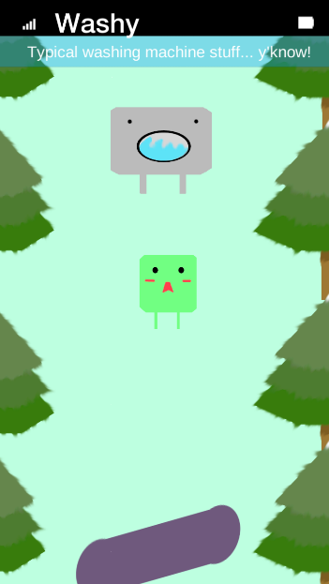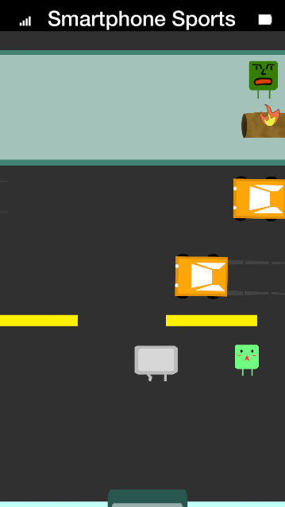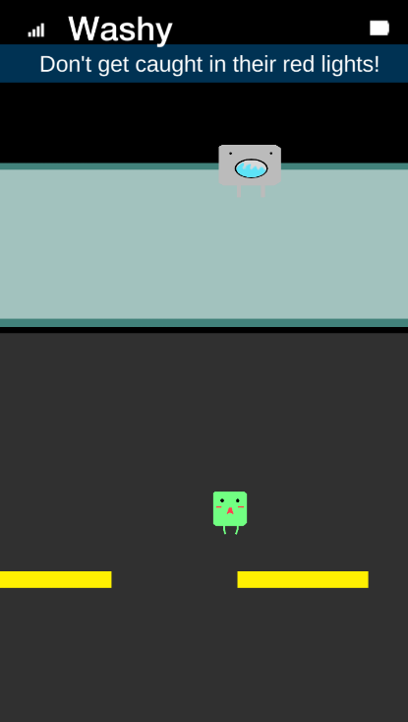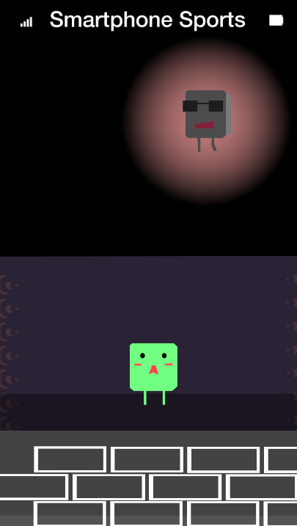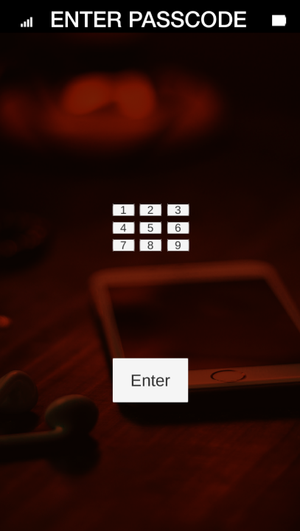

Every character looks like a smartphone app!

Characters are simplistic with simple colors (Facebook, Twitter, Snapchat, etc.)

All art was created except for the grass (CC0) and the phone wallpapers.

Art partially inspired by Keyboard Sports <http://keyboardsports.com/>

## Audio: (All open source CC0)

Inspired By: <http://keyboardsports.com/>

From: <http://opengameart.com/>

## Development Roadmap:

**Platform:** Android, iOS, (Windows Beta Only) **Audience:** Everyone

|  |  |
| --- | --- |
| **Milestone 1:** Pre-production - 9/4/18  **Milestone 2:** Mechanics complete - 10/2/18  **Milestone 3:** Levels complete - 10/23/18 | **Milestone 4:** Polish complete - 11/29/18  ---------------------------  **Launch Day:** 12/5/18 |