A Comprehensive Analysis of Oyster Classification Using YOLOv8 for Object Detection in Marine Environments
Nicholas Corcoran
Department of Computer Science
Salisbury University
Salisbury, MD
ncorcoran1@gulls.salisbury.edu

Enyue Lu
Department of Computer Science
Salisbury University
Salisbury, MD
ealu@salisbury.edu

Yunwei Jin
Department of Engineering and Aviation Sciences
University of Maryland Eastern Shore Princess Anne, MD
yjin@umes.edu

In this work, the use of YOLOv8 (You Only Look Once) models was explored for the classification of oysters into three distinct categories: “Oyster-Closed,” “Oyster-Open,” and “Oyster-Indeterminate.” Three models of various sizes were trained (YOLOv8n, YOLOv8s, YOLOv8m), all of which outperformed existing models in terms of test metrics. Unlike previous researchers [5], who opted for a dual-path YOLOv10 approach—allowing for classification under ideal viewing conditions and basic identification under poor conditions—this study focused primarily on improving performance in less-than-ideal underwater conditions.
Previously, a large number of “Oyster-Indeterminate” classifications (~13,000) dominated the training data compared to the other two classes (~5,000 each). Efforts to reduce this imbalance, including dataset rebalancing and image augmentation (e.g., partial blurring, grayscale), led to significant performance improvements across all YOLOv8 variants.

Keywords—YOLOv8, Aquaculture, Computer Vision, Machine Learning

Introduction
Accurate oyster classification is critical for automation in aquaculture and quality control. Computer vision and machine learning are highly effective tools for observing and classifying underwater environments without requiring human presence. While not a complete replacement for human observation, a properly trained model can provide immediate classification of oyster states and, by extension, insight into their health and behavior.
In prior work [5], a dual-path YOLOv10 model was trained to handle both ideal and suboptimal viewing conditions, accommodating a variety of underwater images and videos. While effective under controlled conditions, this model suffered from misclassification—particularly an over-reliance on the “Oyster-Indeterminate” class.
This study introduces a streamlined alternative using YOLOv8, a slightly older but highly optimized object detection framework. Results show that, when supported by proper data augmentation and class balancing, YOLOv8 outperforms YOLOv10 models in oyster classification tasks [16]. This emphasizes that newer models are not always superior and underscores the importance of task-specific evaluation and training.
To support deployment on devices with varying computational resources, three YOLOv8 model sizes were trained: YOLOv8n (Nano), YOLOv8s (Small), and YOLOv8m (Medium). This flexible architecture enables real-time performance even on low-power devices or cloud-based systems.

Experiments and Results
The dateset used in prior research is a large collection of annotated images depicting oysters in various environments, many of which are in less than ideal viewing conditions. Upon training an initial test model, it was observed that the model, in independent testing, performed poorly and labeled the majority of images (save those that were glaringly obvious) as “Oyster-Indeterminate”. Upon inspecting the class data on the Roboflow.com website, where it was sourced from, it was found that previously mentioned skewed class distribution (~13,000:5,000) existed. Several actions were taken to correct this and provide more promising training data. First, all images in the training datadset that contained only “Oyster-Indeterminate” classifications were removed entirely, followed by several that were primarily indeterminate. These sets of images served no purpose in improving classification accuracy, and in testing smaller models on this new dataset, noticeable improvements were seen, even in absence of further refinement of the dataset and training process. Secondly, the dataset was agumented in order to increase its size and improve its variability. Images were resized to 640x640, and a Gaussian blur of up to 1.2px was added to simulate underwater conditions and improve model robustness in low-visibility scenarios.

The following table presents the Precision, Recall, and Mean Average Precision (mAP) scores for the three trained YOLOv8 models:

Comparison of final YOLOv8 Models:
Run Name Precision Recall mAP@0.5 mAP@0.5:0.95
YOLOv8m 0.865 0.871 0.902 0.701
YOLOv8s 0.860 0.863 0.899 0.675
YOLOv8n 0.898 0.780 0.894 0.663
Notably, the metrics are very close across all three models, especially in terms off mAP@0.5, where the difference between the highest and lowest score is only 0.008. This suggests that, while increased model complexity offers modest gains, diminishing returns may occur beyond a certain point – likely due to limitations in dataset quality. Despite this, all three models numerically outperform those from prior research, validating the effectiveness of the newly balanced dataset and image augmentations. Below are the Confusion Matrices for YOLOv8 Nano, Small, and Medium models, respectively

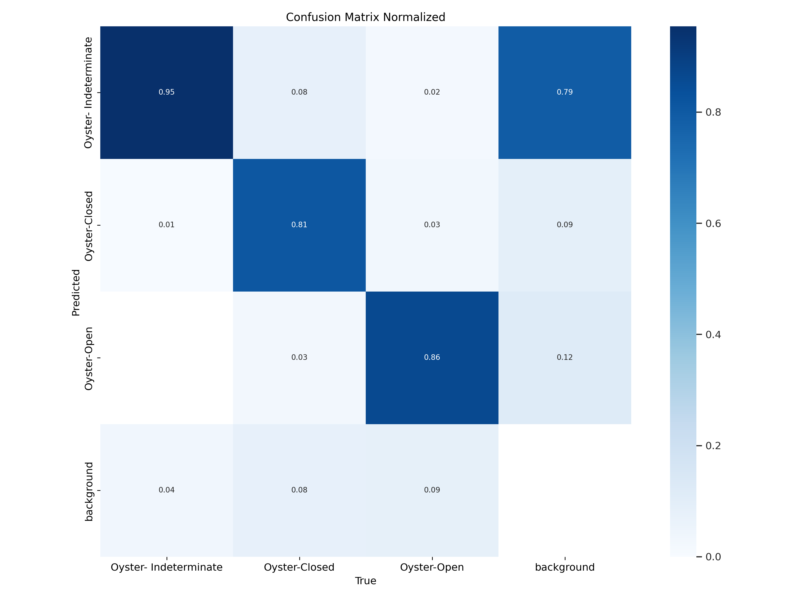Figure 1: YOLOv8n - Nano
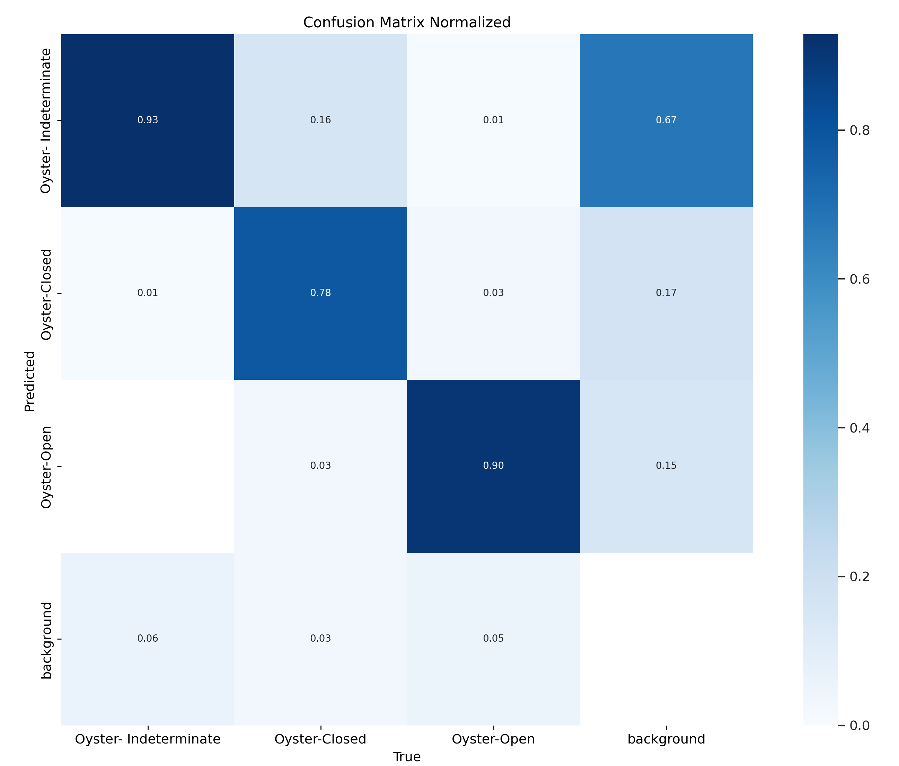Figure 2: YOLOv8s - Small

As can be seen in the confusion matrices, the models perform very well, however the performance across models is very similar, indicating a bottleneck in performance that is likely caused by a non-ideally fit dataset for this specific application
Figure 3: YOLOv8m - Medium
Note that completely re-annotating the dataset and adding clearer images, as suggested in the previous research paper, was considered and would likely have led to better results. However, due to the time constraints of this particular research opportunity, more effort was placed in refining what already existed and the code by which the models were trained. Further researchers are advised to, at least partially, re-annotate the dataset, in hopes of producing better results.

Conclusion
This research demonstrated that YOLOv8-based models, when trained with targeted data augmentation and class balancing, can serve as effective classification models, and even outperform their newer counterparts, in underwater image recognition of oysers under challenging viewing conditions. The modesl showed minor differences in precision and recall between the Nano, Small, and Mdedium Vrsions.
While the results of this study, done on an expedited time-frame and without funding, are promising, there are several areas for improvement. Future work should explore the training of larger models (e.g., YOLOv8l, YOLOv8x), advanced feature selection to improve computational efficiency, and the partial or full realnnotation of the dataset to better capture the true class values depicted in the dataset. Real-time testig in underwater enviroments would also help assess the practical deployability of these models.
This study highlights the importance proper data preparation while also shining light on the promising nature inherent to using machine learning for underwater image detection.

Acknowledgment
Many thanks are owed to Dr. Lu and Dr. Jin, for facilitating this brief, but effective and educational, period of research.

References
- B. L. Bodirsky, S. Rolinski, A. Biewald, I. Weindl,
A. Popp, and H. Lotze-Campen, “Global food demand
scenarios for the 21 st century,” PloS one, vol. 10,
no. 11, e0139201, 2015.
- F. Lipschultz and G. E. Krantz, “Production optimiza-
tion and economic analysis of an oyster (Crassostrea
virginica) hatchery on the Chesapeake Bay, Maryland,
USA,” in Proceedings of the World Mariculture Society,
Wiley Online Library, vol. 11, 1980, pp. 580–591.
- M. W. Gray et al., “Hatchery crashes among shellfish re-
search hatcheries along the Atlantic coast of the United
States: A case study of production analysis at Horn
Point Laboratory,” Aquaculture, vol. 546, p. 737 259,
2022.
- J. Comfort, I. Rudy, Y. Jin, and E. Lu, Image processing
and computer vision algorithms for sustainable shell-
fish farming, Poster presentation, Baltimore, MD, Mar.
2023.
- J. Comfort, I. Rudy, Y. Jin, and E. Lu, “Detecting the
multiple states of oyster activity and orientation using
deep learning image processing and computer vision
algorithms,” Unpublished, 2022.
- A. Mekovsky, A. Emmert, I. Rudy, Y. Jin, and E. Lu,
Machine learning and computer vision techniques to
identify and monitor ostreidae nondesruptively, Poster
presentation, Location: Charlotte, North Carolina, Mar.
2024.
- R. E. Grizzle, M. A. Brodeur, H. A. Abeels, and
J. K. Greene, “Bottom habitat mapping using towed
underwater videography: Subtidal oyster reefs as an
example application,” Journal of Coastal Research,
vol. 24, no. 1, pp. 103–109, 2008.
- B. Sadrfaridpour, Y. Aloimonos, M. Yu, Y. Tao, and
D. Webster, “Detecting and counting oysters,” in 2021
IEEE International Conference on Robotics and Au-
tomation (ICRA), 2021, pp. 2156–2162. DOI: 10.1109/
ICRA48506.2021.9561268
- M. Modasshir, S. Rahman, O. Youngquist, and I. Rek-
leitis, “Coral identification and counting with an au-
tonomous underwater vehicle,” in 2018 IEEE interna-
tional conference on robotics and biomimetics (ROBIO),
IEEE, 2018, pp. 524–529.
- R. Zhang, X. Chen, Z. Wan, M. Wang, and X. Xiao,
“Deep learning based oyster packaging system,” Ap-
plied Science, vol. 13, no. 13105, pp. 1–18, 2023.
- A. A. Freitas, “Comprehensible classification models: A
position paper,” ACM SIGKDD explorations newsletter,
vol. 15, no. 1, pp. 1–10, 2014.
- A. Wang et al., “YOLOv10: Real-time end-to-end ob-
ject detection,” arXiv preprint arXiv:2405.14458, 2024.
- A. Godil, R. Bostelman, W. Shackleford, T. Hong,
and M. Shneier, “Performance Metrics for Evaluating
Object and Human Detection and Tracking Systems,”
National Institute of Standards and Technology, Tech.
Rep. NISTIR 7972, Jul. 2014.
- T. Bottger, P. Follmann, and M. Fauser, “Measuring
the accuracy of object detectors and trackers,” in Lec-
ture Notes in Computer Science - Pattern Recognition,
Springer, vol. 10496, 2017, pp. 415–426.
- DigiAqua., Bivalves detection object detection dataset
and pre-trained model by digiaqua. RoboFlow Uni-
verse, Aug. 2023
- J. Essandoh, M. Straus, N. Vukov, Y. Jin, and E. Lu, “Visual identification of oysters using machine learning,” in 2024 IEEE International Conference on Big Data (BigData), IEEE, 2024, doi: 10.1109/BigData62323.2024.10825968.

