**Factory Method:**

Definition: “The factory pattern is used to replace class constructors, abstracting the process of object generation so that the type of the object instantiated can be determined at run-time.”

This is the formal definition of factory method pattern.

In my opinion to understand Factory Method Pattern easily we can say that it’s a method that provides the object of a class at run time. Now let’s understand this with a very easy example.

Suppose, we have an ice-cream factory. So the first scenario comes in mind that it makes ice-cream obviously. We can treat this as a "Factory" of our Factory Method Pattern. Say, you went to a shop to buy a chocolate ice-cream. So what do we usually do? We ask for the ice-cream, don't we? and the shopkeeper provides us the ice-cream we wanted. Here we will make a call to this Factory that will give me a chocolate ice-cream like we do at a store. And the task of this method (Factory) will be to fulfill the desired demand that a customer makes. So basically Factory Method Pattern is just a method which actually fulfills our demand of object creation at run-time.

Now, let's have a look at the UML class diagram of Factory Method Pattern.

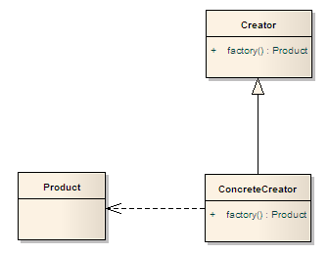

Now we will learn about these blocks and what actually they represent.

1. **ConcreteCreator**: Concrete classes that will create the Product. This will keep track of what Product it has created.
2. **Product**: This is the object that will be created by combining available raw materials.
3. **Creator**: This is the interface for creating the actual products

Now we will implement Factory Method Pattern in our program.

First we need to understand where we want to implement this pattern and then how to implement. Let’s review the scenario of where to implement this pattern.

Suppose we have an Ice-cream Factory. We make ice-cream of two categories (chocolate & Vanilla). We are going very well in market. Our selling rate is quite satisfactory. Now one day we got an interesting phone call from one of our customers that his boy wants something in different taste. He is boring with these two tastes. Similarly we received some more phone calls regarding this issue of changing the taste of ice-cream we make. So we called an urgent meeting and decided to create something special for our valuable customers. In meeting we have also decided to use our existing available raw materials and technologies. So obviously all we need is to change something core items that will give us a different taste and flavor but all other procedure will be same.

Here the idea of Factory Method Pattern describes that we can reuse our existing available raw materials, technologies and anything that we can use to create new items.

In software development the available useable things are methods, properties etc.

So let’s develop software that can handle these types of requirements. This is why we should use the factory  
method pattern.

In a sentence we are capable of using Factory Method Pattern where the requirements are frequently changing. Here is a simple demonstration of the above discussion.