Gymnasium №1

**The Russian training conference**

**“Lomonosov readings”**

**«Phrasal verbs in English songs,**

**or “cultural shock”»**

Done by

Student Gleb Chekmarev

Form 7

School №24

Research adviser

Lydia K. Yuldasheva

Teacher of English

Sterlitamak

March 6, 2020

Content

1. Introduction……………………………………………………….....3
2. Main part
   1. What phrasal verbs, are and their history of origin………………4

2.2 Analysis of 10 song texts of the «Imagine Dragons»……………5

2.3 The most used postpositions with verbs………..………………..6

2.4 Meaning of postpositions in the context of the songs………..….7

2.5. The practical part………………………………………………..9

1. Conclusion………………………………………………………...10

IV. Bibliography……………………………………………………….11

**Introduction**

Phrasal verbs is essential part of English. According to statistics, native speaker speech consists of 40% with phrasal verbs. For example, everybody knows the verb “take”. If we use the preposition “after” with it, it turns out into “to be like someone”; the preposition “off”, we get “take off” – to remove, to depart, and to raise, these verbs don’t have any congeniality meaning.

Phrasal verbs are used in English songs as well. I am fond of music. You can take any song in English and you meet phrasal verbs. My favourite band is «Imagine Dragons». Once I tried to translate its songs into Russian, with my dictionary, so I was a little bit confused. There were phrasal verbs, which had different meanings. I was interested in the fact and I decided to do the research work.

Phrasal verbs quickly and unexpectedly change their meanings. As a result, when we translate them, we are getting into the cultural shock.

“Cultural shock” is an experience a person may have when one moves to a cultural environment which is different from one’s own; it is also the personal disorientation a person may feel when experiencing an unfamiliar way of life due to immigration or a visit to a new country, a move between social environments, or simply transition to another type of life.

**The hypothesis** of our research: having studied common prepositions we have a chance to guess the meaning the majority phrasal verbs without a dictionary.

**The goal** of the research is to analyse all the phrases verbs from 10 songs of «Imagine Dragons».

**The tasks** are:

1. To find out what phrasal verbs mean.
2. To analyze the texts of the songs with phrasal verbs.
3. To identify the most used postposition with verbs.
4. To open up the meanings of the postpositions.
5. To do a survey with students of 7th class.

**The object** of the research is songs.

**The subject** of the study is phrasal verbs in songs.

We used the following **methods**:

* Searching the information
* Classification
* Analysis
* Comparison
* Survey

**What phrasal verbs are and their history?**

A phrasal verb in English is a combination of two or three words: a verb with adverb, a verb with a preposition, or a verb with an adverb and a preposition. In fact the meaning of the verb varies depending on the prepositions.

Their history start in XI century, because of the Norman Conquest **(was told on French, which, это убрать?)** Plain folks didn’t know and created own ones with old verbs and prepositions. In 1925, Logan Smith the first time used term phrasal verb in his book «Words and idioms».

Phrasal verbs in old English had literally senses. They were formed with verbs of action and a preposition, denoting spatial orientation: look up, walk out. Later these meanings had been expanded, and phrasal verbs has got new unobvious meanings. Many of them appeared during the france and the Latin influence on English.

We don’t aim to give a morphological classification of phrasal verbs in this work.

**Analysis of 10 song texts of the «Imagine Dragons»**

**«Believer» Imagine Dragons**

To fire up - вспылить

To break down – упасть духом

To build up – восстановиться (психологически)

To spirit up – придаваться решительности, подбадривать

To break up – сломаться (психологически)

**«Natural» Imagine Dragons**

To give up – сдаваться, отказываться

To give in – уступать

To step in – вмешиваться

To cast away – избавляться

To face up – встретить что-то смело

**«Rise Up! » Imagine Dragons**

To fade away - угасать

To call out – вызывать

To walk away – уходить

To open up – открывать

To look up – улучшаться

To rise up – вставать, подниматься.

To be up – бодрствововать

To walk down – спускаться

To flip through – быстро пролистать, просмотреть (книгу,статью)

To blow away – быть удивлённым

**«On Top of the World» Imagine Dragons**

To run away – убегать

To look down – смотреть свысока

To keep on - продолжать

To give up – сдаваться

To fall down – терпеть неудачу

To get up – подниматься (после неудачи)

**«Friction» Imagine Dragons**

To get down – спускаться

To get out – вырываться

To get into – подчиниться

To take over – поглощать

To ease off – сбавлять обороты (=расслабляться)

To stuck in – застрять в

**«Demons» Imagine Dragons**

To look into - исследовать

To fade out – постепенно ослабевать

To call out – вызывать

To let down – опускать

To take down – брать с собой,

**«Polaroid» Imagine Dragons**

To come on – появляться

To start over – начать сначала

To let down – опускать

To shut up – заставить замолчать

To sit down – садиться

To touch out – коснуться

To burn out – сгорать

**«Bleeding out» Imagine Dragons**

To bleed out – пролить кровь

To bring down - погубить

To take in – принять

To lost around – потерять

To hold on – не сдаваться

**«I bet my life» Imagine Dragons**

To let down – опускать

To wait up – дожидаться

To break down – довести до слёз

To set out – излагать

**«Ready aim fire» Imagine Dragons**

To fire away – начинать

To bottle up – сдерживать

To shake up – взбудоражить

To look through - смотреть в

To get up – подниматься (после неудачи)

**The most used postpositions with verbs**

Having analysed the songs of «Imagine Dragons», I made the following conclusion - the most used postpositions are:

* Up
* Down
* Out

There are 44 postpositions in English, which can be like adverbs.

In songs, I have found 12 postpositions, but there are only 3 the most used.

2.4 **Meaning of postpositions in the context of the songs**

Движение и расположение

Отклонение, отказ, уступка

Прикреплени и ограничение

Выполнение и завершение

Подготовка и начало

Отделение

Up

Поломка и разрушение

Собирание

Приближение

Появление и создание

Рост и улучшение

Out

`

Появление

Выйти

Полнота, завершённость

Увеличение, расширение

Воспроизведение, издавание, испускание

Нахождение вне дома

Перемещение, исключение, предотвращение

Продолжительность и противодействие

Поддержка и помощь

Окончание, исчезновение

Поиск, обнаружение, получение

Организация, выбор, разделение и распределение

Нападение, критика, протест

In our opinion, knowing all the meanings a postposition, we can sense and understand the meaning of phrasal verbs.

**The practical part**

We did a survey with the students of the 7th grade.

1. Are there phrasal verbs in Russian?

2. How many phrasal verbs are there in English?

3. Are there phrasal verbs in English songs or their take a part in a casual speech?

4. Would you like to know more about phrasal verbs?

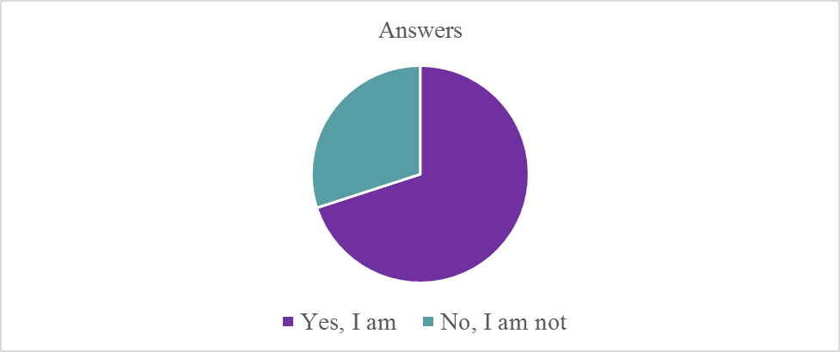

**Bibliography**

1. Мюллер. В.К. Англо-русский словарь. Полная версия. Более 180000 слов, выражений и значений / В. К. Мюллер. – М.: Эксмо, 2006.
2. Русско-английский словарь. Под ред. Е. А. Мужжевнева. – Москва: ,,Русский язык”, 1994.
3. Все предлоги английского языка – СПБ: ООО ,,Виктория Плюс”
4. Английские предлоги: значение и употребление. – Москва: Апрель 2013
5. Английский язык. Фразовые глаголы / Н.Ю Голицына. – Москва: издательство АСТ, 2019
6. Фразовые глаголы английского языка, Новый подход / Н.Ю Голицына. – Москва. Издательство АСТ, 2017
7. Фразовые глаголы в английском языке / В.В. Ильченко. – Москва: Эксмо, 2015
8. https://music.yandex.ru
9. https://www.lexico.com
10. https://en.wikipedia.org