QUOTEIT / DATA MODEL

Entity Relationship Diagram
Data dictionary and relationship specification for the QuoteIt application
Summit Bootcamp | Programming and Development Track | Version 1.0 | 28 October 2026

1. Entity relationship diagram
QuoteIt stores its domain data in three related tables. A user authors many quotes, and a user can like many quotes. The quote_likes table resolves that many-to-many relationship and records when each like was created.
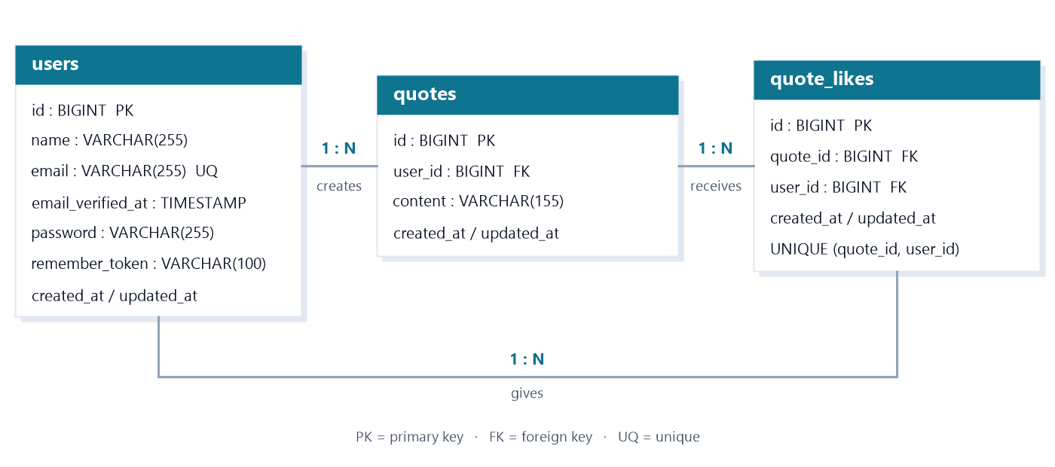Figure 1. Entity relationship diagram for the QuoteIt domain model.

2. Relationship summary
Relationship | Cardinality | Key / table | On delete | Description
Users -> Quotes | 1 : N | quotes.user_id -> users.id | CASCADE | A user authors zero or more quotes; each quote has exactly one author.
Users -> Quote likes | 1 : N | quote_likes.user_id -> users.id | CASCADE | A user casts zero or more likes; each like belongs to one user.
Quotes -> Quote likes | 1 : N | quote_likes.quote_id -> quotes.id | CASCADE | A quote receives zero or more likes; each like targets one quote.
Users <-> Quotes | M : N | quote_likes(quote_id, user_id) | CASCADE | Resolved by the quote_likes associative table; one row per user-quote pair.
quote_likes is an associative entity. Its composite unique index on (quote_id, user_id) guarantees that a user can like a given quote at most once, while any number of users may like the same quote.
PK = primary key | FK = foreign key | UQ = unique
Cardinality: 1 : N means one parent row is referenced by many child rows. The M : N relationship between users and quotes is resolved by the quote_likes table.

3. Data dictionary
The table lists every application column, its SQL type, its key or constraint, and whether it accepts NULL. Laravel timestamp columns are nullable and are managed automatically by Eloquent.
Table | Column | Type | Key / constraint | Null | Description
users | id | BIGINT UNSIGNED | PK, auto-increment | No | Primary key.
users | name | VARCHAR(255) | - | No | Display name.
users | email | VARCHAR(255) | UNIQUE | No | Login identifier.
users | email_verified_at | TIMESTAMP | - | Yes | Verification time.
users | password | VARCHAR(255) | - | No | Hashed password.
users | remember_token | VARCHAR(100) | - | Yes | Remember-me token.
users | created_at | TIMESTAMP | - | Yes | Created timestamp.
users | updated_at | TIMESTAMP | - | Yes | Updated timestamp.
quotes | id | BIGINT UNSIGNED | PK, auto-increment | No | Primary key.
quotes | user_id | BIGINT UNSIGNED | FK -> users.id (CASCADE) | No | Author of the quote.
quotes | content | VARCHAR(155) | - | No | Quote text, max 155.
quotes | created_at | TIMESTAMP | - | Yes | Created timestamp.
quotes | updated_at | TIMESTAMP | - | Yes | Updated timestamp.
quote_likes | id | BIGINT UNSIGNED | PK, auto-increment | No | Primary key.
quote_likes | quote_id | BIGINT UNSIGNED | FK -> quotes.id (CASCADE) | No | Liked quote.
quote_likes | user_id | BIGINT UNSIGNED | FK -> users.id (CASCADE) | No | User who liked.
quote_likes | created_at | TIMESTAMP | - | Yes | Liked timestamp.
quote_likes | updated_at | TIMESTAMP | - | Yes | Updated timestamp.

4. Keys, indexes, and integrity rules
The migrations declare the following database-level constraints. Cascading deletes keep the dataset consistent when a user or quote is removed.
Object | Type | Definition | Purpose
users_email_unique | Unique index | users(email) | Prevents duplicate accounts.
quotes_user_id_foreign | Foreign key | quotes(user_id) -> users(id) ON DELETE CASCADE | Deletes a user's quotes with the account.
quote_likes_quote_id_foreign | Foreign key | quote_likes(quote_id) -> quotes(id) ON DELETE CASCADE | Deletes likes when a quote is deleted.
quote_likes_user_id_foreign | Foreign key | quote_likes(user_id) -> users(id) ON DELETE CASCADE | Deletes likes cast by a deleted user.
quote_likes_quote_id_user_id_unique | Unique index | quote_likes(quote_id, user_id) | One like per user per quote.

5. Design notes
• Primary keys use Laravel's $table->id(): unsigned BIGINT, auto-increment.
• created_at and updated_at are nullable Eloquent-managed timestamps.
• Models live in app/Models; quote_likes is the pivot for likes and likedQuotes.

