# 1.jpg

**WMB Assessment Cover Sheet**

*WM6001-Website Authoring 1*

**Course No. and Title:**

*Individual Project*

**Assessment Title:**

*201500413*

**Student ID:**

**Student Name:**

*Fajer Allengawi*

*Ancy Cheriyan*

**Tutor:**

**Due Date: 25 October 2016**

**Date submitted:**

**Late Rule:**

***Late submissions will incur a penalty of 5% per each calendar day***

**By submitting this assessment for marking, either electronically or as hard copy, I confirm the following:**

* This assignment is **my own work.**
* Any information used has been properly referenced.
* I understand that a copy of my work may be used for moderation.
* I have kept a copy of this assignment.

Do not write below this line. For Polytechnic use only*.*

**Date of Marking:**

**Assessor:**

**Grade/Mark:**

**Comments:**

Table of Contents

Introduction 3

The promoting product 3

Target audience 3

Appearance 3

Aim 4

Mock up Screens 4

References 7

# Introduction

In this report I will be discussing about the product that I have chosen for my website. I will be discussing about the reasons why in my opinion, and after research, the coffee product from “Swiss Water Process” grabbed my attention.

# The promoting product

The product I have chosen is “coffee”. Coffee contains several important nutrients. Majority of the people around the world drinks coffee, whether it’s on a daily basis or not. Coffee has many advantages and disadvantages.

A disadvantage is when we intake excess caffeine. Through research, I found that “Swiss Water” company uses the process of using solely water osmosis to decaffeinate beans. Their coffee is free of caffeine. Swiss water process headquarters is located in Canada. However, there are branches in North America and they are thinking of expanding more. Moreover, I have picked the “Swiss Water Process” coffee.

# Target audience

The target audiences are the coffee lovers. Many people are addicted to coffee but can’t intake a lot of caffeine and so they should be aware about this existence of Swiss water process.

The targeted audiences are from teenagers to adults as youngsters are not into coffee much as seen from studies, and are aimed for both genders.

# Appearance

The website is designed in such a way to give a calm and relaxing feeling to the audiences. Coffee colors represent light yet a friendly feeling and that’s the main aim. The website would tell its own story without giving a feel of emptiness.

I have created its own logo from scratch and by editing all of the images that I have used. In the logo, the coffee brings out a smoke which represents a love symbol to attract all the coffee lovers. The background that I have chosen is of white stripes that gives a relaxing feel. Further-more all images have a description, incase an image fails to load. The slogan is ‘relax’ to give a calm feeling. The font is Century which has a unique style to it.

I created my website aiming for an elegant design to spotlight coffee as coffee is a delicate and an elegant product. With research and studies, I have successfully added the java scripts required. The website also consists of six pages, homepage, about us, our coffee, reviews, contact us and latte. However, the Latte is not a main page. In addition, a CSS style sheet which contains all the styles. Swiss water process sells only 3 various types of coffee bags. They come in 1kg, 2kg and 3kg.

# Aim

The aim for this website that I have created is to let people know about this decaffeinated coffee and promote it.

# Mock up Screens

The following images are mock up screens of the website.

**Index**  
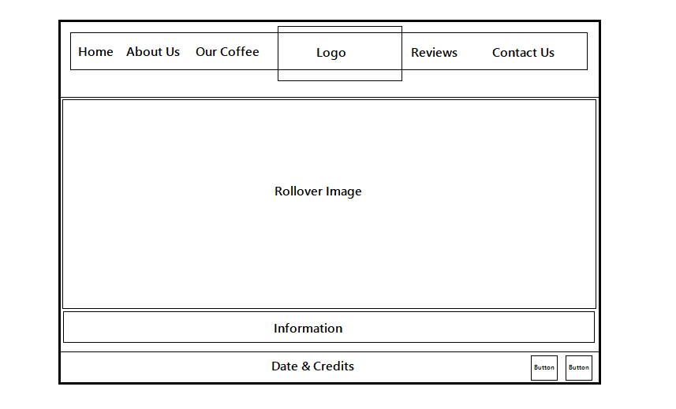

The home screen has little information about the coffee and two main pictures which are the welcome message and the statement message. The menu bar is consistent in all the main pages.

**About Us**

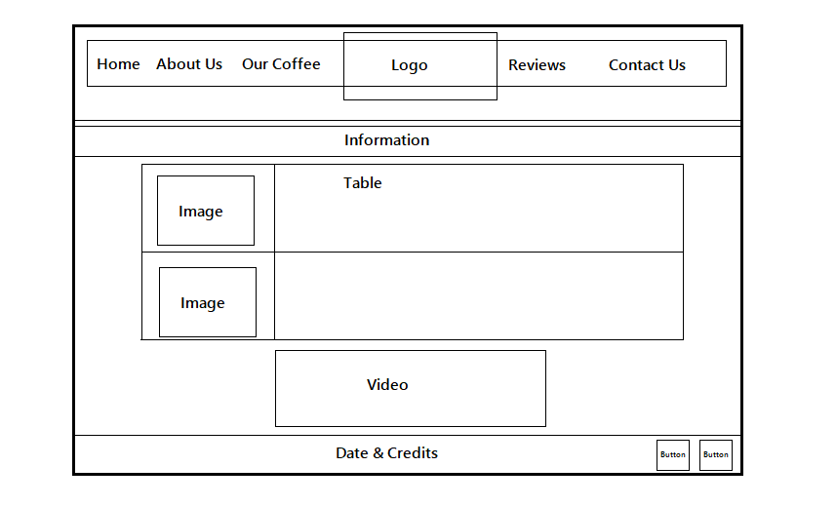  
About us page, contains more information about their coffee. There is a video explaining the process of the coffee. A table which shows what different flavors are served in their coffee shop.

**Our Coffee**

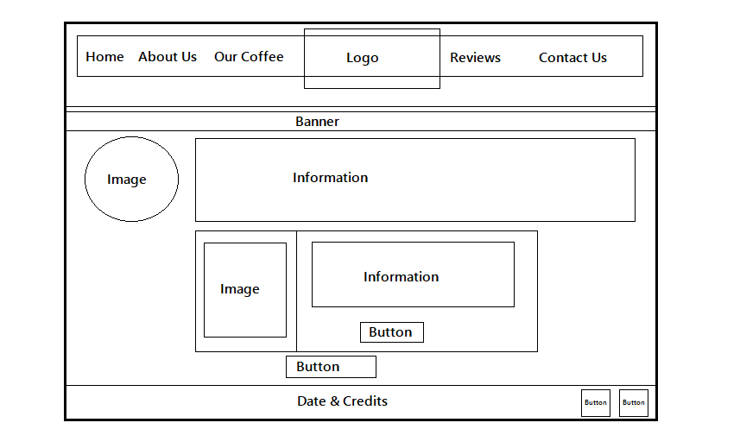

Our Coffee page contains information as well as it is the shopping page for customers who want to buy our coffee beans.

**Reviews**

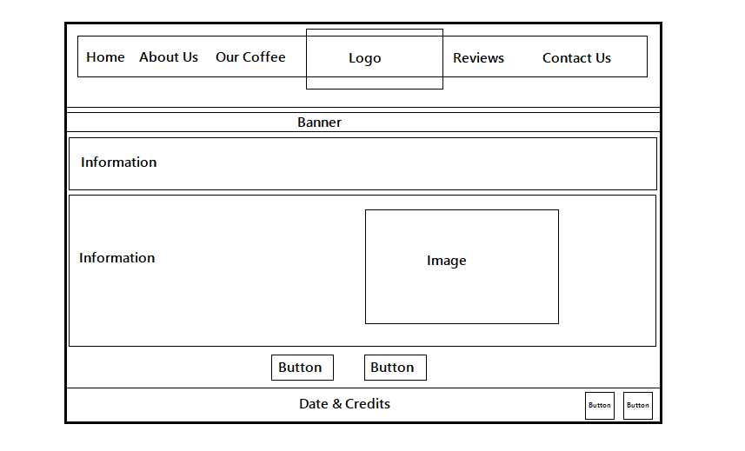

Reviews page, is where the visitors can comment about anything related to Swiss water process “the product”.

**Contact Us  
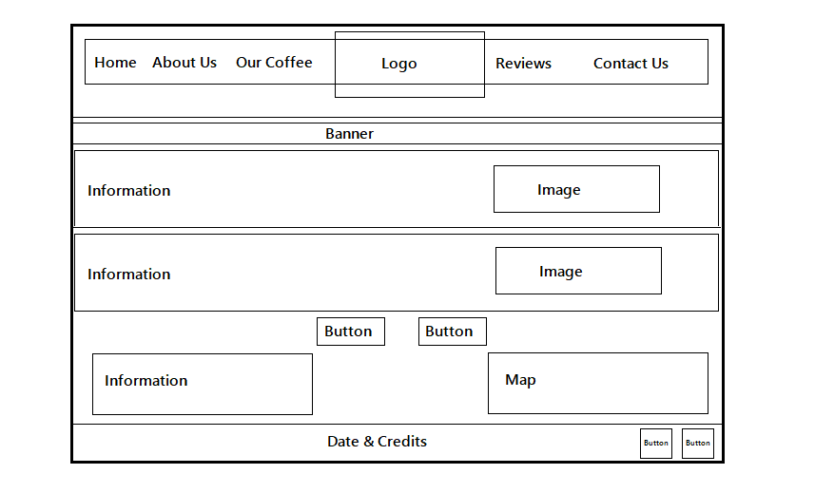**

Contact Us page, is where the visitors can see on the Google map where the coffee shop is located and the address. They can also send

# References

The information used is from:

* Decaf Coffee | Coffee Without Caffeine | Swiss Water. (2015). Retrieved November 15, 2016, from <https://www.swisswater.com/>
* Durand, F. (2014). How To Make a Latte at Home Without an Espresso Machine - Cooking Lessons from The Kitchn. Retrieved November 15, 2016, from <http://www.thekitchn.com/how-to-make-a-latte-without-an-espresso-machine-cooking-lessons-from-the-kitchn-211090>

The video used is from:

* <https://www.youtube.com/watch?v=fhz9njRLbl0&feature=youtu.be>

Few main images that have been used are from:

* Caffè Mocha | Starbucks Coffee Company. (n.d.). Retrieved November 15, 2016, from <http://www.starbucks.com.sg/menu/beverages/espresso-beverages/caffè-mocha>
* (n.d.). Angelkarafilli. Retrieved November 15, 2016, from <http://angelkarafilli.tumblr.com/post/124837076926/coffee>
* Coffee, books, tattoos, & photographs. (n.d.). Retrieved November 15, 2016, from <http://coffeecamerasinkandbooks.tumblr.com/>