**1st Homework for Computer Architecture**

**Read Chapter1 then do the following problems.**

**(Total 210 points)**

**In 6th Edition**

**1.6 1.8 1.11 1.15**

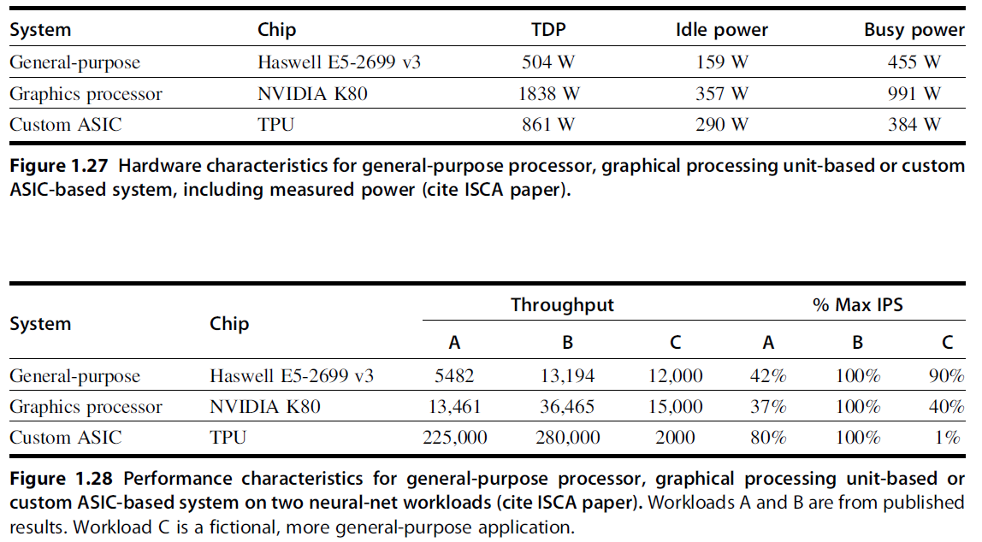

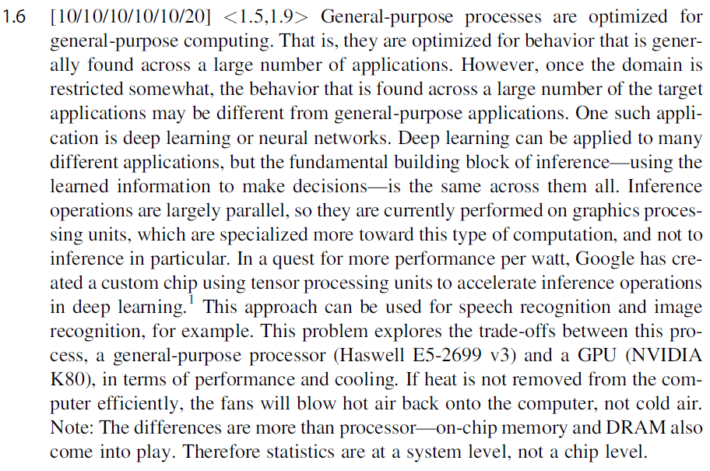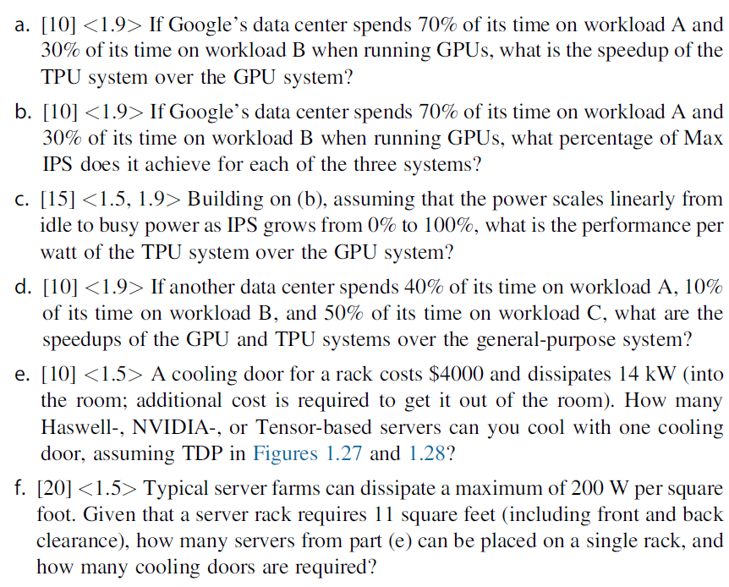

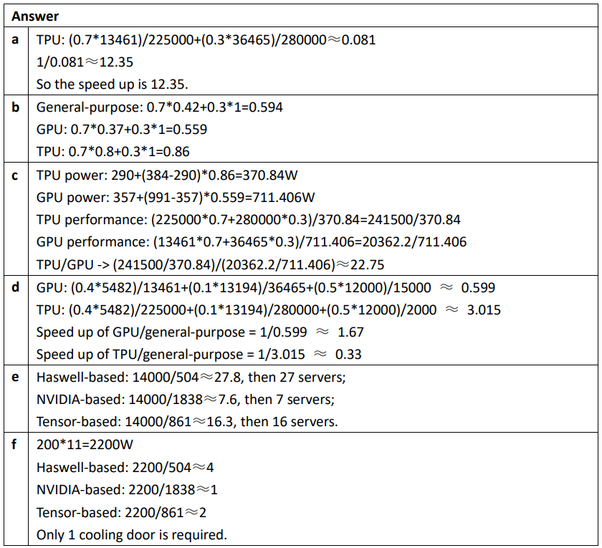

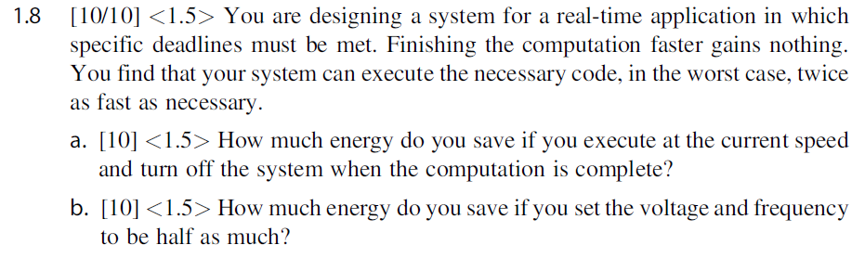

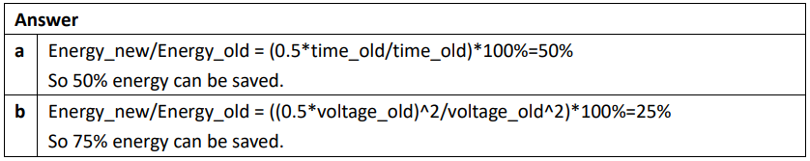

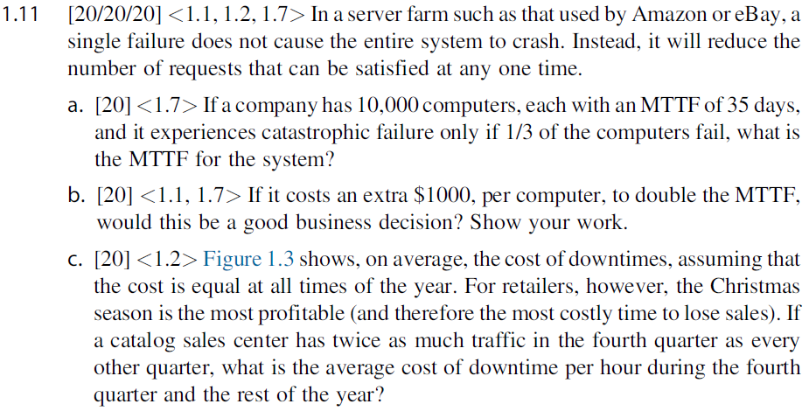

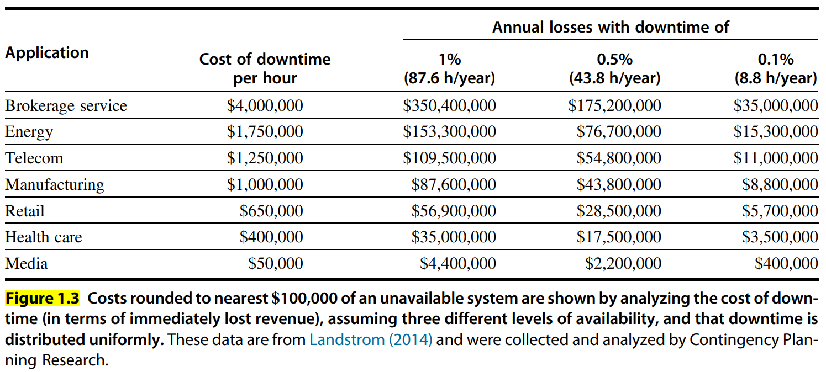

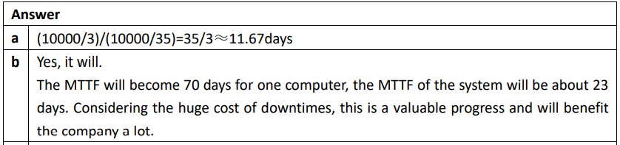

|  |  |
| --- | --- |
| **c** | 650000 =  2x = 1040000 $/h for 4th quarter  x = 520000 $/h for others |

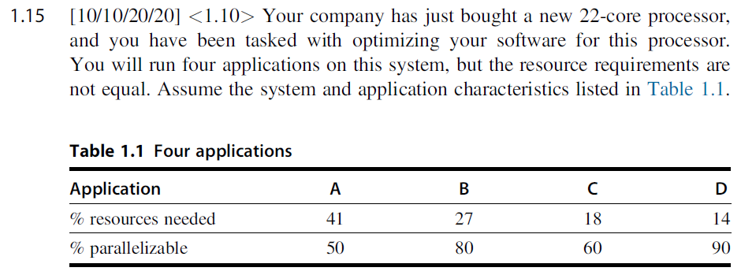

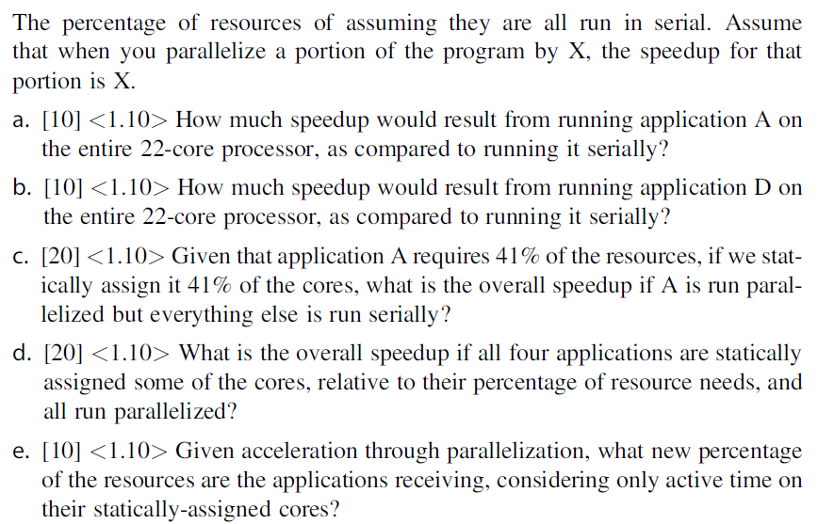

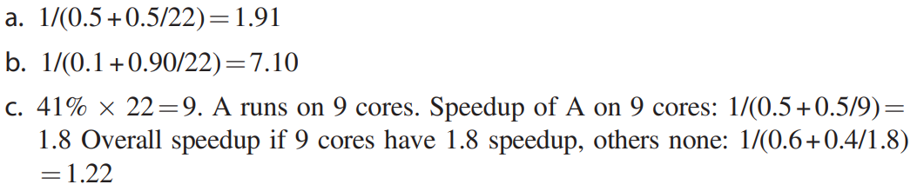

**(注意，中间结果不要近似，只在最终结果近似)**

