**3st Homework for Computer Architecture**

**Read Chapter 2 Appendix B then do the following problems.**

**(Total 152 points)**

**In 6th Edition**

**2.1 2.24 B.5 B.8**

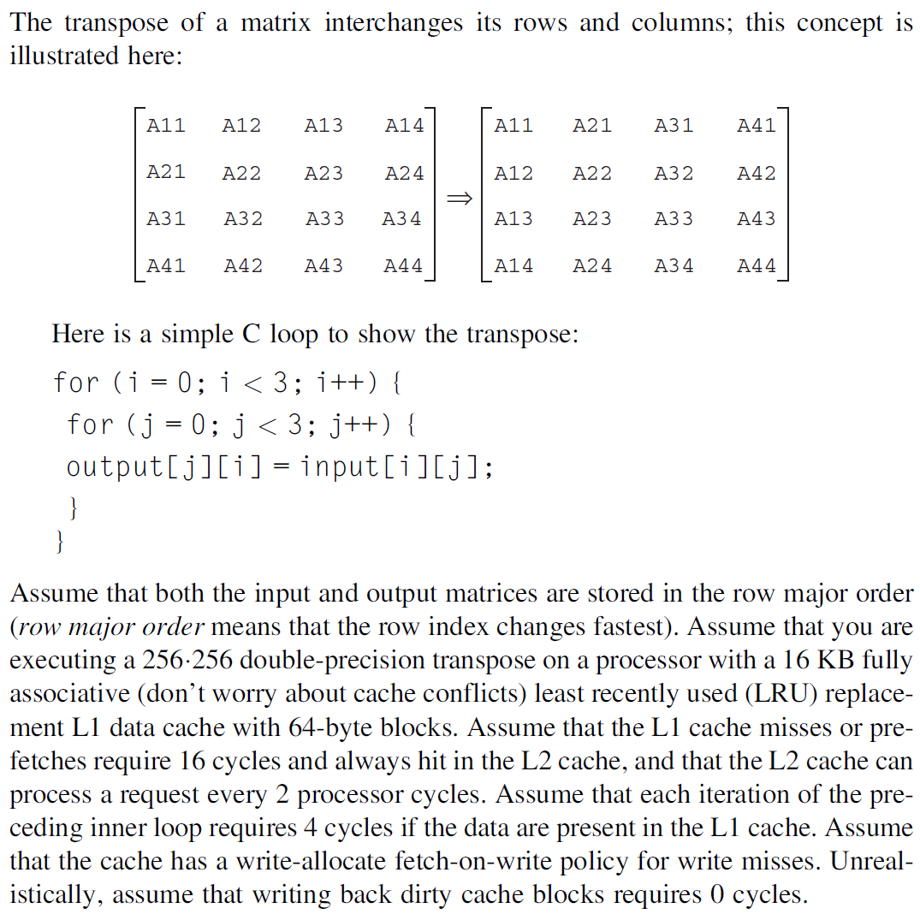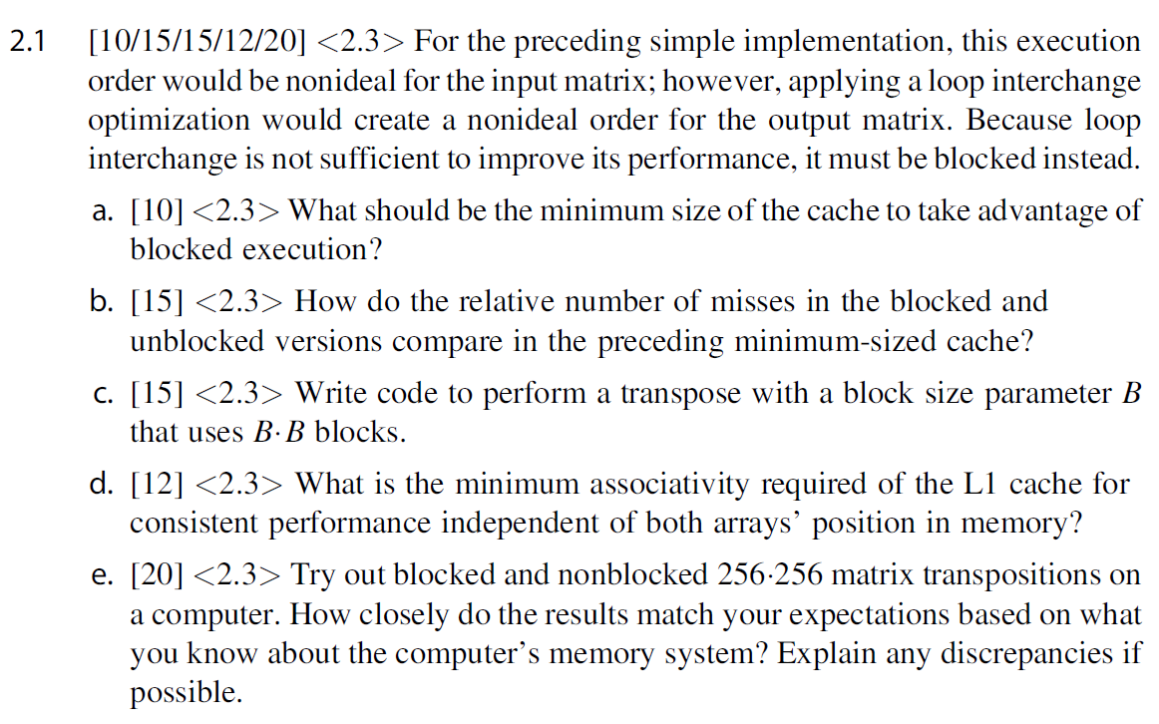

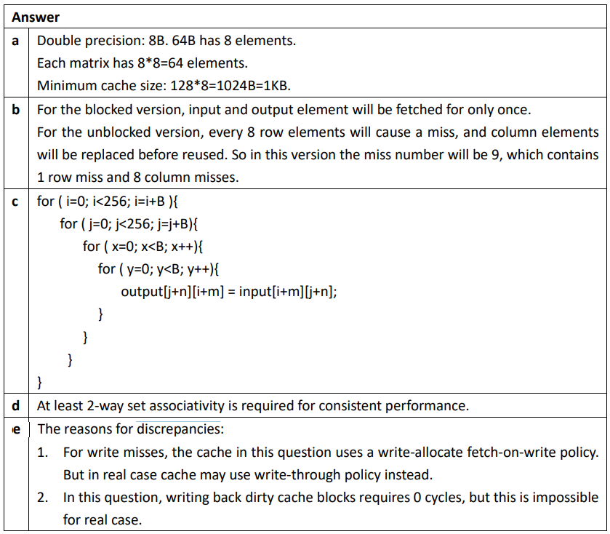

**C题想不清楚可以全部算出来取比值，blocked版本是256/8 * 256/8 * 16(每个块8个input 8个output)，unblocked版本是256*256/8（input 8个1次miss）+256*256（output全miss），比值是4.5**

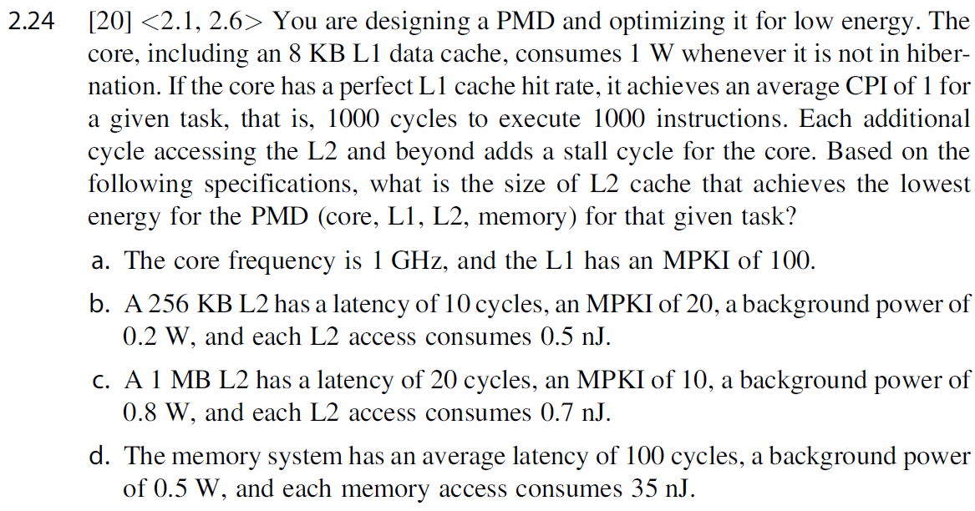

**Ans：**

**这个性能是要求功耗(1000inst)的并不是功率**

**纯memory：(1000ns(hit time) + 100(miss) * 100ns (miss penalty)) * (1w(CPU power) + 0.5w(memory power)) + 100(memory miss) * 35nJ(miss energy) = 20000nJ**

**L2 256KB: (1000ns(hit time) + 100(L1 miss) * 10ns (L1 miss penalty) + 20(L2 miss rate)*100ns(L2 miss penalty) ) * (1w(CPU power) + 0.2w(L2 power) + 0.5w(memory power)) + 100(L1 miss) * 0.5nJ(L1 miss energy) +20(L2 miss) * 35nJ(L1 miss energy)+ = 7550nJ**

**L2 1M: (1000ns(hit time) + 100(L1 miss) * 20ns (L1 miss penalty) + 10(L2 miss rate)*100ns(L2 miss penalty) ) * (1w(CPU power) + 0.8w(L2 power) + 0.5w(memory power)) + 100(L1 miss) * 0.7nJ(L1 miss energy) +10(L2 miss) * 35nJ(L1 miss energy)+ = 9620nJ**

**所以选择L2 256KB**

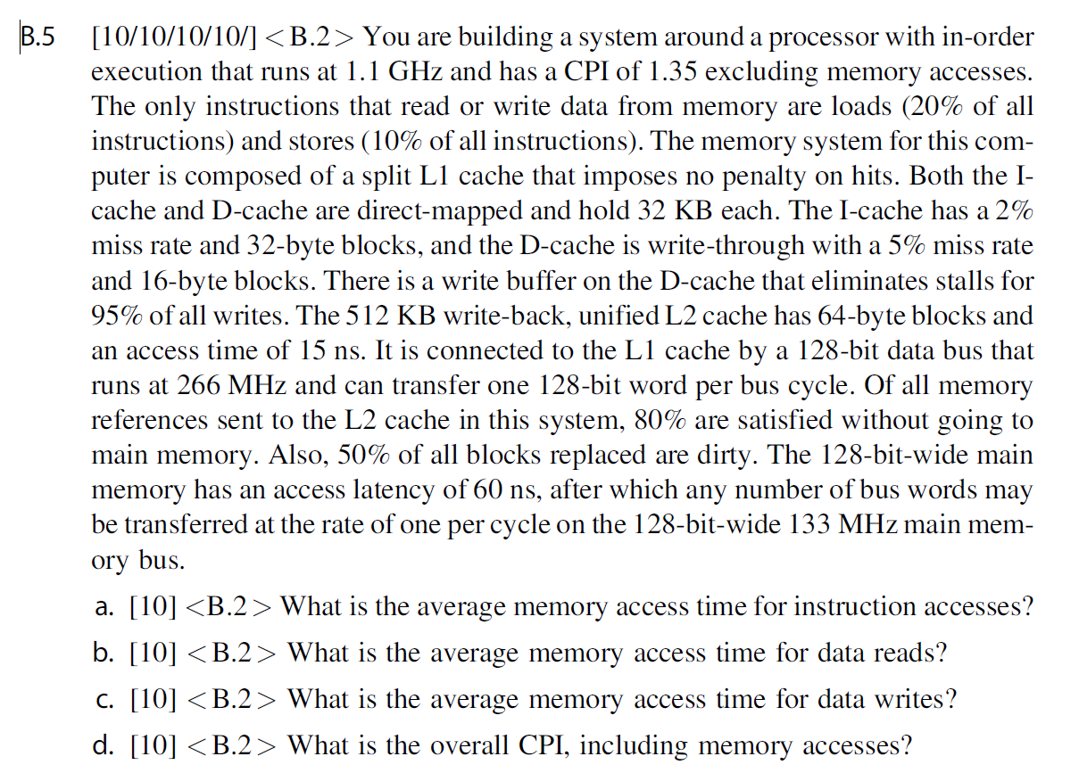

|  |  |
| --- | --- |
| **Answer** | |
| **a** |  |
| **b** |  |
| **c** |  |
| **d** |  |

**AMAT是平均存储访问时间，是一个度量，用于最终求整体CPI，这里认为hit time是0或者hit time是CPI*CC或者CC都可以算对，最终算CPI(d)减回去就好。(b)里面L1 read miss rate说了是5%。(c)里面write是write through的，通常也是认为no allocate，那么意味着每一次写操作都会涉及一次L2访存，write buffer减掉了95%的L2访存，所以得到上述结果。**

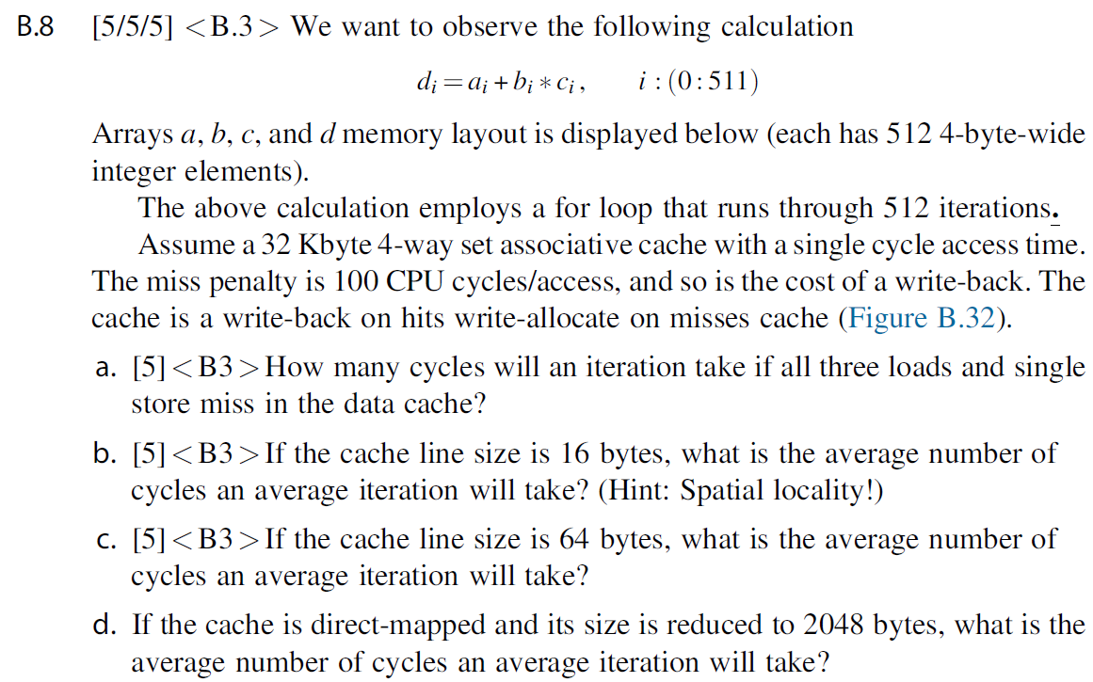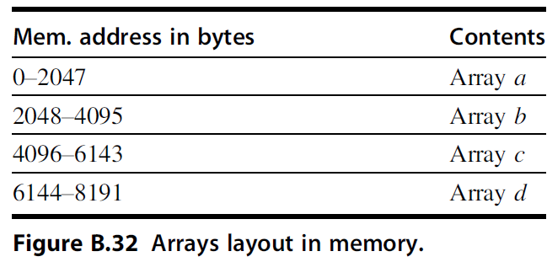

**Answer:**

