**4th Homework for Computer Architecture**

**Read Chapter 4 and 5 then do the following problems.**

**(Total 110 points)**

**In 6th Edition**

**4.13 5.1 5.23**

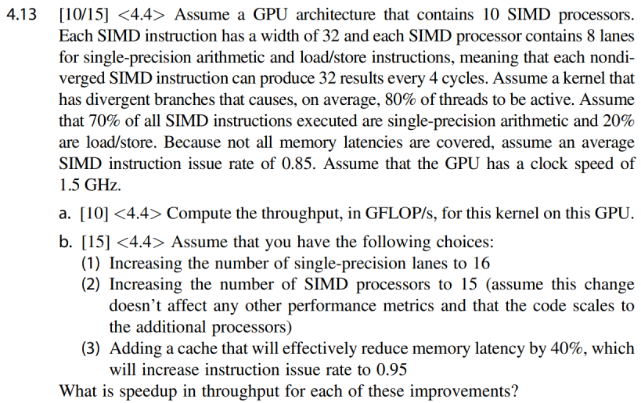

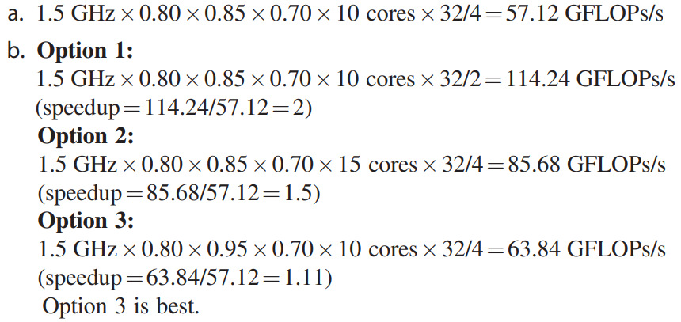

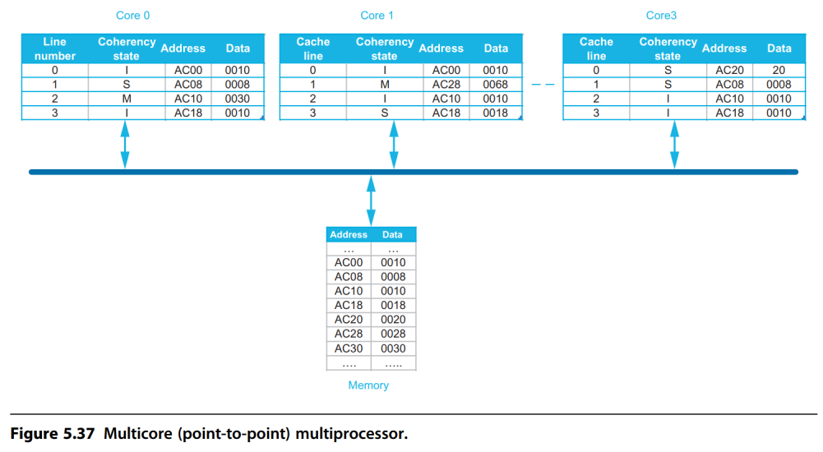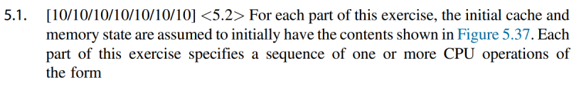

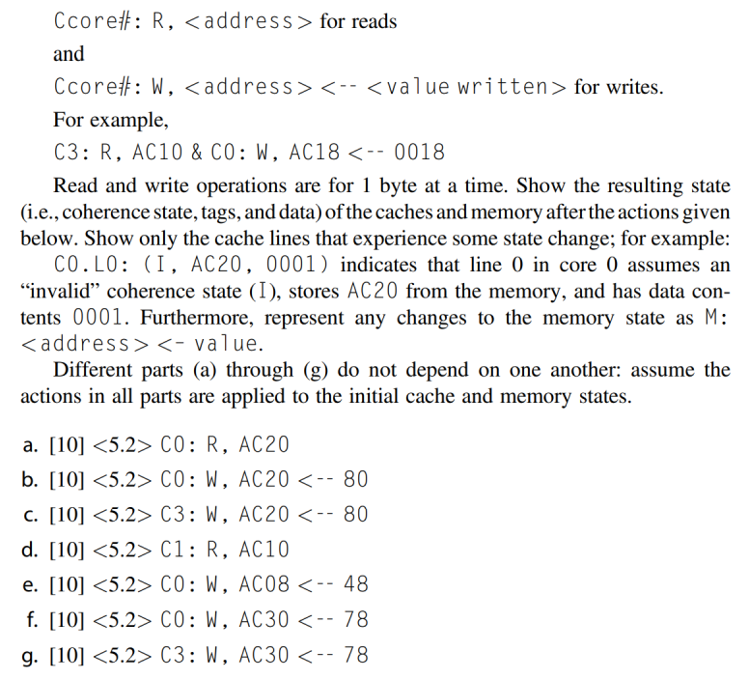

|  |  |
| --- | --- |
| **Answer** | |
| **a** | C0.L0:(S, AC20, 0020)  return 0020 |
| **b** | C3.L0:(I, AC20, 0020)  C0.L0:(M, AC20, 0080) |
| **c** | C3.L0:(M, AC20, 0080) |
| **d** | C0.L2:(S, AC10, 0030)  M: AC10 <- 0030  C1.L2:(S, AC10, 0030)  return 0030 |
| **e** | C3.L1:(I, AC08, 0008)  C0.L1:(M, AC08, 0048) |
| **f** | M: AC10 <- 0030  C0.L2:(M, AC30, 0078) |
| **g** | C3.L2:(M, AC30, 0078) |

