Zhejiang University
Second Semester of 2003 —2004 Academic Year

Data Structure & Algorithm

Allowed Time: 120m, College: Chu KeChen Honors College

Student Name______________ Student ID_____________
Teacher Name __He Qinming__

(Following Form only for Teacher)
Item Number | 一  (25) | 二  (8) | 三  (12) | 四  (8) | 五  (11) | 六  (16) | 七  (20)
mark

一、Single Choice & Blank Filling（2 marks for each item of Single Choice and 3 marks for each item of Blank Filling, total 25 marks）

1、There is a linked list L consisting of an ordered numbers. The size of the list is n. In order to insert a new number x, what is the average time complexity of this operation?
- O(1) B) O(n) C) O(nlogn) D) O(n*n)
2、The degree of each node in a tree of height h is 0 or 2.(NOTE: the height of a one-node-tree is 0). The number of the nodes in the tree is at least::
A) 2h B) 2h-1 C) 2h+1 D) 2^{h}-1
3、For a binary tree, the pre-order travel is abdgcefh, the in-order travel is dgbaechf, the post-order travel is :
A）bdgcefha B) gdbecfha C) bdgaechf D) gdbehfca
4、In order to get the 10 largest numbers (NOTE: not 10th) from 5000 random numbers, what is the best algorithm:
- Quick Sort B) Heap Sort C)Merge Sort D) Shell Sort
5、If the input to a stack is 1,2,3,4,…,n, and the first output is n, the i-th output is :
A）n-i B）n-i+1 C）i D）undecided
6、A file contains only 8 letters in the following frequency:0.30, 0.70, 0.10, 0.03, 0.20, 0.06, 0.22, 0.02。The average length of an optimal encoding for the letters is _______________
7、There are five jobs needed to be processed by a processor. The processing time for each job is 15,8,3,6,10 respectively. The minimum average completion time is ____________
8、We use Divide and Conquer algorithm to solve a problem of complexity N. The problem is divided into 4 sub-problems of equal complexity N/3, and the additional work to compute the final work is O(n*n). What is the time complexity of this algorithm_________________
9、We need to merge two binomial queues of size 13 and 21 respectively. Please give the names of non-empty binomial trees in the merged binomial queue (e.g. B0, B1, B3): _________________
10. Consider a disjoin set problem, following picture shows the current state of the implicit representation of the tree for the strategies of union-by-size and path compression. Please depicture the state of implicit representation after finishing operation SetUnion(int S[],3,5), Find(8, int S[])
Before operations:
S:
-1 | -1 | -2 | 3 | -4 | 5 | 5 | 7
1 2 3 4 5 6 7 8

After operations:
S:
1 2 3 4 5 6 7 8

二、G is an undirected graph. In G’s adjacency matrix representation, each row contains at least 2 non-zero elements. Please show that there is a cycle in G. (8marks)

三、Following is an weighted undirected graph’s adjacency list representation. Each node consists of three fields: vertex, cost of the edge and the link of next edge.
Please：1）show the result of Depth First Search (DFS) starting from vertex “a”;
2）show the articulation nodes(关节点) (if existing);
3）give a minimum spanning tree(最小生成树) （12marks）
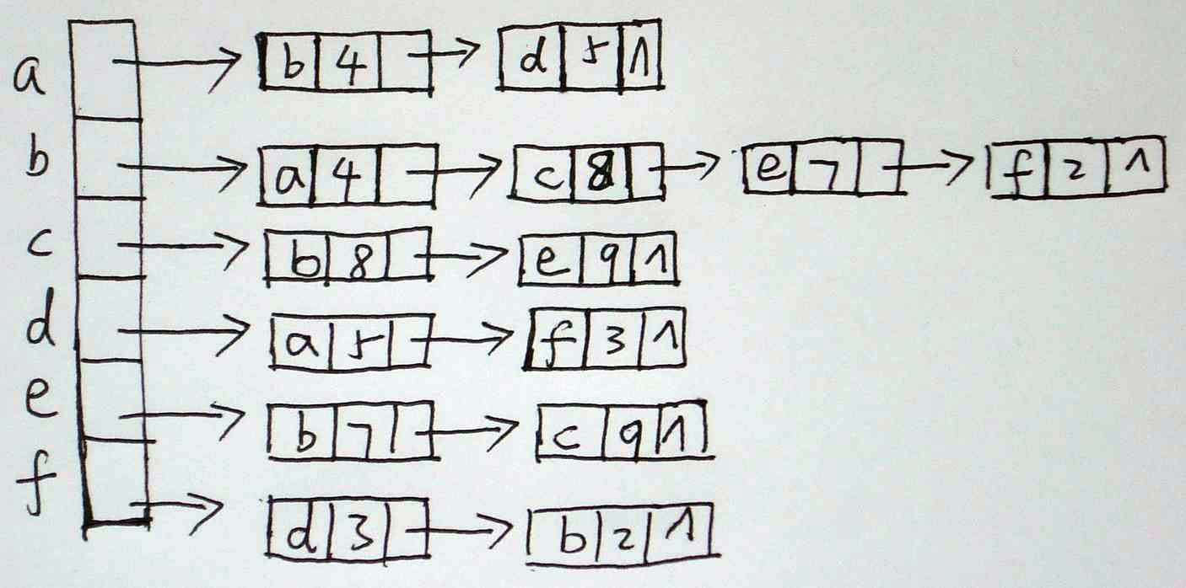

四、Please give an example with minimum number of key order, show AVL tree’s four kinds of rotations (LL,RR,LR,RL). Depicture each step of your construction。（8marks）。

五、A quick sort routine can be implemented in a non-recursive way through use of stack. Fill in the blanks for such a routine（11marks）：

struct stackElement {
int left;
int right;
};

void push(struct stackElement x); /*push x into a stack */
struct stackElemet pop(); /*pop an element from a stack. If stack is empty, returns NULL*/

/*Qsort: sort v[0],v[1],…v[n] into increasing order */
void Qsort( int v[], int n )
{ int i, last, left, right;
void swap(int v[], int i, int j); /*swap v[i], v[j] */
struct stackElement tmp;

tmp.left=0; tmp.right= n-1;
push(tmp);

while ((tmp=pop())!=NULL) {
left=tmp.left; right=tmp.right;
if (left>=right) continue;
swap(v, left, (left+right)/2); /*move partition elem */
last=left;
for(i=left+1; i<=right; i++)
if (v[i]<v[left]) _________________________; /* one statement */
swap(v, left, last);
tmp.left=left; tmp.right=last-1;
push(tmp);
___________________________________________ /* multi-statements */
}
}

六、For a hash table of size n (n=11), the hash function is h(x)=x % n, and the collision resolution strategy is linear probing F(i)=i. Following is the state of hash table after insert 7 elements.
 |  | 13 | 3 | 14 | 26 | 6 | 16 | 2
0 1 2 3 4 5 6 7 8 9 10
Please: (1) give a possible insert order of these elements;
(2) In general, write an algorithm to “guess” a possible input order from any state of such hash table, and give the time complexity of your algorithm.(16 marks)

七、The eccentricity(偏心度) of a vertex v in graph G=(V,E) is
max (the shortest path from v to w)
w∈V
The center of graph G is the vertex that has the minimum eccentricity.
Please (1) depicture an algorithm to obtain the center of a graph.
(2) Write a C function int CenterOfGraph( int A[][MAX], int n), A is the adjacency matrix of G, and n is the number of vertexes. The function returns the center of graph. (20 marks)

