浙江大学2006–2007学年秋冬季学期
《数据结构与算法分析》课程期末考试试卷
开课学院： 计算机学院中加班 ，考试形式：闭卷，允许带_ 无 入场
考试时间：_2007_年_1_月_26_日, 所需时间： 120 分钟
考生姓名： ___学号： 专业： ____教师： 陈越
题序 | 一 | 二 | 三 | 四 | 总 分
得分
评卷人

- I. Please fill in the blanks: ( There could be multiple answers for one blank ). (24 points; 2 points/blank) Note: Zero point for a blank selection since there is at least one answer for each problem.

- (1) Given a string of expression, a+b/c. Please use a stack to re-order the expression into abc/+. Here let P stand for “push” and O for “pop”. For example, ABC is re-ordered into BCA by PPOPOO. The sequence of stack operations is . (2 points) c
a) PPPOOPOPOO b) POOPPPOPOO c) POPPOPPOOO d) PPOPPOOOPO

(2) Which of the following method(s) is(are) for solving collisions in a hash table? (2 points) bd
a) binary search b) linear probing
c) key mod prime d) separate chaining.

(3) To find the shortest path between a pair of given vertices, method can be used. a
a) Dijkstra b) Hashing c) Kruskal d) Critical Path

(4) In the disjoint set problem, if Unions are performed by height, then the depth of any tree with N nodes is a .
a) O(log N) b) O(1) c) O(N) d) N/2

(5) An undirected graph with N vertices has at most c edges.
a) N b) N (N – 1) c) N (N – 1)/2 d) 2N

- (6) Breath-first search with the adjacency list representation of a graph is similar to the d traversal of a binary tree.
a) preorder b) inorder c) postorder d) level-order
(7) In the following integer sequences, b is(are) NOT a heap.
a) (100,85,98,77,80,60,82,40,20,10,66)
b) (100,85,40,77,80,60,66,98,82,10,20)
c) (10,20,40,60,66,77,80,82,85,98,100)
d) (100,98,85,82,80,77,66,60,40,20,10)

(8) Among the following sorting algorithms, b has the average run time O(NlogN) with the smallest extra space.
a) Quick sort b) Heap sort c) Merge sort d) Radix sort

- ?(9) A binomial queue of size 43 can be represented by the following binomial queues .
a) B0 B1 B2 B3 B4 B5 b) B0 B1 B3 B5
c) B1 B3 B5 B6 d) B0 B2 B4 B5

- ？(10) A leftist tree with r nodes on the right path must have nodes.
a) at least 2r-1 b) at most 2r-1 c) at least 2r-1 d) at most 2r-1

- (11) Which of the following problems are not known to be run in polynomial time: b .

a) Euler circuit problem b) Hamilton cycle problem
c) Single-source unweighted shortest-path problem
d) Single-source unweighted longest-path problem

- (12) If a complete binary tree of height h (>=0) is represented by an array, then the index of the left most leaf is b .
a) 2h-1 +1 b) 2h c) 2h+1 -1 d) 2h+1

- II. Given the function descriptions of the following two (pseudo-code) programs, please fill in the blank lines. (10 points)

(1) The function is to insert an element X into a binary search tree T. (4 points)
SearchTree Insert( ElementType X, SearchTree T )
{ if ( T == NULL ) {
T = malloc( sizeof( struct TreeNode ) );
T->Element = X;
T->Left = T->Right = NULL; }

else if ( X<T->Element )
T->Left = Insert( X, T->Left );
else if ( X > T->Element )
T->Right = Insert( X, T->Right );
;
return T;
}

(2) The function is to delete the node with minimal key from a min-heap H. (6 points)

ElementType DeleteMin( PriorityQueue H )
{
int i, Child;
ElementType MinElement, LastElement;

MinElement = H->Elements[ 1 ];
LastElement = H->Elements[ H->Size-- ];
for ( i = 1; i * 2 <= H->Size; i = Child ) {
Child = i * 2;
if(Child!=H->Size&&H->Elements[child+1]<H->Elements[child])
Child++;
if ( LastElement > H->Elements[ Child ] )
H->Elements[ i ]= H->Elements[ Child ] ;
else break;
}
H->Elements[ i ] = LastElement ;
return MinElement;
}

- III. Please write or draw your answers for the following problems on the answer sheet. (56 points)

(1) Please draw the resulting tree after deleting 8 from the following B-tree. (4 points)

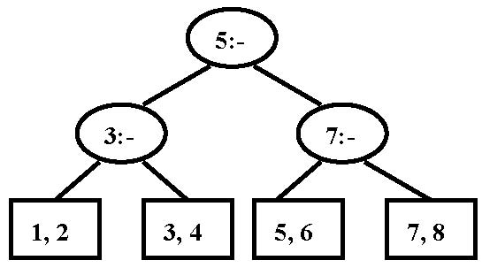

(2) Please draw the results of rotations when inserting {18，15，1，2，12，5，10，7} into an initially empty AVL tree. (16 points)

(3) For the given graph, please draw:
a. its biconnected components and (6 points) {0},{1,2,3,4},{5,6,7},{8,9}
b. the minimum cost spanning tree (9 points)

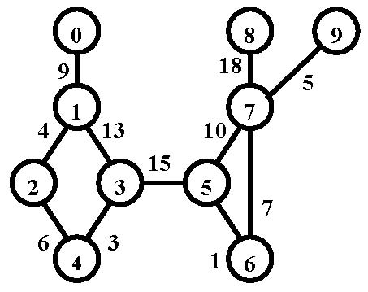 ans: 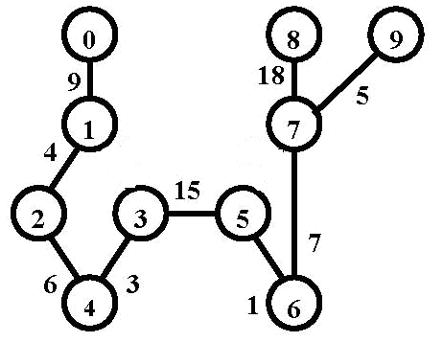

(4) The followings are the partial results of a binary tree’s traversals in pre-order, in-order and post-order. Please draw the corresponding tree. (6 points)
Pre-order : _AEFC_
In-order: A_ED_B
Post-order: FE_B_D

D
/ \
A C
\ \
E B
/
F

(5) Given a segment of text “this_is_an_ideal_string”, how many bits are required to store the string as 1-byte characters? (2 points) How many bits are need to store its Huffman code? (2 points) Please draw the corresponding Huffman tree with the assumption that all the characters are initially stored in an array in the alphabetical order. (6 points)

(6) Show the optimal binary search tree for the following words, where the frequency of occurrence is in parentheses: an (0.10), be (0.20), can (0.30), if (0.25), or (0.15). (5 points)

IV. Please write an algorithm for finding the shortest path between a given pair of vertices v and w. If there is more than one minimum path from v to w, a path with the fewest number of edges must be chosen. (10 points)

void Dijkstra( Table T,Vertex start,Vertex end )
{ /* T is initialized by Figure 9.30 on p.301 */
Vertex V, W;
T[ start ].Dist=Mindis;
T[ start ].Length=0;
for ( ; ; ) {
V = smallest unknown distance vertex (if more than one, choose the one whose Length is min);
if ( V == NotAVertex )
break;
T[ V ].Known = true;
If( V==end)
Break;
for ( each W adjacent to V )
if ( !T[ W ].Known )
if ( T[ V ].Dist + Cvw < T[ W ].Dist ) {
Decrease( T[ W ].Dist to
T[ V ].Dist + Cvw );
T[ W ].Path = V;
T[ W ].Length=T[ V ].Length+1;
} /* end-if update W */
} /* end-for( ; ; ) */
}

