TECHNICAL PROJECT REPORT

Reliable Medical Image Classification
with Limited Labels
PatchCamelyon (PCam) · Pretrained ResNet-50 vs. ViT-B/16 · Label-budget study · Calibration & reliability

Problem · Dataset · Architectures · Parameters · Results · Comparison · Limits & Enhancements
Implementation: Google Colab (Tesla T4 GPU) · PyTorch · timm · scikit-learn
October 2026

Table of Contents
1. Executive Summary 3
2. The Problem and Why We Chose This Project 3
2.1 Problem statement 3
2.2 Why this project? 3
2.3 Objectives 4
3. The Dataset: PatchCamelyon (PCam) 4
3.1 Origin and content 4
3.2 How the labels are defined 4
3.3 Splits and class balance 5
3.4 Stain and scanner shift between splits 5
4. Why Several Label Budgets, Seeds and Metrics? 6
5. Methodology and Code Walk-through 6
6. Architectures and Their Parameters 8
6.1 ResNet-50 (convolutional network) 8
6.2 ViT-B/16 (Vision Transformer) 8
6.3 The two classification heads 9
6.4 SmallCNN trained from scratch 9
6.5 Parameter summary and rationale 10
7. Evaluation Metrics 11
8. Results 11
8.1 Validation macro-F1 versus label budget 11
8.2 ViT versus ResNet (paired by head, fraction and seed) 12
8.3 Label efficiency 12
8.4 Test-set performance 12
8.5 Calibration: does confidence reflect reliability? 13
8.6 Error analysis and selective prediction 14
9. Comparison and Discussion 15
9.1 What the comparison teaches 15
10. Limitations and Why We Enhanced the Pipeline 16
10.1 Limitations of a naive approach, and the enhancement we made for each 16
10.2 Remaining limitations (threats to validity) 16
11. Future Work 17
12. Conclusion 17
References 17
Appendix A. Reproducibility and Artifacts 18

1. Executive Summary
This project asks a practical question for medical AI: can pretrained visual representations classify histopathology images well when only a small fraction of the training labels is available, and can we trust the confidence the model reports? Labels in pathology are expensive because they require expert annotation, so the value of a method is measured not only by its accuracy with all the labels but by how gracefully it behaves when labels are scarce.
We used the PatchCamelyon (PCam) benchmark (327,680 lymph-node patches, tumour / no tumour) and built a fully reproducible Colab pipeline. Two frozen ImageNet encoders (a CNN, ResNet-50, and a Vision Transformer, ViT-B/16) were each combined with two small classification heads (linear and 1-hidden-layer MLP) and trained with 10 %, 25 %, 50 % and 100 % of the training labels over 3 random seeds (2 × 2 × 4 × 3 = 48 experiments). A small CNN trained from scratch provides a no-pre-training reference. Beyond accuracy, we measured calibration (ECE, Brier, NLL, temperature scaling, bootstrap confidence intervals) and failure behaviour (confusion matrices, risk–coverage curves, high-confidence errors).
Key findings
1. Frozen features are extremely label-efficient but plateau. Validation macro-F1 with only 10 % of the labels is 99 %–102 % of the value obtained with 100 % (≈ 0.84–0.86). Ten times more labels bring no gain: the bottleneck is the quality of the ImageNet representation, not the number of labels.
2. ViT-B/16 is best at the smallest budget. At 10 % labels ViT beats ResNet-50 by +0.013 (linear) and +0.019 (MLP) macro-F1; at higher budgets the gap is small and mixed. On the test set (seed 0) ViT also has the lower error rate (16.3 %–17.0 % vs 18.4 %–19.0 %).
3. The from-scratch CNN is the strongest model on the test set (macro-F1 0.863 at 10 % → 0.887 at 100 %), above the frozen-feature models (test accuracy ≈ 0.81–0.84). ImageNet features of natural photographs transfer only partially to H&E histology; however the scratch CNN was run with one seed only.
4. Raw confidence is over-confident; temperature scaling helps. All fitted temperatures T > 1 (1.19–1.47). Test ECE falls from 0.035–0.073 to 0.010–0.042 in all four examined configurations.
5. Confidence is informative but not safe on its own. Error-detection AUROC is 0.76–0.79, yet 589–1,201 test patches are misclassified with confidence ≥ 0.90. The system is a research prototype, not a diagnostic tool.

2. The Problem and Why We Chose This Project

2.1 Problem statement
Metastasis detection in lymph-node tissue is a time-consuming task performed by pathologists on gigapixel whole-slide images (WSIs). Deep learning can assist by flagging suspicious regions, but supervised deep learning normally needs very large labelled datasets. In pathology, each label requires a trained specialist, so the labelled set is usually small compared with the unlabelled archive. The problem addressed here is therefore:
Given a binary patch-classification task (tumour tissue present in the centre of a 96 × 96 patch or not), how does model quality change as the number of available training labels shrinks from 100 % to 10 %, which pretrained representation (CNN or Transformer) copes best, and are the resulting probabilities trustworthy enough to support a human-in-the-loop workflow?

2.2 Why this project?
- Real-world relevance. Annotation cost is the main obstacle to medical AI deployment. Quantifying "how much accuracy do we lose per label we do not buy" is directly useful for planning annotation budgets.
- A clean, standard benchmark. PCam is large (≈ 330 k images), balanced, small enough (96 × 96) to experiment quickly on a free Colab T4, and widely used, so results can be placed in context.
- Transfer learning is the natural remedy for scarce labels. Comparing two modern pretrained families (ResNet-50 and ViT-B/16) with the same pre-training data (ImageNet-1k) isolates the effect of the architecture itself.
- Trust matters as much as accuracy in medicine. A model that outputs "97 % tumour" must be right about 97 % of the time. Most low-label studies ignore calibration; this project measures it explicitly and tests a simple fix.
- Computationally honest design. Because the encoders are frozen, each image is embedded once and 48 experiments then run in seconds each, which makes a rigorous multi-seed study feasible on a free GPU.

2.3 Objectives
- Build a reproducible, resumable pipeline to download, inspect and process PCam.
- Compare ResNet-50 (CNN) and ViT-B/16 (Transformer) pretrained representations under identical conditions.
- Compare a linear head and a 1-hidden-layer MLP head to see whether extra classifier capacity helps when labels are scarce.
- Measure performance at 10 %, 25 %, 50 % and 100 % of the training labels, with 3 seeds each, to obtain learning curves with uncertainty.
- Provide a no-pre-training reference (small CNN from scratch) to answer "does pre-training actually help?".
- Evaluate quality (macro-F1, balanced accuracy, AUROC), calibration (ECE, Brier, NLL, temperature scaling, bootstrap CIs) and failure modes (confusion matrices, risk–coverage, high-confidence errors).
- Keep strict train / validation / test separation so that conclusions are not inflated by leakage.

3. The Dataset: PatchCamelyon (PCam)

3.1 Origin and content
PCam (Veeling et al., 2018) is derived from the CAMELYON16 challenge, which contains H&E-stained whole-slide images of sentinel lymph-node sections from two Dutch hospitals. The slides were scanned at 10× magnification and cut into 327,680 colour patches of 96 × 96 pixels, each paired with a binary label. The data are distributed as HDF5 files on Zenodo; our notebook downloads them with resumable wget -c, converts them to uint8 .npy memory-maps on the local disk for fast random access, and copies the (tiny) label arrays to Google Drive so later steps survive a runtime reset.

3.2 How the labels are defined
A patch is positive (1) if the central 32 × 32 pixel region contains at least one pixel of tumour tissue; tumour located only in the outer ring does not change the label. Consequently (i) the task is local rather than "is there tumour anywhere in the patch", and (ii) labels are inherently noisy near the boundary of the central window. This is important for interpreting errors: some "mistakes" are ambiguous cases in which tumour touches the window edge.
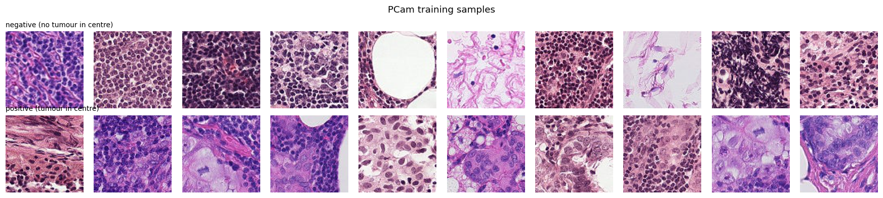
Figure 1 – Random PCam training samples. Top row: negative (no tumour in the centre). Bottom row: positive (tumour in the centre). Source: notebook cell 3.

3.3 Splits and class balance
Table 1 – PCam splits as loaded in the notebook
Split | Images | Positives | Positive rate | Shape / dtype
Train | 262,144 | 131,072 | 0.5000 | 96×96×3, uint8
Validation | 32,768 | 16,369 | 0.4995 | 96×96×3, uint8
Test | 32,768 | 16,377 | 0.4998 | 96×96×3, uint8
Total | 327,680 | 163,818 | 0.4999

The three splits are practically perfectly balanced, so accuracy is not misleading, although we still report macro-F1 and balanced accuracy as a good habit for medical data where balance rarely holds in deployment. The official predefined partition was kept untouched.

3.4 Stain and scanner shift between splits
PCam's splits come from different slides, so staining and scanner differences create a domain shift between train, validation and test. We quantified it from 5,000 randomly sampled images per split.
Table 2 – Colour statistics per split (5,000 sampled images each, pixel values in [0, 1])
Split | Mean R | Mean G | Mean B | Std R | Std G | Std B
Train | 0.7018 | 0.5400 | 0.6924 | 0.2354 | 0.2778 | 0.2127
Validation | 0.6975 | 0.5354 | 0.6879 | 0.2364 | 0.2786 | 0.2149
Test | 0.6800 | 0.5222 | 0.6940 | 0.2420 | 0.2832 | 0.2099

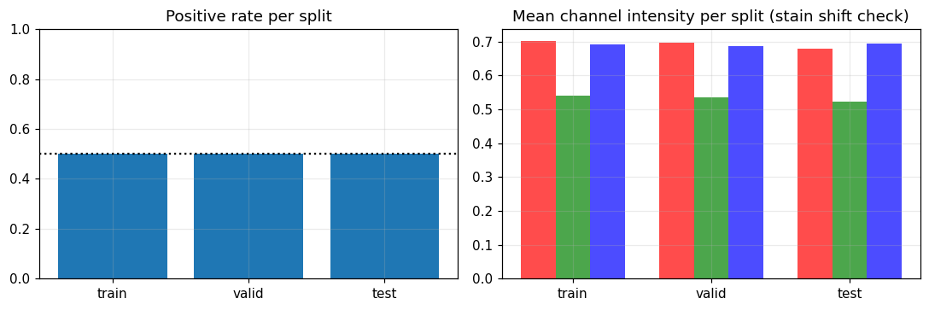
Figure 2 – Positive rate (left) and mean channel intensity (right) per split. Source: notebook cell 3.
The test set is visibly shifted (lower red and green means, higher blue mean). This matters later: models that look good on validation can lose accuracy on test, which is a well-known PCam pitfall and one of the reasons we never use the test set for any selection.

4. Why Several Label Budgets, Seeds and Metrics?
The phrase "multiple labels" in this project means multiple label budgets: the same experiment repeated with 10 %, 25 %, 50 % and 100 % of the training labels. The reasons are:
- A single full-data score hides annotation efficiency. One number at 100 % cannot tell us whether the last 200,000 labels were worth their cost. Four budgets produce a learning curve that shows saturation, diminishing returns, and the cross-over point where one architecture overtakes another.
- It simulates real annotation constraints. 10 % and 25 % mimic a hospital that can afford to label only a small part of its archive; 50 % and 100 % show the benefit of expanding the labelled set.
- It separates two explanations of weak performance. If accuracy rises with more labels, labels are the bottleneck; if the curve is flat (as for our frozen encoders), the representation is the bottleneck.
- Nested, class-stratified subsets (10 % ⊂ 25 % ⊂ 50 % ⊂ 100 %, per seed) make the points on a curve directly comparable, because each larger budget contains every sample of the smaller one and the class ratio is preserved.
- Three seeds (0, 1, 2) change which samples enter the subset and the head initialisation. Reporting mean ± standard deviation shows how much of an observed difference is just sampling luck, which is crucial at 10 % where the subset is small.
- Several metrics are used because each one answers a different question: macro-F1 and balanced accuracy (class-balanced quality), AUROC (ranking independent of threshold), ECE / Brier / NLL (probability quality) and risk–coverage (usefulness of confidence for deferring cases).
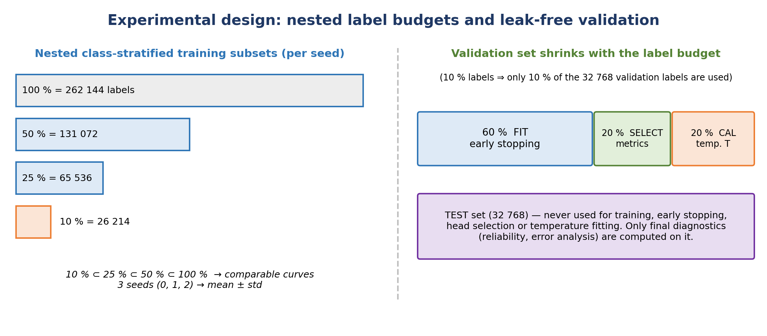
Figure 3 – Experimental design: nested label budgets (left) and the validation split that shrinks with the budget (right).
A rigor rule that is easy to miss: the validation set shrinks with the label budget
If the training set is cut to 10 % but early stopping and calibration still use all 32,768 validation labels, the "low-label" setting would secretly use 32 k extra labels. We therefore scale the validation set by the same fraction and split it 60 % FIT (early stopping) / 20 % SELECT (reported validation metrics) / 20 % CAL (temperature scaling fitting). The consequence is that, at 10 %, validation metrics are computed on only ≈ 650 images, which explains part of the seed-to-seed variance.

5. Methodology and Code Walk-through
The notebook is organised as numbered Colab cells. Each long-running cell has a wall-clock budget (3.5 h, below Colab's 4 h limit), saves its state atomically and skips already-finished work when re-run, so an interrupted session can be resumed without losing results.
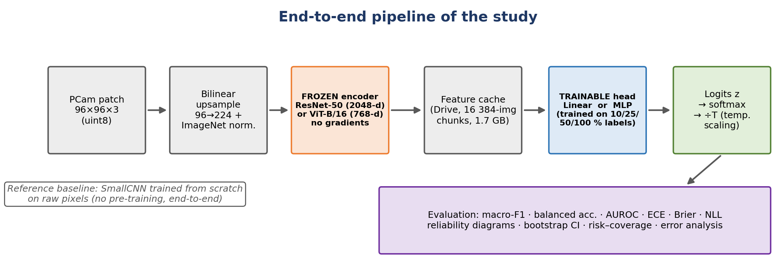
Figure 4 – End-to-end pipeline: frozen encoder → cached features → trainable head → calibrated probabilities → evaluation.
Table 3 – What each notebook cell does and why
Cell | What the code does | Why
1 Setup | Mounts Google Drive, installs timm / h5py / scikit-learn, defines the config CFG (seeds 0-2, fractions, models, batch size 256, 224 px), helper functions (seeding, Budget time guard, atomic saves, JSONL logging), verifies a GPU and saves the environment to logs/environment.json. | Reproducibility: every setting and package version is recorded in one place.
2 Data | Resumable download of the 6 PCam HDF5 files from Zenodo, conversion to uint8 memory-mapped .npy, labels copied to Drive. Download + conversion took ≈ 697 s (valid), 694 s (test), 2,836 s (train). | Fast random access for training; resilience to Colab disconnections.
3 Dataset analysis | Positive rates, per-channel mean/std from 5,000 images per split, sample grid, stain-shift plot. | Understand balance and domain shift before modelling.
4 Feature extraction | Builds frozen ResNet-50 / ViT-B/16 with timm (num_classes=0), upsamples 96→224 bilinearly, normalises with the encoder's own mean/std, runs in fp16 autocast and saves features in 16,384-image chunks (float16). ResNet ≈ 393 s, ViT ≈ 928 s in total. | Embed each image once; all later experiments reuse the cache.
5 Toolkit | Defines the heads, train_head (AdamW, early stopping), metrics (macro-F1, balanced accuracy, AUROC, ECE, Brier, NLL), temperature scaling (LBFGS on log T), nested subset sampling, and the 60/20/20 validation split. Never touches the test set. | One tested toolkit used by every run avoids inconsistencies.
6 Label-budget grid | 48 runs = 2 encoders × 2 heads × 4 fractions × 3 seeds. Each run trains a head on the nested subset, evaluates on the validation SELECT subset, fits T on CAL, saves a checkpoint and appends a JSON record. Each run takes 1–10 s. | Learning curves with mean ± std.
7 Aggregation | Mean ± std tables, label efficiency (F1@10 % / F1@100 %), paired ViT − ResNet gaps, learning-curve plots. Validation only. | Model comparison without test leakage.
8 Calibration | Selects the best head per encoder by validation F1, loads the saved checkpoints, computes test logits, reliability diagrams (raw vs. temperature-scaled) and 1,000-sample bootstrap 95 % CIs on ECE. | Does confidence reflect reliability?
9 Error analysis | Confusion matrices, FPR/FNR, confidence histograms, error-detection AUROC, risk–coverage curves, AURC, errors with confidence ≥ 0.90. | Where and how does the model fail?
10 Scratch CNN | Trains SmallCNN end-to-end at the 4 budgets (1 seed) with augmentation, OneCycle LR, mixed precision, per-epoch checkpoints, early stopping, temperature scaling. | Does pre-training actually help?
11–14 Reporting | Writes RESULTS.md, verifies files (56 checkpoints, 48 feature files, 5 figures), measures folder sizes (features 1.719 GB, checkpoints 0.153 GB), creates .gitignore. | Delivery and repository hygiene.

6. Architectures and Their Parameters
Three model families are compared. The two pretrained encoders are used purely as frozen feature extractors (no gradient flows into them); only the small head on top is trained. The third model is trained end-to-end from random initialisation.

6.1 ResNet-50 (convolutional network)
ResNet-50 (He et al., 2016) stacks 16 bottleneck residual blocks in four stages (3-4-6-3). Each block compresses the channels with a 1 × 1 convolution, applies a 3 × 3 convolution, expands again with a 1 × 1 convolution, and adds the input back through a skip connection. The skip connections let gradients flow through 50 layers and make very deep networks trainable. Convolutions have a strong locality and translation-equivariance bias: spatial context is built up gradually with depth. We remove the 1000-class classifier (num_classes=0) and keep the 2,048-dimensional global-average-pooled vector. Weights: resnet50.tv_in1k (ImageNet-1k, supervised), about 23.5 M parameters without the classifier.
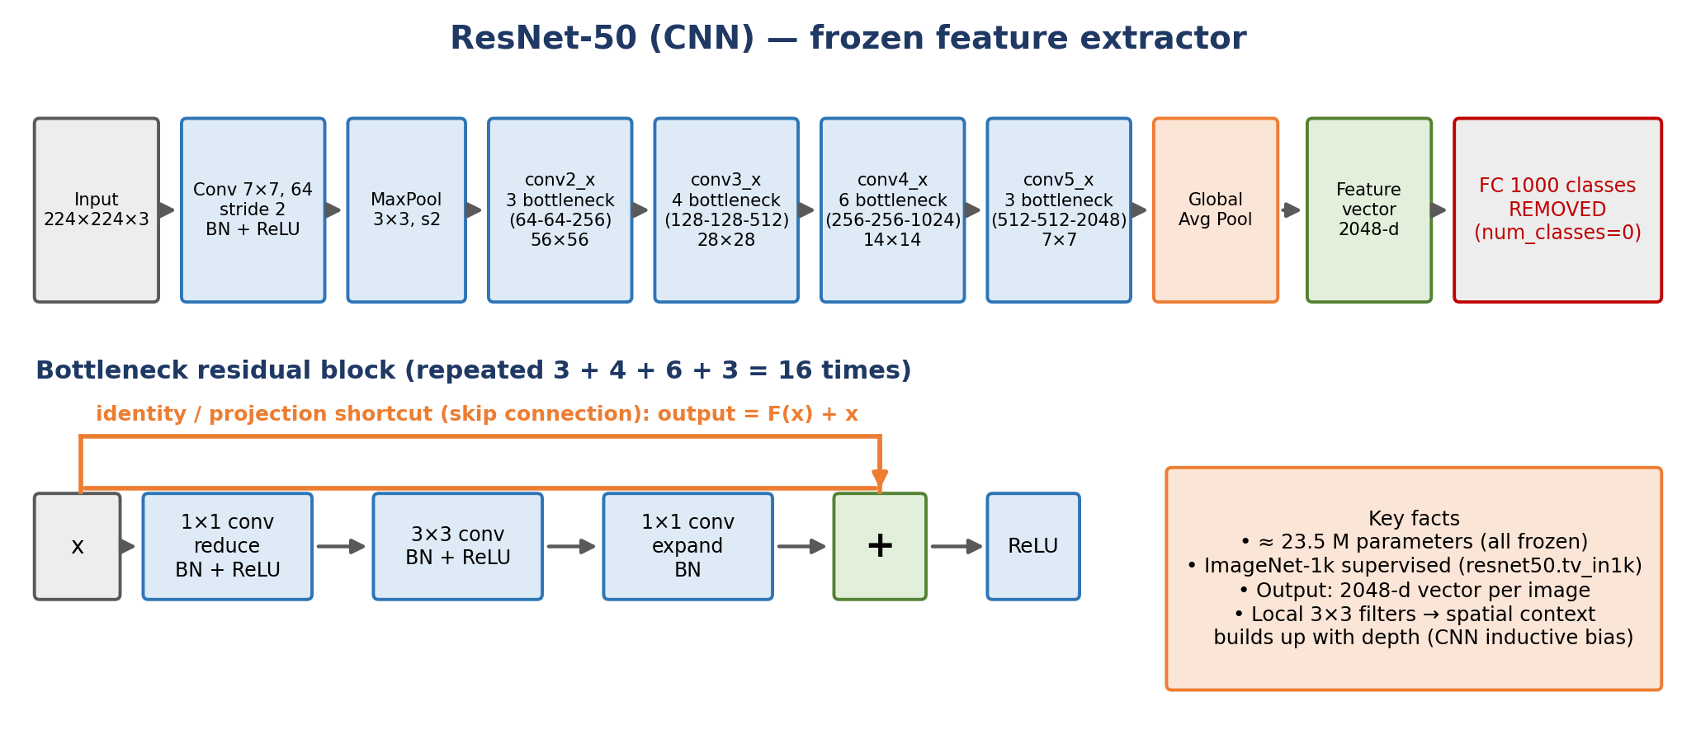
Figure 5 – ResNet-50 feature extractor and the bottleneck residual block.

6.2 ViT-B/16 (Vision Transformer)
The Vision Transformer (Dosovitskiy et al., 2021) cuts the 224 × 224 image into 196 non-overlapping 16 × 16 patches, projects each to a 768-dimensional token, prepends a learnable [CLS] token and adds position embeddings. Twelve identical encoder blocks (LayerNorm → multi-head self-attention with 12 heads → residual; LayerNorm → MLP 768→3072→768 with GELU → residual) let every patch exchange information with every other patch from the first layer, giving global context but a weaker built-in locality bias than a CNN. The output [CLS] token (768-d) is the image descriptor. Weights: vit_base_patch16_224.augreg_in1k (ImageNet-1k, supervised, AugReg recipe), about 86 M parameters.
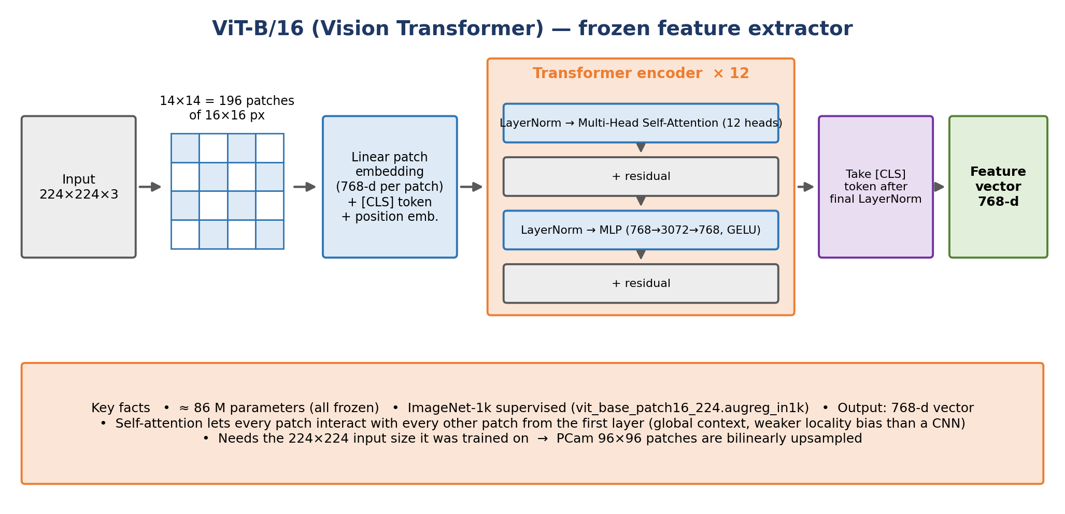
Figure 6 – ViT-B/16 feature extractor.
Why both are ImageNet-1k supervised. Using the same pre-training data for both encoders means a difference in results can be attributed to the architecture (convolution vs. attention) and not to different pre-training data. Why upsample to 224. Both networks were trained at 224 × 224; ViT in particular has fixed position embeddings for a 14 × 14 patch grid, so the 96 × 96 PCam patches are bilinearly resized and normalised with each model's own ImageNet mean/std.

6.3 The two classification heads
Features are first standardised (mean and standard deviation computed from the training subset). The linear head is a single Linear(d → 2) layer, a "linear probe": if it works well, the frozen feature space is already (nearly) linearly separable for this task. The MLP head adds one hidden layer (Linear(d → 512) → GELU → Dropout(0.3) → Linear(512 → 2)), testing whether a non-linear decision boundary helps or whether the extra capacity overfits when labels are scarce.
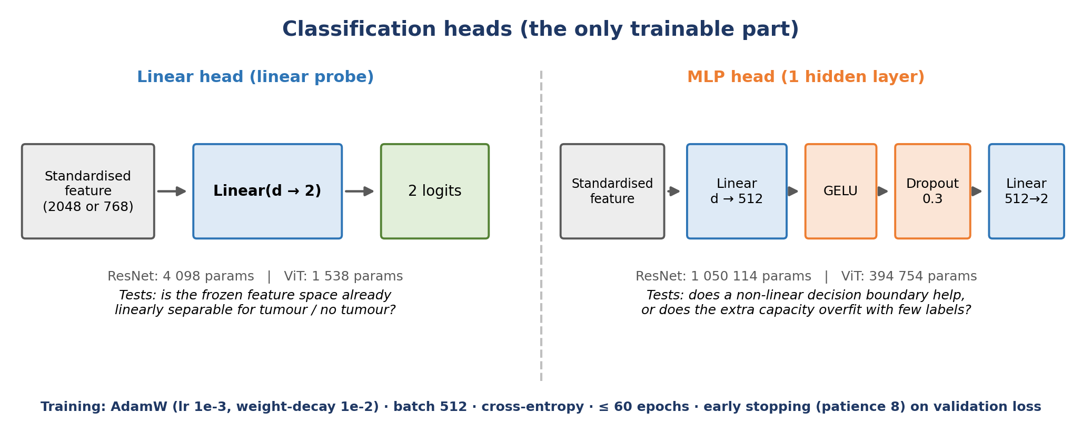
Figure 7 – Linear and MLP classification heads (the only trainable part of the feature-based models).

6.4 SmallCNN trained from scratch
As a reference without pre-training, a compact VGG-style CNN with four double-convolution blocks (32 → 64 → 128 → 256 channels, each block: two 3 × 3 convolutions with batch-norm + ReLU, then 2 × 2 max-pooling) is trained directly on 96 × 96 pixels. It uses global average pooling, dropout 0.3 and a 256 → 2 linear classifier, for 1,173,730 trainable parameters, roughly 20× fewer than ResNet-50 and 70× fewer than ViT-B/16. Because it learns from PCam pixels it can adapt to histological texture, nuclei shape and stain; because it has few parameters it needs fewer labels than a large network trained from scratch would.
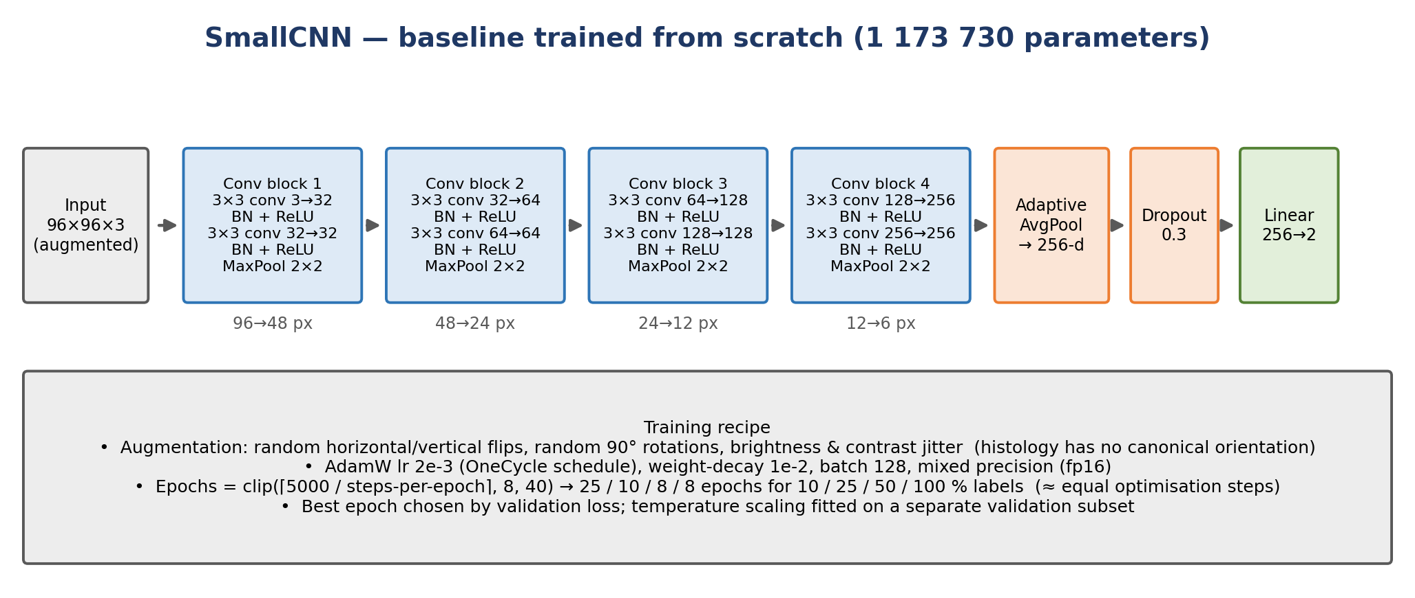
Figure 8 – SmallCNN baseline and its training recipe.

6.5 Parameter summary and rationale
Table 4 – Model sizes
Model | Encoder parameters | Feature size | Trainable parameters | Pre-training
ResNet-50 + linear | ≈ 23.5 M (frozen) | 2,048 | 4,098 | ImageNet-1k
ResNet-50 + MLP | ≈ 23.5 M (frozen) | 2,048 | 1,050,114 | ImageNet-1k
ViT-B/16 + linear | ≈ 86 M (frozen) | 768 | 1,538 | ImageNet-1k
ViT-B/16 + MLP | ≈ 86 M (frozen) | 768 | 394,754 | ImageNet-1k
SmallCNN (scratch) | none | n/a | 1,173,730 | none

Table 5 – Hyper-parameters actually used in the code, and why
Component | Setting | Reason
Input resolution | 96 → 224 (bilinear) | Match the encoders' pre-training size.
Feature storage | float16, chunks of 16,384 | Halves disk use (1.7 GB total); chunking enables resuming.
Head optimiser | AdamW, lr 1e-3, weight-decay 1e-2 | Standard, stable for small heads; decoupled weight decay regularises.
Head training | batch 512, ≤ 60 epochs, early stopping patience 8 on validation-FIT loss | Prevents overfitting; ties training length to the validation budget.
MLP | hidden 512, GELU, dropout 0.3 | Moderate capacity with regularisation.
Label budgets / seeds | 10, 25, 50, 100 % / seeds 0, 1, 2 | Learning curves with uncertainty.
Validation split | 60 % FIT / 20 % SELECT / 20 % CAL, scaled by budget | Independent roles avoid optimistic bias; no hidden extra labels.
Temperature scaling | one scalar T (log-parametrised, LBFGS, clamped to [0.05, 20]) | Fixes over/under-confidence without changing the ranking.
ECE | 15 bins on confidence ∈ [0.5, 1] | Standard top-label ECE for a binary problem.
Bootstrap | 1,000 resamples of the test set, 95 % percentile CI | Quantifies sampling uncertainty of ECE.
SmallCNN optimiser | AdamW, lr 2e-3 OneCycle, wd 1e-2, batch 128, fp16 mixed precision | Fast convergence in a short epoch budget on a T4.
SmallCNN epochs | clip(⌈5000 / steps-per-epoch⌉, 8, 40) → 25 / 10 / 8 / 8 | Roughly equal optimisation steps across budgets.
SmallCNN augmentation | h/v flips, 90° rotations, brightness & contrast jitter | Histology has no canonical orientation; jitter mimics stain variation.

7. Evaluation Metrics
Table 6 – Metrics and what each one tells us
Metric | Meaning | Why it is used
Macro-F1 | Mean of the F1 scores of the two classes. | Treats both classes equally.
Balanced accuracy | Mean of sensitivity and specificity. | Class-wise performance; robust to imbalance.
AUROC | Probability that a random positive is ranked above a random negative. | Separation quality independent of a threshold.
ECE (15 bins) | Weighted gap between confidence and accuracy per confidence bin. | Do probabilities mean what they say? Lower is better.
Temperature-scaled ECE | ECE after dividing logits by a fitted T. | Measures what a simple post-hoc fix can achieve.
Brier score / NLL | Mean squared probability error / negative log-likelihood (proper scoring rules). | Jointly reward accuracy and calibration; NLL punishes confident errors heavily.
Error-detection AUROC | How well low confidence identifies misclassified patches. | Is uncertainty informative for human review?
Risk–coverage, AURC | Error rate on the retained patches when the least confident are deferred. | Selective prediction / human-in-the-loop.
FPR / FNR | False-positive and false-negative rates. | In medicine a false negative (missed tumour) is usually costlier.

8. Results
Important reading rule. Aggregate comparisons (Sections 8.1–8.3) use validation data only, to keep the test set untouched. Test-set numbers (Sections 8.4–8.6) are final diagnostics for the head selected on validation (linear for both encoders), seed 0. Validation and test numbers must not be compared directly with each other.

8.1 Validation macro-F1 versus label budget
Table 7 – Validation macro-F1, mean ± std over 3 seeds (scratch CNN: 1 seed)
Model / head | 10 % | 25 % | 50 % | 100 %
ResNet-50 / Linear | 0.8495 ± 0.0061 | 0.8525 ± 0.0049 | 0.8473 ± 0.0016 | 0.8531 ± 0.0076
ResNet-50 / MLP | 0.8374 ± 0.0061 | 0.8521 ± 0.0069 | 0.8504 ± 0.0050 | 0.8460 ± 0.0099
ViT-B/16 / Linear | 0.8624 ± 0.0041 | 0.8512 ± 0.0041 | 0.8456 ± 0.0037 | 0.8468 ± 0.0041
ViT-B/16 / MLP | 0.8561 ± 0.0063 | 0.8488 ± 0.0028 | 0.8535 ± 0.0106 | 0.8422 ± 0.0132
SmallCNN (scratch) | 0.8796 | 0.8942 | 0.9110 | 0.9070

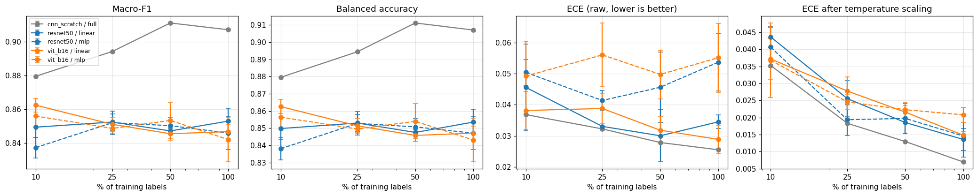
Figure 9 – Learning curves (validation): macro-F1, balanced accuracy, raw ECE and temperature-scaled ECE versus the percentage of training labels. Source: notebook cell 7.
The feature-based curves are essentially flat: going from 26 k to 262 k labels changes macro-F1 by less than about 0.01, which is the same order as the seed standard deviation. The frozen representation is so dominant that the linear probe has already extracted nearly everything it can at 10 %. The scratch CNN, in contrast, improves with labels (0.880 → 0.911 at 50 %) and surpasses all frozen-feature models even at 10 %. Note that the scratch CNN uses a different random split of the validation set than the feature models, so its validation values are indicative rather than strictly paired.

8.2 ViT versus ResNet (paired by head, fraction and seed)
Table 8 – Macro-F1 gap, ViT − ResNet (mean ± std over 3 paired seeds)
Head | 10 % | 25 % | 50 % | 100 %
Linear | +0.0129 ± 0.0094 | −0.0013 ± 0.0088 | −0.0016 ± 0.0052 | −0.0062 ± 0.0054
MLP | +0.0186 ± 0.0022 | −0.0034 ± 0.0094 | +0.0031 ± 0.0154 | −0.0038 ± 0.0070

ViT's advantage appears at 10 % labels (positive for both heads) and disappears at higher budgets, where ResNet is marginally better at 100 %. With three seeds and gaps of the same size as the standard deviation, these are tendencies in this setup, not a universal ranking.

8.3 Label efficiency
Table 9 – Fraction of the 100 %-label F1 retained with 10 % of the labels (validation)
Model / head | F1 @ 10 % | F1 @ 100 % | Retained
ResNet-50 / Linear | 0.8495 | 0.8531 | 99.58 %
ResNet-50 / MLP | 0.8374 | 0.8460 | 98.99 %
ViT-B/16 / Linear | 0.8624 | 0.8468 | 101.84 %
ViT-B/16 / MLP | 0.8561 | 0.8422 | 101.65 %
SmallCNN (scratch) | 0.8796 | 0.9070 | 96.97 %

Retained values above 100 % do not mean that fewer labels generalise better; they reflect finite validation samples (≈ 650 images at 10 %), subset composition and run-to-run noise.

8.4 Test-set performance
Test macro-F1 was recorded for the scratch CNN. For the feature models the notebook stored the error rate; because the test set is balanced (positive rate 0.4998) accuracy and balanced accuracy are practically identical, so we report test accuracy = 1 − error rate (seed 0, linear head).
Table 10 – Test performance (seed 0)
Model | 10 % | 25 % | 50 % | 100 %
ResNet-50 / Linear – accuracy | 0.8097 | 0.8157 | 0.8165 | 0.8109
ViT-B/16 / Linear – accuracy | 0.8303 | 0.8366 | 0.8348 | 0.8302
SmallCNN – macro-F1 | 0.8630 | 0.8773 | 0.8853 | 0.8867

Two observations. First, the validation → test drop is larger for the frozen-feature models (≈ 0.85 → 0.81–0.83) than for the scratch CNN (0.907 → 0.887 at 100 %), which is consistent with the stain shift documented in Section 3.4 and with the brightness/contrast augmentation used by the CNN (a plausible explanation, not tested by an ablation). Second, the scratch CNN is the best model on test at every budget, so in this experiment domain-specific learning beat generic pretrained features, even with 10 % of the labels.

8.5 Calibration: does confidence reflect reliability?
Table 11 – Test ECE before/after temperature scaling (seed 0, linear head, 95 % bootstrap CI)
Model | Labels | T | Raw ECE [95 % CI] | Scaled ECE [95 % CI]
ResNet-50 | 10 % | 1.474 | 0.0728 [0.0691, 0.0768] | 0.0243 [0.0219, 0.0292]
ViT-B/16 | 10 % | 1.275 | 0.0346 [0.0314, 0.0384] | 0.0099 [0.0085, 0.0149]
ResNet-50 | 100 % | 1.282 | 0.0715 [0.0680, 0.0756] | 0.0421 [0.0389, 0.0465]
ViT-B/16 | 100 % | 1.193 | 0.0369 [0.0338, 0.0411] | 0.0157 [0.0132, 0.0201]

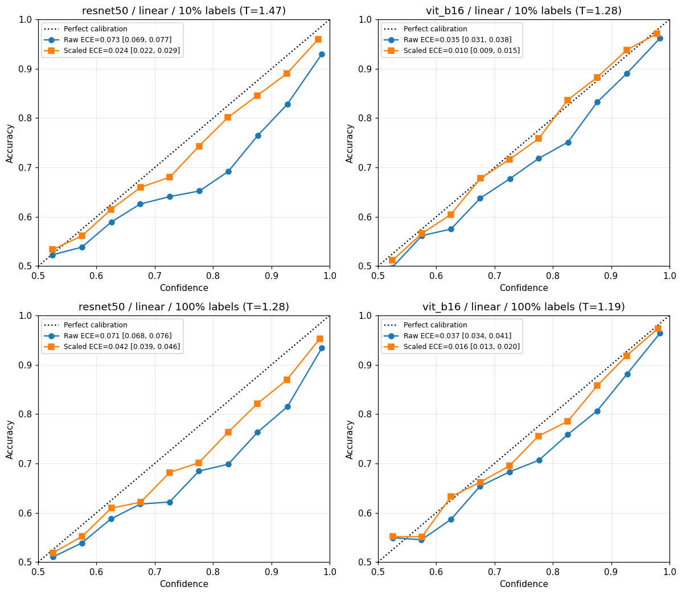
Figure 10 – Reliability diagrams on the test set. Dotted line = perfect calibration; blue = raw, orange = after temperature scaling. Source: notebook cell 8.
In all four cases the raw curve lies below the diagonal (accuracy < confidence), i.e. the models are over-confident, and every fitted temperature is above 1, which softens the probabilities. Temperature scaling reduces ECE everywhere and the confidence intervals of raw and scaled ECE do not overlap. ViT is better calibrated than ResNet both before and after scaling. Temperature scaling cannot repair everything: ResNet at 100 % keeps a residual ECE of 0.042, a hint that the temperature fitted on the (shifted) validation data does not fully transfer to the test slides.

8.6 Error analysis and selective prediction
Table 12 – Test error analysis (seed 0, linear head)
Model | Labels | Error | FPR | FNR | Err-detect AUROC | AURC | Risk @90 % cov. | Errors with conf ≥ 0.9
ResNet-50 | 10 % | 0.1903 | 0.0890 | 0.2917 | 0.7592 | 0.0798 | 0.1611 | 902
ResNet-50 | 25 % | 0.1843 | 0.0875 | 0.2812 | 0.7787 | 0.0706 | 0.1550 | 1,201
ResNet-50 | 50 % | 0.1835 | 0.0889 | 0.2783 | 0.7774 | 0.0713 | 0.1528 | 947
ResNet-50 | 100 % | 0.1891 | 0.0794 | 0.2990 | 0.7652 | 0.0773 | 0.1592 | 1,195
ViT-B/16 | 10 % | 0.1697 | 0.1062 | 0.2333 | 0.7920 | 0.0623 | 0.1370 | 589
ViT-B/16 | 25 % | 0.1634 | 0.1016 | 0.2252 | 0.7890 | 0.0598 | 0.1329 | 740
ViT-B/16 | 50 % | 0.1652 | 0.1023 | 0.2281 | 0.7921 | 0.0592 | 0.1338 | 639
ViT-B/16 | 100 % | 0.1698 | 0.1011 | 0.2385 | 0.7883 | 0.0616 | 0.1390 | 688

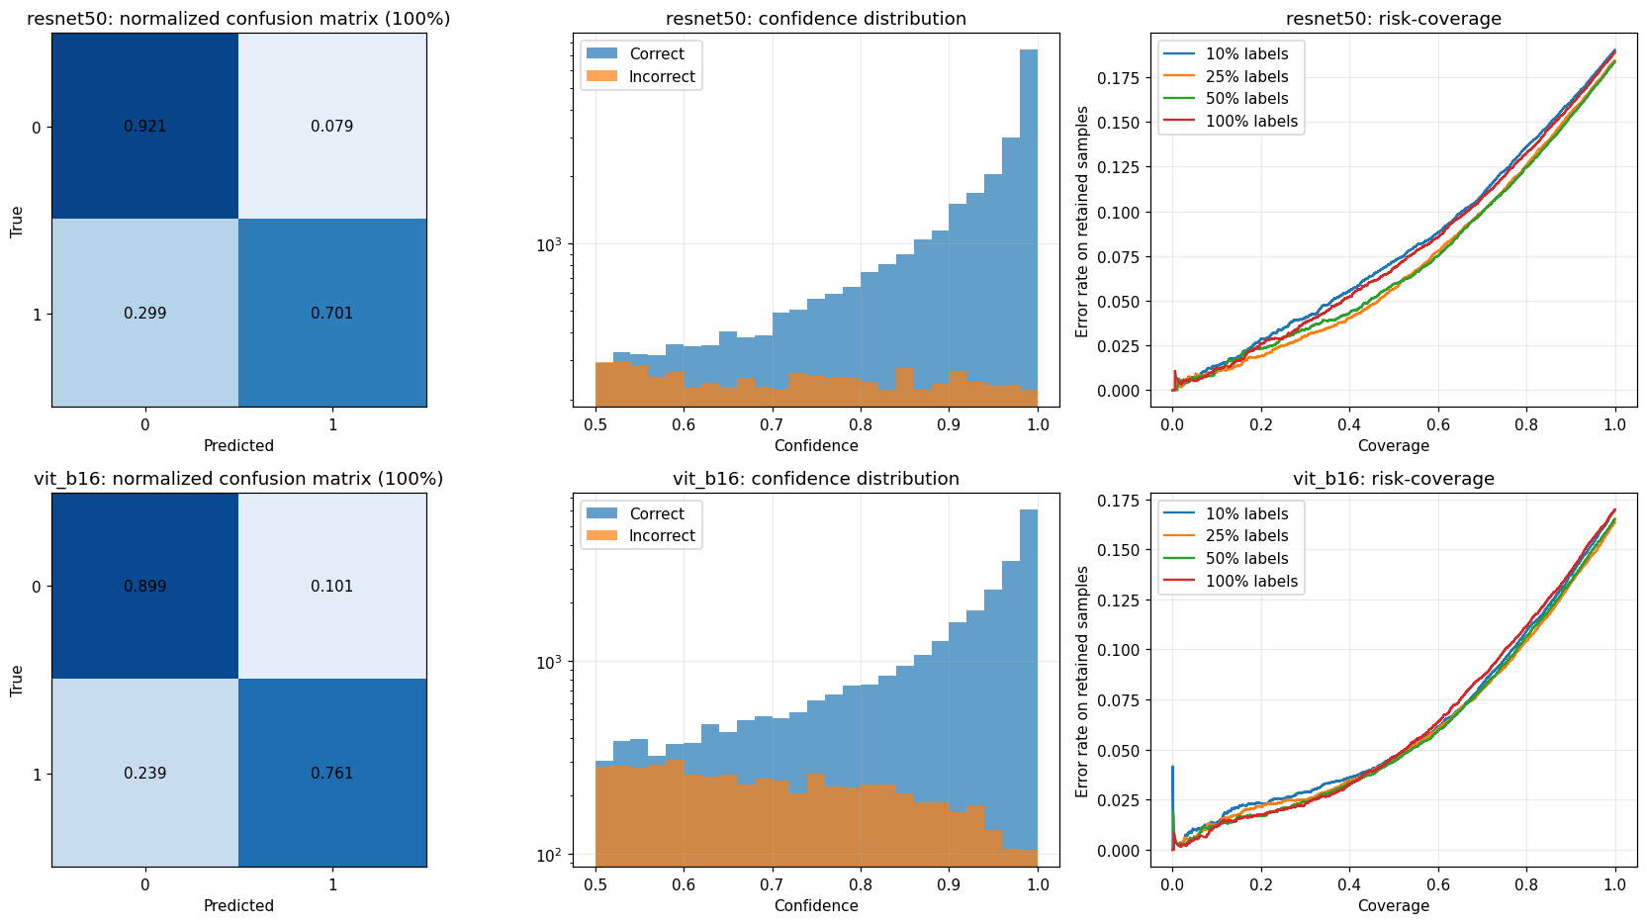
Figure 11 – Normalised confusion matrices (100 % labels), confidence distributions of correct vs. incorrect predictions, and risk–coverage curves. Source: notebook cell 9.
- Where the errors are. The dominant error is the false negative: ResNet-50 misses 28–30 % of tumour patches and ViT 23–24 %, versus 8–11 % false positives. In a screening context this is the costly direction, so the decision threshold should be tuned with clinical input rather than left at 0.5.
- ViT vs ResNet. ViT has the lower overall error and FNR; ResNet has the lower FPR. Neither dominates on every metric.
- Confidence is informative. The AUROC for detecting errors from confidence is 0.76–0.79 (random = 0.5); retaining only the most confident 80 % of the patches lowers the error to about 0.10–0.13.
- But it is not enough. Between 589 and 1,201 of the 32,768 test patches are wrong while the model is ≥ 90 % confident. These "confident mistakes" cannot be filtered out by a confidence threshold alone.
- Labels barely change the picture. Error rates, FNR and AURC are almost identical from 10 % to 100 % labels, mirroring the flat validation learning curves.

9. Comparison and Discussion
Table 13 – Side-by-side comparison of the model families
Aspect | ResNet-50 (frozen) | ViT-B/16 (frozen) | SmallCNN (scratch)
Inductive bias | Local convolutions, translation equivariance | Global self-attention, weak locality bias | Local convolutions (shallow)
Trainable parameters | 4 k (linear) / 1.05 M (MLP) | 1.5 k (linear) / 0.39 M (MLP) | 1.17 M (all)
Learning from | ImageNet photographs | ImageNet photographs | PCam pixels only
Cost per experiment | Seconds (cached features); encoder pass ≈ 6.5 min once | Seconds; encoder pass ≈ 15.5 min once | Minutes per run, GPU training with augmentation
Val. macro-F1 (10 % → 100 %) | 0.850 → 0.853 (linear) | 0.862 → 0.847 (linear) | 0.880 → 0.907
Test (10 % → 100 %) | Acc 0.810 → 0.811 | Acc 0.830 → 0.830 | Macro-F1 0.863 → 0.887
Test error pattern | Lower FPR (≈ 8–9 %), higher FNR (≈ 28–30 %) | Lower FNR (≈ 23–24 %), higher FPR (≈ 10 %) | n/a (not stored)
Calibration (test ECE raw → scaled) | 0.073 → 0.024 (10 %); 0.072 → 0.042 (100 %) | 0.035 → 0.010 (10 %); 0.037 → 0.016 (100 %) | 0.026 → 0.023 (10 %); 0.032 → 0.012 (100 %)
Strengths | Label-efficient; cheap; stable | Best frozen model at 10 %; best calibrated; lowest FNR | Adapts to histology; improves with data; smallest val→test drop
Weaknesses | Domain gap, flat curve, high FNR | Domain gap, flat curve, needs 224-px input | Needs more compute and labels; single seed here; noisy validation loss

9.1 What the comparison teaches
- Pre-training makes small label budgets viable but not optimal. Frozen ImageNet features reach ≈ 0.85 validation F1 with only 26 k labels, yet they cannot exceed that with 10× more labels, because they were never trained on tissue.
- Architecture matters mostly when labels are scarcest. ViT's global attention gives a small, consistent advantage at 10 % and better calibration; the advantage vanishes with more labels.
- Head capacity does not help. The MLP is never consistently better than the linear head and often has higher variance and worse ECE. The features are the limit, not the classifier.
- Domain-specific training wins when it can be afforded. A 1.2 M-parameter CNN trained on PCam beats 23 M and 86 M-parameter frozen encoders on test. The next logical step is therefore to fine-tune or to use histology-specific self-supervised pre-training (Section 11).
- Accuracy, calibration and error structure are different things. The model that is most accurate is not automatically the one whose confidence is most trustworthy, and a good aggregate score can hide a 24–30 % miss rate on tumour patches.

10. Limitations and Why We Enhanced the Pipeline

10.1 Limitations of a naive approach, and the enhancement we made for each
Table 14 – From limitation to enhancement
Limitation of a basic study | Why it is a problem | Enhancement in this project
Single full-data score | Hides annotation efficiency and saturation. | Four nested label budgets (10 / 25 / 50 / 100 %).
One run per setting | A small random subset may be unrepresentative. | 3 seeds → mean ± std; paired comparisons.
One architecture | A conclusion may be specific to that network. | CNN (ResNet-50) vs Transformer (ViT-B/16), same pre-training data.
Only a strong classifier | Does not show if capacity or features limit performance. | Linear vs MLP heads.
Accuracy only | Misleading under imbalance; ignores probability quality. | Macro-F1, balanced accuracy, AUROC, ECE, Brier, NLL.
Raw, uncalibrated confidence | Over-confident outputs are unsafe for decision support. | Reliability diagrams, temperature scaling, bootstrap CIs.
Aggregate metrics only | Hide failure behaviour. | Confusion matrices, FPR/FNR, risk–coverage, high-confidence errors.
Full validation set used with few labels | Secretly uses 32 k extra labels in the low-label setting. | Validation shrinks with the budget; 60/20/20 FIT/SELECT/CAL split.
Model selection on the test set | Optimistic, leaked estimates. | Selection on validation; test used only for final diagnostics.
No reference without pre-training | Cannot tell whether pre-training helps. | SmallCNN trained from scratch.
Fragile Colab sessions | Disconnections destroy hours of work. | Time-boxed, resumable cells; atomic saves; Drive checkpoints; cached features.
Non-reproducible outputs | Hard to audit or reuse. | Environment JSON, JSONL run logs, RESULTS.md, .gitignore.

10.2 Remaining limitations (threats to validity)
- Patch-level, single-benchmark scope. No whole-slide, patient-level or multi-hospital validation; results may not transfer to other scanners, stains or tissues.
- Not a clinical system. No claim of diagnostic safety is made. Weak (centre-window) labels and a 24–30 % miss rate for frozen features would be unacceptable for diagnosis.
- Scratch CNN has one seed and a budget-dependent epoch schedule (25 / 10 / 8 / 8). Its comparison with the 3-seed feature models is therefore indicative, not statistical. Its validation loss is also noisy between epochs (e.g. a spike to 1.23 at epoch 9 of the 10 % run), so the "best epoch" is partly luck.
- Different training procedures. Frozen encoder + shallow head and end-to-end CNN training are not compute-matched or optimiser-matched.
- Calibration and error analysis use seed 0 only and the linear head. Bootstrap CIs capture test-sampling uncertainty but not variation across seeds, hospitals or scanners.
- Small validation subsets at low budgets (≈ 650 images for SELECT at 10 %) make low-budget validation metrics noisy; retained-% values above 100 % illustrate this.
- Validation → test shift. Temperature fitted on validation does not fully carry over to the stain-shifted test set (e.g. ResNet-50 at 100 %).
- Frozen encoders and ImageNet only. No fine-tuning and no histology-specific pre-training were tried.
- Feature-model test macro-F1 was not stored, so Table 10 uses accuracy derived from the error rate (equivalent here because the test set is balanced).

11. Future Work
- Repeat the scratch-CNN runs with at least 3 seeds per budget and report confidence intervals and paired tests for all headline metrics.
- Fine-tune ResNet-50 and ViT-B/16 end-to-end (and partially, e.g. last blocks) with validation-only selection and matched compute.
- Try histology-specific self-supervised pre-training (e.g. DINO / MAE trained on unlabelled pathology patches), which targets the domain gap identified here and uses the cheap unlabelled archive.
- Use stain normalisation and stronger colour augmentation to reduce the validation → test shift; evaluate on external datasets.
- Select the operating threshold with clinicians by weighting false negatives and false positives, and report sensitivity at fixed specificity.
- Study confidence-based deferral with human reviewers and add stronger uncertainty estimates (ensembles, MC-dropout) for the confident-error cases.
- Add active learning to choose which patches to label instead of random subsets.
- Package the work with pinned dependencies, a configuration file, a model card and an inference script.

12. Conclusion
This project built a rigorous, reproducible study of PatchCamelyon classification under limited labels. Frozen pretrained representations are remarkably label-efficient: 10 % of the labels give the same validation quality as 100 %, with the Vision Transformer slightly ahead at the smallest budget and better calibrated. However, the same experiment shows that frozen ImageNet features plateau at a modest level and that a small CNN trained on PCam itself outperforms them on the test set, pointing to the domain gap, rather than the number of labels, as the real limitation. Confidence scores are over-confident out of the box, but a single temperature parameter removes most of the miscalibration, and confidence carries real information about errors, although hundreds of confident mistakes remain.
The pipeline is deliberately defensive against the usual pitfalls (test leakage, hidden labels in validation, single-seed conclusions, uncalibrated outputs). Its scope is a patch-level research benchmark; it should be presented as a technical prototype and a basis for fine-tuning and domain-specific pre-training, not as a clinically validated diagnostic tool.

References
- Veeling, B. S., Linmans, J., Winkens, J., Cohen, T., Welling, M. (2018). Rotation Equivariant CNNs for Digital Pathology. MICCAI 2018. (PatchCamelyon dataset)
- Bejnordi, B. E. et al. (2017). Diagnostic Assessment of Deep Learning Algorithms for Detection of Lymph Node Metastases in Women With Breast Cancer. JAMA, 318(22). (CAMELYON16)
- He, K., Zhang, X., Ren, S., Sun, J. (2016). Deep Residual Learning for Image Recognition. CVPR 2016.
- Dosovitskiy, A. et al. (2021). An Image is Worth 16×16 Words: Transformers for Image Recognition at Scale. ICLR 2021.
- Steiner, A. et al. (2021). How to train your ViT? Data, Augmentation, and Regularization in Vision Transformers. (AugReg weights)
- Guo, C., Pleiss, G., Sun, Y., Weinberger, K. Q. (2017). On Calibration of Modern Neural Networks. ICML 2017. (temperature scaling, ECE)
- Wightman, R. PyTorch Image Models (timm). https://github.com/huggingface/pytorch-image-models

Appendix A. Reproducibility and Artifacts
Table 15 – Verified project artifacts (from the notebook's verification cells)
Artifact | State
RESULTS.md | Created
results/summary_mean_std.csv, calibration_table.csv, error_analysis.csv | Present and non-empty
Checkpoints (ckpt/) | 56 files, ≈ 0.153 GB
Extracted features (features/) | 48 chunk files, ≈ 1.719 GB
Figures (figures/) | 5 PNG files
Hardware / software | Tesla T4 GPU, PyTorch 2.11 (CUDA 13), timm, scikit-learn, h5py
Project root | /content/drive/MyDrive/pcam_project

For GitHub, commit the notebook, README, RESULTS.md, small result CSVs and figures; the generated .gitignore excludes ckpt/, features/, preds/, labels/, logs/ and temporary files. All numbers in this report are copied from the executed notebook outputs; values that were not recorded (for example feature-model test macro-F1) were not invented.

