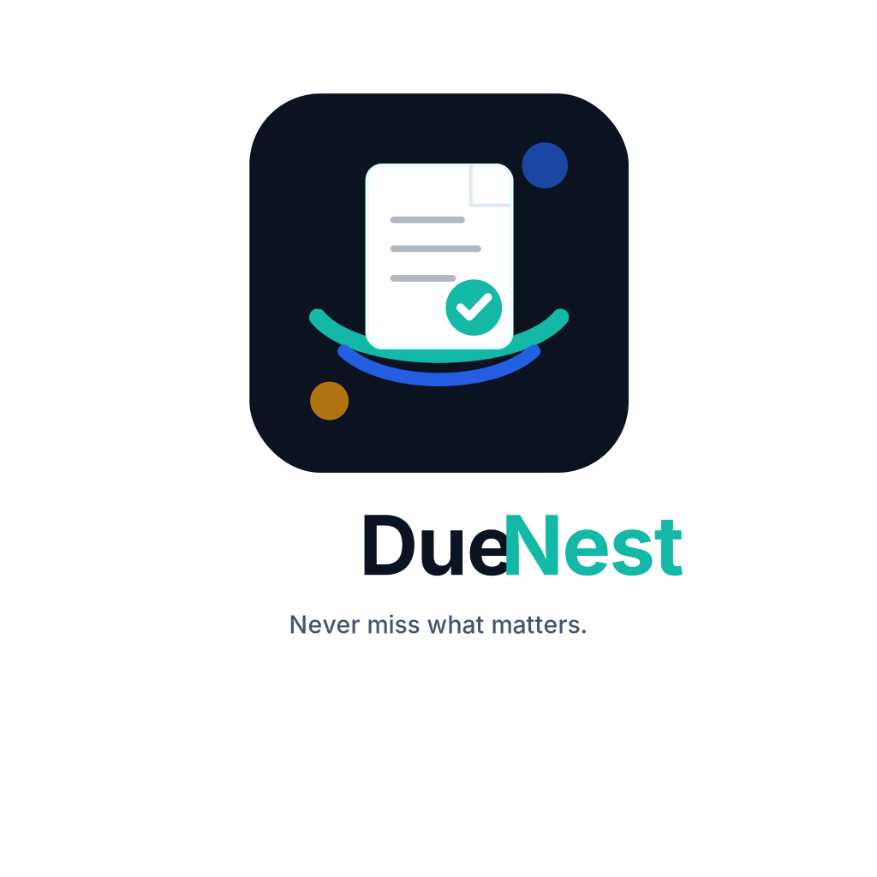
DueNest Brand Guidelines
World-class brand system for an AI-powered life-admin platform
Documents, deadlines, and renewals in one secure AI workspace.

01. Brand Essence
Item | Guidance
Brand Promise | DueNest gives users peace of mind by keeping important documents, deadlines, subscriptions, renewals, and application packs organized in one secure workspace.
Product Category | AI-powered life-admin platform.
Mission | To help people stay ready for the documents, renewals, and deadlines that matter most.
Vision | To become the trusted personal operating system for life administration.
Core Feeling | Calm control: users should feel prepared, protected, and organized.

02. Positioning
Item | Guidance
Primary Positioning | DueNest helps students, professionals, families, freelancers, and small teams manage essential documents, deadlines, subscriptions, renewals, reminders, and reusable application packs.
Competitive Difference | Unlike finance-first subscription apps, DueNest is broader: it combines document vault, renewal intelligence, application packs, secure sharing, and AI extraction.
Primary Tagline | Documents, deadlines, and renewals in one secure AI workspace.
Short Tagline | Never miss what matters.

03. Logo Concept
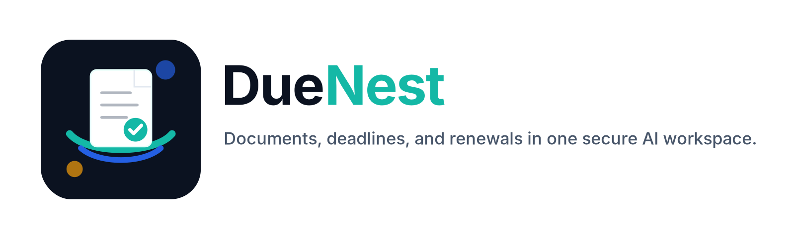
Item | Guidance
Symbol Meaning | The DueNest mark combines a secure document, a completion check, and nested arcs. It communicates safety, readiness, and organized deadlines.
Usage Principle | Use the horizontal logo for websites, pitch decks, and GitHub documentation. Use the icon for app, favicon, profile images, and compact UI surfaces.
Clear Space | Keep clear space around the logo equal to at least the height of the icon check circle.
Do Not | Do not stretch, recolor randomly, add shadows to the logo, rotate the icon, or place it on low-contrast backgrounds.

04. Color System
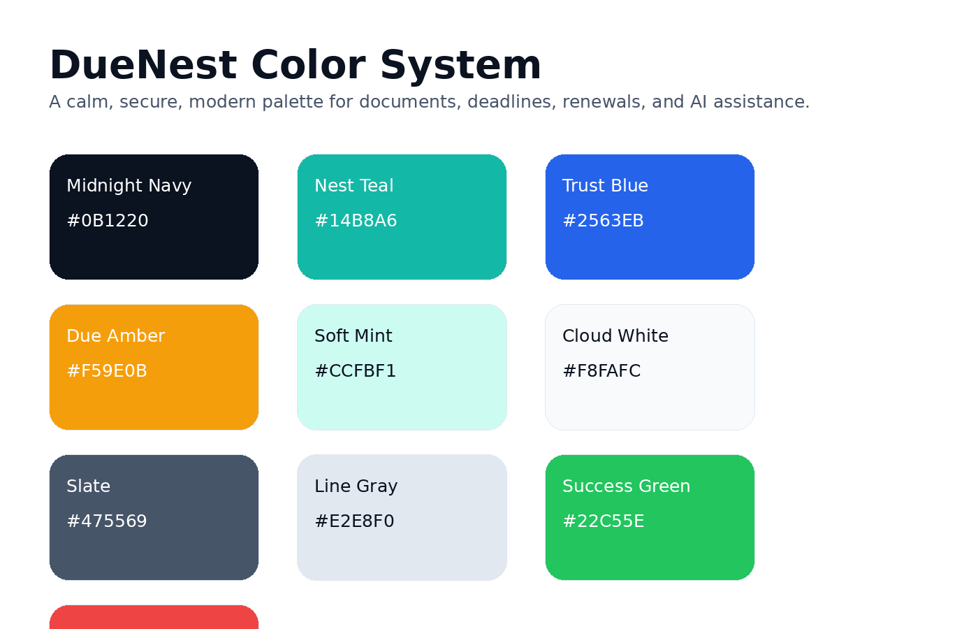
Item | Guidance
Midnight Navy | Primary trust color for headers, dark backgrounds, hero sections, and premium UI.
Nest Teal | Primary action color for CTAs, success states, highlights, and brand emphasis.
Trust Blue | Secondary technology color for links, integrations, and AI workflows.
Due Amber | Reminder/accent color for upcoming dates and medium urgency.
Risk Red | Use only for expired, failed, critical, or dangerous states.

05. Typography
Item | Guidance
Display Font | Use Sora or Space Grotesk for headlines and hero sections.
Body Font | Use Inter for body text, dashboards, forms, and product UI.
Fallback | Use system-ui, sans-serif when custom web fonts are not loaded.
Rule | Keep the typography clean, calm, and readable. Avoid decorative fonts.

06. UI Design Direction
Item | Guidance
Visual Style | Modern SaaS, calm fintech-level trust, clean dashboards, soft cards, strong spacing, rounded panels, and clear data hierarchy.
Component Style | Cards with subtle borders, rounded corners, readable tables, status badges, progress indicators, and calm empty states.
Dashboard Mood | The user should instantly understand what is urgent, what is safe, and what requires action.
Accessibility | Use strong contrast, visible focus states, readable font sizes, semantic headings, and clear form labels.

07. Voice and Copy
Item | Guidance
Tone | Trustworthy, practical, calm, intelligent, and protective.
Avoid | Avoid fear-based pressure, exaggerated AI claims, and vague startup buzzwords.
Good Copy | Your passport expires in 90 days. Prepare renewal documents early.
Bad Copy | AI will revolutionize your life admin forever.

08. Product Pillars
Item | Guidance
Secure Document Vault | Store passports, visas, certificates, contracts, receipts, licenses, insurance, and other essential files.
Deadline Intelligence | Track expiry dates, renewal dates, cancellation windows, recurring payments, and application deadlines.
Application Packs | Generate reusable packs for jobs, scholarships, visas, internships, grants, and compliance needs.
AI Assistance | Extract dates, classify documents, summarize contracts, detect risks, and recommend actions later in the roadmap.

09. Implementation Identity
Item | Guidance
Repository Name | duenest
Architecture | Responsive web app first, PWA second, native mobile later if validated.
Core Stack | Next.js, TypeScript, TailwindCSS, shadcn/ui, Django REST Framework, PostgreSQL, Celery, Redis, S3-compatible storage.
Portfolio Positioning | A SaaS-style AI life-admin platform showing full-stack engineering, security awareness, document processing, background jobs, and product thinking.

10. Asset Inventory
This kit includes SVG and PNG logos, favicons, app icons, social banners, color tokens, CSS variables, Tailwind tokens, messaging files, and project documents. Upload the full ZIP to Drive so the brand is preserved as a single source of truth.

11. Launch Checklist
- Use the same logo, tagline, and color palette across GitHub, README, landing page, dashboard, pitch deck, and social banners.
- Before public launch, verify domain, social handle, app-store, and trademark availability.
- Do not upload real sensitive documents while testing. Use sample or fake documents until security controls are production-ready.
- Build the responsive web app first, then PWA, then mobile app only after validation.
- Keep all brand assets in a single Drive folder and avoid modifying original master files directly.

