Abdoul-Nourou Yigo

Dr. Lopamudra Mukherjee

Machine Learning

September 24 2018

Homework1

e. The least Squares errors and parameters of the learning function.

* Square errors output:

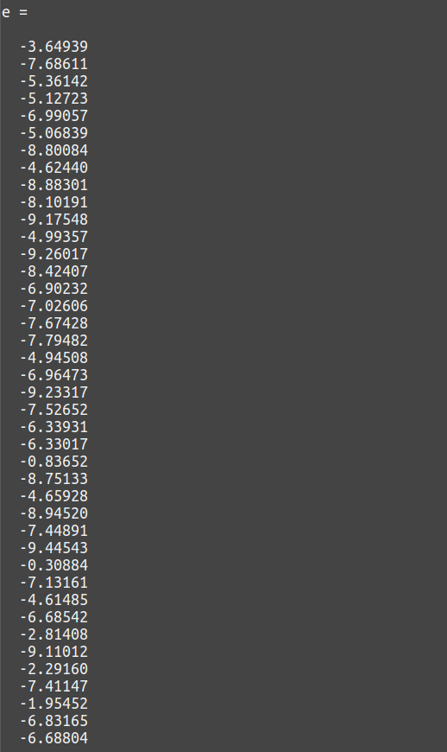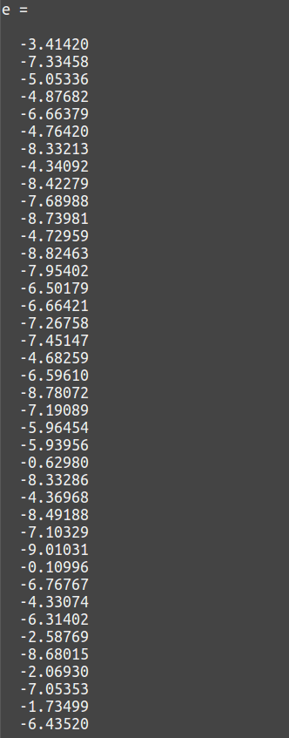

* Parameter of the learning function

The following output is showing how the parameter of the learning function is decreasing at each level of iteration.

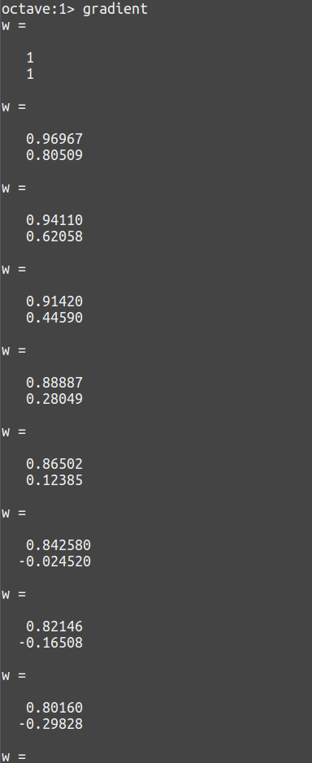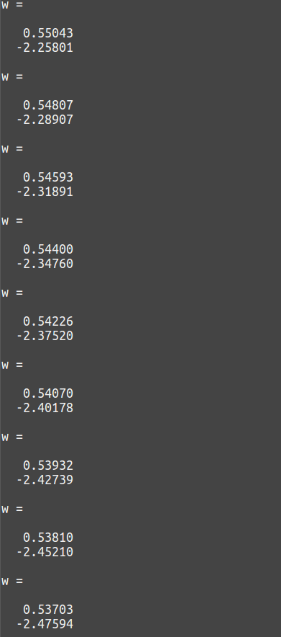

f. Plot the least squares error in each iteration

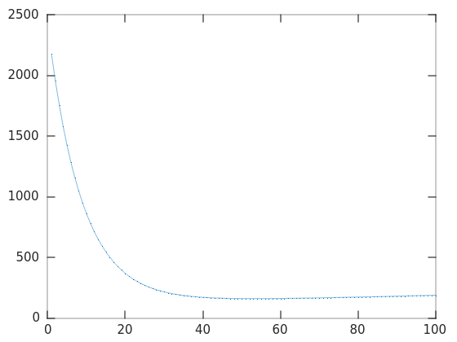

g. Plot the line found via the optimization and the original points

