Abdoul-Nourou Yigo

Dr. Lopamudra Mukherjee

Machine Learning

Homework2

1. Visualization of the dataset.

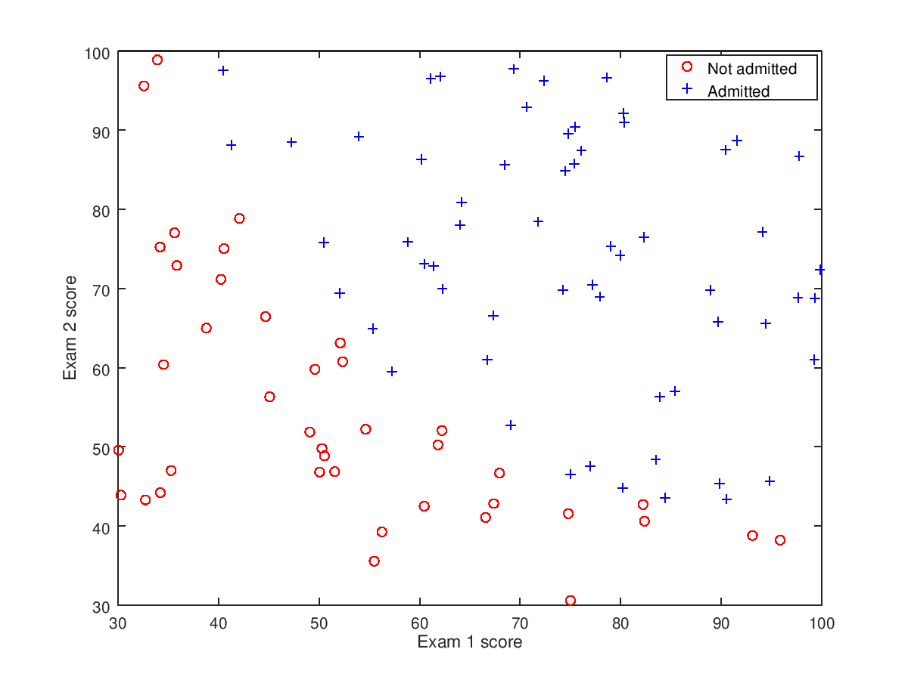

b) Implementation cost function using gradient descent. Plot of the cost with the number of iterations.

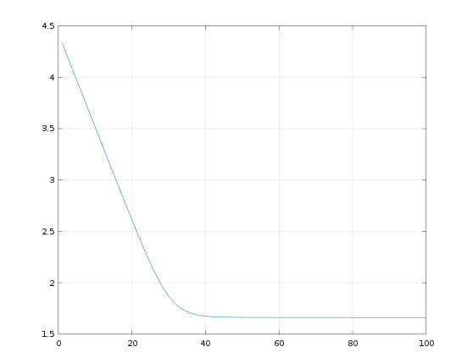

c) Optimal parameters θ2 and θ1. Plot of the decision boundary with the training data.

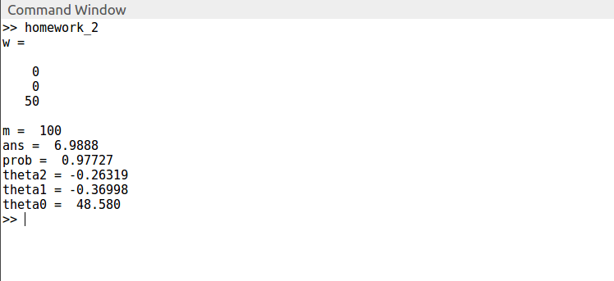

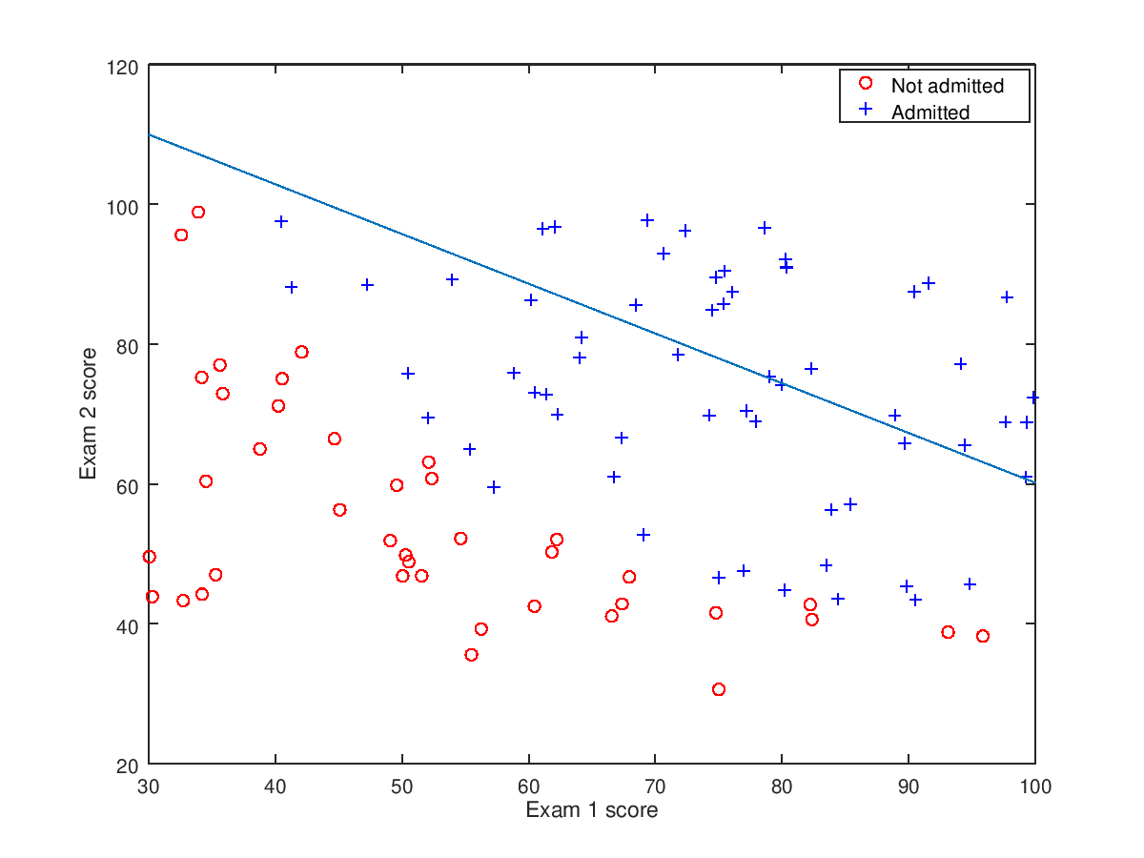

d) The admission probability if a student has Exam 1 score 100 and an Exam 2 score 50.

