Abdoul-Nourou Yigo

Dr. Lopamudra Mukherjee

Machine Learning

**Homework4**

b. I. The parameters and cluster assignments for the best solution

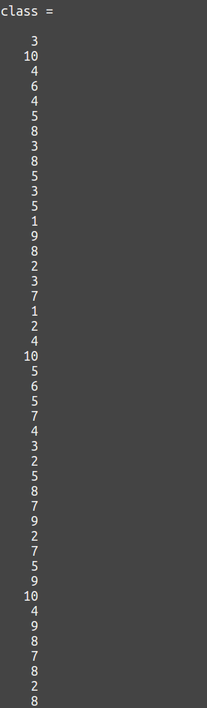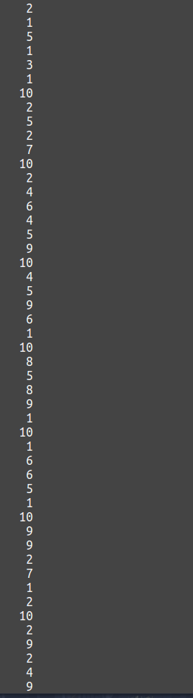

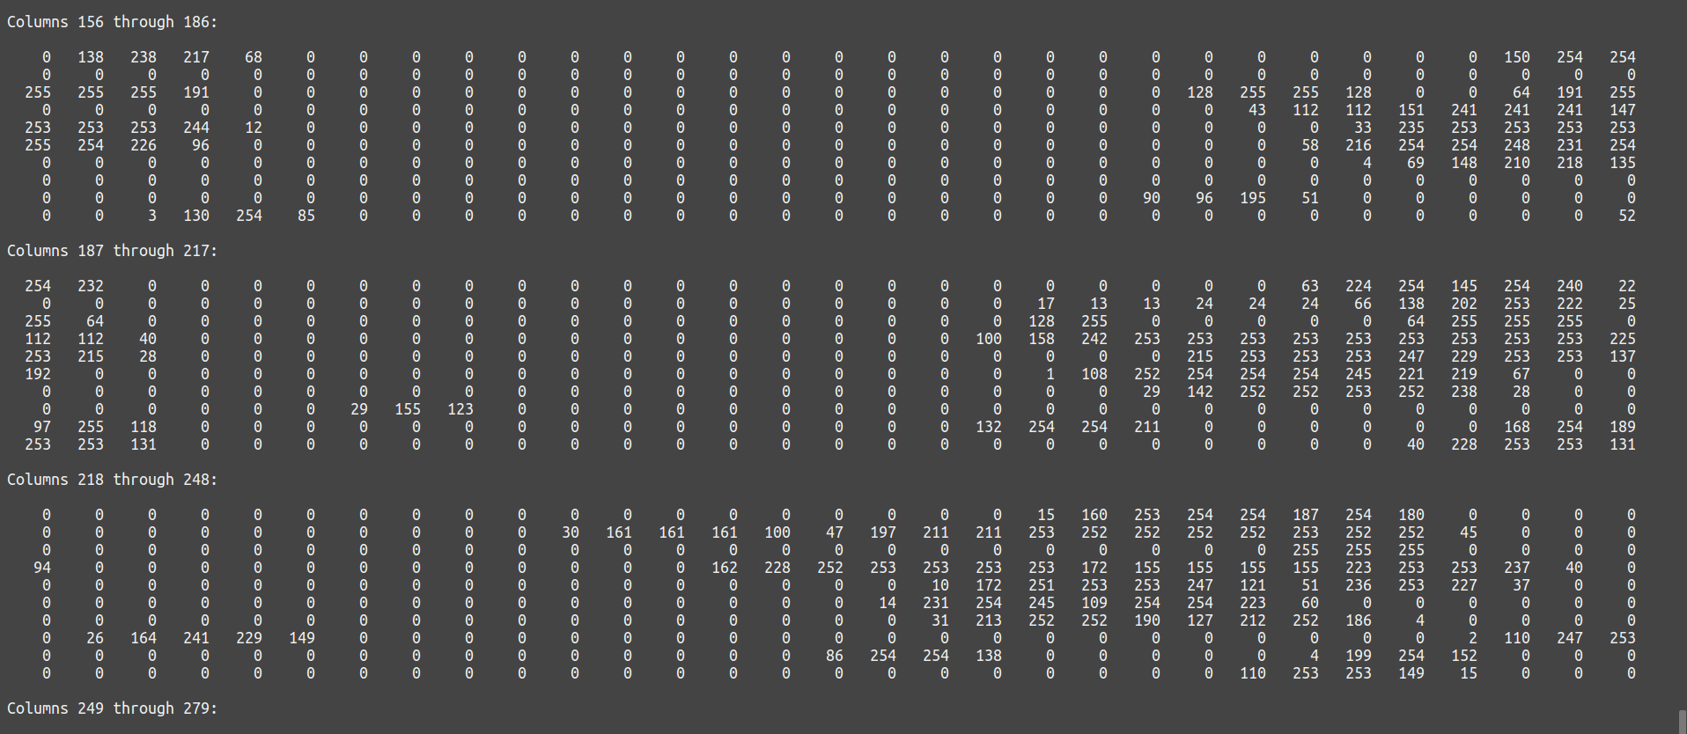

II. The objective/loss-function over k-means iterations for the best solutions

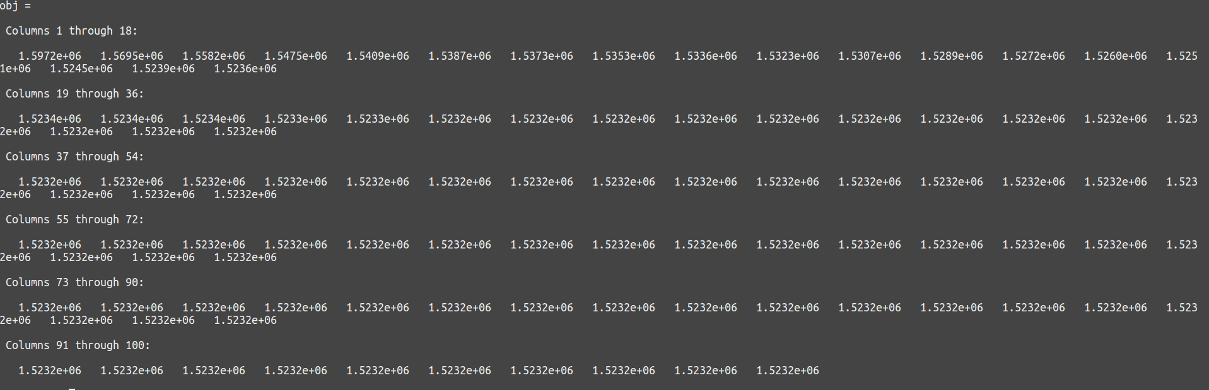

c. Plotting the values of best solutions for K = 5; 10; 20; 25.

* Plotting for K = 5

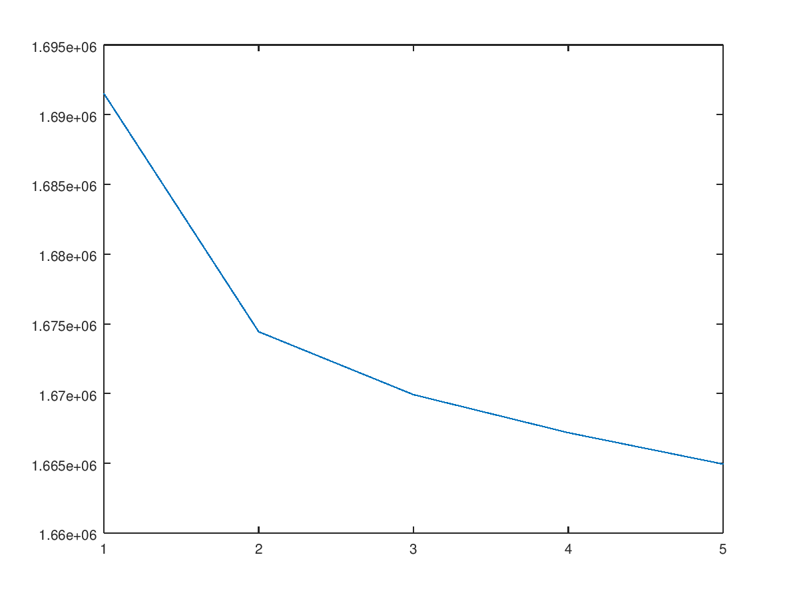

* Plotting for K = 10

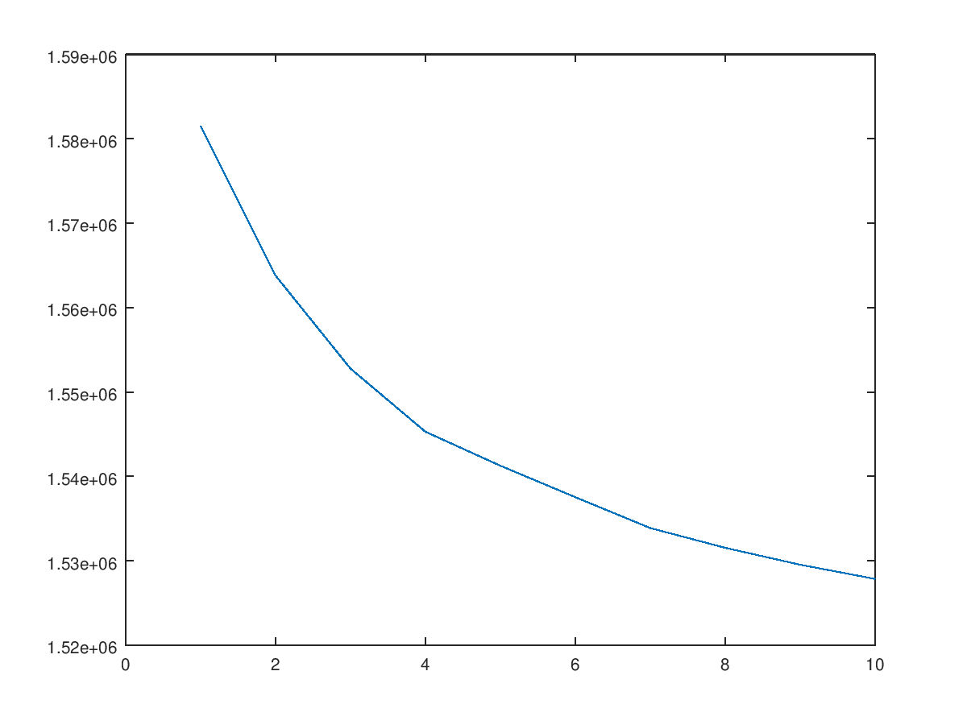

* Plotting for K = 15

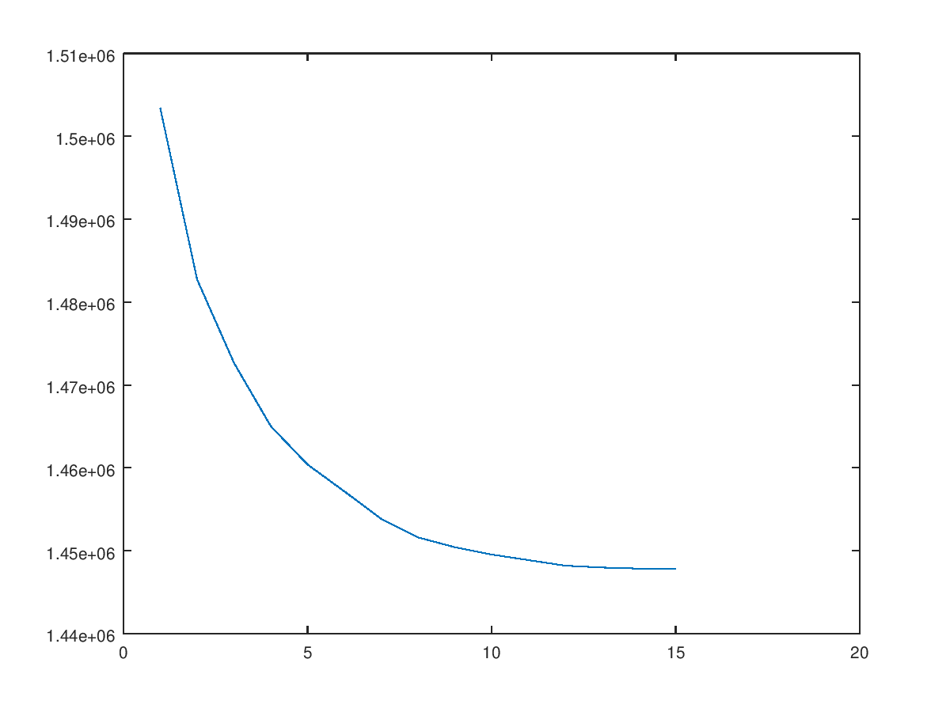

* Plotting for K = 20

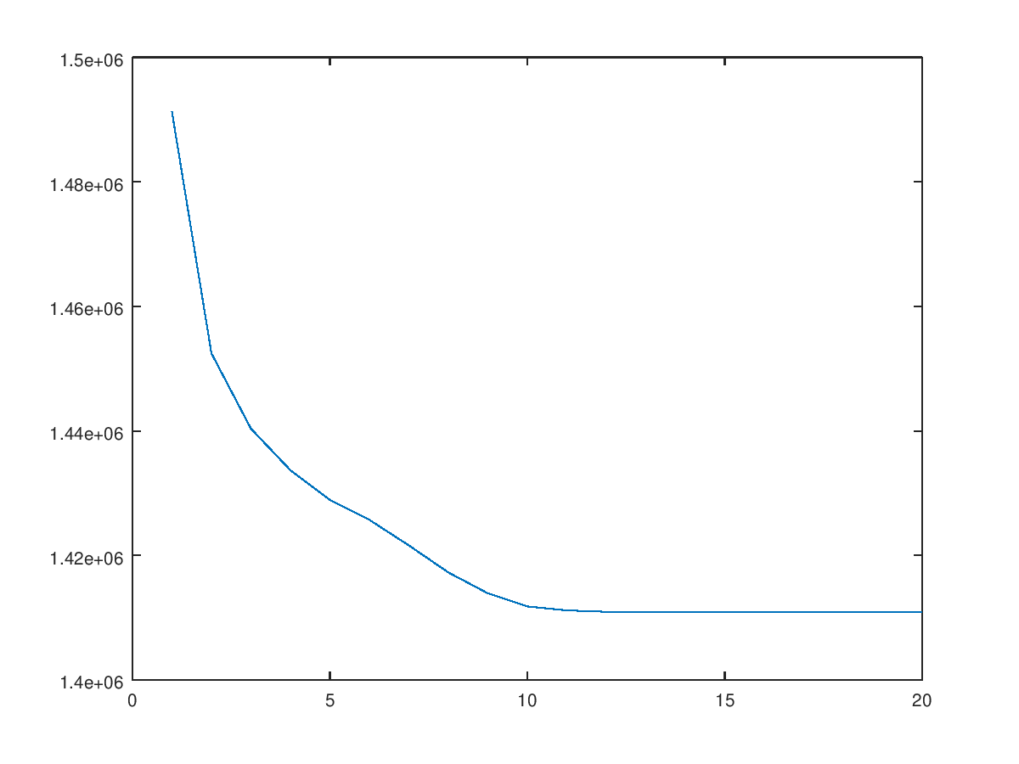

* Plotting for K = 25

