A Mini project-1 Report

on

**Real-Time Seismic Activity Monitoring using IOT**

Submitted in partial fulfilment of the requirements for the

Award of the degree of

**BACHELOR OF TECHNOLOGY**

**IN**

**ELECTRICAL AND ELECTRONICS ENGINEERING**

**By**

M. SUMANTH 218W5A0207

N. NAGABABU 208W1A0236

K. JAYANTH 208W1A0226

P. PURNA NANDA 208W1A0241

**Under the guidance of**

**Sri.S.N.V.S.K.CHAITANYA**



DEPARTMENT OF ELECTRICAL AND ELECTRONICS ENGINEERING

**V. R. SIDDHARTHA ENGINEERING COLLEGE (AUTONOMOUS)**

(Affiliated to JNTUK, Kakinada)

**Sponsored by SAGTE, Kanuru, Vijayawada-520007**

**(Approved by AICTE, Accredited by NBA and NAAC ‘A+’ GRADE)**

**2022-2023**

**Department of ELECTRICAL AND ELECTRONICS ENGINEERING**

**V. R. SIDDHARTHA ENGINEERING COLLEGE**



**CERTIFICATE**

This is to certify that the Mini project-1 report titled “ **Real-Time Seismic Activity Monitoring using IOT”** a bonafide record of work done by **M.SUMANTH(218W5A0207), N.NAGABABU (208W1A0236), K.JAYANTH(208W1A0226)** and **P.PURNA NANDHA (208W1A0241)** under my guidance and supervision and is submitted in partial fulfillment of the requirements for the award of the degree of Bachelor of Technology in Electrical & Electronics Engineering, V.R. Siddhartha Engineering College, (Autonomous, Affiliated to JNTUK) during the academic year 2022-2023.

**Sri.S.N.V.S.K.CHAITANYA Dr.P.V.R.L.NARASIMHAM**

Assistant Professor Professor & HOD

EEE Dept. EEE Dept.

**DECLARATION**

We hereby declare that the work is being presented in this EPICS project report **“Real-Time Seismic Activity Monitoring using IOT”** submitted towards the partial fulfilment of requirements for the award of the degree of **Bachelor of Technology** in **Electrical and Electronics Engineering** in V. R. Siddhartha Engineering College, Vijayawada is an authentic record of our work carried out under the supervision of **Sri.S.N.V.S.K.CHAITANYA,** **Assistant Professor** in EEE Department, in V. R. Siddhartha Engineering College, Vijayawada. The matter embodied in this dissertation report has not been submitted by us for the award of any other degree. Furthermore, the technical details furnished in various chapters of this report are purely relevant to the above Mini project-1**.**

M. SUMANTH (218W5A0207)

N. NAGABABU (208W1A0236)

K. JAYANTH (208W1A0226)

P. PURNA NANDA (208W1A0241)

# ACKNOWLEDGEMENT

Presentation and motivation always play a key role in the success of any venture.

We express our sincere thanks to **Dr.A.V. Ratna Prasad**, Principal, Velagapudi Ramakrishna Siddhartha Engineering College, Kanuru, Vijayawada.

We pay our deep sense of gratitude to **Dr.P.V.R.L.Narasimham**, HOD, Electrical and Electronics Engineering and **Dr. A. VEERA REDDY**, Asst.Prof, Electrical and Electronics Engineering for encouraging us to the highest peak and for providing us the opportunity to prepare the project. We are immensely obliged to our classmates for their elevating inspiration, encouraging guidance and kind supervision in the completion of our project.

We acknowledge our indebtedness and deep sense of gratitude to our respected guide **Sri.S.N.V.S.K.CHAITANYA**, Assistant Professor, Electrical and Electronics Engineering who has offered good guidance and kind supervision throughout the course to shape this present work.

Finally, we conclude by conveying thanks to those who helped us in finalizing the project within the limited time frame.

M. SUMANTH (218W5A0207)

N. NAGABABU (208W1A0236)

K. JAYANTH (208W1A0226)

P. PURNA NANDA(208W1A0241)

**ABSTRACT**

Seismic activities have been a major concern for the safety of the population and their property. The need for constant monitoring of these activities has become a crucial aspect to reduce the impact of natural disasters such as earthquakes and landslides. The traditional methods of monitoring seismic activities have been expensive and require a large setup. This paper presents a low-cost solution for monitoring seismic activities through the use of sensors

The system continuously collects data from various sensors to the Arduino Uno microcontroller. The system provides a level indicating of land, slope and inclination finder of land, earthquake prediction and land slide prediction. The sensors used in the system are cost-effective and easy to install. The data collected from the sensors is processed and displayed in the serial plotter, providing real-time updates on the seismic activities.

The proposed solution is an effective way to monitor seismic activities and reduce the impact of natural disasters. By providing real-time updates, the system enables authorities to take necessary measures to protect the population and their property. The low-cost solution makes it accessible to a larger audience and contributes to the overall safety and security of the community.

**Keywords:** seismic activities,earthquake, gyro sensor, Arduino Uno , accelerometer, monitoring.

**CONTENTS**

1. INTRODUCTION 7

1.1. Motivation 8

2. PROBLEM DESCRIPTION 8

3. SOLUTIONS 9

4. FEASIBLE SOLUTION………………………………………………………………………………....10

4.1. Block diagram of system………………………………………………………………..…11

4.2. Working principle……………………………………………………………………........12

4.3. Working of arduino uno…………………………………………………………………...14

4.4. Working of esp8266 wifi module……………………………………………....................15

4.5. Workng of mpu 6050 sensor………………………………………………………………16

4.6. Working of sim900a gsm module…………………………………………………………17

4.7. Working of 2x16 lcd module………………………………………………………………18

4.8. Working of buzzer……………………………………………………………....................19

5. CONCLUSION………………………………………………………………………………..…...20

6. REFERENCES 21

# INTRODUCTION

Seismic activity is a natural phenomenon that can cause significant damage to property and loss of life. Developing a system that can detect seismic activity and notify people in real-time is critical in ensuring safety and reducing damage. However, existing seismic activity monitoring systems are often expensive and complex, making them inaccessible to many people, particularly those in developing countries. Therefore, the aim of this project is to develop a low-cost and easy-to-use system that can detect seismic activity and notify people in real-time.

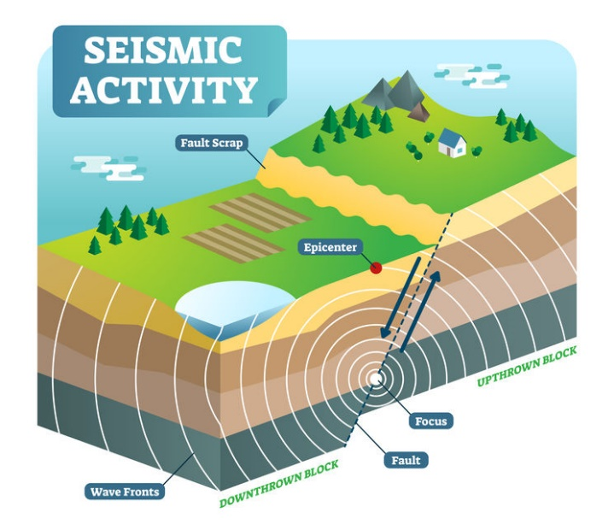

Fig 1. Seismic Activity

The project is designed to monitor earthquake readings and send notifications when threshold values are exceeded. It uses an MPU6050 3-axis gyro sensor to collect data, which is then displayed on a 16x2 LCD and sent to Thingspeak for further analysis. The Arduino board is used to control the sensor and transmit data over Wi-Fi to Thingspeak using Wifi module.When the readings exceed threshold values, a notification is sent to the concerned authorities using a GSM module.

* The project also plots the data using the Serial Plotter in the Arduino IDE, allowing for real-time visualization of the earthquake readings.
* The project can be used in earthquake-prone areas to help detect seismic activity and take appropriate action to prevent damage and loss of life.
* The project can be customized to suit specific requirements, such as changing the threshold values, adding more sensors, or modifying the notification system.

# 1.1. Motivation

Seismic activity can have devastating effects on people's lives, causing significant property damage and loss of life. In developing countries, the lack of effective seismic activity monitoring systems and early warning mechanisms increases the risk of damage and loss of life. Therefore, developing a low-cost and easy-to-use seismic activity monitoring system can help to reduce the impact of seismic activity and protect people's lives and property.

By developing a low-cost and accessible seismic monitoring system, this project aims to empower communities around the world to monitor seismic activity and take proactive measures to prevent damage and loss of life. This system can also be easily replicated and deployed in different locations, making it a versatile and scalable solution for seismic monitoring. Overall, this project demonstrates the potential of low-cost and accessible IoT solutions for addressing complex problems and improving the safety and well-being of communities.

1. PROBLEM DESCRIPTION

Seismic activity, such as earthquakes, can cause significant damage to buildings and infrastructure, as well as cause injury or death to people. In order to better understand and respond to seismic activity, it is important to be able to detect and measure it accurately and in real-time. However, existing seismic detection systems are often expensive and difficult to deploy, making it challenging to monitor seismic activity in many regions of the world. The goal of this project is to develop a compact and low-cost seismic detection system using a gyro sensor with an Arduino Uno board. The system should be able to detect and measure seismic activity in real-time, and provide data that can be used to analyze the magnitude, duration, and frequency of earthquakes.



Fig 2.1 Earthquake destruction

The existing seismic activity monitoring systems are often expensive and complex, requiring significant expertise to install and operate. Additionally, these systems are often not easily accessible to people in developing countries who are at the highest risk of seismic activity. Furthermore, the lack of real-time alerts and notifications poses a significant challenge to ensuring safety in case of seismic activity. GPR is a powerful tool for detecting subsurface structures and features, but it is not effective for monitoring seismic activity in real-time. GPR is also expensive and requires specialized equipment and expertise, making it inaccessible to many communities. Large seismographs are effective for detecting large earthquakes, but they often fail to detect small earthquakes that can be precursors to larger earthquakes. Additionally, large seismographs are expensive and require significant infrastructure.

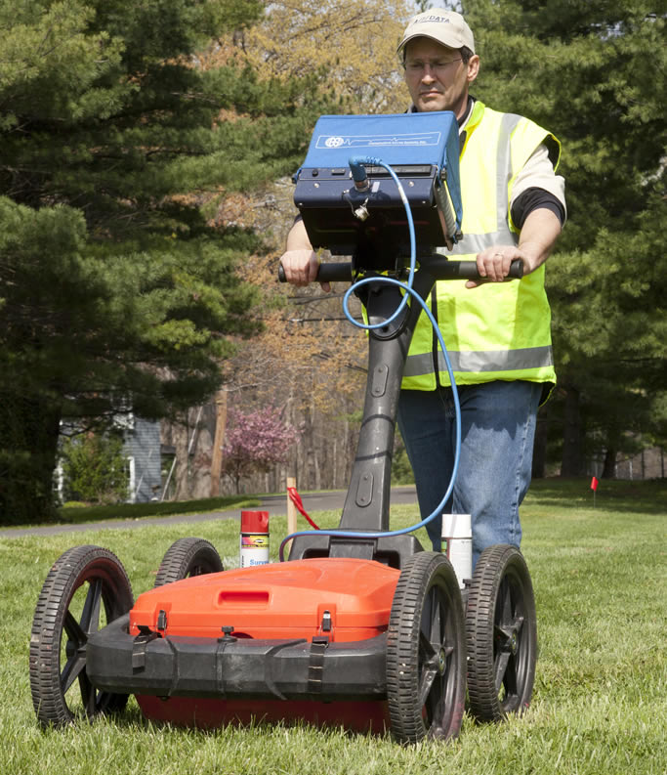

Fig 2.2 GPR machine

These limitations create a significant problem for communities that are at risk of seismic activity. This is where the system developed in this project comes in, using off-the-shelf components to provide an affordable and accessible solution to the problem of seismic monitoring.

1. SOLUTIONS

* The first method is “Remote Real Time Monitoring and Safety System for Earthquake and Fire Detection Based on Internet of Things” [1], This research project is focused on designing and developing a system that can remotely monitor the status of earthquake or fire, and initiate safety measures to reduce damage. The people can be alerted with the alarm and electric power cut. The system is based on Arduino Uno board equipped with Microcontroller ATmega328p which processes the environmental signals obtained from vibration and fire sensors.

The main drawbacks are Vibration sensors are prone to false alarms, which can result in unreliable readings. Gyro sensors, on the other hand, are less prone to false alarms and provide more accurate and reliable readings.

* The second method is “IoT Based Landslide Detection and Monitoring” [2], Here the moisture and accelerometer sensors are interfaced with raspberrypi to collect the moisture and the earth movement, then the collected data is monitored in the thingspeak.

The main drawback of the system is the cost of raspberrypi is very high as some people can not afford it.

* The third method is “IoT based Landslide Detection and Monitoring System”, The main objective to study the landslide detection is to prevent the natural calamity by detecting its early movement. This basic network can detect the slightest movements of a ground or slop instability due to the several reasons such as dielectric moisture, pore pressure and so on that may occurs during a landslide.

Here Nodemcu board is used and for further development it is not suitable because of its small size and a smaller number of pins.

1. **FEASIBLE SOLUTION**

The solution to the problem of high cost and complexity of traditional seismic monitoring systems is a low-cost and accessible system using off-the-shelf components. The system uses an MPU6050 gyro sensor, Arduino Uno, Wi-Fi module, GSM module, and 16x2 LCD display. The system measures the changes in 3-axis acceleration values and sends an alert message to the user when the threshold values are exceeded. The system also sends data to ThingSpeak, where users can access and analyze the data in real-time. The system is easy to replicate and deploy in different locations, making it accessible to a wide range of users.

The project is powered by a stable power source and requires a reliable communication network to ensure effective transmission of data and alert messages. The code for the project is written in the Arduino IDE, and can be easily modified and adapted to suit the needs of different environments. Overall, the project provides an effective and low-cost solution for monitoring seismic activity in real-time, which is critical for ensuring public safety in earthquake-prone areas.

**4.1. BLOCK DIAGRAM OF SYSTEM**



Mobile phone

Speaker

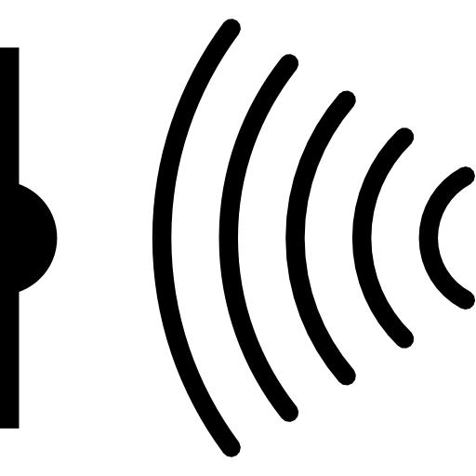

Gyro sensor

LCD Display

GSM Module

Serial Plotter

Thingspeak Server

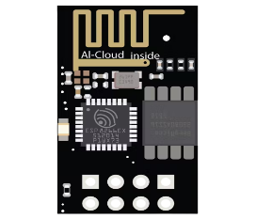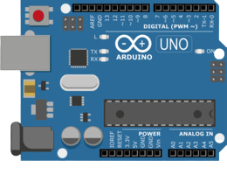

Arduino Uno board

ESP8266 Wi-Fi module

Fig 4.1 Block Diagram

**4.2. Working Principle**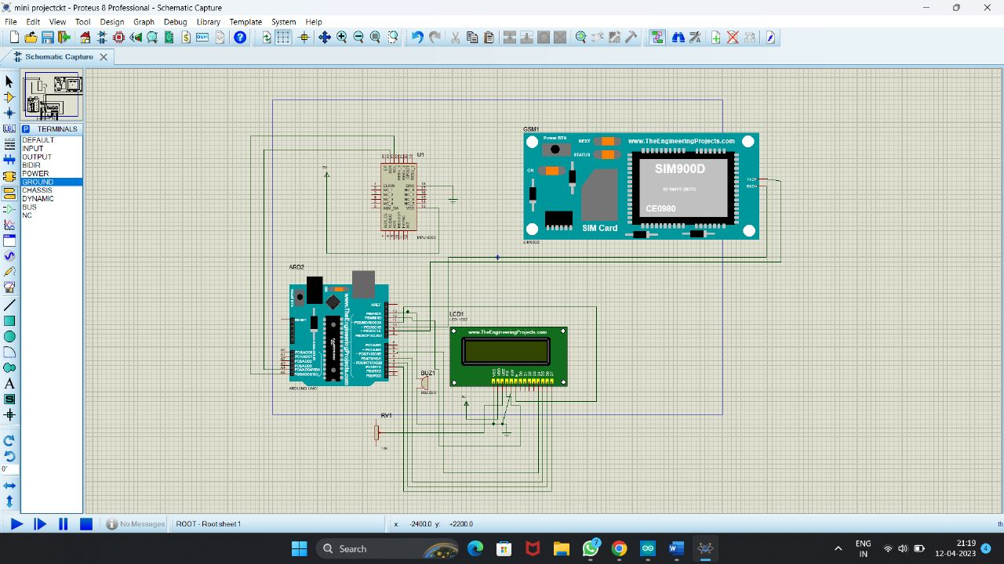

Fig 4.2 Schematic model

The seismic monitoring project using an MPU6050 gyro sensor, Arduino Uno, Wi-Fi module, 2x16 LCD display, GSM module, and buzzer works by measuring changes in the 3-axis values using the MPU6050 gyro sensor. The Arduino Uno processes and transmits the data to the Wi-Fi module and GSM module, which provide reliable communication channels for transmitting the data to ThingSpeak and sending alert messages to the user.

The 2x16 LCD display and buzzer provide real-time feedback to the user, with the LCD displaying the current 3-axis values and alert messages, and the buzzer sounding an alarm when an earthquake is detected. The project also includes a threshold value, which triggers an alert message and buzzer alarm when exceeded.

The technical specifications of the project are as follows:

* MPU6050 gyro sensor: measures changes in the 3-axis values of acceleration and rotation
* Arduino Uno: processes and transmits data to the Wi-Fi module and GSM module, and controls the LCD display and buzzer alarm
* ESP8266 Wi-Fi module: provides a reliable communication channel for transmitting data to ThingSpeak
* SIM900A GSM module: sends alert messages to the user when an earthquake is detected
* 2x16 LCD display: displays the current 3-axis values and alert messages
* Buzzer: produces an audible alarm when an earthquake is detected

The main component of this system is the Arduino Uno board. It uses a 3-axis MPU6050 gyro accelerometer sensor to detect changes in axis values. Other components include a 16x2 LCD, a SIM900 GSM module, a Wi-Fi module, and a buzzer. The SCL and SDA pins are used to establish serial communication between the MPU6050 and the Arduino Uno board. The sensor calibrates the gyro offset values when it is at rest by using its fixed position. The sensor measures changes in the x, y, and z axis values, which can be used to calculate earthquake magnitude. The x, y, and z values are displayed on the Serial Monitor and the 16x2 LCD. The Arduino IDE's Serial Plotter is used to visualize the x, y, and z values.

When the magnitude exceeds a certain threshold, an alert message is displayed on the Serial Monitor and the 16x2 LCD, and the buzzer sounds. The GSM module's TX and RX pins are connected to the Arduino Uno to establish serial communication and alert the user wherever they are. The WiFi module's TX and RX pins are also connected to the Arduino Uno to send data from the Arduino Uno to the WiFi module. The data is then transmitted from the WiFi module to ThingSpeak to remotely monitor the seismic graph in a designated field.

In conclusion, this system utilizes an Arduino Uno board, a 3-axis MPU6050 gyro accelerometer sensor, a 16x2 LCD, a SIM900 GSM module, a WiFi module, and a buzzer. The system measures changes in the x, y, and z axis values to determine earthquake magnitude, which is then displayed on both the Serial Monitor and the 16x2 LCD. The Serial Plotter in the Arduino IDE is used to visually represent the x, y, and z values. The buzzer sounds and an alert message is displayed on the Serial Monitor and the 16x2 LCD when the magnitude surpasses a certain threshold. The GSM module alerts the user wherever they may be, and the WiFi module transfers data from the Arduino Uno to ThingSpeak for remote monitoring of the seismic graph in a designated field.

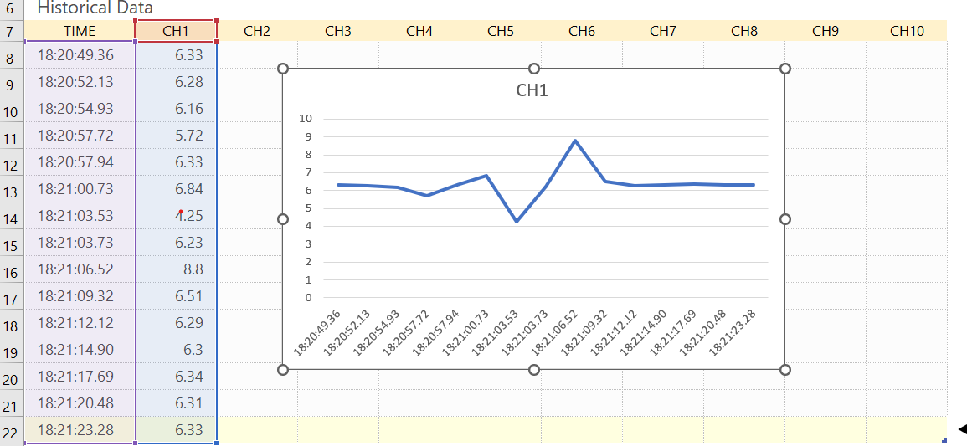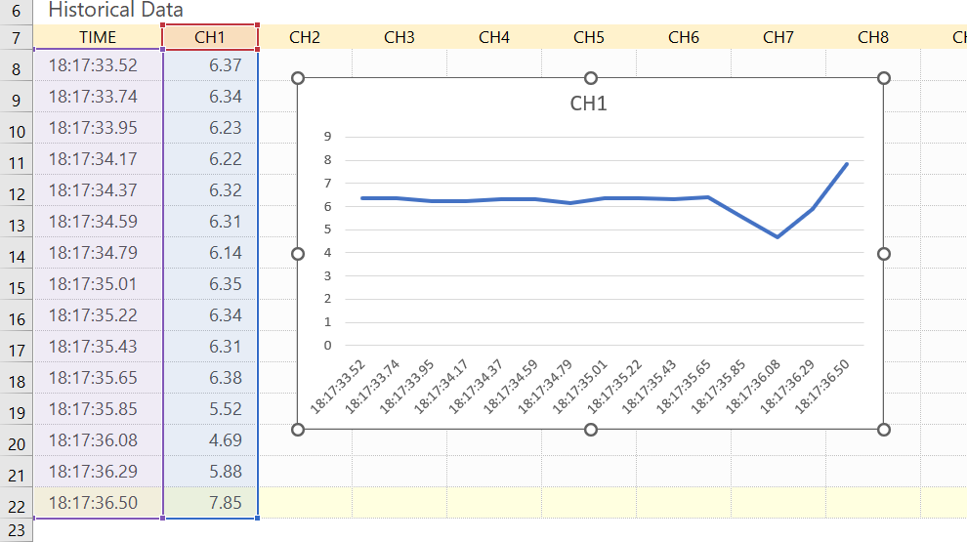**4.3. WORK CARRIED OUT**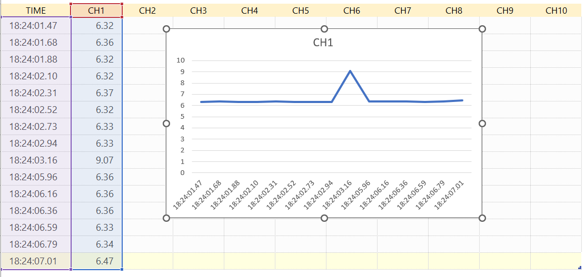

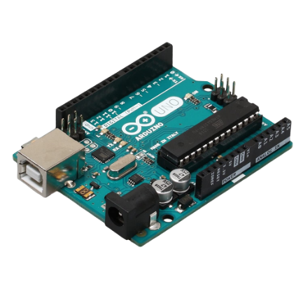**4.4. Working of Arduino Uno**

Fig 4.3 Arduino Uno Board

Arduino UNO is a microcontroller board with an open-source software development environment and it can be used to read sensors and control motors, lights and more. It can store programs which can then be uploaded to this board for interaction with physical objects.

Atmega328P microcontroller is placed on the board that comes with a number of features like timers, counters, interrupts, PWM, CPU, I/O pins and based on a 16MHz clock that helps in producing more frequency and number of instructions per cycle.

This board comes with a built-in regulation feature that keeps the voltage under control when

the device is connected to the external deviceA reset pin is present in the board that resets the whole board and takes the running program in the initial stage.

* There are 14 I/O digital and 6 analog pins incorporated in the board that allows the external connection with any circuit with the board. These pins provide flexibility and ease of use to the external devices that can be connected through these pins. There is no hard and fast interface required to connect the devices to the board. Simply plug the external device into the pins of the board that are laid out on the board in the form of the header.
* The 6 analog pins are marked as A0 to A5 and come with a resolution of 10bits. These pins measure from 0 to 5V, however, they can be configured to the high-range using analogReference () function and AREF pin.
* Only 5 V is required to turn the board on, which can be achieved directly using a USB port or external adopter, however, it can support an external power source up to 12 V which can be regulated and limit to 5 V or 3.3 V based on the requirement of the project.

In addition to its data processing capabilities, the Arduino Uno also facilitates communication with the Wi-Fi module, which is used to transfer the data to ThingSpeak,

a cloud-based IoT platform. The Arduino Uno sends the data to the Wi-Fi module in a format that can be read by ThingSpeak. This data can then be accessed and analysed by users remotely in real-time.

Overall, the Arduino Uno plays a critical role in this seismic monitoring project, serving as the brain of the system and facilitating data processing and communication with other components. Its ease of use, low cost, and flexibility make it an ideal choice for this project, enabling the development of a low-cost and accessible seismic monitoring system that can be easily replicated and deployed in different locations.

* 1. 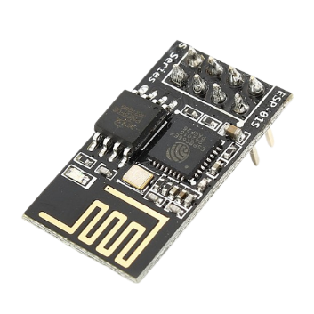**Working of Esp8266 Wi-Fi module**

Fig 4.4 Esp8266 Wi-Fi module

The ESP8266 is a Wi-Fi module that enables wireless communication between the seismic monitoring system and a cloud-based IoT platform such as ThingSpeak. The module is compact, low-cost, and has low power consumption, making it an ideal choice for this project.

The ESP8266 Wi-Fi module is responsible for transferring the data collected by the Arduino Uno to the cloud-based IoT platform, ThingSpeak. The module establishes a Wi-Fi connection with a network and then sends data to ThingSpeak using HTTP or HTTPS protocol. The module can also be configured to receive commands from ThingSpeak, which can be used to adjust the parameters of the seismic monitoring system remotely.

The working of the ESP8266 module typically involves the following steps:

1. Initialization: The ESP8266 module is initialized by setting up the MCU, configuring the Wi-Fi parameters, and initializing other settings such as GPIO pins, communication interfaces, etc.
2. Wi-Fi Connection: The module connects to a Wi-Fi network by scanning for available networks, authenticating with the appropriate credentials (e.g., SSID and password), and obtaining an IP address from the DHCP server.
3. Data Transmission/Reception: Once connected to the Wi-Fi network, the module can send and receive data over the internet using protocols such as HTTP, MQTT, or custom protocols. This involves setting up appropriate sockets, establishing connections, and transmitting/receiving data packets.
4. GPIO and Other Operations: The ESP8266 module can also perform operations on GPIO pins or communicate with other devices or sensors using UART, SPI, I2C, or other interfaces, as programmed in the application code.
5. Sleep Mode: The ESP8266 module supports low-power sleep modes to conserve energy when not actively transmitting or receiving data. It can be configured to enter sleep mode and wake up periodically or based on specific events, depending on the application requirements.

The ESP8266 module plays a critical role in enabling remote monitoring and analysis of seismic activity data in real-time. Once the data is transferred to ThingSpeak, users can access the data remotely and visualize it using various tools provided by the platform. This enables users to monitor seismic activity in real-time and identify trends or anomalies that could indicate potential earthquakes.

In addition to its data transfer capabilities, the ESP8266 module also provides a way to configure the Wi-Fi network settings of the seismic monitoring system. This allows the system to be easily configured for different Wi-Fi networks, making it ideal for deployment in different locations. ESP8266 Wi-Fi module is a key component of this seismic monitoring system, enabling wireless communication with a cloud-based IoT platform and enabling real-time remote monitoring and analysis of seismic activity data.

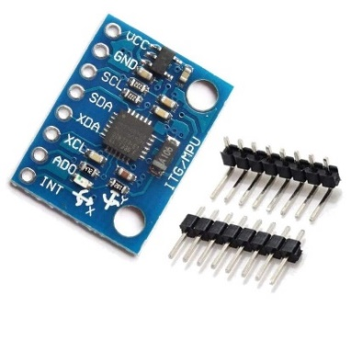**4.5 Working of MPU 6050 sensor**

Fig 4.5 Gyro Sensor

The MPU6050 is a low-cost 6-axis motion tracking sensor that includes a 3-axis accelerometer and a 3-axis gyroscope. In this seismic monitoring project, the MPU6050 sensor plays a critical role in measuring the 3-axis acceleration values, which are used to detect seismic activity.

The MPU6050 sensor communicates with the Arduino Uno using the I2C communication protocol. It measures the acceleration values in the x, y, and z directions and sends the data to the Arduino Uno in a predefined format. The Arduino Uno then processes the data and compares it with predefined threshold values to determine whether an earthquake is occurring or not.

The MPU6050 sensor is highly accurate and provides reliable data, making it an ideal choice for this seismic monitoring project. It is also low-cost and easy to use, enabling the development of a low-cost and accessible seismic monitoring system that can be easily replicated and deployed in different locations.

Overall, the MPU6050 sensor plays a critical role in this seismic monitoring project, providing accurate and reliable data on the 3-axis acceleration values, which are used to detect seismic activity. Its low cost and ease of use make it an ideal choice for this application, enabling the development of a low-cost and accessible seismic monitoring system that can be used in a wide range of environments

* 1. 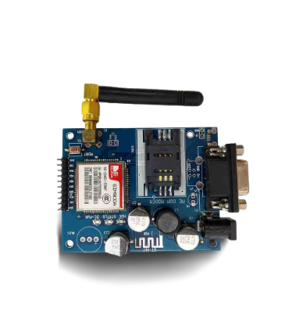 **Working of Sim900a GSM Module**

Fig 4.6 GSM module

GSM (Global System for Mobile Communications, originally Groupe Special Mobile) A GSM modem or GSM module is a device that uses GSM mobile telephone technology to provide a wireless data link to a network. GSM modems are used in mobile telephones and other equipment that communicates with mobile telephone networks. A GSM module or a GPRS module is a chip or circuit that will be used to establish communication between a mobile device or a computing machine and a GSM or GPRS system. They use SIMs to identify their device to the network.

It is a widely used mobile communication system in the world. GSM is an open and digital cellular technology used for transmitting mobile voice and data services operate at the 850MHz, 900MHz, 1800MHz, and 1900MHz frequency bands. The time division multiple access (TDMA) technique relies on assigning different time slots to each user on the same frequency. It can easily adapt to data transmission and voice communication and can carry 64kbps to 120Mbps of data rate.

In this seismic monitoring project, the SIM900A GSM module plays a critical role in sending alert messages to the user via SMS when an earthquake is detected. The SIM900A GSM module communicates with the Arduino Uno using the serial communication protocol. When an earthquake is detected, the Arduino Uno sends a message to the SIM900A GSM module in a predefined format. The SIM900A GSM module then sends an alert message to the user via SMS, providing them with real-time information on the seismic activity.

**4.7 Working of 2x16 LCD module**

The 2x16 LCD (Liquid Crystal Display) module is a small display that can display up to 32 characters in two lines of 16 characters each. In this seismic monitoring project, the 2x16 LCD module plays a critical role in displaying alert messages on the device when an earthquake is detected.

The features of this LCD mainly include the following.

* The operating voltage of this LCD is 4.7V-5.3V
* It includes two rows where each row can produce 16-characters.
* The utilization of current is 1mA with no backlight
* Every character can be built with a 5×8 pixel box
* The alphanumeric LCDs alphabets & numbers
* Is display can work on two modes like 4-bit & 8-bit
* These are obtainable in Blue & Green Backlight
* It displays a few custom generated characters

The 2x16 LCD module communicates with the Arduino Uno using the parallel communication protocol.

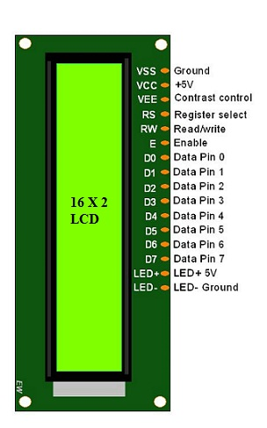

Fig 4.7 2*16 LCD module

When an earthquake is detected, the Arduino Uno sends a message to the 2x16 LCD module in a predefined format. The 2x16 LCD module then displays the alert message on its screen, providing real-time information on the seismic activity.

The 2x16 LCD module is highly reliable and provides a simple way to display information in a small form factor. It is also low-cost and easy to use, enabling the development of a low-cost and accessible seismic monitoring system that can be easily deployed in different locations7

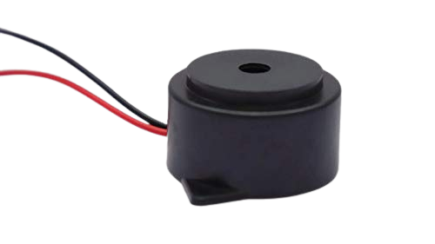 **4.8 Working of Buzzer**

Fig 4.8 Buzzer

A buzzer is an electronic component that can produce an audible sound when an electrical signal is applied to it. It is a useful component for adding an alarm or alert functionality to the project. Here a 95DB, 2300 +/-500Hz frequency buzzer is used. In the device the buzzer to provide an audible alarm when the seismic activity exceeds a certain threshold or any other event of interest occurs

The buzzer is connected to the Arduino Uno, and when an earthquake is detected, the Arduino Uno sends a signal to the buzzer to sound the alarm. The buzzer produces a loud, high-pitched sound that is easily audible in a quiet environment, alerting the user to the presence of seismic activity. It provides a simple and effective way to alert users of seismic activity without requiring them to monitor a display or wait for an SMS alert.

**6. CONCLUSION**

The project successfully developed a low-cost and easy-to-use seismic activity monitoring system using electronic components. The system is effective in detecting seismic activity and notifying people in real-time, ensuring safety and reducing damage. The use of low-cost components makes the system accessible to people in developing countries who are at the highest risk of seismic activity. Further research can be done to optimize the algorithms used to detect seismic activity and improve the accuracy of the measurements. Additionally, the system can be expanded to include more sensors and components to provide more detailed information about seismic activity, further improving its effectiveness in ensuring safety.

Although the project has some limitations, such as the need for a stable power source and a reliable communication network, it provides an effective and reliable tool for detecting and responding to seismic activity. The project is easy to use and can be easily scaled to suit the needs of different environments, making it a versatile and adaptable tool for improving public safety and disaster response efforts around the world.

Overall, this project represents an important step forward in earthquake monitoring technology, providing a low-cost and accessible solution that can help to save lives and prevent damage in earthquake-prone areas. With further development and refinement, this project has the potential to revolutionize the way we detect and respond to seismic activity, and to improve disaster response efforts on a global scale.

# REFERENCES

[1]Md Rysul Kibria Badhon, Anadi Ranjan Barai, Fatematuz Zhora, “Remote Real Time Monitoring and Safety System for Earthquake and Fire Detection Based on Internet of Things”, 2019.

[2]Pitambar Pawar, Akshay Patil, Hardik Rathod, Ravi Hadale, “IoT Based Landslide Detection and Monitoring”, 2019.

[3]Mrunal Jawalkar, Nikita Malviya Prerna Hage, Shraddha Chakule, Pranav Pattewar, “IoT based Landslide Detection and Monitoring System”, 2022.

4]Shafiya S, Mr R S Prasanna Kumar, “Landslide, Flood Prediction Using WSN Data”, IJCRT, Volume 8, Issue 3 March 2020 | ISSN: 2320-2882, 2020.

[5]S. K. Shukla, S. K. Chaulya, R. Mandal, B. Kumar, P. Ranjan, P. K. Mishra, G. M. Prasad, S. Dutta, V. Priya, S. Rath, K. Buragohain, P. C. Sarmah, “Real-Time Monitoring System for Landslide Prediction Using Wireless Sensor Networks”, International Journal of Modern Communication Technologies & Research (IJMCTR) ISSN: 2321-0850, Volume-2, Issue-12, December 2014.

[6] Pawan Nandkishor Hinge, Rohit Ramesh Bawage, Pallavi Nandkishor Hinge, “Wireless Sensor Network for Detecting Vibrations Before Landslides”, International Journal of Engineering Research & Technology (IJERT) IJERT ISSN: 2278-0181, Vol. 3 Issue 10, October- 2014.