**1. Design of the Database using an ER Diagram**

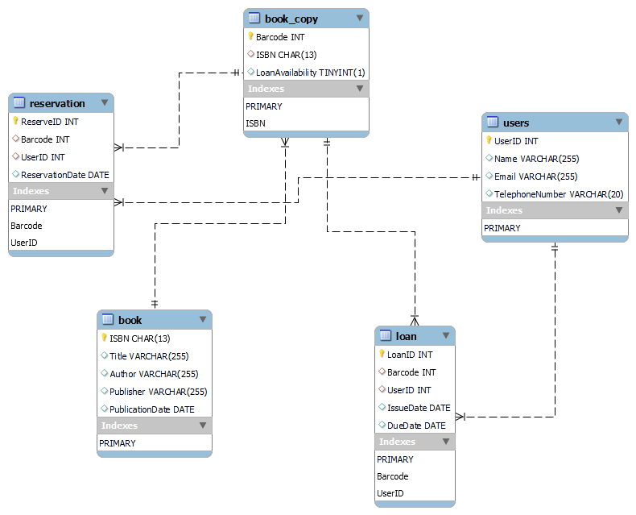

**2. Relational Database Schema**

**Tables and Keys:**

1. **Book**

* ***ISBN*** (varchar(13)) PRIMARY KEY
* Title (varchar(255))
* Author (varchar(255))
* Publisher (varchar(255))
* Date_of_Publication (date)

1. **Copy_of_Book**

* ***Bar_Code*** (varchar(20)) PRIMARY KEY
* ISBN (varchar(13)) FOREIGN KEY REFERENCES Book(ISBN)
* Loan_Availability (boolean)

1. **User**

* ***User_ID*** (varchar(8)) PRIMARY KEY
* Name (varchar(255))
* Email_Address (varchar(255))
* Telephone_Number (varchar(15))

1. **Loan**

* ***Loan_ID*** (int) PRIMARY KEY
* User_ID (varchar(8)) FOREIGN KEY REFERENCES User(User_ID)
* Bar_Code (varchar(20)) FOREIGN KEY REFERENCES Copy_of_Book(Bar_Code)
* Issue_Date (date)
* Overdue_Date (date)

1. **Reservation**

* ***Reservation_ID*** (int) PRIMARY KEY
* User_ID (varchar(8)) FOREIGN KEY REFERENCES User(User_ID)
* Bar_Code (varchar(20)) FOREIGN KEY REFERENCES Copy_of_Book(Bar_Code)
* Date_of_Reservation (date)

**3. Implementation of Database**

* **Books**

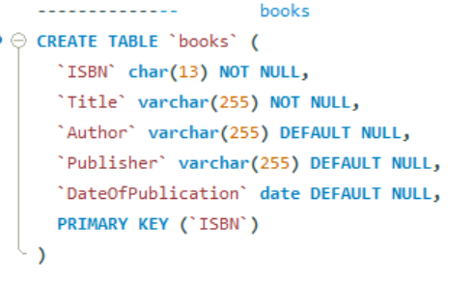

* **Book_copies**

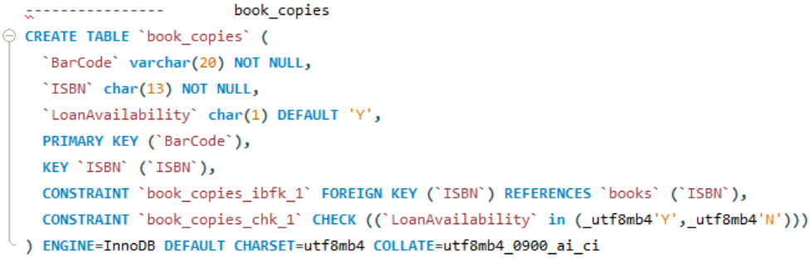

* **Users**

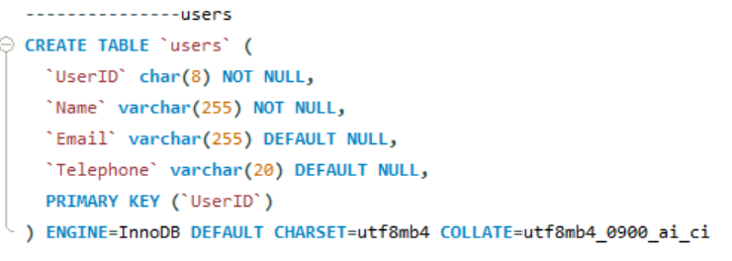

* **Loans**

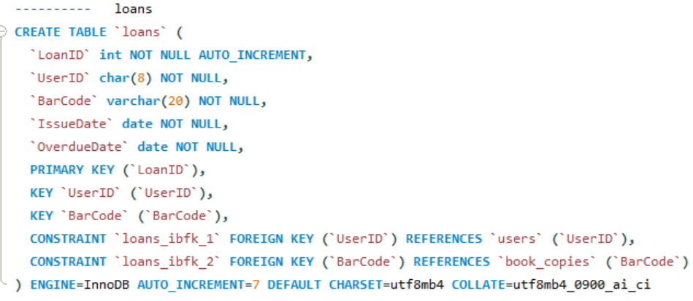

* **Reservation**

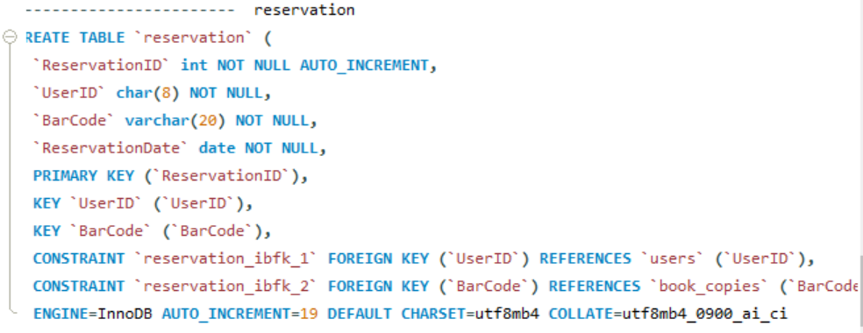

**Insert some records**

**Books Table**

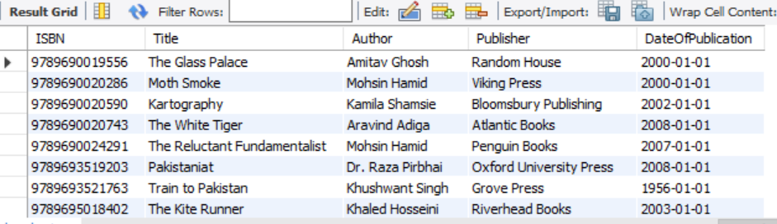

**Users table**

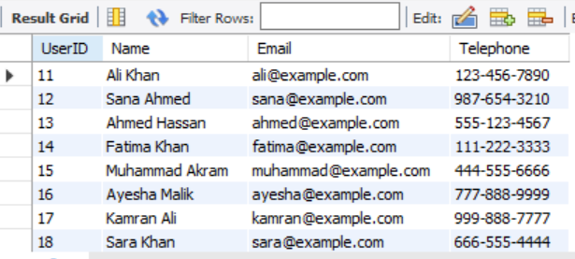

**Reservation Table**

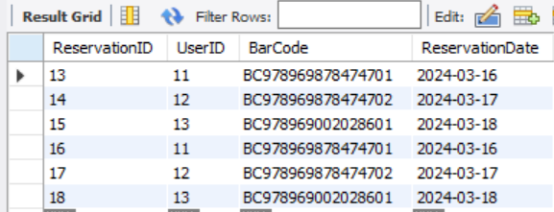

**Book_copies Table**

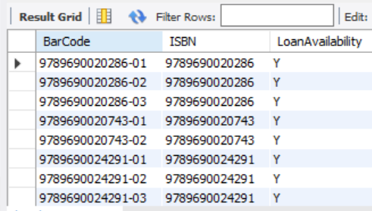

**Loans Table**

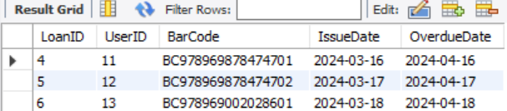

**4. SQL statements and results screenshot**

1. **Search for a book by key words in book title and display all details of the book**

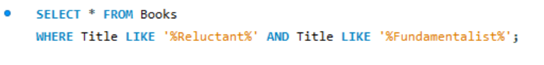

**Output**

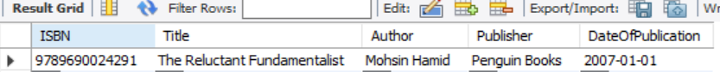

1. **Search for a book by author and display all details of the book**

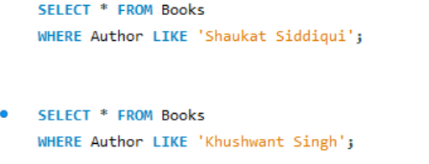

**Output**

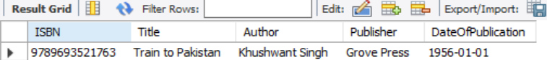



1. **Search for a book by ISBN and display if it is available for loans.**

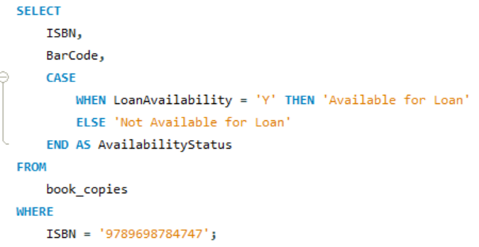

**Output**

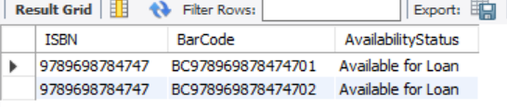

**d) Make a reservation for a book**

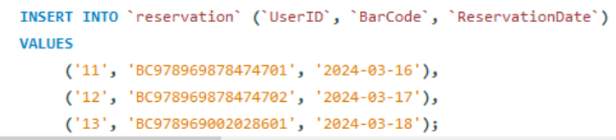

**Output**

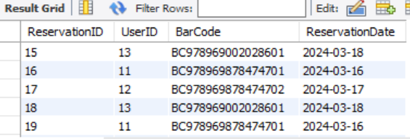

1. **Produce a list of loans to users: display user name, user ID, book title and bar codes for those books on loan.**

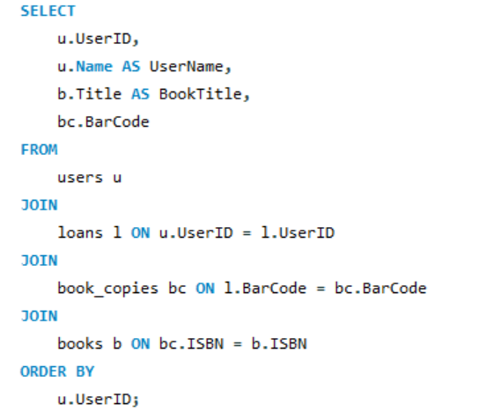

**Output**

