SQA_Internship_DafiLabs_WEEK 3_SESSION 3_2026
Automation Testing Practice Tasks

Tester Name : Nouman Parvaiz
Testing Type : Automation Testing

1. AI Prompts Used
Playwright Web Automation Project
Create an automation testing project using Playwright for a developed one-page personal portfolio website. The goal is to apply practical browser automation, meaningful assertions, and clear reporting — demonstrating real-world QA automation skills, not just isolated test snippets.

Cypress Automation and Playwright Comparison
As a QA Automation Engineer experienced in both Cypress and Playwright. Install and configure Cypress, then automate selected scenarios that were already tested in Playwright, so the two tools can be compared practically on the same portfolio website.

Postman API Automation Testing
Create a complete Postman API Automation Testing project using the JSONPlaceholder public API. The collection should contain at least 8 API requests covering GET, POST, PUT, PATCH, and DELETE methods. Include both positive and negative test cases, validate status codes, response body values, required fields, and response times. Use environment variables such as baseurl, postId and userId for better organization. Add Postman test scripts with assertions for each request, run the full collection using Collection Runner, and provide steps for exporting the collection and environment files. Organize the project professionally and include a brief summary suitable for assignment submission.

Selenium and Robot Framework Practice
Create a basic automation testing project using Selenium with JavaScript. Implement at least two test scenarios: one that opens a website and navigates to another page, and another that fills out a form and verifies the result using assertions and clean selectors. Then create one similar test scenario using Robot Framework to demonstrate keyword-driven automation. Include the Selenium and Robot Framework code, execution steps, expected results.

2. Learning Summary

Playwright
Build a Playwright automation suite using the Page Object Model for the portfolio website. Automate at least 5 scenarios — title check, navbar navigation, contact form validation (valid & invalid inputs), successful form submission, and responsive UI/button checks. Capture screenshots/videos, generate an HTML report, and run across 2+ browsers.

Cypress Automation and Playwright Comparison
Cypress and Playwright are both effective automation testing tools. Cypress is easier to set up and learn, with an interactive interface that makes debugging simple. Playwright provides broader browser support, faster execution, and advanced testing capabilities. Cypress is well-suited for beginners and quick test automation, while Playwright is a strong choice for complex, large-scale, and cross-browser testing projects.

Postman API Automation Testing
In this task, a Postman API Automation Testing project was created using the JSONPlaceholder public API. The collection included 8 API requests covering GET, POST, PUT, PATCH, and DELETE methods. Positive and negative test cases were implemented to validate status codes, response body values, required fields, and response times. Environment variables were used to improve organization and reusability. The collection was executed through Collection Runner, and the collection and environment files were exported for submission.

Selenium and Robot Framework Practice
In this task, a basic automation testing project was developed using Selenium with JavaScript. Two test scenarios were automated: opening a website and navigating to another page, and completing a form with result verification using assertions and clean selectors. A similar form automation scenario was then implemented in Robot Framework to understand keyword-driven testing. The task also included comparing both approaches and identifying which one was easier to use for test automation.

3. All Tasks Screenshots
- Playwright
Test Execution+ Installation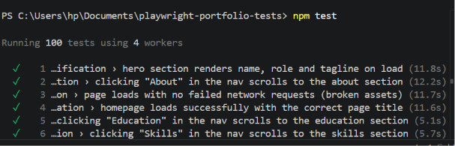
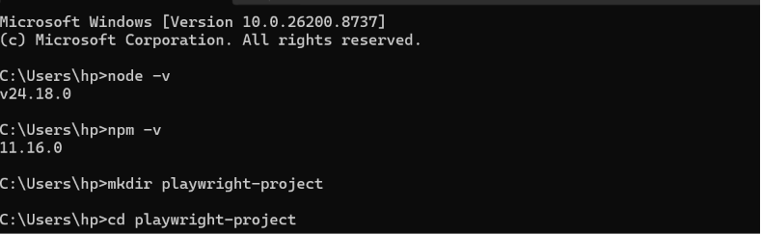

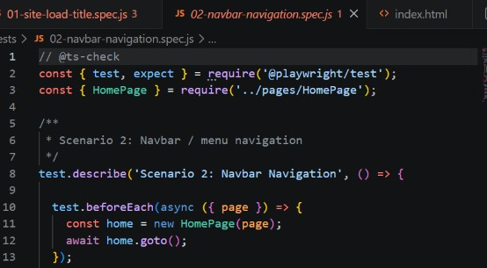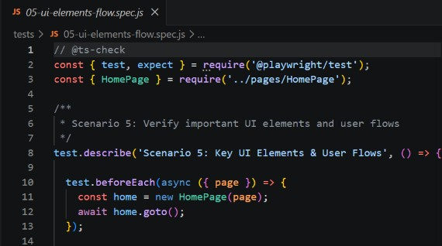

Output
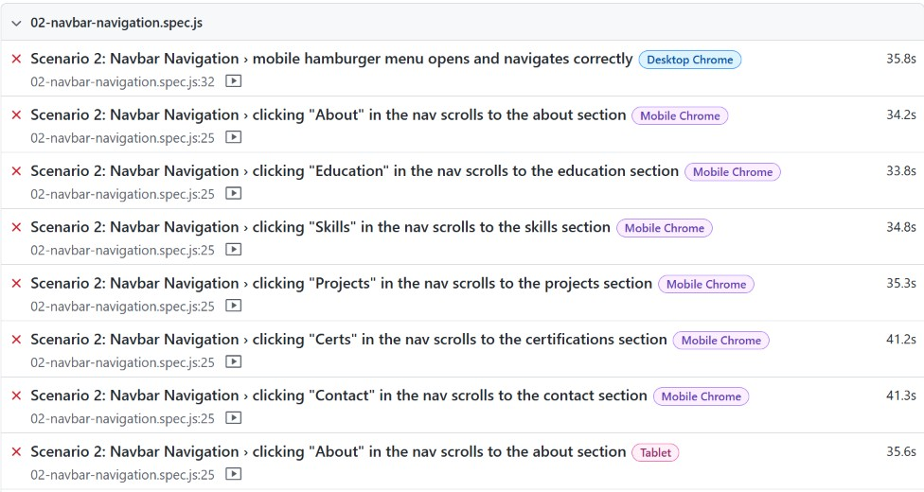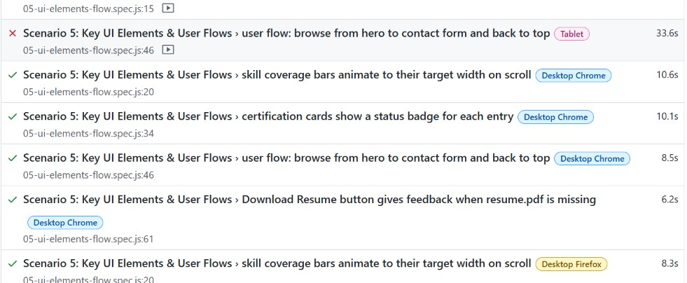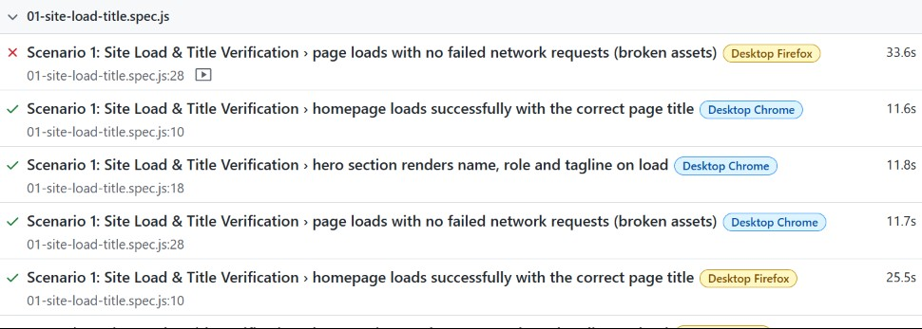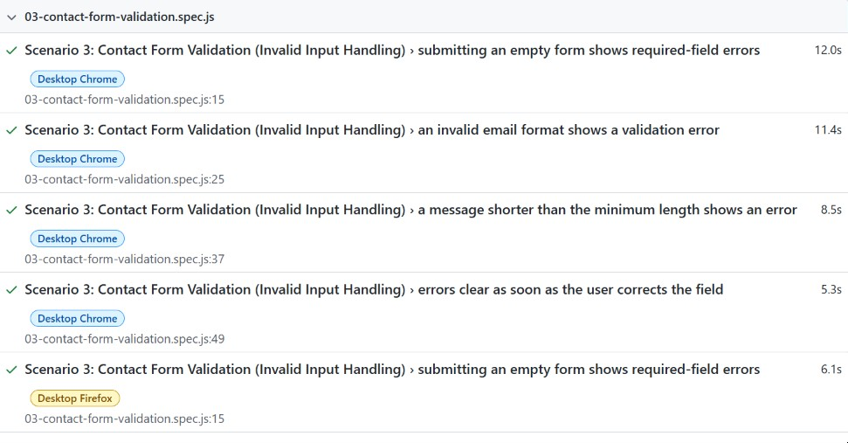

- Cypress Automation and Playwright
Test Execution+ Installation

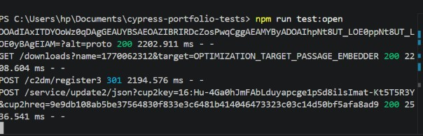

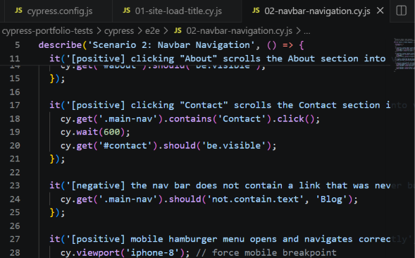

Output

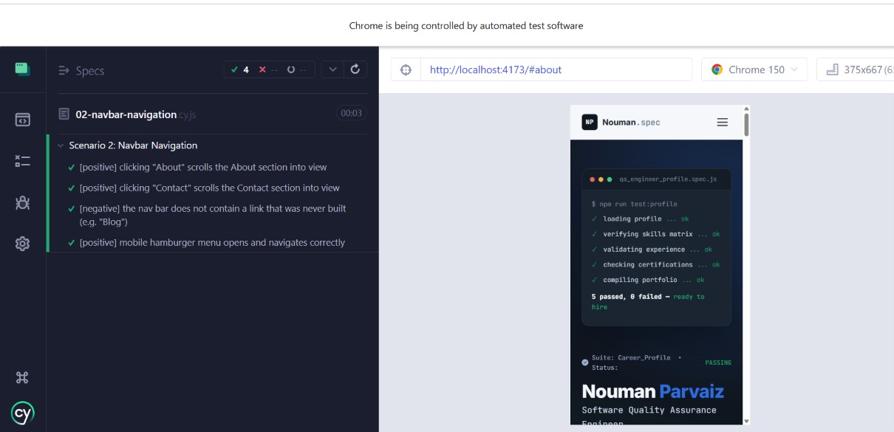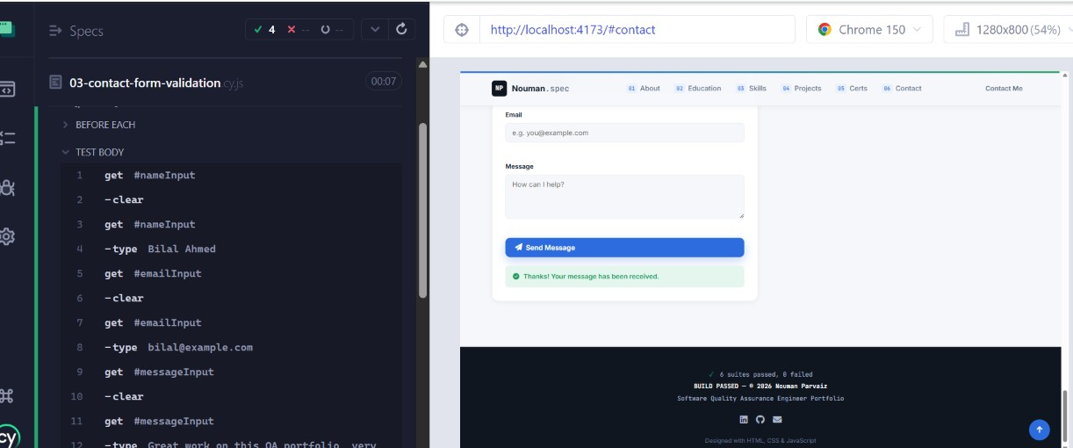

- Postman API

Outputs

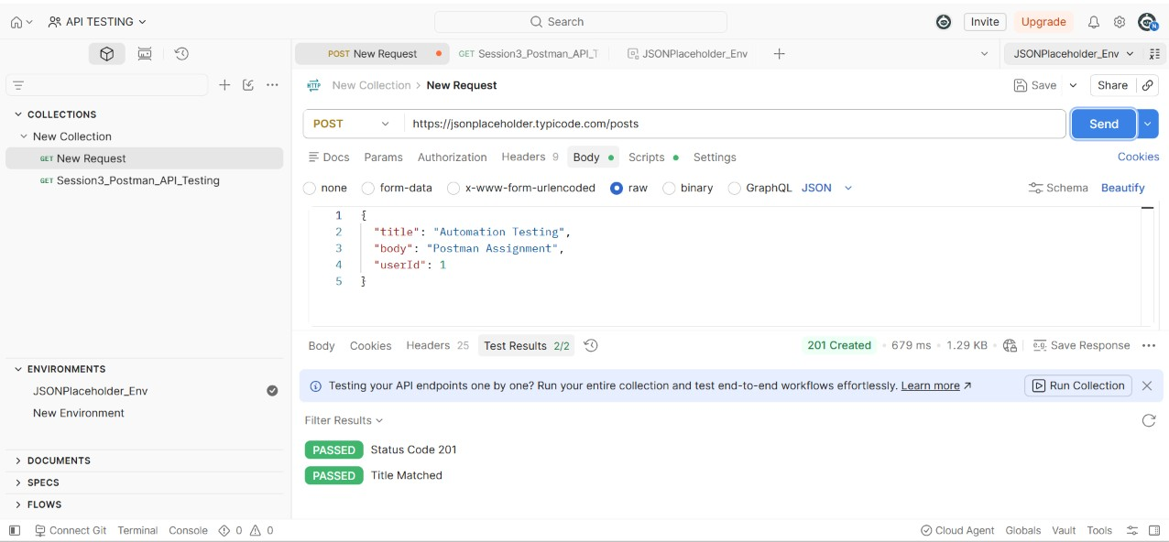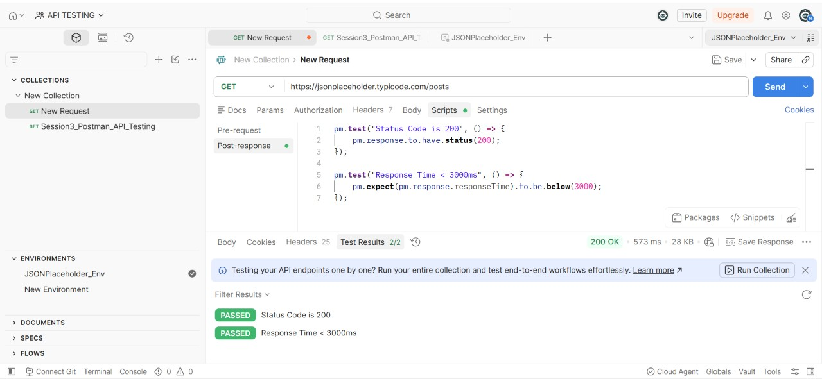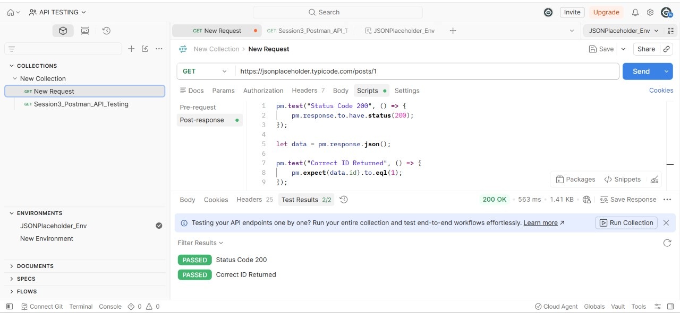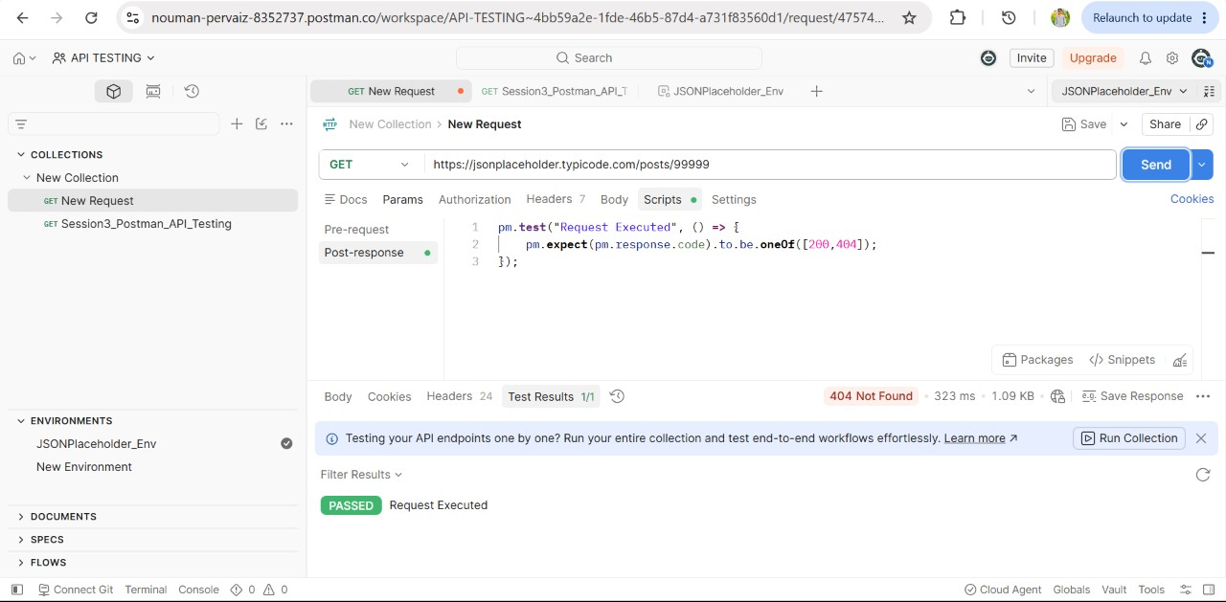

Collection runner

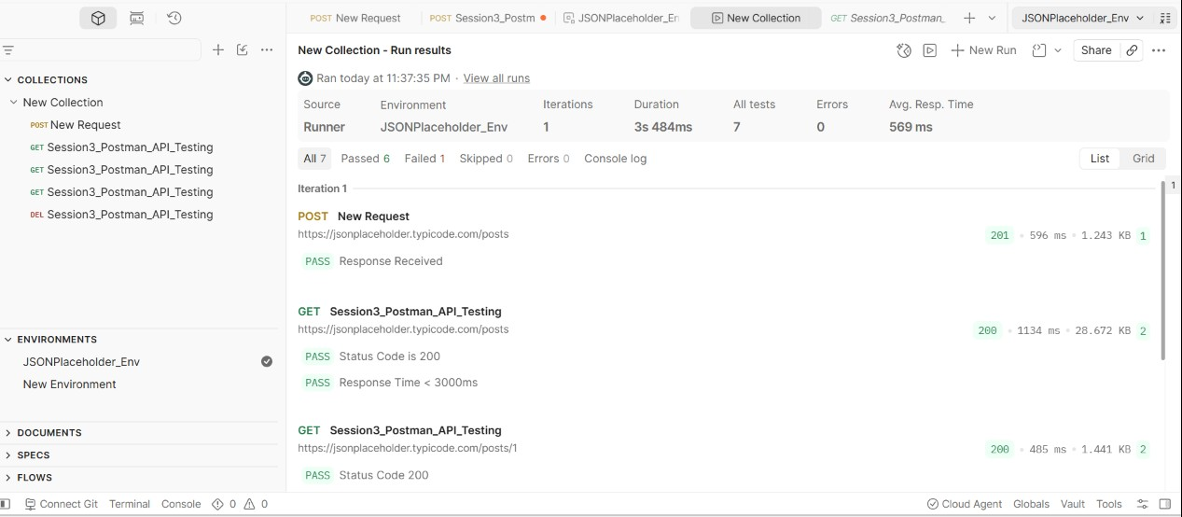

- Selenium and Robot Framework
Test execution+installation

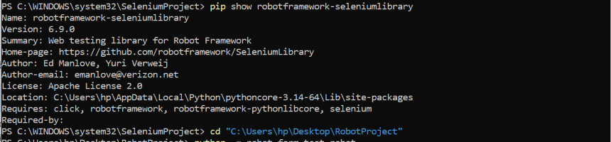

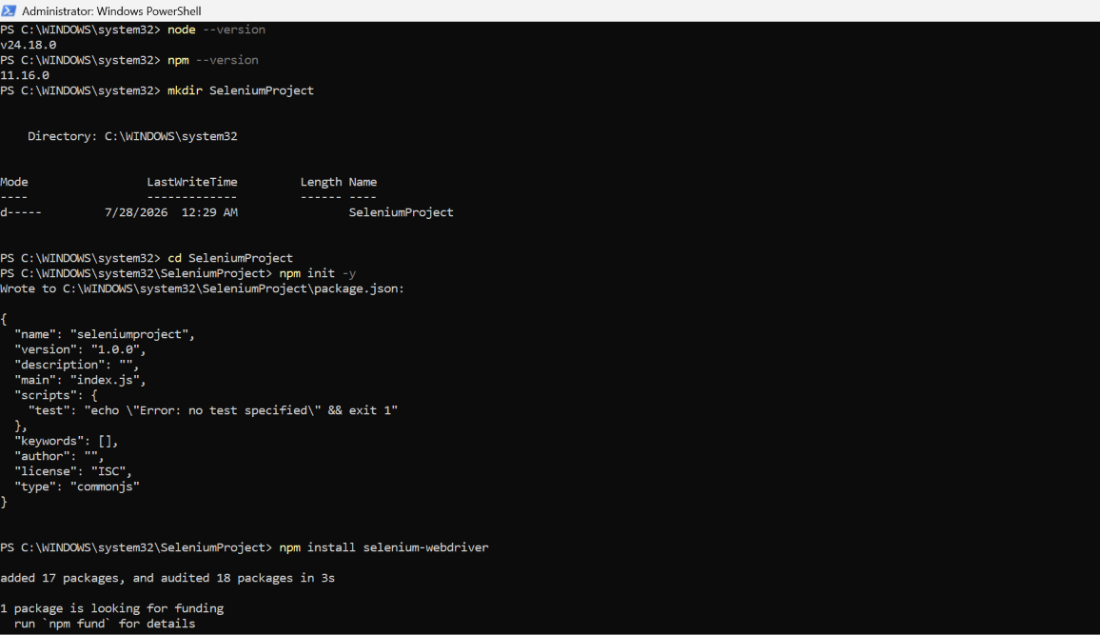
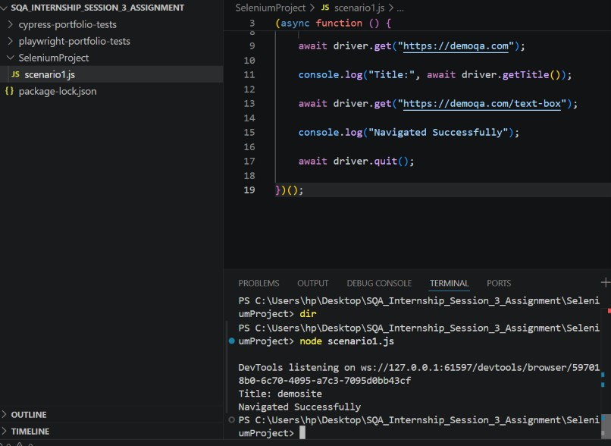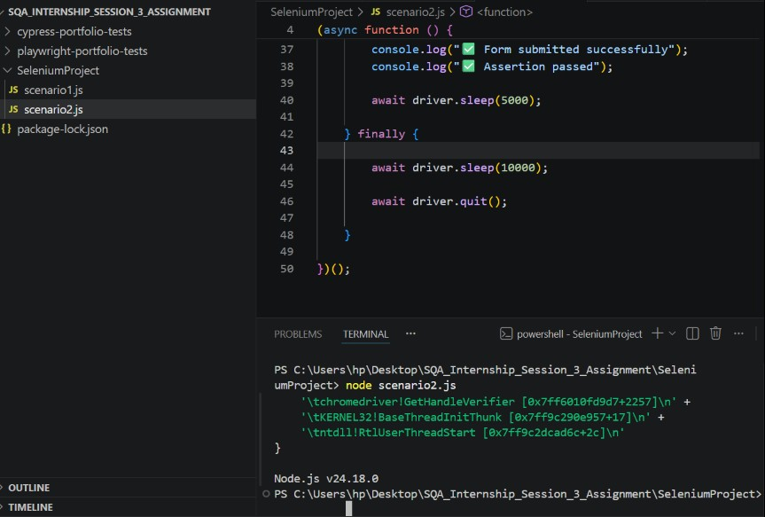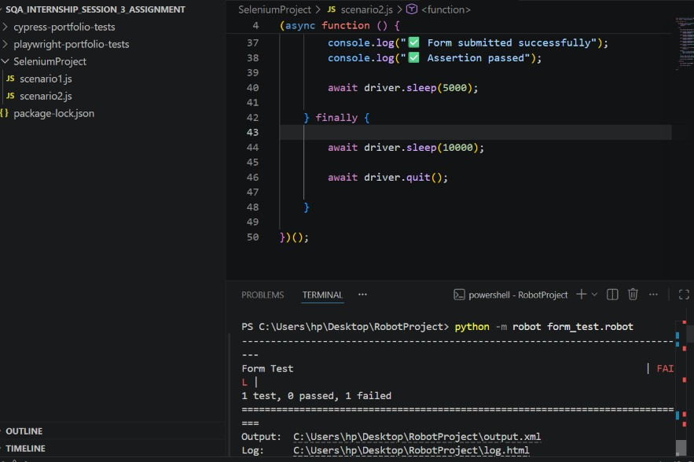

Form Test report
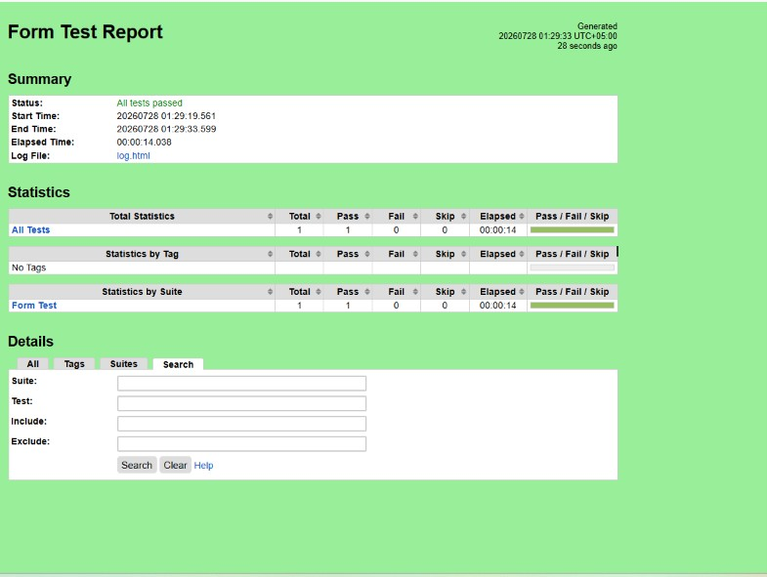
Form log test
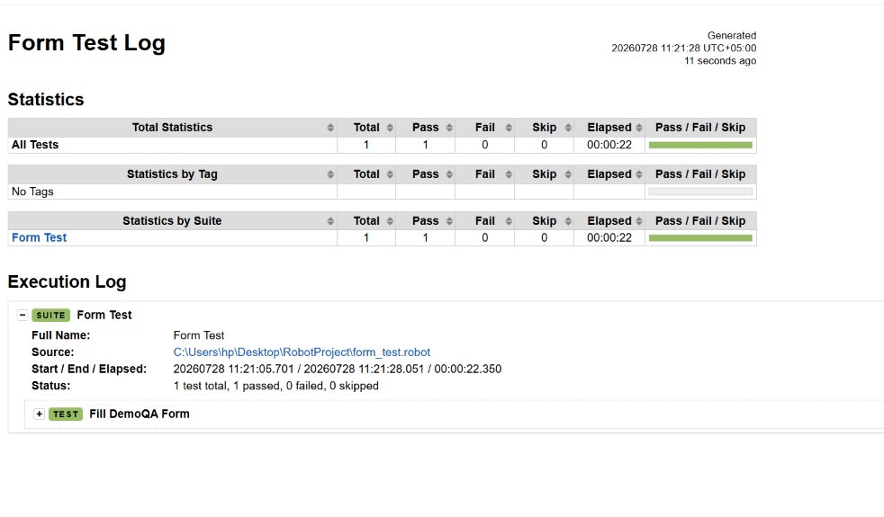
4. Short learning summary with challenges faced
Cypress and Playwright are both effective automation testing tools. Cypress is easier to set up and learn, with an interactive interface that makes debugging simple. Playwright provides broader browser support, faster execution, and advanced testing capabilities. Cypress is well-suited for beginners and quick test automation, while Playwright is a strong choice for complex, large-scale, and cross-browser testing projects.Selenium/Robot Framework challenges were mostly about setup and low-level element interaction, while Playwright's challenges were more about test design (POM structure, waiting strategies, missing real form functionality) — Cypress would likely add its own browser-scope limitations on top of similar locator issues.

- Emp Radar Time Tracking
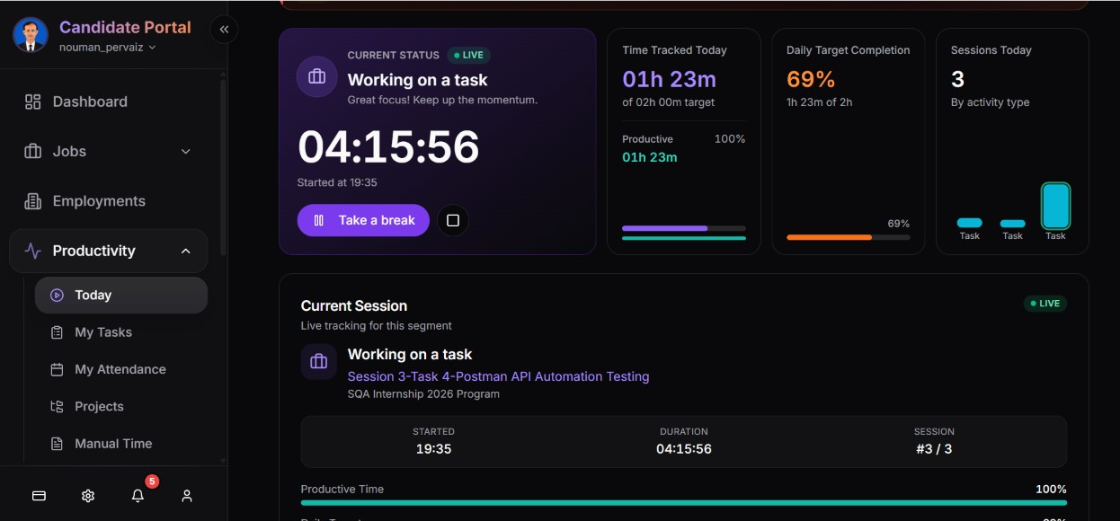

- Loom Video link

https://www.loom.com/share/5d62c5df82a04313bae0688ed79bbfd5

