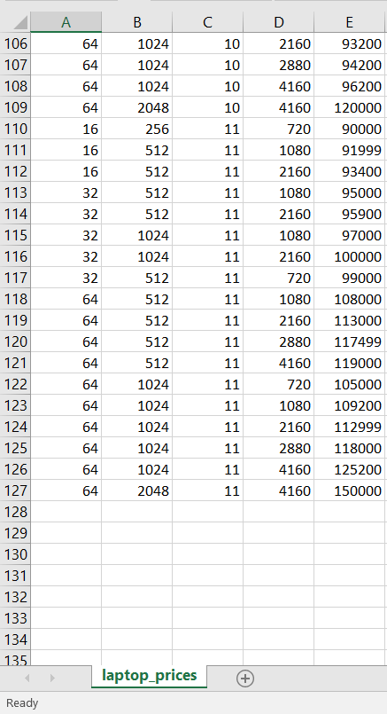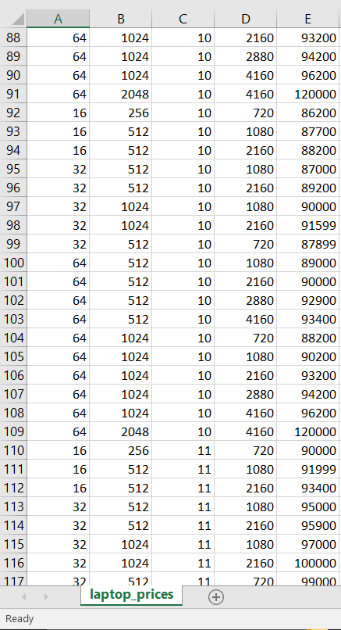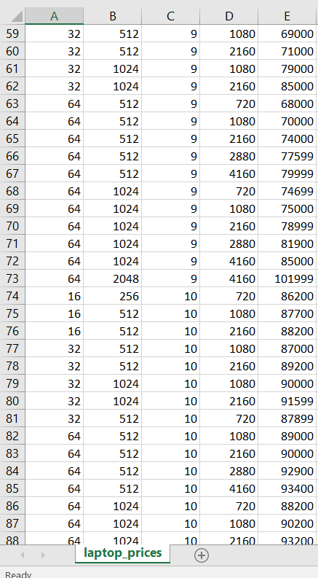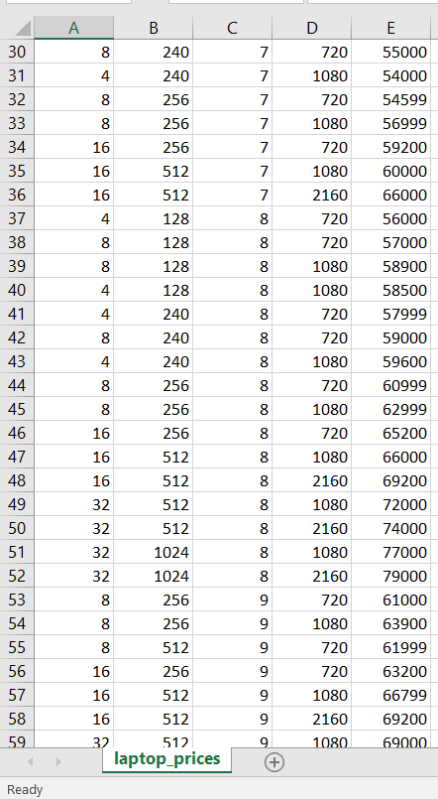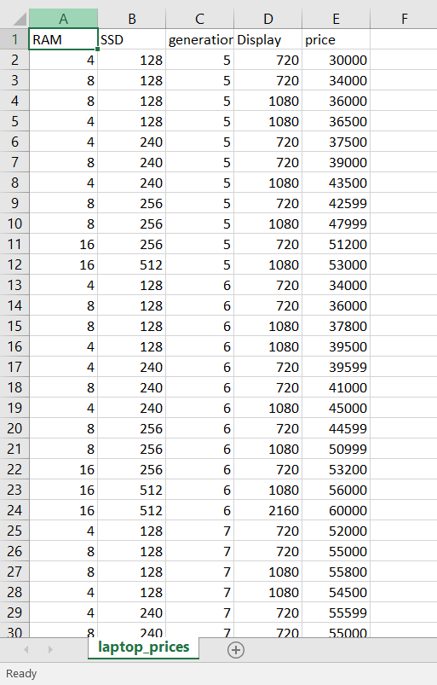My Dataset laptop_prices.csv🡨 -----------------------With libraries-------------------------------🡪

import pandas as pd

import numpy as np

data = pd.read_csv('/Users/Nouman/ML/laptop_prices.csv')

# print(data.describe())

X = data['SSD']

Y = data['price']

mean_x = np.mean(X)

mean_y = np.mean(Y)

size = len(X)

numerator = 0

denominator = 0

for i in range(size):

numerator += (X[i] - mean_x)*(Y[i] - mean_y)

denominator += (X[i]-mean_x) ** 2

m = numerator/denominator

c = mean_y - (m * mean_x)

print("Value of constant c =",c)

🡨 ------------------------------Scatter plot-----------------------🡪

max_x = np.max(X) + 100

min_x = np.min(X) - 100

x = np.linspace(min_x, max_x, 1000)

y = m*x + c

import matplotlib.pyplot as plt

plt.plot(x, y, color='Blue', label='Regression Line')

plt.scatter(X, Y, c='#ef5423', label='Scatter Plot')

plt.xlabel('SSD')

plt.ylabel('price')

plt.legend()

plt.show()

🡨 ----------------------------Manual Method-----------------------------🡪

n = 0

d = 0

for i in range(size):

y_pred = m * X[i] + c

n += (y_pred-mean_y) **2

d += (Y[i] - mean_y) **2 🡪 r_square = n/d 🡪 r_square