1. Train an adaline to solve the following classification problem

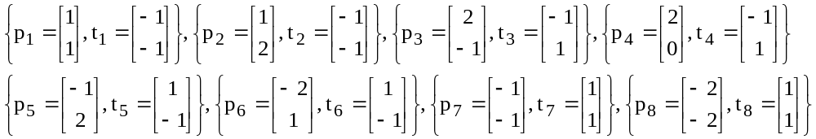
Draw the decision limits found

2. Train an Adaline to solve the following pattern recognition problem:

Patterns:

Output 60 0 -60

The goal is to train the network so it manages to classify the six patterns in the respective T, G or F. To do so, the following six patterns are presented randomly and their weights are adjusted after each presentation. Use a learning constant equal to 0,03. After each training cycle, determine the value of the quadratic medium error which would be used as quality measure of the network. Make a chart of the error in function of the training cycles that allows to analyze the network convergence.

3. For the following neural network, with following start parameters:

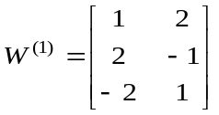 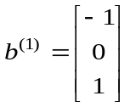 W⁽²⁾ = [1 2 –1] b⁽²⁾ = 1

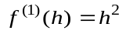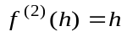

Execute a iteration of the backpropagation algorithm with a learning constant of α = 0.5 and the following input pattern:

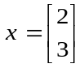, t = 1

4. Solve the XOR problem using a multilayer perceptron with BP.

- Use in both the hidden and the output layer the sigmoidal activation function with a coding in [0,1]

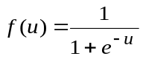

- Then use for both layers the sigmoide bipolar activation function with a coding in [-1,1]

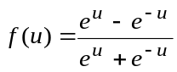

Is there difference regarding the number of training cycles for the network’s speed?

