Nouman Zahid FA23BCS085
Abdul Haseeb FA23BCS120
Naive Bayes Classification

Table of Contents
1. Introduction 2
Problem: 2
Contributions: 2
2. Background 2
Bayes’ Theorem: 2
3. Dataset & Preprocessing 3
4. Methodology 5
• Hyperparameters 5
• Training 5
• Metrics 5
5. Experimental Results 5
Accuracy 5
6. Conclusion 6
References 6

1. Introduction

Problem:
Train a Naive Bayes (NB) classifier to predict class labels from features.
Objectives
- Implement and compare NB variants: Gaussian, Multinomial, Bernoulli.
- Design preprocessing pipeline based on data type (continuous/discrete/binary).
- Evaluate models with standard metrics.

Contributions:
- Reproducible NB pipeline.
- Comparative study of NB variants and smoothing.
- Analysis using confusion matrix and ROC curves.

2. Background
Bayes’ Theorem:
P(C∣x)=P(x∣C)P(C)P(x)P(C|x) = \frac{P(x|C)P(C)}{P(x)}P(C∣x)=P(x)P(x∣C)P(C)​
Decision rule (MAP): choose class with highest posterior.
- Naive Independence Assumption:
Features are conditionally independent given the class:
P(x∣C)=∏P(xj∣C)P(x|C) = \prod P(x_j|C)P(x∣C)=∏P(xj​∣C).
- Variants:
  - GaussianNB: for continuous data.
  - MultinomialNB: for counts/frequencies (e.g., text).
  - BernoulliNB: for binary features.

3. Dataset & Preprocessing
- Dataset:
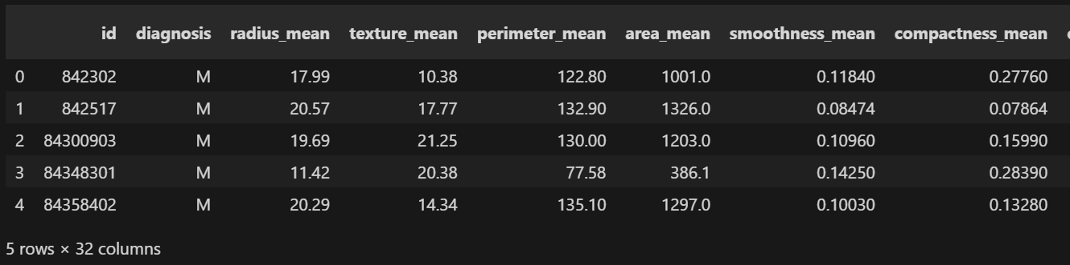
- Steps:
  - Handle missing values (impute/drop).
  - Encode categorical features.
  - For text: tokenization + vectorization (Count/TF-IDF).
  - Correlations btw features to choose suitable one
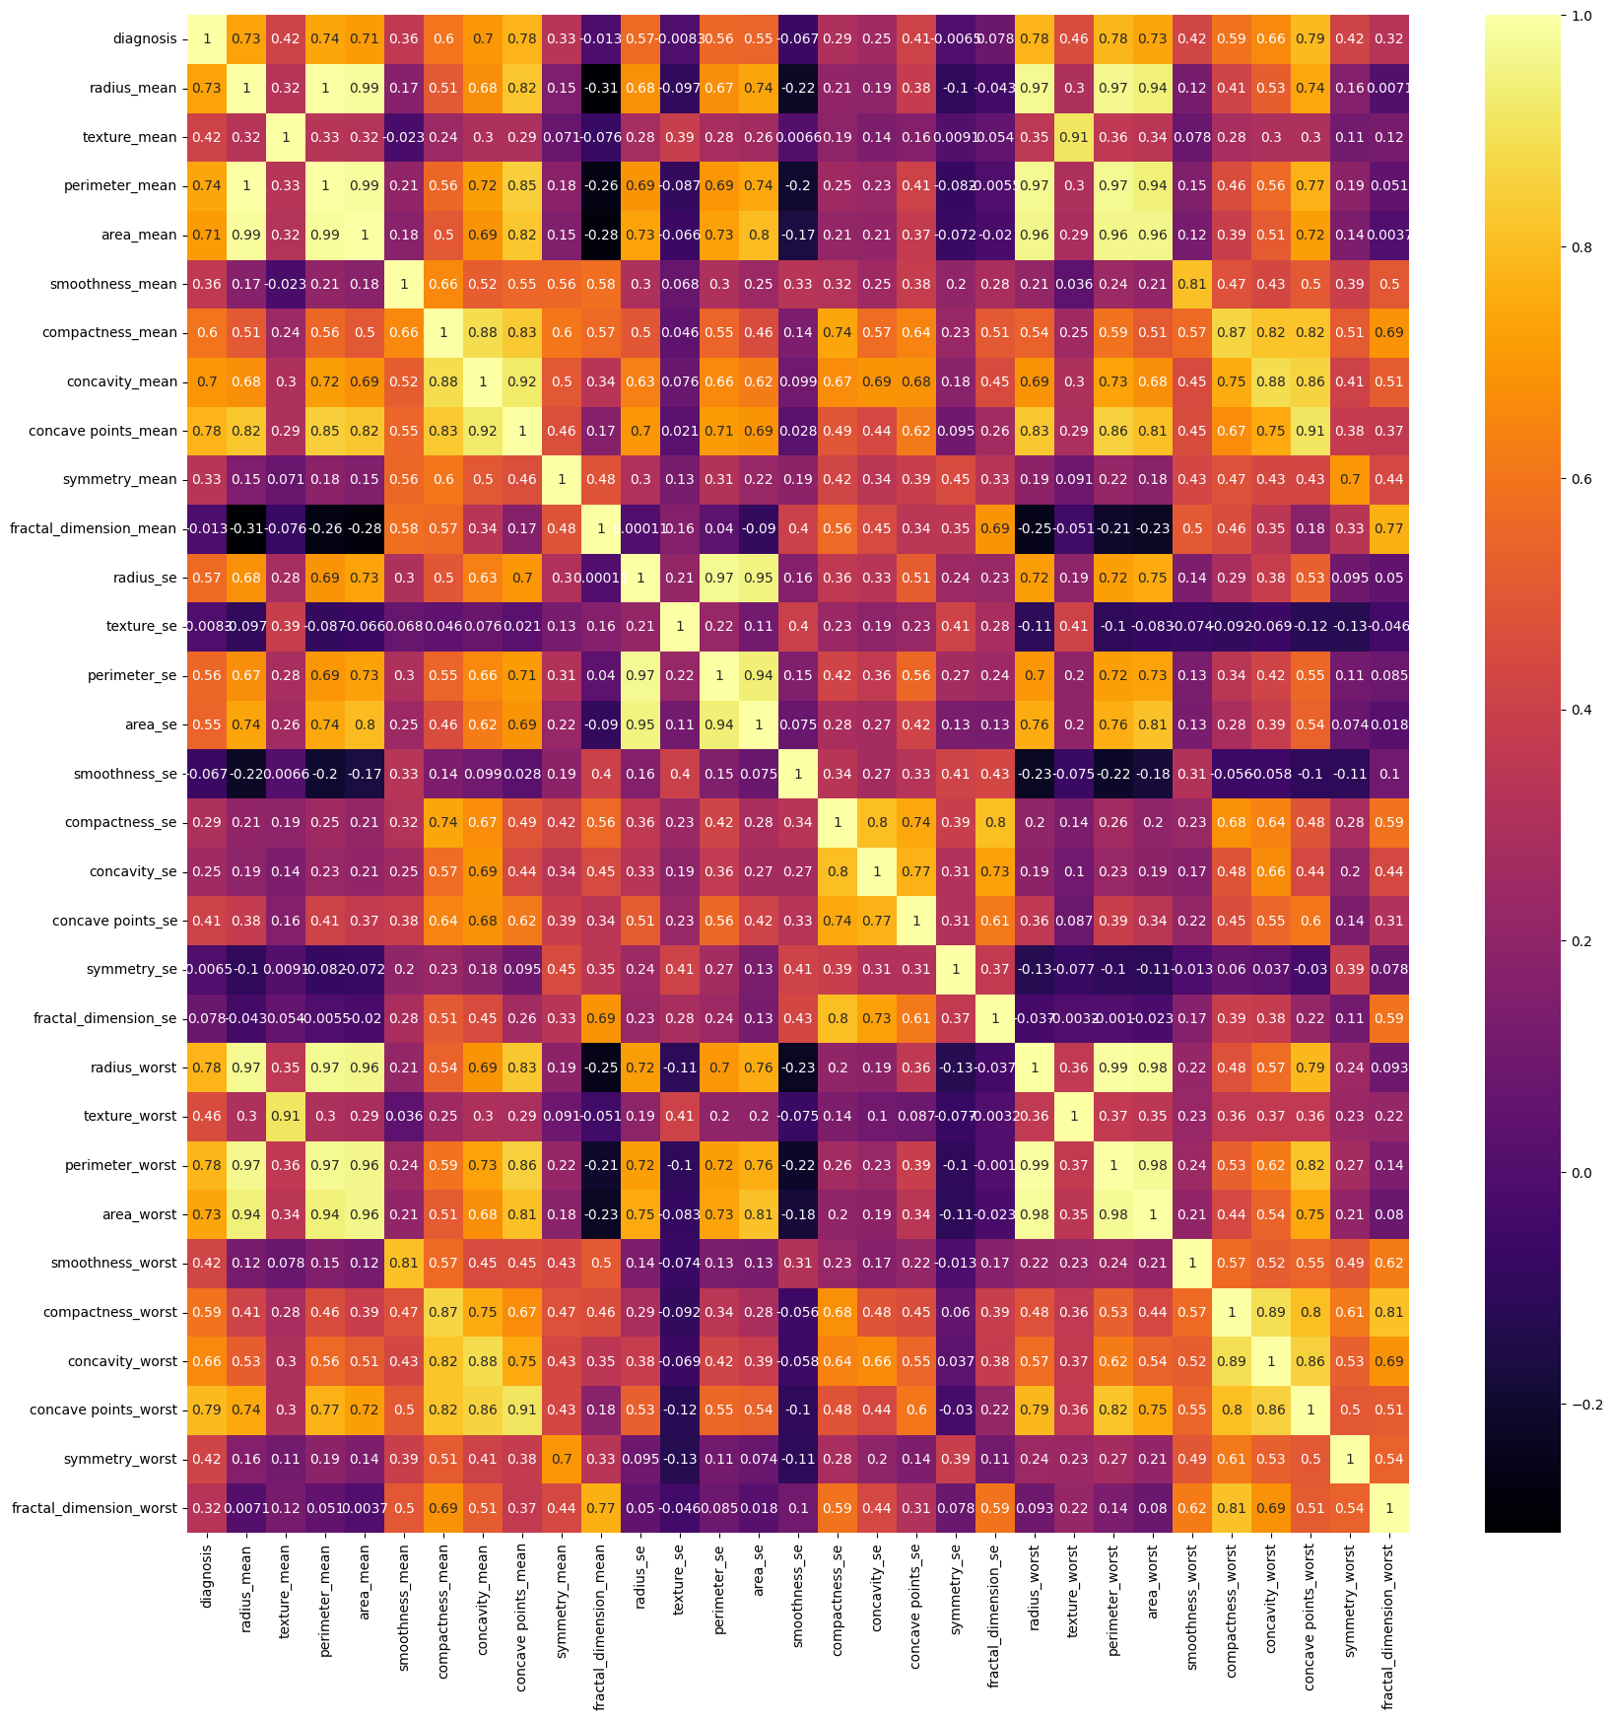

4. Methodology
- Hyperparameters:
  - GaussianNB: var_smoothing ∈ {1e-9, 1e-8, 1e-7}
  - MultinomialNB: alpha ∈ {0.1, 0.5, 1.0}
  - BernoulliNB: alpha ∈ {0.1, 0.5, 1.0} + binarization
- Training:
Train/validate models, final evaluation on test set.
- Metrics:
Accuracy, Precision, Recall, F1, ROC-AUC, Confusion matrix.

5. Experimental Results
Accuracy:
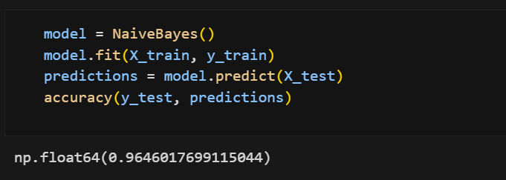

6. Conclusion

Naive Bayes is a simple yet powerful baseline. With proper preprocessing and smoothing, it provides robust results. For future work, richer features and ensemble approaches can enhance performance.

References
[1] C. M. Bishop, Pattern Recognition and Machine Learning, Springer, 2006.
[2] A. McCallum and K. Nigam, "A comparison of event models for naive bayes text classification," AAAI-98 Workshop on Learning for Text Categorization, 1998.
[3] F. Pedregosa et al., "Scikit-learn: Machine Learning in Python," Journal of Machine Learning Research, vol. 12, pp. 2825-2830, 2011.
[4] W. McKinney, "Data Structures for Statistical Computing in Python," Proceedings of the 9th Python in Science Conference, pp. 51-56, 2010.

List of Figures
- Figure 1: Naive Bayes pipeline architecture
- Figure 2: Feature distribution visualization
- Figure 3: ROC curves for multi-class classification
- Figure 4: Confusion matrix heatmap

