
Machine Learning Fundamentals
Decision Tree Classifications
Report: Breast Cancer Diagnoses
Submitted To:
Mr. Umar Nauman

Submitted By:
Nouman Zahid FA23-BCS-085
Abdul Haseeb FA23-BCS-120

Contents
Problem Statement 2
Dataset 2
Techniques Used 2
Rationale for Techniques 2
Results 3
Decision Tree - Full Features 3
Decision Tree - Reduced Features 4
Decision Tree - PCA Features 4
List of Figures 5
References 6

Project Report

Problem Statement
The objective of this project is to classify breast tumors as malignant or benign using clinical features from the scikit-learn breast cancer dataset.

Dataset
The dataset is the scikit-learn breast cancer dataset. It contains numeric measurements computed from digitized images of fine needle aspirate (FNA) of breast masses.
- Total samples: 569;
- Total features (including target): 31

Techniques Used
Why we used these techniques😊
- Train-test split: To evaluate model performance on unseen data.
- Correlation analysis: To remove highly correlated (redundant) features and reduce dimensionality.
- Principal Component Analysis (PCA): To project the data into principal components and reduce dimensionality while preserving variance.
- Decision Tree Classifier: A simple, interpretable classification model used for baseline evaluation.

Rationale for Techniques
Correlation analysis helps remove redundant features which can reduce overfitting and improve training speed. PCA provides an orthogonal basis capturing most variance which is useful when many features are correlated. Decision Trees are quick to train and provide understandable decision rules.

Results
Model | Description | Accuracy
Full | Decision Tree (Full features) | 0.9474
Reduced | Decision Tree (Reduced features) | 0.9035
PCA | Decision Tree (PCA features) | 0.9123

Decision Tree - Full Features
Accuracy: 0.9474
Classification Report:
precision recall f1-score support
0 0.93 0.93 0.93 43
1 0.96 0.96 0.96 71
accuracy 0.95 114
macro avg 0.94 0.94 0.94 114
weighted avg 0.95 0.95 0.95 114
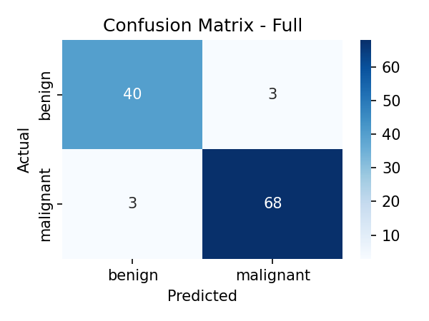

Decision Tree - Reduced Features
Accuracy: 0.9035
Classification Report:
precision recall f1-score support
0 0.82 0.95 0.88 43
1 0.97 0.87 0.92 71
accuracy 0.90 114
macro avg 0.89 0.91 0.90 114
weighted avg 0.91 0.90 0.90 114
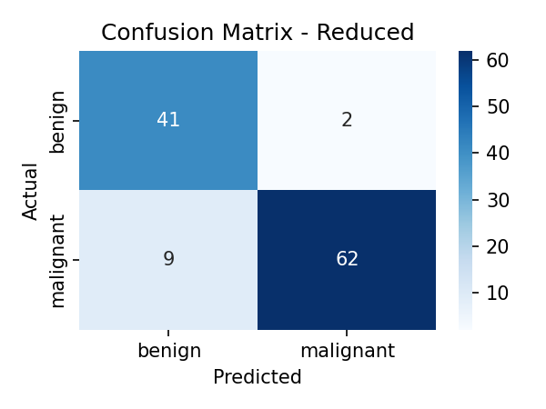

Decision Tree PCA Features:

Accuracy: 0.9474
Classification Report:
precision recall f1-score support
0 0.89 0.98 0.93 43
1 0.99 0.93 0.96 71
accuracy 0.95 114
macro avg 0.94 0.95 0.94 114
weighted avg 0.95 0.95 0.95 114
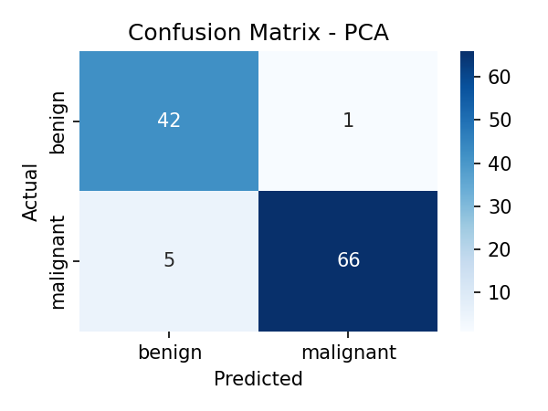

List Of Figures:
Figure 1: Confusion matrix - Full features
Figure 2: Confusion matrix - Reduced features
Figure 3: Confusion matrix - PCA features

References:
1. Pedregosa et al., Scikit-learn: Machine Learning in Python, JMLR 2011.
2. The scikit-learn breast cancer dataset documentation: https://scikit-learn.org/stable/modules/generated/sklearn.datasets.load_breast_cancer.html

