

Submitted To:
Mr. Umar Nauman

Submitted By:
Nouman Zahid FA23-BCS-085
Abdul Haseeb FA23-BCS-120

Machine Learning Fundamentals
KNN
Task02

Contents
1. Problem Statement 2
2. Dataset 2
2.1 Schema 2
2.2 Target Distribution 2
3. Methods 2
4. Results 3
4.1 Accuracy vs K 3
4.2 Classification Report 4
4.3 Figures from Notebook 4
5. Discussion 7
6. References 7

KNN Classification on Diabetes Dataset

1. Problem Statement
This document reports a K-Nearest Neighbors (KNN) classifier applied to the Pima Indians Diabetes dataset. The goal is to predict the presence of diabetes (binary outcome) using eight physiological measurements.

2. Dataset
The dataset contains 768 rows and 9 columns (8 features and 1 binary target). Certain features may contain zeros that represent missing or unrecorded values¹.

2.1 Schema
Column | Type | Min | Max
Pregnancies | int64 | 0 | 17
Glucose | int64 | 0 | 199
BloodPressure | int64 | 0 | 122
SkinThickness | int64 | 0 | 99
Insulin | int64 | 0 | 846
BMI | float64 | 0.0 | 67.1
DiabetesPedigreeFunction | float64 | 0.078 | 2.42
Age | int64 | 21 | 81
Outcome | int64 | 0 | 1
Table 1: Dataset schema with types and ranges

2.2 Target Distribution
No Diabetes: 500; Diabetes: 268

3. Methods
We split the data into training and test sets (80/20 split) with a fixed random seed. Continuous features were standardized using z-score normalization (mean=0, std=1) via StandardScaler. A KNN classifier was trained for k in [1, 20], and the best k was selected based on test-set accuracy.

4. Results

4.1 Accuracy vs K
K | Accuracy
1.0 | 0.6233766233766234
2.0 | 0.6558441558441559
3.0 | 0.7077922077922078
4.0 | 0.7012987012987013
5.0 | 0.6948051948051948
6.0 | 0.7012987012987013
7.0 | 0.6818181818181818
8.0 | 0.7077922077922078
9.0 | 0.6818181818181818
10.0 | 0.6883116883116883
11.0 | 0.7077922077922078
12.0 | 0.7207792207792207
13.0 | 0.7077922077922078
14.0 | 0.7272727272727273
15.0 | 0.7207792207792207
16.0 | 0.7467532467532467
17.0 | 0.7532467532467533
18.0 | 0.7597402597402597
19.0 | 0.7597402597402597
20.0 | 0.7597402597402597
Table 2: Accuracy across neighborhood sizes k
Best k = 18 with accuracy = 0.7597. Final test accuracy using best k: 0.7597.

4.2 Classification Report
class | precision | recall | f1-score | support
0 | 0.7719298245614035 | 0.8888888888888888 | 0.8262910798122066 | 99.0
1 | 0.725 | 0.5272727272727272 | 0.6105263157894737 | 55.0
Table 3: Per-class precision, recall, F1, and support

4.3 Figures from Notebook
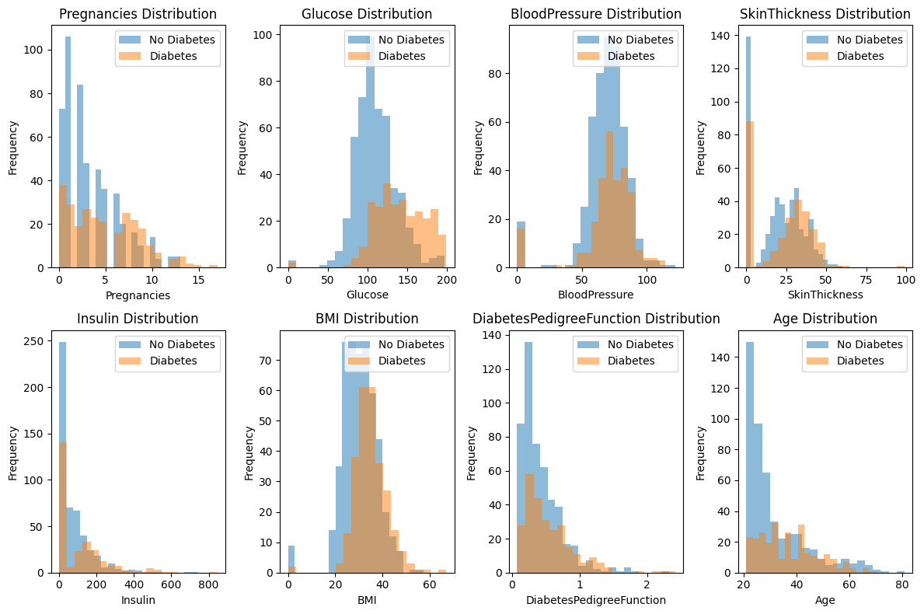
Figure 1: {column} Distribution
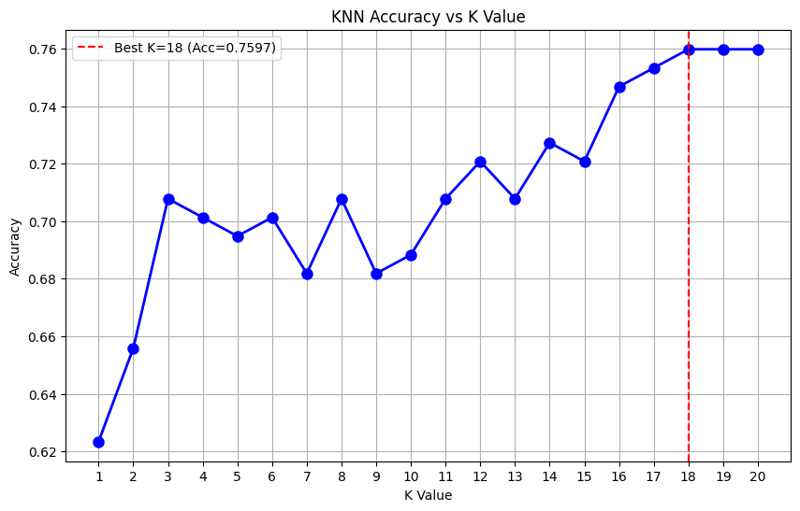
Figure 2: KNN Accuracy vs K Value
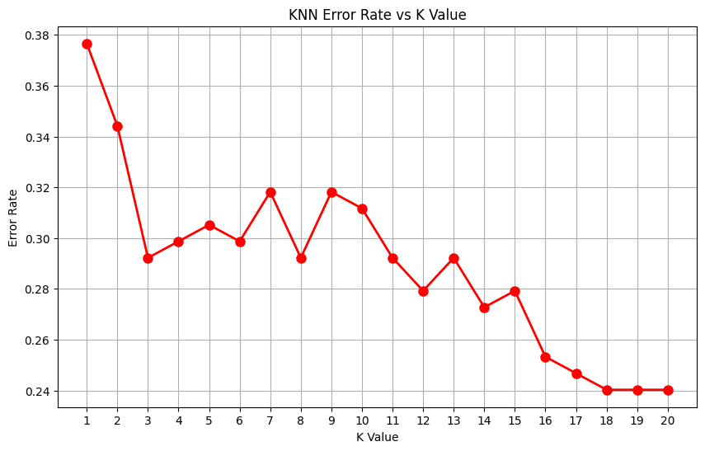
Figure 3: KNN Error Rate vs K Value
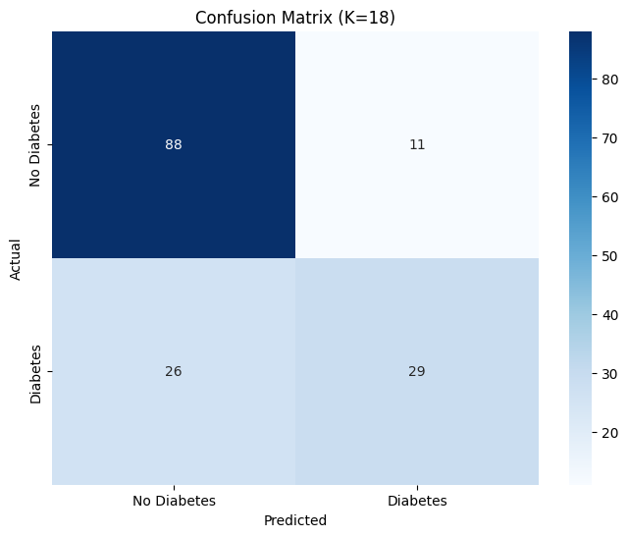
Figure 4: Confusion Matrix (K={best_k})
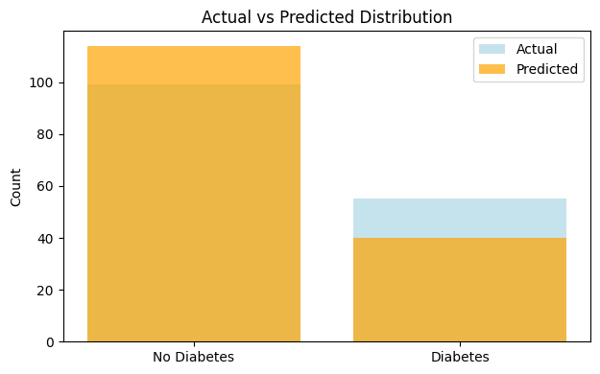
Figure 5: Actual vs Predicted Distribution

5. Discussion
Performance improves as k increases up to a point (here around k=18-20). Larger k values can reduce variance but may introduce bias. The moderate class imbalance and potential presence of zero-as-missing values likely affect sensitivity to the positive class.

6. References
scikit-learn: KNeighborsClassifier: https://scikit-learn.org/stable/modules/generated/sklearn.neighbors.KNeighborsClassifier.html
scikit-learn: StandardScaler: https://scikit-learn.org/stable/modules/generated/sklearn.preprocessing.StandardScaler.html
Pima Indians Diabetes dataset: https://www.kaggle.com/datasets/uciml/pima-indians-diabetes-database

