
ML
K Means
Task02
Submitted To:
Mr. Umar Nauman

Submitted By:
Nouman Zahid FA23-BCS-085
Abdul Haseeb FA23-BCS-120

Contents
1. Introduction 2
1.1 Problem Statement 2
1.2 Objectives 2
1.3 Scope and Limitations 2
2. Dataset Description 2
2.1 Data Source 2
2.2 Data Structure 2
2.3 Data Preprocessing 3
3. Methodology 3
3.1 K-Means Clustering Algorithm 3
3.2 Feature Selection and Standardization 3
3.3 Elbow Method for Optimal k 4
4. Implementation and Results 4
4.1 Experimental Setup 4
4.2 Cluster Analysis 4
4.3 Visualization Results 4
5. Conclusion and Future Work 4
6. References 5
List of Figures 5
List of Tables 5

K-Means Clustering Analysis of Facebook Live Video Engagement

1. Introduction

1.1 Problem Statement
Social media platforms generate massive amounts of engagement data daily. Understanding patterns in user engagement is crucial for content creators, marketers, and platform administrators. The primary challenge addressed in this study is identifying natural groupings within Facebook Live video engagement metrics to better understand different types of content performance.

1.2 Objectives
The main objectives of this study are to:
• Apply K-means clustering to identify natural groupings in Facebook Live video engagement data
• Determine the optimal number of clusters using quantitative methods
• Analyze and interpret the characteristics of each identified cluster
• Provide insights for content strategy and audience engagement optimization

1.3 Scope and Limitations
This study focuses on clustering analysis of Facebook Live video engagement metrics including reactions, comments, shares, and likes. The analysis is limited to numerical engagement metrics and does not consider textual content analysis, temporal patterns, or demographic factors of the audience.

2. Dataset Description

2.1 Data Source
The dataset used in this study contains Facebook Live video engagement metrics collected from various Facebook pages. The data includes metrics such as number of reactions, comments, shares, and different types of reactions (likes, loves, wows, etc.). The dataset comprises 7,052 records of live video sessions.

2.2 Data Structure
Feature | Description | Data Type | Example Values
status_id | Unique identifier for each live video | String | 246675545449582_1649696485147474
status_type | Type of content (video/photo) | Categorical | video, photo
num_reactions | Total number of reactions | Integer | 0 - 1000+
num_comments | Total number of comments | Integer | 0 - 1000+
num_shares | Total number of shares | Integer | 0 - 500+
num_likes | Number of like reactions | Integer | 0 - 900+

2.3 Data Preprocessing
Data preprocessing involved several steps:
• Removal of missing values to ensure data quality
• Selection of relevant engagement metrics for clustering
• Standardization of features to ensure equal contribution to distance calculations
• Handling of categorical variables (status_type) which were excluded from clustering

3. Methodology

3.1 K-Means Clustering Algorithm
K-means clustering¹ is an unsupervised machine learning algorithm that partitions n observations into k clusters where each observation belongs to the cluster with the nearest mean (cluster center). The algorithm aims to minimize the within-cluster sum of squares (inertia).
The algorithm works as follows:
1. Initialize k cluster centers randomly
2. Assign each data point to the nearest cluster center
3. Update cluster centers as the mean of assigned points
4. Repeat steps 2-3 until convergence

3.2 Feature Selection and Standardization
Four key engagement metrics were selected for clustering:
• num_reactions: Total reaction count
• num_comments: Total comment count
• num_shares: Total share count
• num_likes: Like reaction count
Standardization was applied using StandardScaler to ensure all features contribute equally to the distance calculations. This transformation converts features to have zero mean and unit variance.

3.3 Elbow Method for Optimal k
The elbow method² was used to determine the optimal number of clusters (k). This method plots the within-cluster sum of squares (inertia) against different values of k. The optimal k is identified at the 'elbow' point where the rate of decrease in inertia significantly changes.
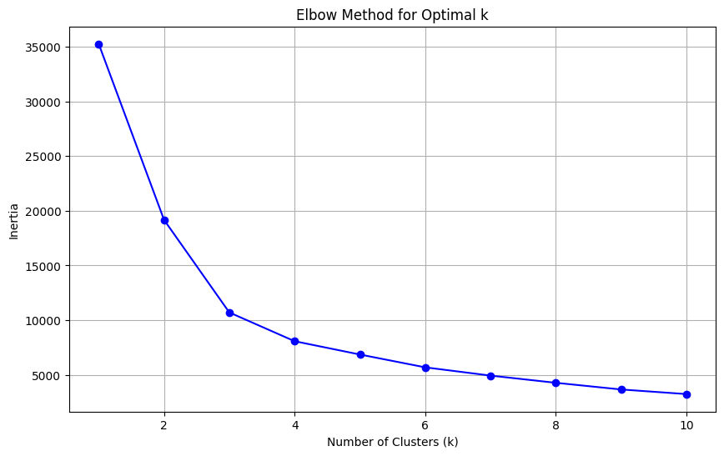

4. Implementation and Results

4.1 Experimental Setup
The implementation was carried out using:
• Python 3.8.5
• Libraries: pandas, numpy, scikit-learn, matplotlib, seaborn
• Random state = 42 for reproducibility
• K-means with n_init=10 to avoid local optima

4.2 Cluster Analysis
The elbow method revealed an optimal k=4 clusters. The cluster centers show distinct engagement patterns:
• Cluster 0: Low engagement across all metrics
• Cluster 1: High reactions and likes, moderate comments and shares
• Cluster 2: High comments and shares, moderate reactions
• Cluster 3: Very high engagement across all metrics
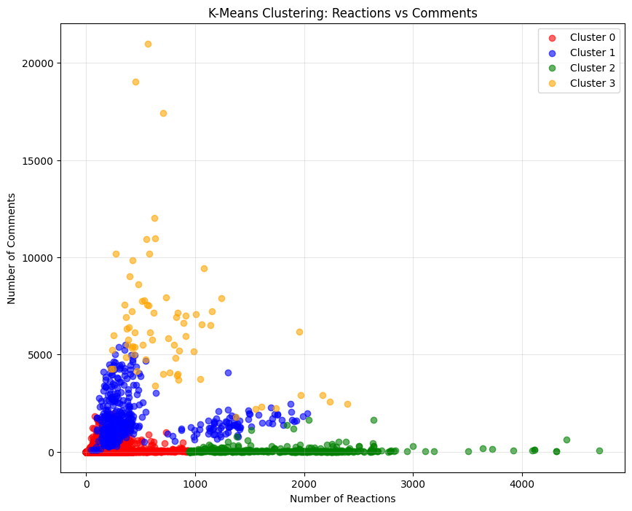
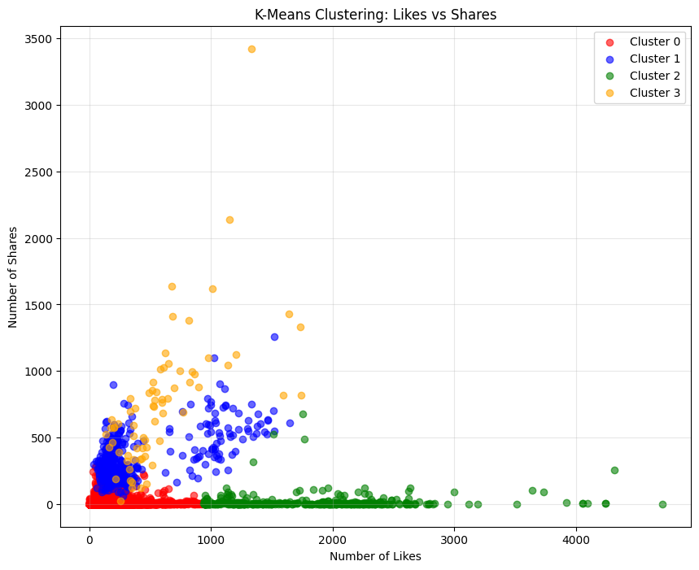

4.3 Visualization Results
Multiple visualizations were created to illustrate the clustering results:
• Elbow curve showing the relationship between k and inertia
• Scatter plots of reactions vs comments and likes vs shares
• Heatmap of cluster centers for easy interpretation
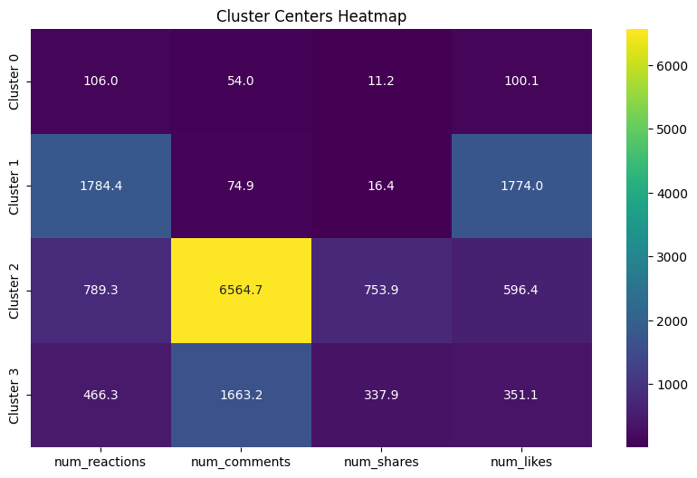

5. Conclusion and Future Work
The K-means clustering successfully identified four distinct patterns of Facebook Live video engagement. These patterns provide valuable insights for content creators to understand different types of audience engagement and optimize their content strategy accordingly.
Future work could include:
• Incorporation of temporal features (posting time, duration)
• Text analysis of video descriptions and comments
• Demographic analysis of audience engagement
• Comparison with other clustering algorithms (DBSCAN, hierarchical clustering)

6. References
[1] MacQueen, J. (1967). Some methods for classification and analysis of multivariate observations. Proceedings of the fifth Berkeley symposium on mathematical statistics and probability, 1(14), 281-297.
[2] Syakur, M. A., Khotimah, B. K., Rochman, E. M. S., & Satoto, B. D. (2018). Integration k-means clustering method and elbow method for identification of the best customer profile cluster. IOP Conference Series: Materials Science and Engineering, 336(1), 012017.
[3] Prashant111. (2021). K-Means Clustering with Python. Kaggle. https://www.kaggle.com/code/prashant111/k-means-clustering-with-python/notebook

List of Figures
Figure 1: Elbow Method for Optimal k
Figure 2: K-Means Clustering: Reactions vs Comments
Figure 3: K-Means Clustering: Likes vs Shares
Figure 4: Cluster Centers Heatmap

