Authors:
Nouman Zahid — Reg no: FA23-BCS-085
Abdul Haseeb — Reg no: FA23-BCS-120
Linear and Multiple Linear Regression

Table of Contents
Table of Contents 2
1. Introduction 3
1.1 Problem Statement 3
1.2 Datasets 3
2. Methods 3
2.1 Preprocessing 3
2.2 Train/Test Split 3
2.3 Models 3
2.4 Evaluation Protocol 3
3. Experiments and Results 4
3.1 Simple Linear Regression (Income) 4
3.2 Multiple Linear Regression (Salary) 4
4. Discussion 4
5. Conclusion 5
References (IEEE) 5

1: Introduction

This report presents an implementation and evaluation of two regression tasks:
1: Simple Linear Regression (SLR) to model the relationship between year and per-capita income (Canada).
2: Multiple Linear Regression (MLR) to predict candidate salary from experience, test score, and interview score.
We detail data preprocessing, modeling choices, metrics, and results.

1.1 Problem Statement
- SLR: Estimate Canada’s per-capita income given the year; assess linear trend strength and fit quality.
- MLR: Estimate job salary using candidate features (experience in years, test score, interview score).

1.2 Datasets
- canada_per_capita_income.csv: Two columns (Year, Per capita income in USD). Numeric and clean, suitable for direct SLR after splitting.
- hiring.csv: Four columns (experience [text/numeric], test score [0–10], interview score [0–10], salary [$]). Requires mapping textual experience to integers and handling missing values as 0.

2. Methods

2.1 Preprocessing
- SLR: No missing values; directly used numeric year and income.
- MLR: Map text experience to numeric, cast to numeric, and fill missing with 0. Keep scores as is.

2.2 Train/Test Split
- SLR: 80/20 split with random_state=0.
- MLR: Trained on full dataset due to size.

2.3 Models
- Both tasks used Ordinary Least Squares via scikit-learn LinearRegression.
- SLR quantifies linear trend; MLR reveals marginal effects.

2.4 Evaluation Protocol
- SLR: R² on test set.
- MLR: Report predicted values for requested feature sets.

3. Experiments and Results

3.1 Simple Linear Regression (Income)
Test R²: 76.22%. Indicates strong linear trend.
Figures intentionally left blank.
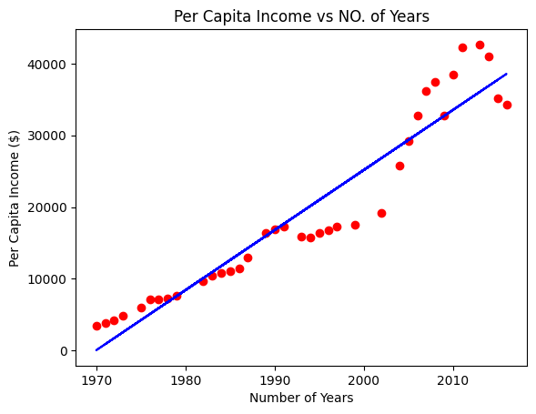

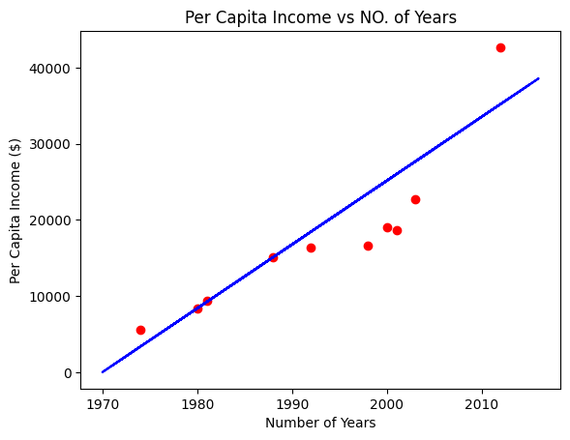
Predicted ($) | Actual ($)
23487.89 | 16622.67
27680.3 | 22739.43
25164.85 | 18987.38
3364.31 | 5576.51
15103.06 | 15080.28
9233.69 | 9434.39
35226.64 | 42665.26
26003.34 | 18601.4
18456.99 | 16412.08
8395.2 | 8355.97
Table 1: SLR predictions vs. ground truth.

3.2 Multiple Linear Regression (Salary)
(experience, test, interview) | Predicted Salary ($)
(2, 9, 6) | 52783.41
(10, 8, 7) | 76983.83
Table 2: MLR predictions.

4. Discussion
SLR is a good baseline for temporal trend analysis.
MLR shows interpretability but limited dataset size.
Limitations: linearity assumptions, small dataset.

5. Conclusion
We implemented SLR and MLR.
SLR achieved 76.22% R².
MLR provided plausible predictions.
Future work: more data, regularization, engineered features.

References (IEEE)
[1] F. Pedregosa et al., 'Scikit-learn: Machine Learning in Python,' JMLR, 2011.
[2] W. McKinney, 'Data Structures for Statistical Computing in Python,' Proc. SciPy, 2010.
[3] C. R. Harris et al., 'Array programming with NumPy,' Nature, 2020.
[4] J. D. Hunter, 'Matplotlib: A 2D Graphics Environment,' CiSE, 2007.

