Identifying main entities, activities, and their relationship

In parameter passing, the main components(or factors) include entity passed, evaluation, context and typing. For the known parameter passing styles:

- Call by value :
The entity passed is a value and it is evaluated at the time of procedure call in the context of the calling procedure and entities passed are evaluated in order. The main activity here is to prevent side effect on the entity passed and this can be achieved by using a thunk (method) that copy back the original value of the entity at the end of the procedure call.
We can use a record to hold the entity and the thunk. This is because a record can hold values of different types.
- Call by reference:
Here, the entity passed is a reference(an address in memory) and as in call by value, it is evaluated at the time of the procedure call in the context of the calling procedure. The main activity here is to perform aliasing on the entity passed and the formal parameter, that is, they point to the same memory address and changes made to one effects the other.
- Call by copy-restore:
Here, the entity passed is a value and it is evaluated at the time of procedure call in the context of the called procedure and the entity passed are evaluated in order. The main activity in this style is the copy-restore process which indicates that we make a copy of the argument before executing the function body. This copy is then worked with in the function body. When the function body has completed, the protocol for copy restore dictates that the copy of the argument be restored into the original argument using the address of the argument. We can use a thunk to produce a copy of the arguments using a swap algorithm. We can use a record to hold this thunk so as to capture it(thunk) relationship with the entity passed.
- Call by sharing:
In call by sharing, the entity passed is an object and it is evaluated in the context of the calling procedure at the time of procedure call. The main activity here is the sharing of objects between the caller and the called routines after assignment of actual parameter to formal parameter and mutation of these objects possible by called functions. We can use records to hold(implement) these objects and to perform this sharing of objects, we can use pointers that points to these objects(or their value).
- Call by name:
In call by name, the entity passed is a value and it is evaluated in order at the time they are used(or needed) in the context of the calling procedure. The main activity here is substituting the entity passed into the function’s body. To perform this substitution, we use capture avoiding substitution(lambda capture) . We can use a record to hold the method used for the capture avoiding substitution.
- Call by need:
Here, the entity passed can be a value(or computation) and it is evaluated in order, in the context of the calling procedure at the time they are needed. The main activity here is to evaluate the entity and store the result for subsequent uses. This can be achieved by wrapping the entity passed in a thunk and when the entity is needed, we call the thunk and use the value. The thunk only runs the computation once and saves it and just returns the saved value. We can use a record to hold this thunk.
- Call by macro expansion:
Here, the entity passed is a value(or reference) and is evaluated in order, in the context of the calling procedure at the time they are needed. The main activities here involve substituting the formal parameter in the called procedure with the entity passed and also textually substituting the called procedure code for the procedure call in the caller program. The body of the called procedure is evaluated in the caller's context. We can use a method(function) to perform the textual substitution and we can as well use a record structure to hold this method and the entity passed since records can hold values of different types.
- Call by future:
Here, the entity passed is a value(or computation) and it is evaluated concurrently with the program in the context of the calling procedure. The main activities in this technique are
- Computing future expressions concurrently with the flow of the program. We can use a method for computing future expressions and can use a record to hold this method.
-Blocking the main program when a future value is needed which is not yet available. This can be achieved by using a test method that transfer complete control to the future expression needed if it value is not yet available. We can use records to hold this method and the future expressions.
- Optimistic evaluation:
Here, the entity passed is a value(or computation, or continuation) which is partially evaluated for some amount of time in the context of the calling procedure. The main activity here is the partial evaluation of entity passed for some amount of time and using call by name to evaluate the function. We can use a stack to hold the saved state of each partial evaluation when it is interrupted. We can use a scheduling strategy for the partial evaluation of functions arguments, so that it would determine when to stop the evaluation by allocating time slices.

Simple design

Using a top down design approach, assuming an abstract structure say a block. Here, we design the structure in such a way that depending on some factors that effects parameter passing styles, say Entity, Context and Evaluation, we will be able to derive a specific passing style. We can use the union type to hold the various types of entities that can be passed to a method and use a record to hold an entity of the union type. We also use union types to hold various types of context and we also do same for evaluation. Then we use records that holds a parameter of type context for context record and evaluation for evaluation record.
We match the entity passed with a specific passing style depending on the context and evaluation factors that are also passed. For example if the entity passed is value, context be called procedure and evaluation be referred to as Lazy then passing style is Style1. We can use a variant record to hold possible set of passing styles.
For each passing style, we can use a record to hold information about the passing style which include operations that captures the various activities in the passing style.
A design diagram follows below

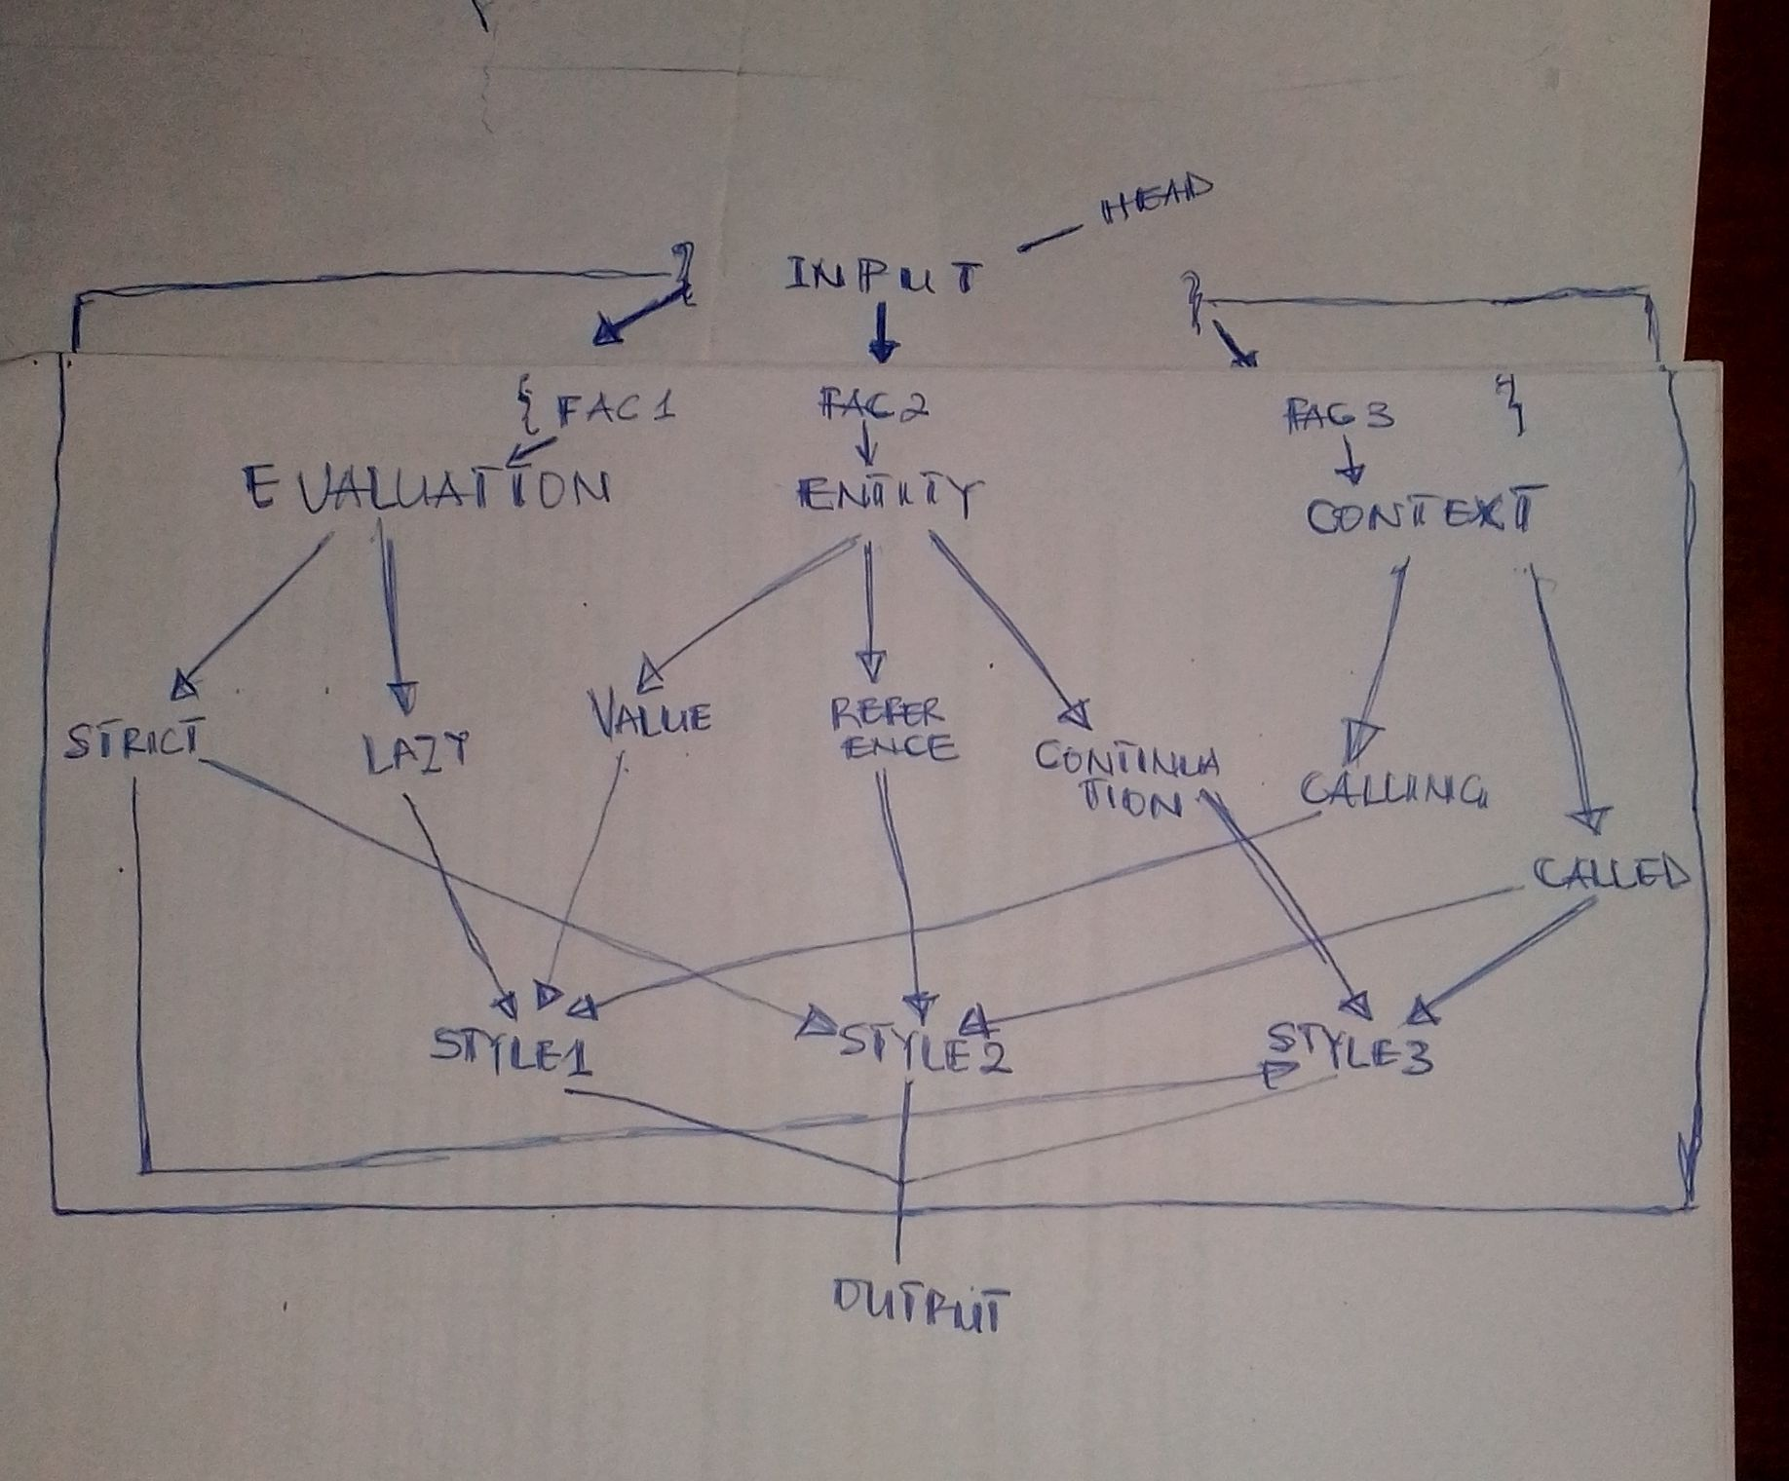
fig.1: Simple design diagram

