Introduction
The rise of short-term rental platforms like Airbnb has created a new market for housing and hospitality across Europe. In major tourist destinations, such as Paris, this has raised important questions about pricing dynamics and housing affordability.
In this paper, we are using a large dataset of Airbnb listings across the most important cities across Europe. Each listing is evaluated for various attributes such as room types, cleanliness and satisfaction ratings, bedrooms, distance from the city center, and more to capture an in-depth understanding of Airbnb prices on both weekdays and weekends. Our data consists of 200 rows for two European cities; Amsterdam and Lisbon. Using econometric methods, we analyze how these variables affect the dependent variable: the total price (realSum)

Research Questions
1- What Variables influence the price?
2- Does log(Price) differ significantly by City and room type, and does their interaction matter?
3- Does the price on weekend differ between Amsterdam and Lisbon?

Descriptive statistics:
Before Regressing the dependent variable, descriptive statistics were performed to ensure soundness of data and validity of assumptions

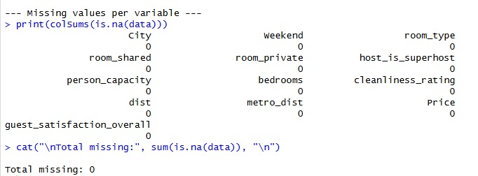

-There are no There aremissing values in any of the variables

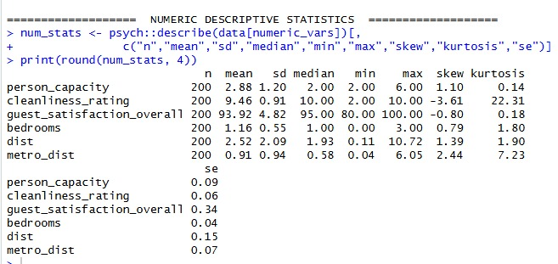

-Based on the statistics shown, customers generally have a high level of satisfaction with an average of 94. On average 1 room is booked and shared by 3 people. Cleanliness also has outstanding ratings, however there are a few extremely low ratings creating strong negative skewness. The Airbnbs are strategically located close to the city center and a metro station.

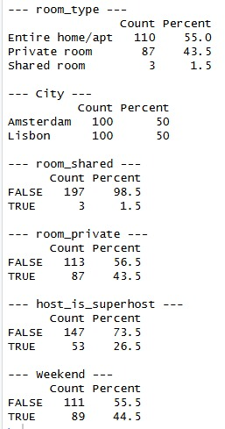
-There’re extremely low instances of shared room with a 1.5% of occurrence. This hinders regression. In this case, its best to observations with shared room to avoid the highly imbalanced categories of the variable room_type.

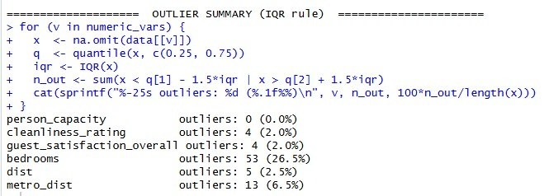
-Checking outliers: The following analysis uses interquartile range to detect outliers. Observations above or below the IQR are flagged as outliers. The variable bedrooms shows an abnormally high percentage of outliers (26.5%) this may be due to it bieng a discrete variable with low variation. As such, these observations shouldn’t be treated as outliers. Metro_dist shows a 6.5% percentage of outliers indicating there may be a cluster of properties located farther than the rest.
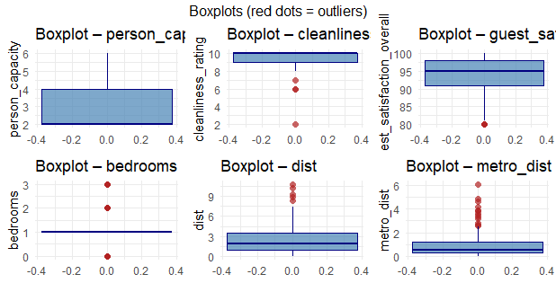

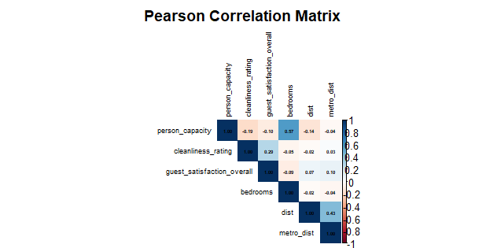
-The box-plots further confirm the extreme skewness of person_capacity and cleanliness. Providing visual illustration of the high rating for both satisfaction and cleanliness, with only a few observations with slightly lower ratings.

The correlation matrix shows that the bedrooms and person_capacity have the strongest linear relationship suggesting Airbnbs accommodating more people tends to have more bedrooms. There’s also a positive relationship between distance from city center variable anddistance to nearest metro and cleanliness rating with overall satisfaction.
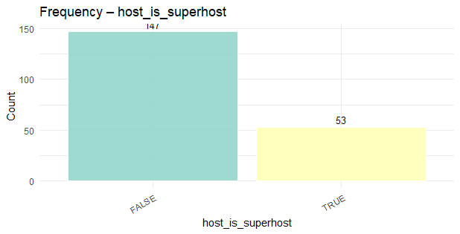
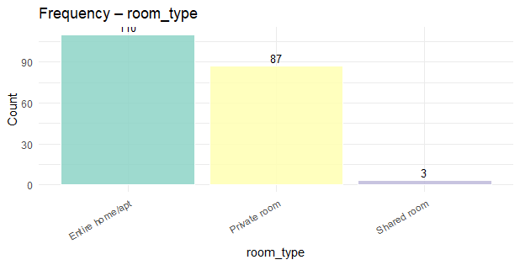
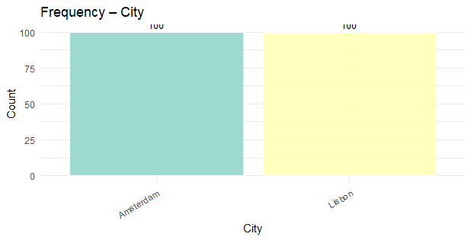

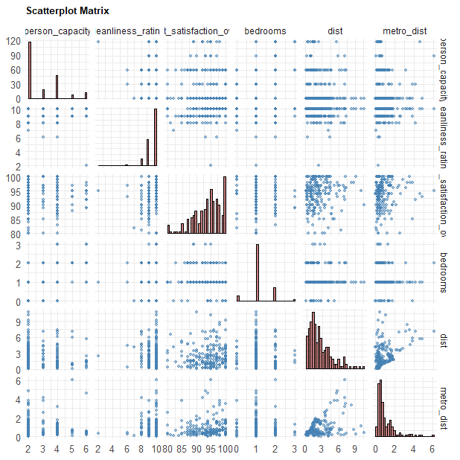

The marginal distributions presented on the diagonal highlight the skewness of the variables. While the pairwise scatterplots reveal a non-linear relationship between dist and metro_dist, more specifically a cone-like shape indicating heteroscedasticity. It also becomes event that the dist and metro_dist have no effect on the overall satisfaction as the scatterplot shows high ratings across all spatial ranges.

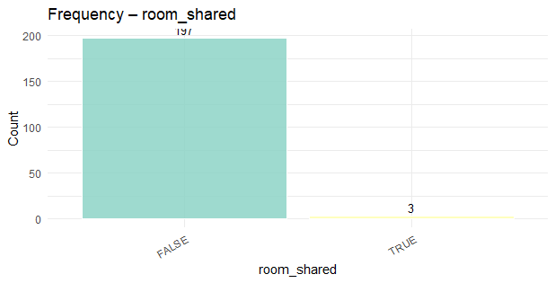
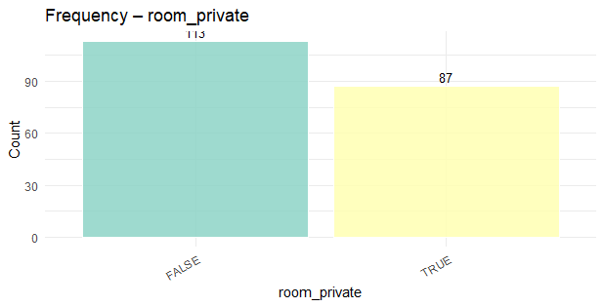
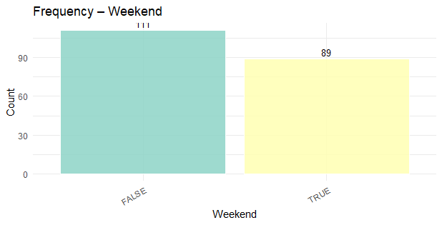

-The dataset contains 200 listings balanced between the 2 cities, Lisbon and Amsterdam, equally. It Is mainly composed of private rooms and entire apartments with very few shared room listings and a ratio of 3:1 non-superhosts to superhosts. Room_Shared is a one-hot encoded representations as almost all observations take the same value.

Data Cleaning

1. Type Conversion
Variables were converted to appropriate types to ensure correct behavior in statistical models.

1.1 Categorical Variables (Factors)
City and room_type were converted to factors with explicitly defined levels. This ensures a consistent reference category in regression models.
- city: levels = c ("Amsterdam", "Lisbon”) → Amsterdam is the reference category
- room_type: levels = c ("Entire home/apt", "Private room”) → Entire home/apt is the reference

1.2 Logical Variables (0/1 Integer)
Three logical (TRUE/FALSE) columns were converted to integer (0/1) for clean model input and numerical operations:
- weekend
- room_private
- host_is_superhost

1.3 Ordinal Variable
cleanliness_rating and guest_satisfaction were converted to integer since both represent ordered numeric scales from 1 to 10.

2. Logical Fixes
Four logical rules were enforced to correct inconsistent values in the data.

2.1 Shared Room Deletion
The dataset originally contained a third room type category: "Shared room". However, this category appeared in only 3 rows out of the entire dataset, making it statistically insignificant and insufficient to support any meaningful analysis or modelling. As a result, these 3 rows were removed entirely from the dataset. The final dataset contains only two room types: "Entire home/apt" and "Private room".

2.2 room_type vs room_private Consistency
The room_private column must be consistent with room_type: Entire home/apt listings should have room_private = 0, and Private room listings should have room_private = 1. Any mismatches were detected and corrected.
Entire home/apt → room_private = 0
Private room → room_private = 1

2.3 Bedrooms = 0 for Private Rooms
Studio apartments (Entire home/apt with 0 bedrooms) are valid and were kept as-is. However, a private room with 0 bedrooms is logically implausible and was treated as a data entry error. All such rows had their bedroom count imputed to 1.
- 16 Private room rows with bedrooms = 0 were imputed to bedrooms = 1

2.4 Cleanliness Rating Range
The cleanliness_rating variable should fall within the valid range of 1 to 10. Values outside this range were clamped to the nearest valid boundary using pmin/pmax:
cleanliness_rating <- pmin (pmax (cleanliness_rating, 1), 10)
Any cleanliness_rating values that were found to be less than 1 were raised to 1, and any values greater than 10 were capped at 10, ensuring all ratings fall within the valid scale.

2.5 Non-negative Distances and Price
Both distance variables (dist., metro_dist) and price were checked to ensure no negative values existed. Any negatives were replaced with 0 using pmax ().

3. Outlier Treatment (Winsorisation)
Outliers were handled using Winsorisation rather than deletion, to retain all rows while reducing the influence of extreme values. A custom winsorise () function was applied that caps values at the 1st and 99th percentiles.

Variable | Issue Found | Treatment
dist | 5 properties located 8-10+ km away, above the IQR upper fence of ~7.4 km | Capped at 99th percentile
metro_dist | 12 properties exceeded the IQR fence (~2.6 km), up to 6 km | Capped at 99th percentile
price | No IQR outliers found, well-behaved distribution | Light cap at 1%/99% as a precaution

The Winsorisation formula applied was:
winsorise <- function(x, lower_q = 0.01, upper_q = 0.99) {
lo <- quantile(x, lower_q, na.rm = TRUE)
hi <- quantile(x, upper_q, na.rm = TRUE)
pmin(pmax(x, lo), hi)
}

QUESTION 1
Model FITTED:
price = guest_satisfaction_overall + cleanliness_rating +
host_is_superhost + weekend + room_type + person_capacity + bedrooms +
city + dist + metro_dist

Model Summary
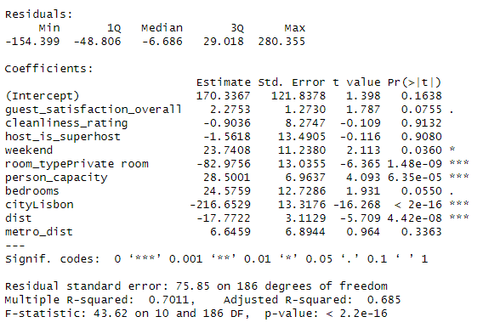

-For this model only weekend, room_type, person_capacity, city and dist are statistically significant while the rest of the variables aren’t.
-The regression model explains 68.5% of the variance in price (adjusted R² = 0.685) and is statistically significant (p < 0.001)
-Intercept (170.3367): Average price when all numerical predictors are zero and the property is on a weekday in Amsterdam, entire home/apt and host is non-super host.
-guest_satisfaction_overall (2.2753): A one-unit increase in guest satisfaction rating increases average price by 2.27, holding all other variables constant. (insignificant)
-cleanliness_rating (-0.9036): A one-unit increase in cleanliness rating decreases average price by 0.9036, holding all other variables constant. (insignificant)
- person_capacity (28.5001): A one-unit increase in person capacity increases average price by 28.5, holding all other variables constant. (significant)
- bedrooms (24.5759): A one-unit increase in number bedrooms increases average price by 24.57, holding all other variables constant. (significant)
- dist (-17.7722)): A one-unit increase in distance from the center of the city decreases average price by 17.77, holding all other variables constant. (significant)
-metro_dist (6.6459): A one-unit increase the distance from the metro increases average price by 6.64, holding all other variables constant. (insignificant)
-weekend (23.7408): Weekend stays are associated with increasing price by 23.74 units on average compared to weekday stays, holding all other variables constant. (significant)
-host_is_superhost (-1.5618): Being a super host is associated with decreasing price by 1.56 units on average compared to non-super hosts, holding all other variables constant. (insignificant)
- room_type (-82.9756): A private room is associated with associated with decreasing price by 82.97 units on average compared to Entire home/apt, holding all other variables constant. (significant)
-city (-216.6529): The property being in Lisbon decreases price by 216.65 units on average compared to the property being in Amsterdam, holding all other variables constant. (significant)
Assumptions checking
1-Linearity Assumption
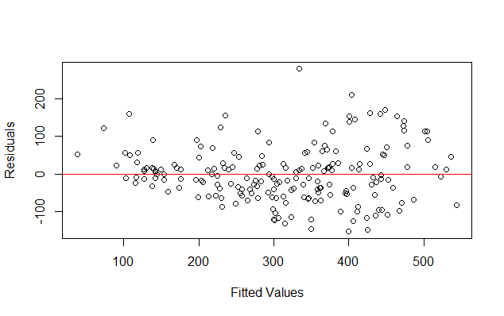
To test the linearity of the residuals, we plotted the residuals vs fitted model shows a random scatter of residuals around zero axis indicating that linearity. Therefore, the linearity assumption is satisfied.
2-Normality Assumption

-To test the normality assumption of the residuals we will plot a Q-Q Plot, run Shapiro-Wilk normality test and Anderson-Darling normality test.
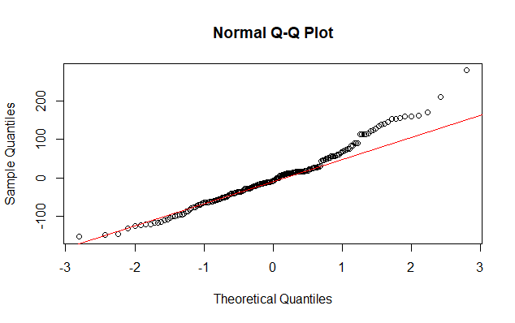
-The Q-Q Plot shows the residuals follow the 45-degree line but not strictly, with some deviations indicating the residuals are (visually) approximately normal.

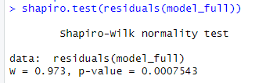
-Shapiro-Wilk Test:
H₀: The residuals are normally distributed
H₁: The residuals are not normally distributed
p-value = 0.0007543
Decision: Reject H₀ (p < 0.05)
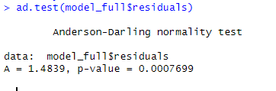
Anderson-Darling Test
H₀: The residuals are normally distributed
H₁: The residuals are not normally distributed
p-value = 0.0007699
Decision: Reject H₀ (p < 0.05)

Conclusion: Both Shapiro-Wilk test and Anderson-Darling test reject the null hypothesis of normality, indicating errors are not normally distributed, even though they are slightly deviated from the 45-degree line in the Q-Q plot. Therefore, the normality assumption is not satisfied.
3-Homoscedasticity Assumption
To check the homoscedasticity of the model, we run studentized Breusch-Pagan test.
Breusch-Pagan test:
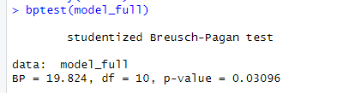
H₀: Residuals are homoscedastic (constant variance)
H₁: Residuals are heteroscedastic (non-constant variance)
p-value = 0.03096
Decision: Reject H₀ (p < 0.05)

Comment: Since the p-value is smaller than 0.05, then there is significant evidence that the residuals are heteroscedastic, meaning that the residuals’ variance is not constant across the range of fitted values. Hence, homoscedasticity assumption is not satisfied.

4- Multicollinearity Assumption

To check the collinearity between the predictor we run a VIF test to check how much a variance of a predictor is inflated due to correlation with other predictors.
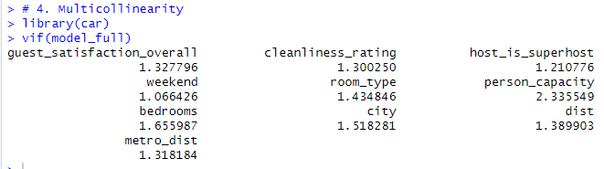

Decision Rule:
VIF < 5 → No serious multicollinearity
VIF between 5 and 10 → Moderate concern
VIF > 10 → Severe multicollinearity (problematic)

Comment: Since all VIF values are below the threshold of 5, then there is no multicollinearity among predictors. Therefore, Multicollinearity assumption is satisfied.
5-Errors Independence Assumption

To check the independence of error we need to check whether errors are correlated with one another. To check that assumption we conducted Durbin-Watson test.
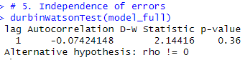
Durbin-Watson test:
H₀: No positive autocorrelation in residuals
H₁: Positive autocorrelation is present
p-value = 0.36
Decision: Fail to reject H₀ (p > 0.05)

Comment: Since p-value is above 0.05 and DW=2.144 then we don’t have evidence of autocorrelation between residuals. Therefore, independence assumption is satisfied.

Checking Specification Error
To check whether the model is correctly specified we meaning that the functional form is appropriate and no important variables are omitted. We conduct Reset Test.
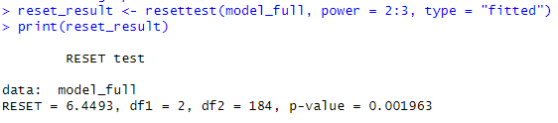
Reset Test:
H₀: The model is correctly specified
H₁: The model is misspecified
RESET statistic = 6.4493
df1 = 2, df2 = 184
p-value = 0.001963
Decision: Reject H₀ (p < 0.05)

Comment: The Reset Test indicates that the model is misspecified meaning that there may be nonlinear relationships not captured in the linear model or there are omitted variables.

Conclusion for the model: After testing the assumption and checking for model misspecification, the model doesn’t satisfy all the assumptions and it is misspecified. The model has heteroscedasticity problem and errors don’t follow normal distribution. Therefore, we will fit another model where we take log for out dependent variable.

Model Fitted
log_price = guest_satisfaction_overall + cleanliness_rating +
host_is_superhost + weekend + room_type + person_capacity + bedrooms +
city + dist + metro_dist

Model Summary

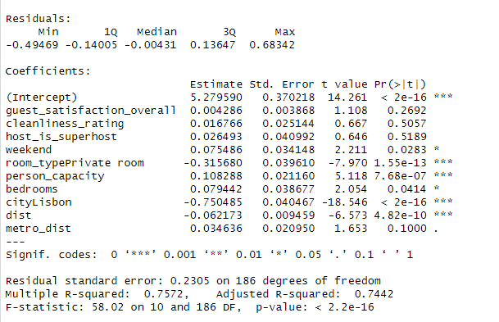
-For this model only weekend, room_type, person_capacity, bedrooms, city and dist are statistically significant while the rest of the variables aren't.
-The regression model explains 74.4% of the variance in log price and is statistically significant (p < 0.001).
-Intercept (5.279590): Average log price when all numerical predictors are zero and the property is on a weekday, in Amsterdam, entire home/apt, and host is non-super host.
-guest_satisfaction_overall (0.004286): A one percent increase in guest satisfaction rating is associated with a 0.004286% increase in price on average, holding all other variables constant. (insignificant)
-cleanliness_rating (0.016766): A one-unit increase in cleanliness rating is associated with a 0.016766% increase in price, holding all other variables constant. (insignificant)
-person_capacity (0.108288): A one percent increase in person capacity is associated with a 0.108288% increase in price on average, holding all other variables constant. (significant)
-bedrooms (0.079442): A one percent increase in number of bedrooms is associated with a 0.079442% increase in price on average, holding all other variables constant. (significant)
-dist (-0.062173): A one percent increase in distance from the center of the city is associated with a 0.062173% decrease in price on average, holding all other variables constant. (significant)
-metro_dist (0.034636): A one percent increase in distance from the metro is associated with a 0.034636% increase in price on average, holding all other variables constant. (insignificant)
-weekend (0.075486): Weekend stays are associated with a 0.075486% increase in price on average compared to weekday stays, holding all other variables constant. (significant)
-host_is_superhost (0.026493): Being a super host is associated with a 0.026493% increase in price on average compared to non-super hosts, holding all other variables constant. (insignificant)
-room_type (-0.315680): A private room is associated with a 0.31568% decrease in price on average compared to Entire home/apt, holding all other variables constant. (significant)
-city (-0.750485): The property being in Lisbon is associated with a 0.750485% decrease in price on average compared to the property being in Amsterdam, holding all other variables constant. (significant)

Assumptions Checking:
1-Linearity Assumption
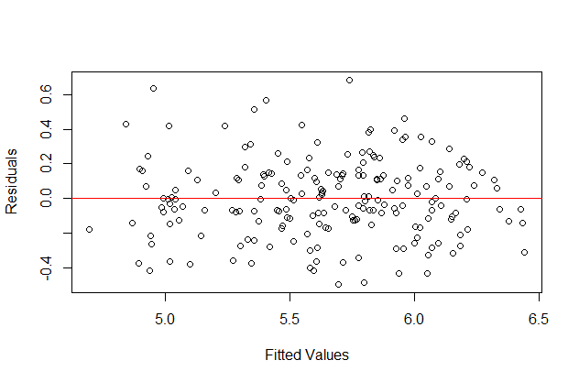
To test the linearity of the residuals, we plotted the residuals vs fitted model shows a random scatter of residuals around zero axis indicating that linearity and also indicated homoscedasticity are satisfied for the fitted model. Therefore, the linearity assumption is satisfied.

2- Normality Assumption
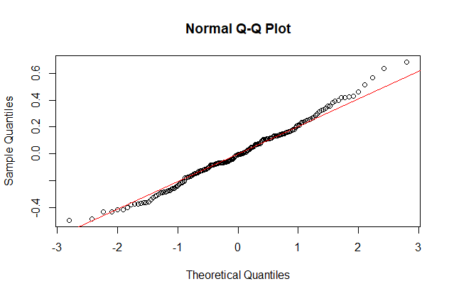
-The Q-Q Plot shows the residuals closely following the 45-degree line with slight deviations in the upper tail, indicating the residuals are approximately normal.

-Shapiro-Wilk Test:
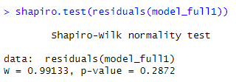
H₀: The residuals are normally distributed
H₁: The residuals are not normally distributed
p-value = 0.2872
Decision: Fail to reject H₀ (p >0.05)
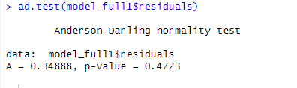
Anderson-Darling Test
H₀: The residuals are normally distributed
H₁: The residuals are not normally distributed
p-value = 0.4723
Decision: Fail to reject H₀ (p >0.05)

Comment: Both Shapiro-Wilk and Anderson-Darling tests fail to reject the null hypothesis of normality, indicating that the errors follow normal distribution and normality assumption is satisfied.

3-Homoscedasticity Assumption
To check homoscedasticity assumption we run Breusch-Pagan test
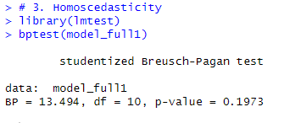
Breusch-Pagan test:
H₀: Residuals are homoscedastic (constant variance)
H₁: Residuals are heteroscedastic (non-constant variance)
p-value = 0.1973
Decision: Fail to reject H₀ (p > 0.05)

Comment: Since the p-value is greater than 0.05, then there is significant evidence that the residuals are homoscedastic, meaning that the residuals’ variance is constant across the range of fitted values. Hence, homoscedasticity assumption is satisfied.

4- Multicollinearity Assumption
To check if there is multicollinearity between predictors, we run a VIF test.
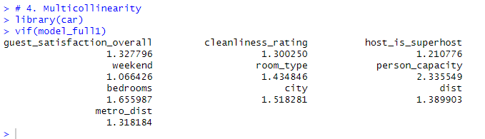

Decision Rule:
VIF < 5 → No serious multicollinearity
VIF between 5 and 10 → Moderate concern
VIF > 10 → Severe multicollinearity (problematic)

Comment: Since all VIF values are below the threshold of 5, then there is no multicollinearity among predictors. Therefore, Multicollinearity assumption is satisfied.

5- Error Independence Assumption
To check the independence of error we need to check whether errors are correlated with one another. To check that assumption we conducted Durbin-Watson test.
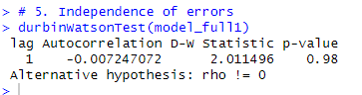
Durbin-Watson test:
H₀: No positive autocorrelation in residuals
H₁: Positive autocorrelation is present
p-value = 0.98
Decision: Fail to reject H₀ (p > 0.05)

Comment: Since p-value is above 0.05 and DW=2.0114 then we don’t have evidence of autocorrelation between residuals. Therefore, independence assumption is satisfied.

Model Specification
To check whether the model is correctly specified we meaning that the functional form is appropriate and no important variables are omitted. We conduct Reset Test.
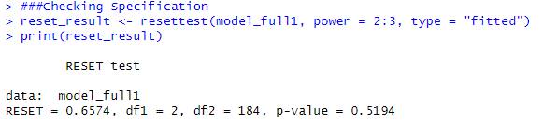
Reset Test:
H₀: The model is correctly specified
H₁: The model is misspecified
RESET statistic = 0.6574
df1 = 2, df2 = 184
p-value = 0.5196
Decision: Fail to reject H₀ (p > 0.05)

Comment: The RESET test is fails to reject the null hypothesis, indicating that there is no evidence of model misspecification. The linear functional form appears to be appropriate. Therefore, the model is correctly specified.

Conclusion:
After taking log for the dependent variable (price), all assumptions that were previously violated are now satisfied and model is correctly specified. The variables that significantly affect the dependent variable (price) are weekend, room_type, person_capacity, bedrooms, city and dist. This regression model explains 74.4% of the variance in log price and is statistically significant.

QUESTION 2
This model was fitted to test if the prices differ significantly by city (Lisbon or Amsterdam) and room type (Entire home/apt or Private rooms) and does their interaction affect the prices as well or not.

First: We fitted the model without log to check the assumptions.
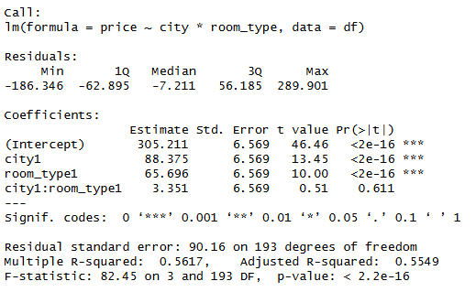
-All the parameters are significant except for the interaction term which is insignificant (with p-value = 0.611).
-The overall model is significant with adjusted R-squared = 0.5549 which means that the variables explain approximately 55.5% of the variation in price.
-The average price in Amsterdam is 305.211 if it’s an entire home or apartment. While the average price is 370.907 for a private room.
-The average price in Lisbon is 393.586 if it’s an entire home or apartment. While the average price is 462.633 for a private room.
-The average change in price is slightly greater by 3.351 in Lisbon than in Amsterdam if it’s a private room, however, this average change in price is insignificant, so there’s no significant difference between process in both cities if it’s a private room.
-Furthermore, we can notice that the residuals are highly and evenly spread which could indicate problems like non-linearity and heteroscedasticity in our model.
1- Linearity Assumption
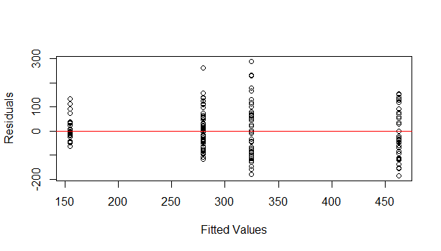
From the Residuals vs Fitted Values, we can see that the residuals are randomly scattered, therefore linearity assumption is satisfied.

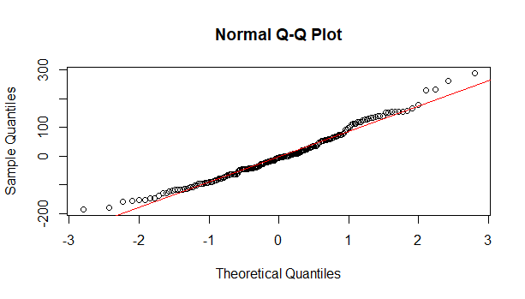
2- Normality Assumption:
-Based on the Q-Q plot, we can notice that the points are not following a tight 45-degree line as we can see some curvatures in the upper and lower tails, which indicates that the normality assumption is also not fulfilled in this model.
-Shapiro-Wilk Test:
H₀: The residuals are normally distributed
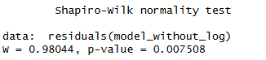
H₁: The residuals are not normally distributed
p-value = 0.007508
Decision: Reject H₀ (p <0.05)
-Anderson-Darling Test
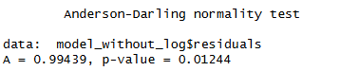
H₀: The residuals are normally distributed
H₁: The residuals are not normally distributed
p-value = 0.01244
Decision: Reject H₀ (p <0.05)

Comment: After conducting the Shapiro-Wilk and Anderson-Darling tests, we can confirm that the p-value is lower than 0.05, which means that we reject the null hypothesis and this indicates that the normality assumption is not met here.

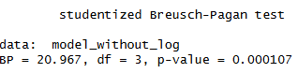
3- Homoscedasticity Assumption:
Based on the Breusch-Pagan test, the p-value is less than 0.05, so we reject the null hypothesis and state that the heteroscedasticity is presented in this model.
4- Multicollinearity Assumption:
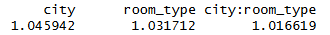
When calculating the Variance Inflation Factor (VIF), we can find that all values are below 5, so we can say that multicollinearity is not a concern in this model.
5- Autocorrelation Assumption:
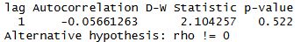
Based on the Durbin-Watson test, the p-value is greater than 0.05 so we fail to reject the null hypothesis which indicates that there’s no autocorrelation between the residuals and thus it means that the data is appropriate for the model.
Checking Specification Error:
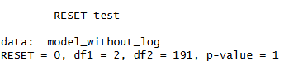
The Ramsey Regression Specification Error Test (Ramsey RESET Test) was applied to check the specification errors, however, since the p-value is greater than 0.05, we fail to reject the null hypothesis, so we can say that there’s no specification error detected in our model.
After checking the assumptions in this model, we can conclude that not the assumptions were satisfied, so we decided to fit another model with log for the price.

Fitting the model with log for price to check the assumptions.
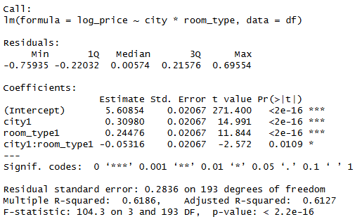
-All the parameters are significant as well as the interaction term.
-The overall model is significant with adjusted R-squared = 0.6127 which means that the variables explain approximately 61.27% of the variation in price.
-The average log_price in Amsterdam is 5.60854 if it’s an entire home or apartment. While the average log_price is 5.8533 for a private room.
-The average log_price in Lisbon is 5.91834 if it’s an entire home or apartment. While the average log_price is 6.10994 for a private room.
-The average change in log_price is slightly lower by 0.05316 in Lisbon than in Amsterdam if it’s a private room and this average change in log_price is now significant in this model.
-Also, we can determine that the residuals become less spread and almost evenly spread which is better than the previous model but further tests will be applied to double check.

1-Checking linearity:
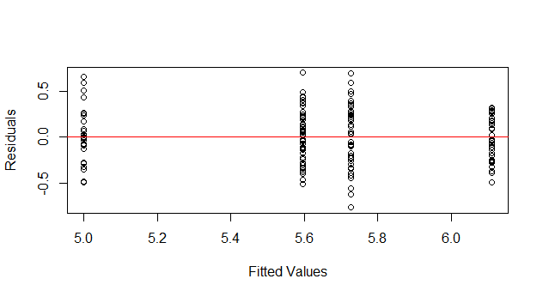

From the Residuals vs Fitted Values, we can see that the residuals are randomly scattered, therefore linearity assumption is satisfied.

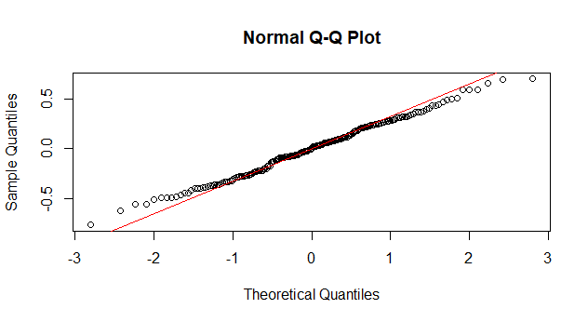
2- Normality Assumption
-The Q-Q Plot shows the residuals closely following the 45-degree line with slight deviations in the upper and lower tail, indicating the residuals are approximately normal.

-Shapiro-Wilk Test:
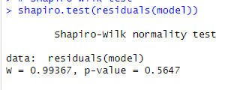
H₀: The residuals are normally distributed
H₁: The residuals are not normally distributed
p-value = 0.5647
Decision: Fail to reject H₀ (p >0.05)
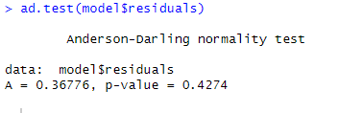
-Anderson-Darling Test
H₀: The residuals are normally distributed
H₁: The residuals are not normally distributed
p-value = 0.4274
Decision: Fail to reject H₀ (p >0.05)

Comment: Both Shapiro-Wilk and Anderson-Darling tests fail to reject the null hypothesis of normality, and the Q-Q Plot shows adherence to the 45-degree line, indicating that the errors follow normal distribution and normality assumption is satisfied.

3- Homoscedasticity Assumption
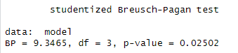
Based on the Breusch-Pagan test, the p-value is less than 0.05, so we reject the null hypothesis and state that the heteroscedasticity is presented in this model.
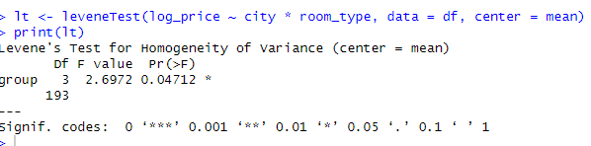
Levene’s Test:
H₀: The variances are equal across all groups (homoscedastic)
H₁: At least one group has a different variance (heteroscedastic)
F-value = 2.6972
df1 = 3, df2 = 193
p-value = 0.04712
Decision: Reject H₀ (p = 0.04712 < 0.05)

Comment: Levene's test and Breusch-Pagan tests both indicate heteroscedasticity. Therefore, homoscedasticity assumption is violated.

4- Multicollinearity Assumption
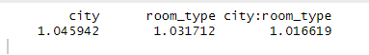
All VIF values are near one indicating no multicollinearity between the predictors and the interaction between them.

5- Autocorrelation of errors assumption
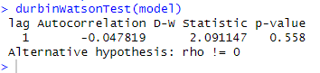
Based on the Durbin-Watson test, the p-value is greater than 0.05 so we fail to reject the null hypothesis which indicates that there’s no autocorrelation between the residuals and thus it means that the data is appropriate for the model.
Checking Specification
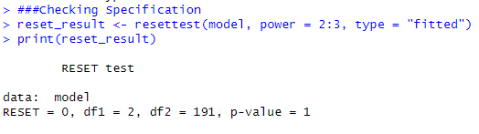
Based on Reset Test we fail to reject the null hypothesis. Therefore, the model is correctly specified

Conclusion:
Even though this model is correctly specified, not all assumptions are satisfied so we will fit another model with square root of the dependent variable (price).

Fitting model with square root of price

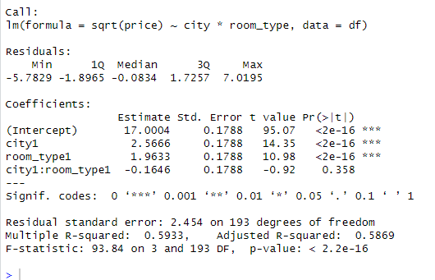

-Only city and room_type are significant while the interaction term is not significant.

-The overall model is significant with adjusted R-squared = 0.5869 which means that the variables explain approximately 58.69% of the variation in sqrt(price).

-The average sqrt(price) in the Amsterdam is 17.0004 if it's an entire home or apartment. While the average sqrt(price) is 18.9637 for a private room.

-The average sqrt(price) in Lisbon is 19.5670 if it's an entire home or apartment. While the average sqrt(price) is 20.3657 for a private room.

-The average change in sqrt(price) is slightly lower by 0.1646 in Lisbon than in Amsterdam if it's a private room, but this average change in sqrt(price) is not significant in this model (p = 0.358).

Checking Assumptions
1-Linearity Assumption

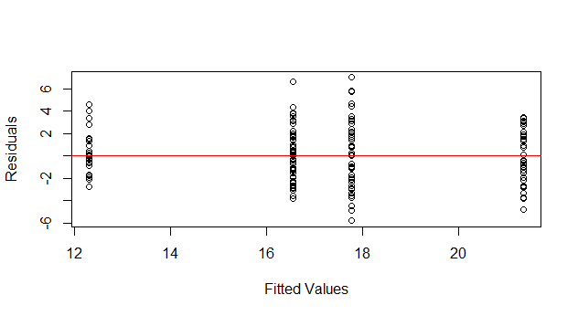
From the Residuals vs Fitted Values, we can clearly determine that the fitted values are highly spread in some parts on the line and shrinking in other parts on the line, so they are not evenly balanced above and below the zero line, so this states that the linearity and homoscedasticity assumptions are not satisfied.
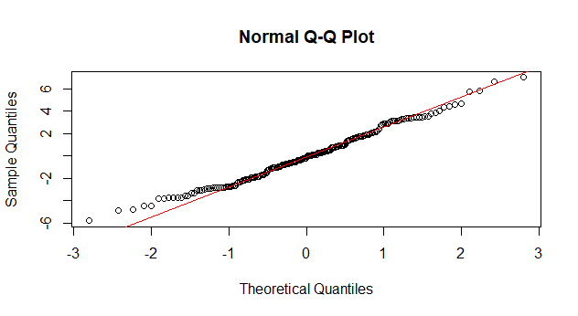
2-Normality Assumption

-The Q-Q Plot shows residuals are following the 45-degree line with slight deviations, indicating normality of residuals.

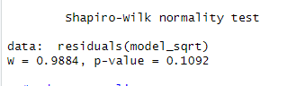
--Shapiro-Wilk Test:
H₀: The residuals are normally distributed
H₁: The residuals are not normally distributed
p-value = 0.1092
Decision: Fail to reject H₀ (p >0.05)

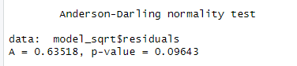
-Anderson-Darling Test
H₀: The residuals are normally distributed
H₁: The residuals are not normally distributed
p-value = 0.09643
Decision: Fail to reject H₀ (p >0.05)

Comment: Both Shapiro-Wilk and Anderson-Darling tests fail to reject the null hypothesis of normality, and the Q-Q Plot shows adherence to the 45-degree line, indicating that the errors follow normal distribution and normality assumption is satisfied.

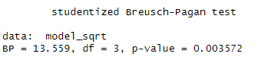
3-Homescedascticity Assumption
Based on the Breusch-Pagan test, the p-value is less than 0.05, so we reject the null hypothesis and state that the heteroscedasticity is presented in this model.

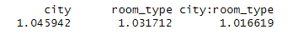
4-Multicollinearity Assumption
All VIF values are near one indicating no multicollinearity between the predictors and the interaction between them.
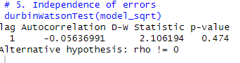
5- Autocorrelation of Errors Assumption
Based on the Durbin-Watson test, the p-value is greater than 0.05 so we fail to reject the null hypothesis which indicates that there’s no autocorrelation between the residuals and thus it means that the data is appropriate for the model

Checking Specification Error
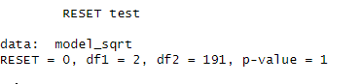
Based on Reset Test we fail to reject the null hypothesis. Therefore, the model is correctly specified

Conclusion: Model does not satisfy all the assumptions.

Fitting Model with log log price
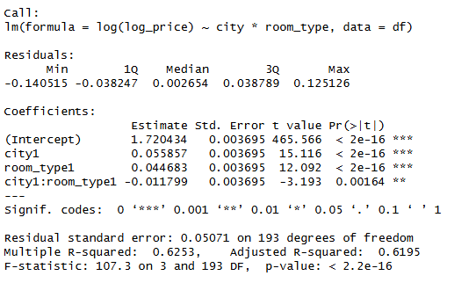
-All of the coefficients are significant and the whole model is significant

Checking the assumptions

1) Linearity Assumption
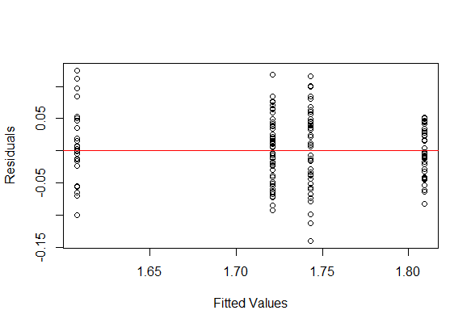

From this plot we can see that the residuals are randomly scattered, therefore linearity assumption is satisfied.

2. Normality Assumption
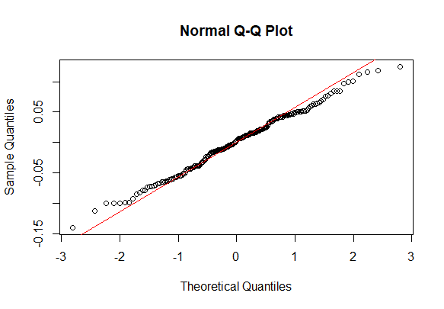
The Q-Q plot is nearly on the 45 degree line
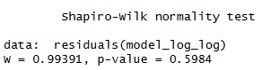
-Both Shapiro Wilk test and Anderson darling test suggest that it is normal
-Normality Assumption is satisfied
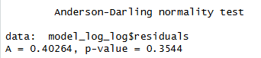
3)Homoscedasticity Assumption
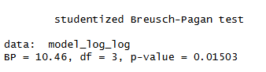
Beursch Pagan test still suggest Heteroscedasticity

4. Multicollinearity Assumption


All the values are less than 5 which means that there is no multicollinearity
5. Independence of errors Assumption

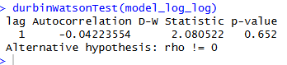
From Durbin Watson we see that there is no autocorrelation
Specification Error
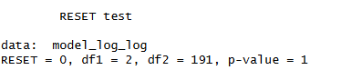
RESET Test says that there no misspecification error

Fitting Model with inverse of log price
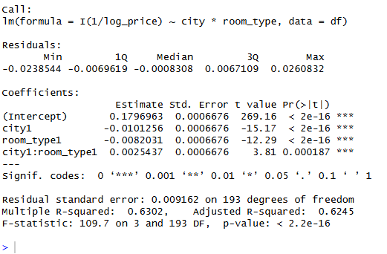
All of the coefficients are significant but their sign is reversed and the whole model is significant
Checking the assumptions
1) Linearity Assumption

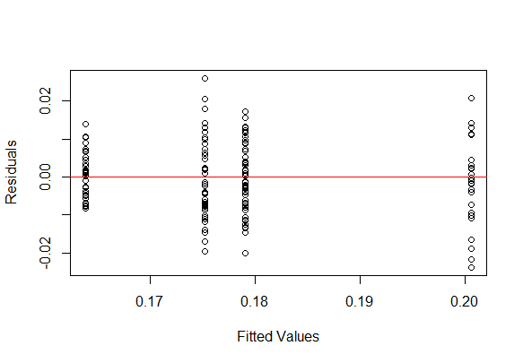
From this plot we can see that the residuals are randomly scattered
2. Normality Assumption

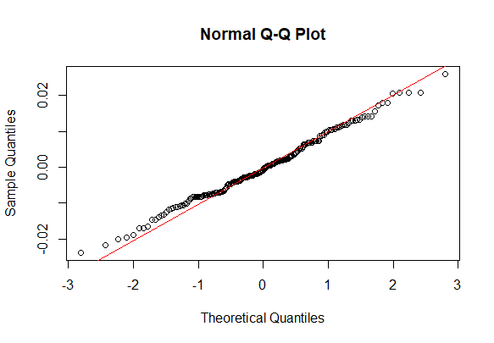
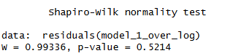
-The Q-Q plot is nearly on the 45 degree line

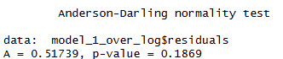
-Both Shapiro Wilk test and Anderson darling test suggest that it is normal

3)Homoscedasticity Assumption

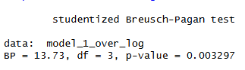
Beursch Pagan test still suggest Heteroscedasticity and it got worst

4. Multicollinearity Assumption

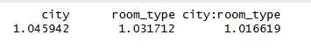
All the values are less than 5 which means that there is no multicollinearity
5. Independence of errors Assumption
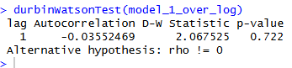
From durbin Watson we see that there is no autocorrelation
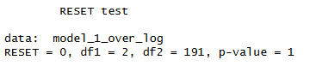
Specification Error
RESET Test says that there no misspecification error

Fitting Model with inverse of sqrt price
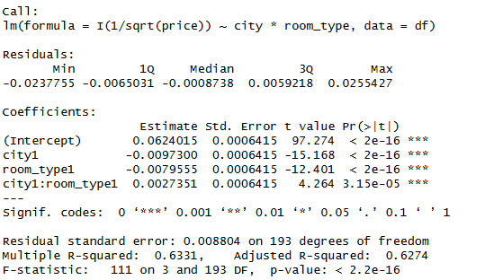
All of the coefficients are significant but their sign is reversed the same that happened with the inverse of log and the whole model is significant.

Checking the assumptions
1) Linearity and Homoscedasticity
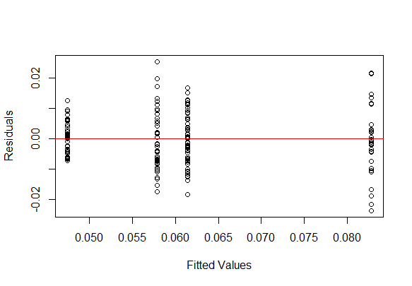From this plot we can see that the residuals are randomly scattered

2. Normality Assumption

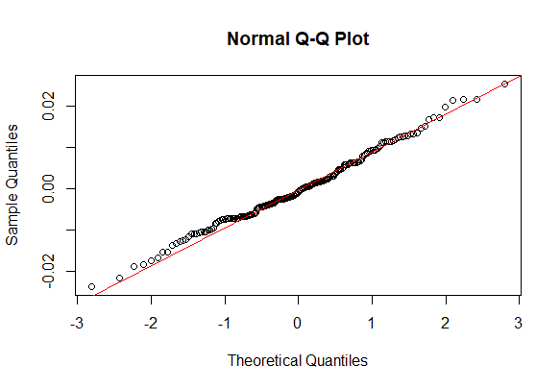
The Q-Q plot is nearly on the 45 degree line

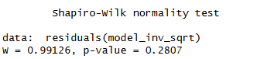
Both Shapiro Wilk test and Anderson darling test suggest that it is normal
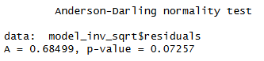
3)Homoscedasticity Assumption

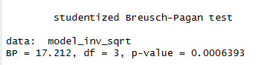
Beursch Pagan test still suggest the existence of Heteroscedasticity
4. Multicollinearity Assumption

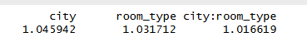
All the values are less than 5 which means that there is no multicollinearity
5. Independence of errors Assumption

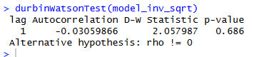
From Durbin Watson we see that there is no autocorrelation
Specification Error
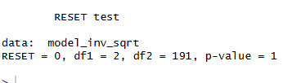
RESET Test says that there no misspecification error.

Conclusion: After trying multiple models and none of them satisfy all the assumptions and all have a heteroscedasticity problem. We will use the log(price) model since its p-value is the closest to 0.05 so it has the least heteroscedastic residuals. Therefore, we will work on robusting that model and fixing its heteroscedasticity issue.

Fixing heteroscedasticity of the log(price) model
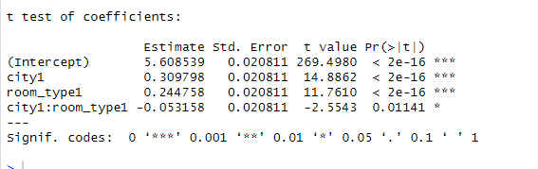

The HC3 robust standard errors confirm that the interaction between city and room_type is significant at the 5% level (p = 0.0114). The heteroscedasticity detected earlier does not affect the substantive conclusions of the model.
Doing F-Test for with and without interaction to see if interaction is important
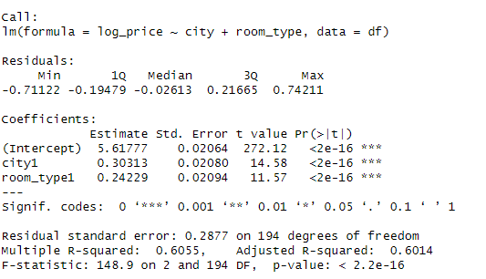

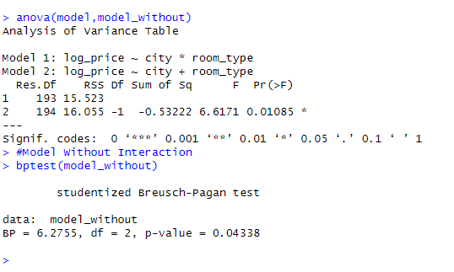
Test Result:
H₀: The interaction term does not improve the model (β_interaction = 0)
H₁: The interaction term significantly improves the model (β_interaction ≠ 0)
F-statistic = 6.6171
p-value = 0.01085
Decision: Reject H₀ (p < 0.05)

- The ANOVA test is significant , indicating that the interaction model (log_price ~ city * room_type) provides a significantly better fit than the additive model (log_price ~ city + room_type). Therefore, the interaction term between city and room_type should be retained in the model.

Which explain more the room type or city ( non-nested F-test Discrimination Approach)

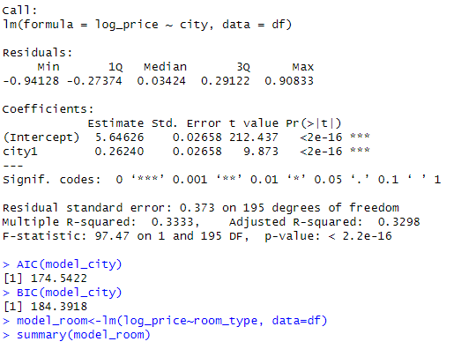
City alone explains approximately 33% of the variation in log_price.
The coefficient for city1 (0.2624) indicates that being in Lisbon increases log_price by 0.2624 units compared to Amsterdam, holding all else constant. This effect is highly significant (p < 0.001).
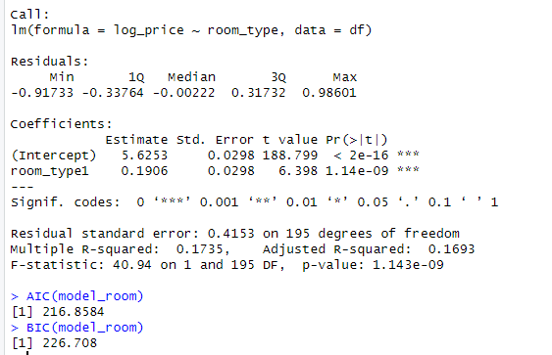
-Room type alone explains approximately 17% of the variation in log_price.
-The coefficient for room_type1 (0.1906) indicates that a private room increases log_price by 0.1906 units compared to entire home/apartment, holding all else constant. This effect is highly significant (p < 0.001)."
Therefore, based on the non-nested model comparison, city explains significantly more variation in log_price than room_type.

Final answer: Log(Price) differs significantly by both City and room type. Additionally, their interaction is statistically significant meaning the effect of City on log price depends on room type and vice versa. Therefore, the interaction matters and should be retained in the model.

Question 3
This model was fitted to test if weekends and weekdays affect the prices among both cities: Amsterdam and Lisbon.
First: We fitted the model without log to check the assumptions.
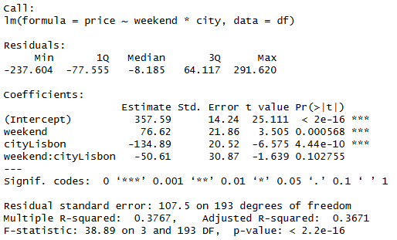
-All the parameters are significant except for the interaction term which is insignificant (with p-value = 0.102755).
-The overall model is significant with adjusted R-squared = 0.3671 which means that the variables explain 36.7% of the variation in price.
-The average price in Amsterdam is 357.59 during weekdays. While the average price is 434.21 during weekends.
-The average price in Lisbon is 222.7 during weekdays. While the average price is 248.71 during weekends.
-The average change in price is smaller by 50.61 in Lisbon than in Amsterdam on weekends, however, this average change in price is insignificant, so there’s no significant difference between the prices on weekends among the two cities.
Linearity Assmption

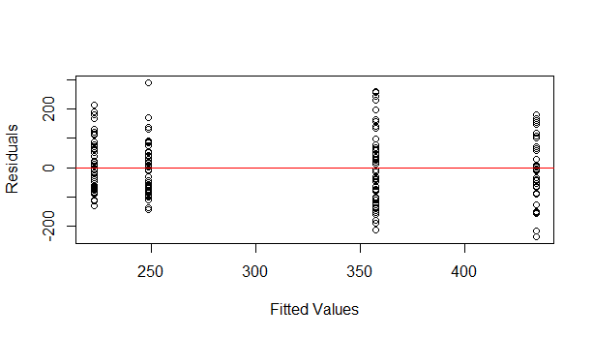
From the Residuals vs Fitted Values, we can notice the expanding spread for the fitted values as we move from the left to the right along the x-axis line. Moreover, the spread of the fitted values above or below the line is not evenly balance along the zero line. So we can say that the linearity and homoscedasticity assumptions were not met in this model.
Normality Assumption:
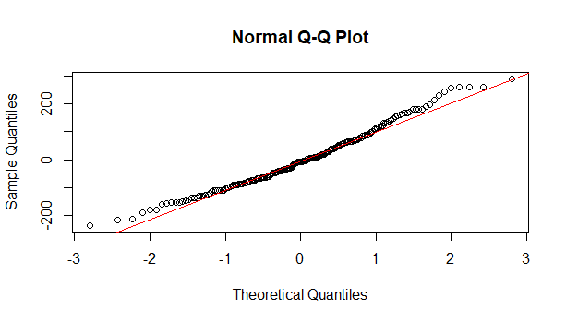
From the Q-Q plot, we can find that the points don’t follow a straight 45-degree line and there’re some obvious deviations at the upper and lower tails which suggests that the normality assumption is violated in this model.
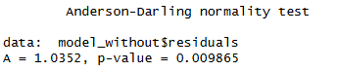
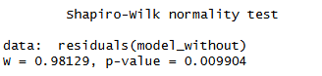
After also conducting the Shapiro-Wilk and Anderson-Darling tests, we can confirm that the p-value is lower than 0.05, which means that we reject the null hypothesis and this indicates that the normality assumption is not met here.
Checking homoscedasticity:
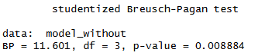
Based on the Breusch-Pagan test, the p-value is less than 0.05, so we reject the null hypothesis and state that the heteroscedasticity is presented in this model.
Checking multicollinearity:

When calculating the Variance Inflation Factor (VIF), we can find that all values are below 5, so we can say that multicollinearity is not a concern in this model.
Checking autocorrelation:
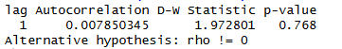
From the Durbin-Watson test, the p-value is greater than 0.05 so we fail to reject the null hypothesis and this indicates that there’s no autocorrelation between the residuals which means that the data is appropriate for the model.
Checking Specification Error:
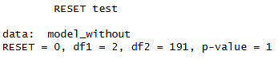
We also conducted the Ramsey Regression Specification Error Test (Ramsey RESET Test) to check the specification errors, however, since the p-value is greater than 0.05, we fail to reject the null hypothesis, so we can say that our model is not mis-specified.
After checking our assumption in this model, we can conclude that the linearity, normality and homoscedasticity assumptions are violated, however, the autocorrelation, multicollinearity, error specification were the assumptions satisfied, that’s why we decided to move forward to fit another model by plugging log into the previous model and check again our assumptions.
Fitting the model with log to check the assumptions.
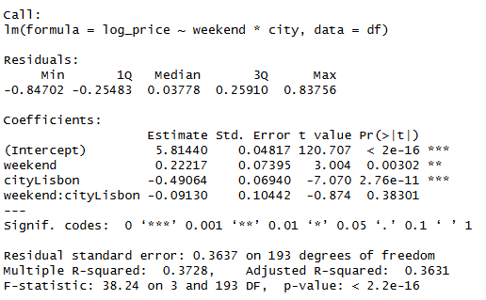
-This model was fitted to test if weekends and weekdays affect the prices among both cities: Amsterdam and Lisbon.
-All the parameters are significant except for the interaction term which is insignificant (with p-value = 0.38301).
-The overall model is significant with adjusted R-squared = 0.36311 which means that the variables explain 36.3% of the variation in log_price.
-The average log_price in Amsterdam is 5.81440 during weekdays. While the average log_price is 6.03657 during weekends.
-The average log_price in Lisbon is 5.32376 during weekdays. While the average log_price is 5.45463 during weekends.
-The average change in log_price is slightly smaller by 0.091 in Lisbon than in Amsterdam on weekends, however, this average change in log_price is insignificant, since the interaction term is insignificant, so this means that there’s no significant difference between prices on weekends among the two cities.
Checking linearity and homoscedasticity:
To assess the linearity and homoscedasticity, we graphed the Residuals vs Fitted Values plot.
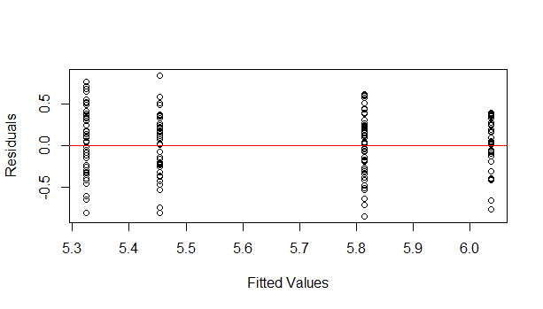
Since our explanatory variables in this model are categorical (City and Weekend), the plot (fitted values) appears as four separate columns, however, we can confidently say that the spread of the values above and below the line is equal across the four columns, thus the linearity assumption is satisfied in our model. Moreover, the vertical height for the column roughly stays the same as we move from left to right and since they are almost similar, then we can also conclude that the assumption of constant variance (homoscedasticity) is also satisfied in this model.
Checking normality:
Q-Q plot, Shapiro-wilk and Anderson-Darling normality tests were employed to test the normality assumption for our data.
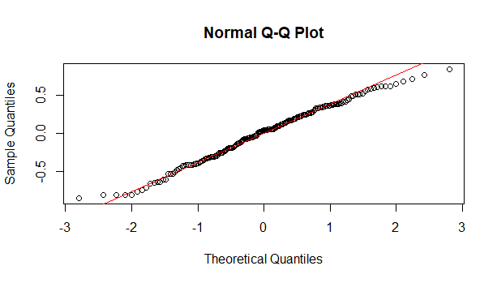
From the Normal Q-Q plot, our residuals follows closely a 45-degree line which indicates the residuals are approximately normally distributed, so the normality assumption is satisfied in our model.
Moreover, the Shapiro-wilk and Anderson-Darling tests were further conducted to double check this assumption in our model.
Null Hypothesis: The data follows a normal distribution.
Alternative Hypothesis: The data doesn’t follow a normal distribution.
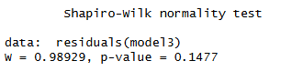
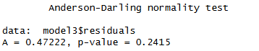
Based on the two tests: Shapiro-wilk and Anderson-Darling normality tests, our p-values are greater than 0.05, which means that we fail to reject the null hypothesis and so there’s no evidence that our data is not normal, thus the normality assumption is met in this model.
Checking homoscedasticity:
The Breusch-Pagan test was conducted to test the assumption of constant variance (homogeneity) for our data.
Null Hypothesis: The variance of residuals is constant (Homoscedasticity)
Alternative Hypothesis: The variance of residuals is dependent on the explanatory variables (Heteroscedasticity)
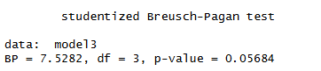
From the Breusch-Pagan test output, the p-value (=0.0568) is greater than 0.05, so it is technically not significant. So, we fail to reject the null hypothesis and conclude that the homogeneity assumption has not been violated. However, since it is approximately close to our alpha (0.05), we have applied the white robust standard errors test at the end to better improve this assumption.
Checking multicollinearity:
We calculated the Variance Inflation Factor (VIF) to assess the multicollinearity assumption within our variables.
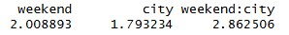
All VIF values below 5 should indicate that the multicollinearity is not a concern for our model.
We can clearly say from our VIF values that multicollinearity is not an issue in our model and there’s no correlation between our variables.
Checking autocorrelation:
Durbin-Watson test was applied to check the autocorrelation for our residuals.
Null Hypothesis: There is no autocorrelation among the residuals.
Alternative Hypothesis: There’s autocorrelation among the residuals.
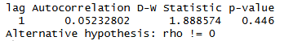
From the Durbin-Watson test, the p-value (=0.446) is greater than 0.05, so we fail to reject the null hypothesis which means that there’s no autocorrelation between the residuals, so this data is appropriate for our model.
Checking specification errors:
Ramsey Regression Specification Error Test (Ramsey RESET Test) was applied to detect if there’s a missing / omitted important variable or an incorrect specification of the error term.
Null Hypothesis: There’s no specification error in our model.
Alternative Hypothesis: There’s a specification error in our model.
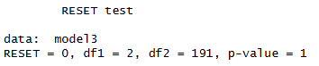
Based on the RESET test, the p-value (=1) is greater than 0.05, so we fail to reject the null hypothesis and therefore we can confidently say that there’s no specification error in our model.
Robust Standard Errors test:
Plugging the Robust Standard Error test was for the aim to check if there’s a possibility to reach a better or a higher p-value than the one we got in the Breusch Pagan test. We will compare the standard error (SE) of the variables in our original fitted model and our new coeftest output.
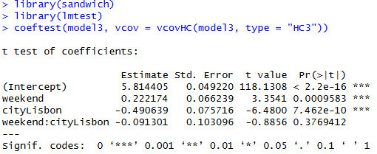
After comparing the Standard Error (SE) among both, we can see that the Standard Errors for the variables didn’t change that much, as they were almost the same for the average log_price in Amsterdam and also for the interaction term. We can find a slight decrease in the std. error for the Weekend variable and a slight increase in the std. error for Lisbon variable. However, we can conclude that robust (HC3) was to go for an extra mile but provided almost similar outputs, so we can suffice by the overall decision obtained from the Breusch-Pagan to confirm that the homoscedasticity assumption is already satisfied.

Appendix

Question 1

# ============================================================
# What Variables influence the price
# Diagnostics: DW, VIF, Shapiro, Anderson-Darling,
# QQ plot, Residuals vs Fitted,
# Breusch-Pagan, RESET test
# ============================================================

# ----- 0. Install & load packages ---------------------------
packages <- c("readxl", "lmtest", "car", "nortest", "ggplot2", "patchwork")
new_pkgs <- packages[!packages %in% installed.packages()[, "Package"]]
if (length(new_pkgs)) install.packages(new_pkgs, dependencies = TRUE)

library(readxl) # read Excel
library(lmtest) # dwtest, bptest, resettest
library(car) # vif
library(nortest) # ad.test (Anderson-Darling)
library(ggplot2) # plots
library(patchwork)# combine ggplots

# ----- 1. Load data -----------------------------------------
# Update the path below if your file is stored elsewhere

df <- read_excel("C:/Users/doaah/Downloads/eco/airbnb_with_guest_satisfaction.xlsx")

# ----- 2. Prepare variables ---------------------------------
# Ensure correct type
df$weekend <- as.integer(df$weekend)
df$room_private <- as.integer(df$room_private)
df$host_is_superhost<- as.integer(df$host_is_superhost)
df$city <- as.factor(df$city) # Amsterdam = ref
df$room_type <- as.factor(df$room_type) # Entire home/apt = ref

# ----- 3. Fit model -----------------------------------------
# ----- 3. Fit model without log -----------------------------------------
model_full <- lm(
price ~ guest_satisfaction_overall +
host_is_superhost + cleanliness_rating + weekend + room_type + person_capacity + bedrooms +
city + dist + metro_dist ,
data = df)
summary(model_full)
#########Checking Assumptions
# -----------------------------
# CHECK ASSUMPTIONS
# -----------------------------

# 1. Linearity + Homoscedasticity
plot(model_full$fitted.values, model_full$residuals,
xlab = "Fitted Values", ylab = "Residuals")
abline(h = 0, col = "red")

# 2. Normality of residuals
qqnorm(model_full$residuals)
qqline(model_full$residuals, col = "red")

# Shapiro-Wilk test
shapiro.test(residuals(model_full))
#Anderson Darling
library(nortest)
ad.test(model_full$residuals)
# 3. Homoscedasticity
library(lmtest)
bptest(model_full)

# 4. Multicollinearity
library(car)
vif(model_full)

# 5. Independence of errors
durbinWatsonTest(model_full)

###Checking Specification
reset_result <- resettest(model_full, power = 2:3, type = "fitted")
print(reset_result)

###############
# ----- 3. Fit model with log for price -----------------------------------------
model_full_log <- lm(
log_price ~ guest_satisfaction_overall + cleanliness_rating +
host_is_superhost + weekend + room_type + person_capacity + bedrooms +
city + dist + metro_dist,
data = df)
summary(model_full_log)

#########Checking Assumptions
# -----------------------------
# CHECK ASSUMPTIONS
# -----------------------------

# 1. Linearity + Homoscedasticity
plot(model_full_log$fitted.values, model_full_log$residuals,
xlab = "Fitted Values", ylab = "Residuals")
abline(h = 0, col = "red")

# 2. Normality of residuals
qqnorm(model_full_log$residuals)
qqline(model_full_log$residuals, col = "red")

# Shapiro-Wilk test
shapiro.test(residuals(model_full_log))
#Anderson Darling
library(nortest)
ad.test(model_full_log$residuals)
# 3. Homoscedasticity
library(lmtest)
bptest(model_full_log)

# 4. Multicollinearity
library(car)
vif(model_full_log)

# 5. Independence of errors
durbinWatsonTest(model_full_log)

###Checking Specification
reset_result <- resettest(model_full_log, power = 2:3, type = "fitted")
print(reset_result)

Question 2

# =============================================================================
# TWO-WAY ANOVA VIA LM
# Price ~ City + room_type + City:room_type
# Full assumption checking suite
# =============================================================================
#Does log(Price) differ significantly by City and room type, and does their interaction matter?

# ---- 0. PACKAGES ------------------------------------------------------------
packages <- c("readxl", "ggplot2", "car", "emmeans", "ggpubr",
"nortest", "lmtest", "moments", "dplyr", "tidyr")

installed <- packages %in% rownames(installed.packages())
if (any(!installed)) install.packages(packages[!installed],
repos = "https://cran.r-project.org")

library(readxl)
library(ggplot2)
library(car)
library(emmeans)
library(ggpubr)
library(nortest)
library(lmtest)
library(moments)
library(tidyr)
library(dplyr) # last — prevents select() masking

# =============================================================================
# SECTION 1 — LOAD & PREPARE DATA
# =============================================================================

df <- read_excel("C:/Users/noura/Downloads/airbnb_with_guest_satisfaction.xlsx")

# Factor coercion
df$city <- factor(df$city, levels = c("Amsterdam", "Lisbon"))
df$room_type <- factor(df$room_type, levels = c("Entire home/apt", "Private room"))
# Numeric coercion
df$price <- as.numeric(df$price)
df$log_price <- as.numeric(df$log_price)

# =============================================================================
# SECTION 2 — FIT THE LM MODEL
# =============================================================================

options(contrasts = c("contr.sum", "contr.poly"))

#first model price without any tranformation
model_without_log <- lm(price ~ city * room_type, data = df)
print(summary(model_without_log))

# -----------------------------
# CHECK ASSUMPTIONS
# -----------------------------

# 1. Linearity + Homoscedasticity
plot(model_without_log$fitted.values, model_without_log$residuals,
xlab = "Fitted Values", ylab = "Residuals")
abline(h = 0, col = "red")

# 2. Normality of residuals
qqnorm(model_without_log$residuals)
qqline(model_without_log$residuals, col = "red")

# Shapiro-Wilk test
shapiro.test(residuals(model_without_log))
#Anderson Darling
library(nortest)
ad.test(model_without_log$residuals)
# 3. Homoscedasticity
library(lmtest)
bptest(model_without_log)

# 4. Multicollinearity
library(car)
vif(model_without_log)

# 5. Independence of errors
durbinWatsonTest(model_without_log)

###Checking Specification
reset_result <- resettest(model_without_log, power = 2:3, type = "fitted")
print(reset_result)

#Fiting Model with log for price
model <- lm(log_price ~ city * room_type, data = df)
print(summary(model))
# -----------------------------
# CHECK ASSUMPTIONS
# -----------------------------

# 1. Linearity + Homoscedasticity
plot(model$fitted.values, model$residuals,
xlab = "Fitted Values", ylab = "Residuals")
abline(h = 0, col = "red")

# 2. Normality of residuals
qqnorm(model$residuals)
qqline(model$residuals, col = "red")

# Shapiro-Wilk test
shapiro.test(residuals(model))
#Anderson Darling
library(nortest)
ad.test(model$residuals)
# 3. Homoscedasticity
library(lmtest)
bptest(model)
lt <- leveneTest(log_price ~ city * room_type, data = df, center = mean)
print(lt)
# 4. Multicollinearity
library(car)
vif(model)

# 5. Independence of errors
durbinWatsonTest(model)

###Checking Specification
reset_result <- resettest(model, power = 2:3, type = "fitted")
print(reset_result)

#Fitting Model with SQRT fo price
model_sqrt <- lm(sqrt(price) ~ city * room_type, data = df)
print(summary(model_sqrt))
# -----------------------------
# CHECK ASSUMPTIONS
# -----------------------------

# 1. Linearity + Homoscedasticity
plot(model_sqrt$fitted.values, model_sqrt$residuals,
xlab = "Fitted Values", ylab = "Residuals")
abline(h = 0, col = "red")

# 2. Normality of residuals
qqnorm(model_sqrt$residuals)
qqline(model_sqrt$residuals, col = "red")

# Shapiro-Wilk test
shapiro.test(residuals(model_sqrt))
#Anderson Darling
library(nortest)
ad.test(model_sqrt$residuals)
# 3. Homoscedasticity
library(lmtest)
bptest(model_sqrt)
# 4. Multicollinearity
library(car)
vif(model_sqrt)

# 5. Independence of errors
durbinWatsonTest(model_sqrt)

###Checking Specification
reset_result <- resettest(model_sqrt, power = 2:3, type = "fitted")
print(reset_result)

#Fitting Model with log log price
model_log_log <- lm(log(log_price) ~ city * room_type, data = df)
print(summary(model_log_log))
# -----------------------------
# CHECK ASSUMPTIONS
# -----------------------------

# 1. Linearity + Homoscedasticity
plot(model_log_log$fitted.values, model_log_log$residuals,
xlab = "Fitted Values", ylab = "Residuals")
abline(h = 0, col = "red")

# 2. Normality of residuals
qqnorm(model_log_log$residuals)
qqline(model_log_log$residuals, col = "red")

# Shapiro-Wilk test
shapiro.test(residuals(model_log_log))
#Anderson Darling
library(nortest)
ad.test(model_log_log$residuals)
# 3. Homoscedasticity
library(lmtest)
bptest(model_log_log)

# 4. Multicollinearity
library(car)
vif(model_log_log)

# 5. Independence of errors
durbinWatsonTest(model_log_log)

###Checking Specification
reset_result <- resettest(model_log_log, power = 2:3, type = "fitted")
print(reset_result)

#Fitting model of 1/log price
model_1_over_log<- lm(I(1/log_price) ~ city * room_type, data = df)
print(summary(model_1_over_log))
# -----------------------------
# CHECK ASSUMPTIONS
# -----------------------------

# 1. Linearity + Homoscedasticity
plot(model_1_over_log$fitted.values, model_1_over_log$residuals,
xlab = "Fitted Values", ylab = "Residuals")
abline(h = 0, col = "red")

# 2. Normality of residuals
qqnorm(model_1_over_log$residuals)
qqline(model_1_over_log$residuals, col = "red")

# Shapiro-Wilk test
shapiro.test(residuals(model_1_over_log))
#Anderson Darling
library(nortest)
ad.test(model_1_over_log$residuals)
# 3. Homoscedasticity
library(lmtest)
bptest(model_1_over_log)

# 4. Multicollinearity
library(car)
vif(model_1_over_log)

# 5. Independence of errors
durbinWatsonTest(model_1_over_log)

###Checking Specification
reset_result <- resettest(model_1_over_log, power = 2:3, type = "fitted")
print(reset_result)

#fitting 1/sqrt price
model_inv_sqrt <- lm(I(1 / sqrt(price)) ~ city*room_type,data = df)

summary(model_inv_sqrt)
# -----------------------------
# CHECK ASSUMPTIONS
# -----------------------------

# 1. Linearity + Homoscedasticity
plot(model_inv_sqrt$fitted.values, model_inv_sqrt$residuals,
xlab = "Fitted Values", ylab = "Residuals")
abline(h = 0, col = "red")

# 2. Normality of residuals
qqnorm(model_inv_sqrt$residuals)
qqline(model_inv_sqrt$residuals, col = "red")

# Shapiro-Wilk test
shapiro.test(residuals(model_inv_sqrt))
#Anderson Darling
library(nortest)
ad.test(model_inv_sqrt$residuals)
# 3. Homoscedasticity
library(lmtest)
bptest(model_inv_sqrt)

# 4. Multicollinearity
library(car)
vif(model_inv_sqrt)

# 5. Independence of errors
durbinWatsonTest(model_inv_sqrt)

###Checking Specification
reset_result <- resettest(model_inv_sqrt, power = 2:3, type = "fitted")
print(reset_result)

#USing log price and fixing the hetro
#####Fixing Hetro
library(sandwich)
library(lmtest)
coeftest(model, vcov = vcovHC(model, type = "HC3"))

#Doing F-Test for with and without interaction to see if interaction is imp
model_without<-lm(log_price~ city+room_type, data=df)
summary(model_without)
anova(model,model_without)
#Model Without Interaction
bptest(model_without)

#Which explain more the room type or city non nested f test
#(discrimination approach)

model_city<-lm(log_price~ city, data=df)
summary(model_city)
AIC(model_city)
BIC(model_city)
model_room<-lm(log_price~room_type, data=df)
summary(model_room)
AIC(model_room)
BIC(model_room)

Question 3

# ============================================================
# Does the price of weekend differ between amsterdam and lisbon
# Diagnostics: DW, VIF, Shapiro, Anderson-Darling,
# QQ plot, Residuals vs Fitted,
# Breusch-Pagan, RESET test
# ============================================================

# ----- 0. Install & load packages ---------------------------
packages <- c("readxl", "lmtest", "car", "nortest", "ggplot2", "patchwork")
new_pkgs <- packages[!packages %in% installed.packages()[, "Package"]]
if (length(new_pkgs)) install.packages(new_pkgs, dependencies = TRUE)

library(readxl) # read Excel
library(lmtest) # dwtest, bptest, resettest
library(car) # vif
library(nortest) # ad.test (Anderson-Darling)
library(ggplot2) # plots
library(patchwork)# combine ggplots

# ----- 1. Load data -----------------------------------------
# Update the path below if your file is stored elsewhere

df <- read_excel("C:/Users/doaah/Downloads/eco/airbnb_with_guest_satisfaction.xlsx")

# ----- 2. Prepare variables ---------------------------------
# Ensure correct type
df$weekend <- as.integer(df$weekend)
df$room_private <- as.integer(df$room_private)
df$host_is_superhost<- as.integer(df$host_is_superhost)
df$city <- as.factor(df$city) # Amsterdam = ref
df$room_type <- as.factor(df$room_type) # Entire home/apt = ref
# ----- 3. Fit model -----------------------------------------
#Fit Model without log
model_without <- lm(
price ~weekend*city,
data = df
)

print(summary(model_without))
# -----------------------------
# CHECK ASSUMPTIONS
# -----------------------------

# 1. Linearity + Homoscedasticity
plot(model_without$fitted.values, model_without$residuals,
xlab = "Fitted Values", ylab = "Residuals")
abline(h = 0, col = "red")

# 2. Normality of residuals
qqnorm(model_without$residuals)
qqline(model_without$residuals, col = "red")

# Shapiro-Wilk test
shapiro.test(residuals(model_without))
#Anderson Darling
library(nortest)
ad.test(model_without$residuals)
# 3. Homoscedasticity
library(lmtest)
bptest(model_without)

# 4. Multicollinearity
library(car)
vif(model_without)

# 5. Independence of errors
durbinWatsonTest(model_without)

###Checking Specification
reset_result <- resettest(model_without, power = 2:3, type = "fitted")
print(reset_result)

#Fitting Model taking Log for price
model3 <- lm(
log_price ~weekend*city,
data = df
)

print(summary(model3))
# -----------------------------
# CHECK ASSUMPTIONS
# -----------------------------

# 1. Linearity + Homoscedasticity
plot(model3$fitted.values, model3$residuals,
xlab = "Fitted Values", ylab = "Residuals")
abline(h = 0, col = "red")

# 2. Normality of residuals
qqnorm(model3$residuals)
qqline(model3$residuals, col = "red")

# Shapiro-Wilk test
shapiro.test(residuals(model3))
#Anderson Darling
library(nortest)
ad.test(model3$residuals)
# 3. Homoscedasticity
library(lmtest)
bptest(model3)
#####Fixing Hetro
library(sandwich)
library(lmtest)
coeftest(model3, vcov = vcovHC(model3, type = "HC3"))
# 4. Multicollinearity
library(car)
vif(model3)

# 5. Independence of errors
durbinWatsonTest(model3)

###Checking Specification
reset_result <- resettest(model3, power = 2:3, type = "fitted")
print(reset_result)

